Josh Hernandez
CSCA 5702
Fundamentals of Data Visualization Final Project

Introduction and Recap of the data, goals, and tasks that influenced project design
For this data visualization project, the method and domain of research was to explore statistical output of National Football League annual offensive statistics and the theoretical rise in offensive production over the last 25 years. Over the last 10-15 years, the NFL has increased penalties and restrictions on defensive players guarding wide receivers (pass catchers). These rule changes have increasingly favored offensive players as it has increased the likelihood that defensive players will be called for defensive holding or pass interference on offensive pass catchers, therefore correlating to increased offensive production across the league overall. The goal of the data analysis is to show an upward trend in several categories of offensive production (Total Yards, Passing Total Yards, Rushing Total Yards), and a positive correlation between the rise in average annual penalties and offensive production. The data was custom sourced from pro-football-reference.com in a csv format. The data was cleaned to eliminate unnecessary statistical measures such as various average individual offensive metrics not relevant to annual averages.

Screenshots of Altair Implementation in Python
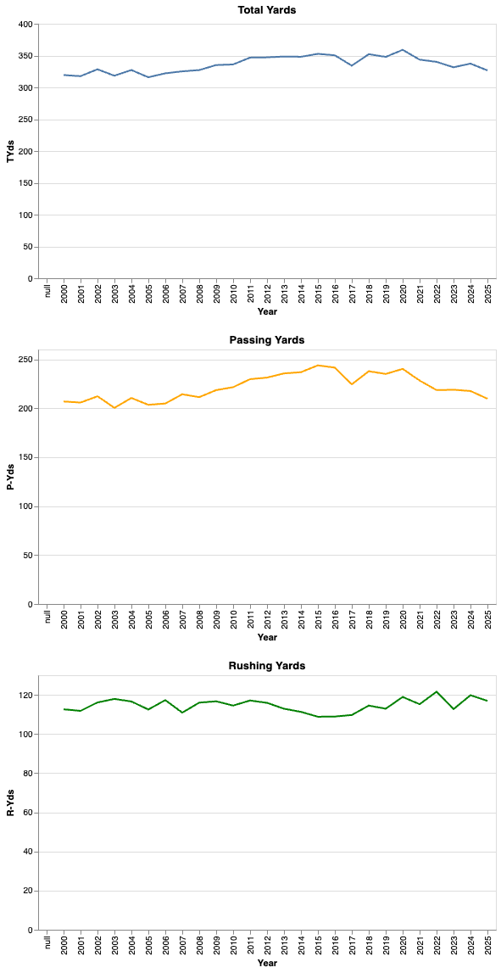
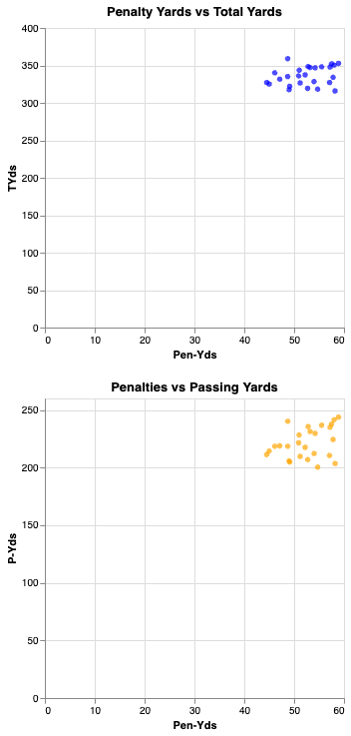

Summary of key elements of the design and accompanying justification
The visualizations were created in Microsoft VS Code with a Jupyter notebook installation. The first line graph shows the averaged league-wide total offensive yards from the years 2000-2025, the second graph shows total passing yards over this same time frame, and the third line graph shows total offensive rushing yards over the same time period as well. Line graphs were chosen to provide the viewer an overall depiction of league wide statistical offensive trends in a clear and meaningful format to show a continuous change over time.
The fourth and fifth scatter plot graphs attempt to show a positive correlation between annual penalty yards and offensive production in two categories: Total league-wide offensive yards and total passing yards. The penalty yards represent the x-axis, and the y-axis is represented by the total annual offensive yards in the respective category.
Discussion of final evaluation approach, including procedure, people recruited, and results
The target question to evaluate and answer from the data visualizations was whether the research subjects could clearly identify the hypothesized statistical trends in NFL offensive production over the last 25 years. The research subjects utilized were as follows: A colleague (High School Mathematics Teacher), friend (IT technician), and parent.
When examining the evaluative measures effectiveness of Insight Depth, two of the users identified a small, but steady overall increase in offensive production when viewing two of the three-line graphs depicting statistics over the last 25 years. Two of the users explained that although the data was not particularly powerful, the overall trends were visible enough to tell a visual data story over the years for the Total Offensive Yards and Total Passing Yards categories. When analyzing the evaluative measure of use cases with respect to the scatter plots, all three users explained that the relationship was relatively weak, but still apparent when referencing how the visualizations addressed the research question. The users all explained that the scatter plots did not address the research question as well as the three previous line graphs and that continual data over time helped them more to understand the hypothesis.
The primary approach that I used to evaluate this study was a journaling study in which I documented the observations and responses from the subjects. Follow up and clarifying questions were made to the participants in order to ensure that their mathematical understanding of the graphs did not impede their ability to clearly understand the results and probing questions revealed their initial thoughts, and reflections prior to this researcher explaining the data more in depth. To instantiate these methods, subjects were asked initially after viewing the data “What are your initial thoughts about the type of story this data explains about overall offensive production over the last 25 years?”. I then proceeded to re-clarify the overall structure of the statistical depictions to strengthen the subjects understanding of the trends and asked a follow up question of “How well do you think the data visualization correlates to a positive trend in increased offensive production?” The subjects all still agreed and explained verbally that after further explanation and understanding that the line graphs depicted a stronger argument to explaining the hypothesis.

Synthesis of findings and adjustments required for future research
In future projects, I will attempt to find data that has stronger overall correlation coefficients and an increase/decrease in data which depicts a stronger relationship visually. The data in this instance did support the predicted trends, but the change in overall offensive production from the line graphs was relatively minimal in the sense that the graphs did not stand out to the users in a powerful fashion. I soon realized after producing the scatter plots in Altair that although the correlation was minimally positive between total penalty yards and total offensive yards/passing yards, that without examining numerical values the trend might be difficult to notice. My choice of including rushing yards in one of the line graphs provided statistical depth, but not necessarily a stronger argument to answer the research question because offensive rushing is not as heavily impacted by the rule changes. For future projects, I would also like to implement tool tips in the graphs to allow users the ability to interact with the data, and also attempt to stack the line graphs into a singular chart. Overall, this data visualization project was a good foundation for future research and revisions to analyzing historical data.

