**Jherome D. Lamosa** 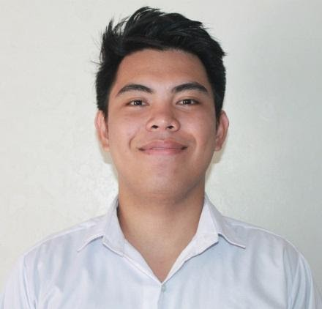

36B, Rizal Street, Brgy. Cutcut, Guiguinto, Bulacan

[Jheromelamosa@gmail.com](mailto:Jheromelamosa@gmail.com)

09558676580



**Career Objective:** Secure a responsible career opportunity to fully utilize my

training and skills, while making a significant contribution to the success of the company.



**Education:**

2014 - 2018 Asian Institute of Computer Studies - Caloocan

Bachelor of Science in Computer Science

2014 - 2010 Talugtug National High School

Talugtug, Nueva Ecija

2010 - 2004 Saverona Elementary School

Saverona, Talugtug, Nueva Ecija



**Experience:**

Sept, 2019 – March, 2021 Customer Service Representative

Valor Global Inc.



**Skills :**

* Hardware Troubleshooting
* Network Troubleshooting
* Microsoft Office (MS Word, Excel, Power point, Internet, etc)
* Adobe Creative Suite (Photoshop, InDesign, After Effects, Dreamweaver)
* Encoding
* Web designing
* English Communication



**Character References:**

Judh Mcwill Ong Guiguinto Bulacan

09661596288

JHEROME D. LAMOSA

Signature

*I hereby certify that the above information is true and correct to the best of my knowledge and belief.*