**Jhersy Aquino Fernandez**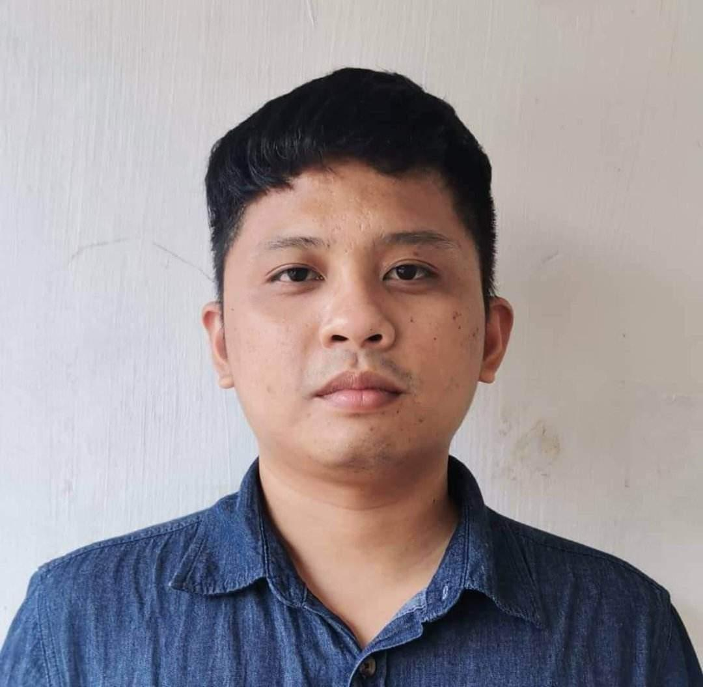

**Don Pedro Malasiqui,Pangasinan**

**Contact No.09612008070**

**Email Address :Jhersyafernandezit@gmail.com**

**Age: 31**

**Summary**

Highly motivated and detail-oriented web and mobile developer with 8+ years of experience. Proficient in PHP and MySQL, and experienced with Next.js, React.js, and MongoDB.. Possesses a strong understanding of database concepts and a passion for building scalable and efficient web applications. skilled in building mobile apps using Flutter and Android Studio, with a robust background in API development and integration.

**Skill/Capabilities**

**Back-end Development:**

* + Experienced in PHP development with a focus on web applications
  + Experienced in PHP framework like Laravel and Codeigniter.
  + Experienced using Next.js.
    - Implementing Server Side Rendering.
    - Develop Application with MongoDB, mongoose and Graphql.
  + Experienced in developing and working with APIs / web apps and integrations
  + Knowledge of MySQL database management system
  + Building small projects using Laravel
  + Familiarity with MS SQL database management system
  + Experienced in creating APIs for mobile and web applications, with skills in:
    - Designing and implementing RESTful APIs for mobile and web applications
    - Integrating APIs with mobile and web applications using HTTP requests and JSON data exchange

**Mobile Development**

* + Experienced in Building Mobile apps using Flutter with Android Studio platform.

including:

* + - Integrating with Firebase as a database.
    - Implementing geolocation and mapping features using google map API.
    - Android Development Using Java , Mysql and SQLITE

**Front-end Development:**

* + Proficient in CSS frameworks like Bootstrap.
  + Strong understanding of HTML, CSS, and JavaScript.
  + Making web applications interactive using jQuery, including:
    - Creating dynamic user interfaces with jQuery animations and effects
    - Enhancing user experience with jQuery's AJAX and JSON capabilities
  + Experienced in React JS development, including:
    - React Hooks
    - React Router
    - Redux

**Database Concepts:**

* + Understanding of database design principles and normalization
  + Familiarity with database modeling and schema design

**Additional Skills:**

* + Creating Window Application using Visual Basic .Net
  + Experienced creating website using CMS like Drupal and Wordpress
  + Familiarity with Mobile Development Technologies like Unity3d
  + Knowledge of Computer Operating Systems (Windows XP/Windows 7, Linux)
  + Familiarity with Office software (Word, Excel, Access, and PowerPoint)
  + Skilled in Graphic design tools (Photoshop, Blender)
  + Experienced in Application Development using Power Apps, Power Automate, and SharePoint
  + Proficient in Developing Dashboards using PowerBI
  + Celonis EMS technical Expert.
  + Creating Graphs and reports using Python.
  + Creating Automation Using Python.

**WORKING EXPERIENCE:**

**Freelance Web Developer**

**Web Developer**

**June 21,2024 - Present**

* Developed a range of web application projects using React, Next.js and MongoDB
* Designed the flow and architecture of the web application projects.
* Designed GUI using Figma.
* Able to develop web projects from start to finish.

**BBS Philippines, Inc.**

**Data Scientist.**

**July 31,2023 - June 21,2024**

* + - Creating web application using Powerapps.
    - Creating Web application using PHP and MSSQL.
    - Creating Dashboard using Power BI.
    - Creating Automation using power automate and UIpath

**Accenture Inc.**

**Packaged Application Senior Analyst**

**December 5, 2022 – July 21,2023**

* Earned Celonis EMS Technical Expert Certificate
* Earned Celonis Value Assessment Expert Certificate
* Earned Celonis Realization Expert Certificate
* Creating Dashboard using Celonis and Power BI.
* Data Transformation using Vertica SQL
* Develop Web Application using PowerApps.

**Asia DTWords 24/7 Philippines Inc.**

**Freelance Front End Development using CMS**

**September 26, 2022 – November 21, 2022**

* Creating webpage using Drupal

**DBSCHENKER**

**Application Support Specialist**

**Feb 17,2020 – Sept 30, 2021**

* Able to Gather System Requirements from the users
* Developed a range of web application projects using Powerapps, MSSql, Sharepoint, PowerBI and Angular/Flask.
* Designed the flow and architecture of the web application projects.
* Designed GUI using Photoshop.
* Able to develop web projects from start to finish.
* Able to conduct training and UAT with the users.

**Advanced Techinnovation Systems**

**Software Developer**

**Jan,2018-Dec, 2019**

**PROJECTS**

* + - S.M.A.L.L.E.R. Data System Development
    - SALAAM Police Volunteer ID and Report Generation System Development

**Freelance Web Developer**

**PHP Web Developer**

**June 20, 2014-Dec 21,2017**

* Developed a range of web application projects using CSS,HTML,PHP and MySql.
* Designed the flow and architecture of the web application projects.
* Designed GUI using Photoshop.
* Able to develop web projects from start to finish.

**Educational Attaintment**

**Tertiary : B.S. Information & Communications Technology**

**Pangasinan state university**

**Bayambang,Pangasinan**

**2010-2014**

**Secondary : Malasiqui National High School**

**Malasiqui,pangasinan**

**2006-2010**

**Primary : Don Pedro Elementary School**

**Don Pedro Malasiqui, Pangasinan**

**2000-2006**

**Training and Seminars**

* **Global Game Jam: Transmission-2018**
* **Microsoft®#WeSpeakCode: Kodu Labs Game Development-2018**
* **Celonis EMS technical Expert badge.**

I hereby certify that the above information is true and correct to the best of my knowledge beliefs.

Jhersy A. Fernandez

Applicant