**M8-UF4-PF**

**Hello GitHub Actions**

**Step-by-Step Instructions**

**1. Create a Pull Request**

* **Go to the Pull Requests tab in your repo.**
* **Click “New pull request”.**
* **A green rectangle with white text

  AI-generated content may be incorrect.**
* **In the dropdowns:**
  + **Base = main**
  + **Compare = welcome-workflow**



* **Click “Create pull request”.**
* **Click “Create pull request” again to confirm.**



**2. Switch to the welcome-workflow Branch**

* **Go to the Code tab.**
* **Use the branch dropdown (top-left area of the file list) to switch to the welcome-workflow branch.**

**3. Create the Workflow File**

* **Navigate to the .github/workflows/ folder.**



* **Click “Add file” > “Create new file”.**
* **In the file name field, type: welcome.yml**

**4. Paste Code Into the File**

**5. Commit the File**

* **Below the code editor:**
  + **Add a commit message (e.g., “Add welcome.yml workflow file”).**
  + **Choose “Commit directly to the welcome-workflow branch”.**
  + **Click “Commit changes”.**

**Activity: Add a job to your workflow file**

**In a separate browser tab, make sure you are on the welcome-workflow branch and open your .github/workflows/welcome.yml file.**

**Edit the file and update its contents to:**

**Step 3: Add a step to your workflow file**

**Step 4: Merge your workflow file**



**Step 5: Trigger the workflow**

**Create a New Branch**

**Make a Change**

**Create a Pull Request**

**Workflow running**

**FINISH!!**

**Test with Actions**

**Activity: Add a test workflow**

**Go to the Actions tab.**

**Click New workflow.**

**Search for "Simple workflow" and click Configure.**

**Name your workflow ci.yml.**



**Step 2: Fix the test**

**Step 3: Upload test reports**

**Step 4: Add branch protections**

**Step 5: Merge your pull request**

**Write JavaScript Actions**

**Step 1: Initialize a new JavaScript project**



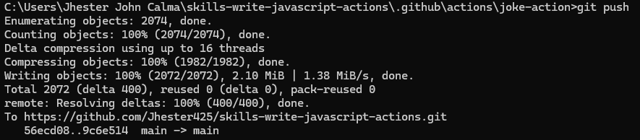

**Step 2: Configure Your Action**

**Step 3: Create the metadata file**

**Step 4: Create the JavaScript files for your action**

**Joke.js  
**

**Main.js**

**Step 5: Add your action to the workflow file**

**Step 6: Trigger the joke action**

