

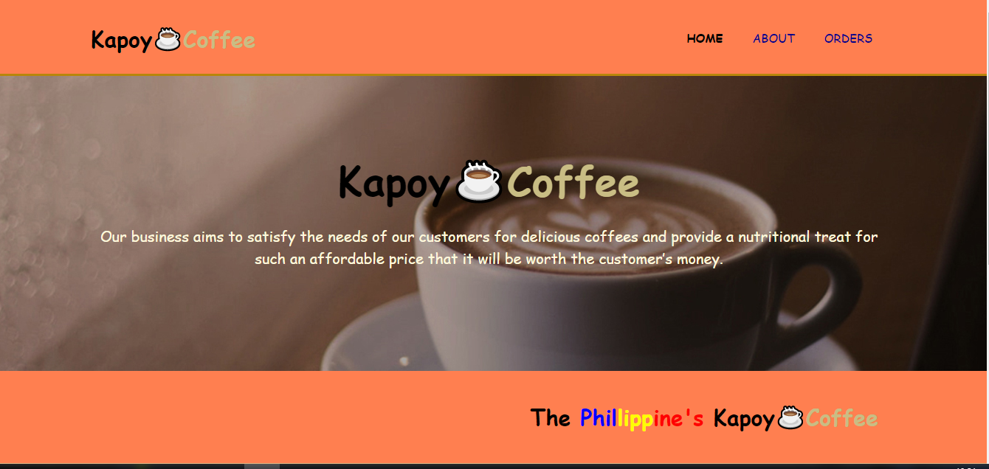These Website is created not to compete to other website but rather to promote the product of our Filipino brand. The Website is called Kapoy☕Coffee by the term “kapoy” the brand claims to give a refreshing taste and feeling The Kapoy☕Coffee is Based on our Shop . As we all know that in these times of pandemic online marketing is one of the leading career’s today that is why we decided to create a brand and website that can help to promote our product to achieve our financial goals. The website does not provide any special service but you could help our product to be fruitful by entering your email address at the About Us page.

The Webpage has 3 Navigation bar’s the Home, About and Orders. The Home page is consist of a showcase image of one of our best product the “Americano” at the center of the Showcase the Name of our brand and below our Aim is to “*satisfy the needs of our customers for delicious coffees and provide a nutritional treat for such an affordable price that it will be worth the customer’s money*”.

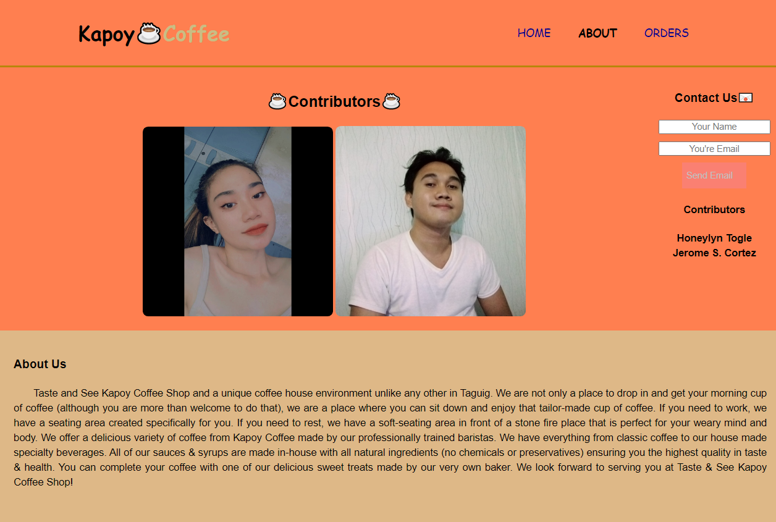

The next page is the About Us page it is the page that shows the person who is behind the Coffee Brand . They are the founder of the brand and website. On the Left side we will see the Contact us with a input text area where you can enter your name and email address to be able to receive weekly updates regarding to the product promos. You can also talk with us once the user have already send us emails and we will make sure to respond to customer inquries as soon as we can.

The Importance of email is because we are also looking for a way to sell our Coffee brand to the business owners and hopefully get investments from the investors to open new branches in many parts of Luzon.

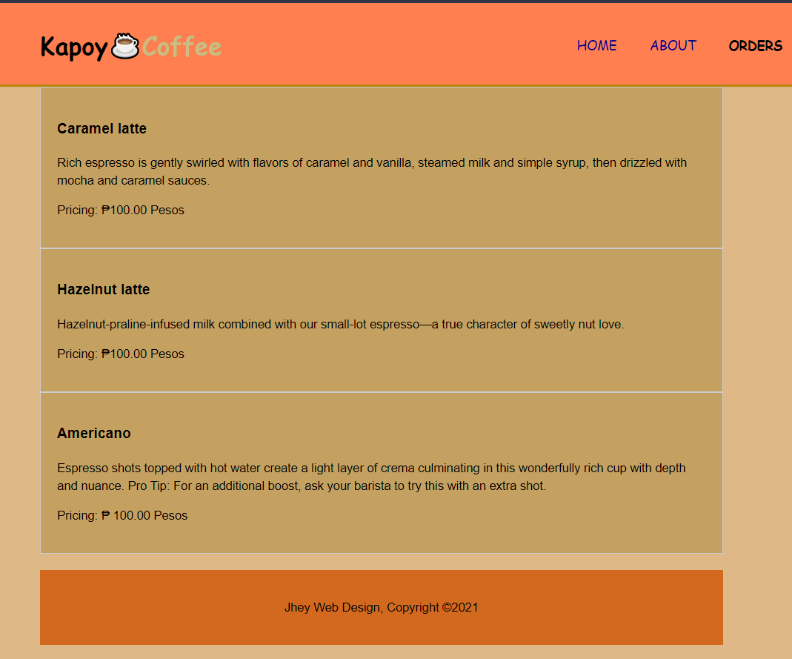At the Third Navigation Bar You Will See the Three Best Selling Coffee in our Shop and in the market for more inquries kindly send us your email at the about page to know more about the classic taste’s and promos from Kapoy☕Coffee.

At the Home page below you will see the web coding language first is the HTML(Hypertext Markup Language), CSS(Cascading Style Sheet) as the formatting language and lastly the Javascript as the Programming Language. Also a special thanks to emailjs.com because it’s a online website which is responsible for connecting my code to many Gmail Accounts. Emailjs is used to get the email from user without using servers and other unfamilliar frameworks.