Practical-3

AIM:Implement Sorting Algorithm(s).

(a) Bubble Sort

(b) Selection Sort

(c) Insertion Sort

Program:

(a)Bubble sort

#include<iostream>

using namespace std;

int sorting(int arr[],int n)

{

int cnt=0;

for(int i=0;i<n;i++)

{

for(int j=0;j<n-1;j++)

{

if(arr[j]>arr[j+1])

{

int temp;

temp=arr[j];

arr[j]=arr[j+1];

arr[j+1]=temp;

cnt++;

}

}

}

cout<<"sorted elements are "<<endl;

for(int i=0;i<n;i++)

{

cout<<"Elements ["<<i+1<<"] :"<<arr[i]<<endl;

}

if(cnt==0)

{

cout<<"Number of times Elements exchanged is 0:";

}

else

{

cout<<"Number of times Elements exchanged is :"<<cnt;

}

}

int main()

{

cout<<"This program is prepared by JHIL 22CE009\n\n";

int arr[20];

int size;

cout<<"Enter the number of elements :";

cin>>size;

for(int j=0;j<size;j++)

{

cout<<"Elements ["<<j+1<<"] :";

cin>>arr[j];

}

sorting(arr,size);

}

(b)Merge sort

#include<iostream>

using namespace std;

int sorting(int arr[],int n)

{

int min_index;

for(int pass=0;pass<n-1;pass++)

{

min_index=pass;

for(int i=pass+1;i<n;i++)

{

if(arr[i]<arr[min_index])

{

min_index=i;

}

}

if(min_index!=pass)

{

int temp;

temp=arr[pass];

arr[pass]=arr[min_index];

arr[min_index]=temp;

}

}

cout<<"sorted elements are "<<endl;

for(int i=0;i<n;i++)

{

cout<<"Elements ["<<i+1<<"] :"<<arr[i]<<endl;

}

}

int main()

{

cout<<"This program is prepared by JHIL 22CE009\n\n";

int arr[20];

int size;

cout<<"Enter the number of elements :";

cin>>size;

for(int j=0;j<size;j++)

{

cout<<"Elements ["<<j+1<<"] :";

cin>>arr[j];

}

sorting(arr,size);

}

(c)insertion sort

#include<iostream>

using namespace std;

int isorting(int arr[],int n)

{

int key,j;

for(int i=2;i<=n;i++)

{

key=arr[i];

j=i-1;

while(j>0 && arr[j]>key)

{

arr[j+1]=arr[j];

j=j-1;

}

arr[j+1]=key;

}

cout<<"sorted elements are "<<endl;

for(int i=1;i<=n;i++)

{

cout<<"Elements ["<<i<<"] :"<<arr[i]<<endl;

}

}

int main()

{

cout<<"This program is prepared by JHIL 22CE009\n\n";

int arr[20];

int size;

cout<<"Enter the number of elements :";

cin>>size;

for(int j=1;j<=size;j++)

{

cout<<"Elements ["<<j<<"] :";

cin>>arr[j];

}

isorting(arr,size);

}

Output:-

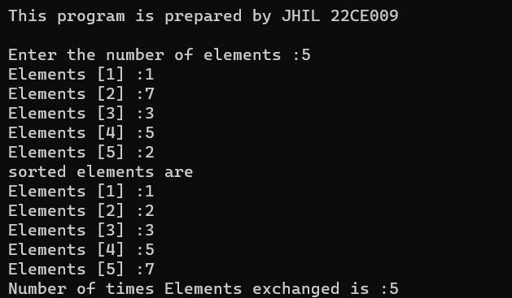

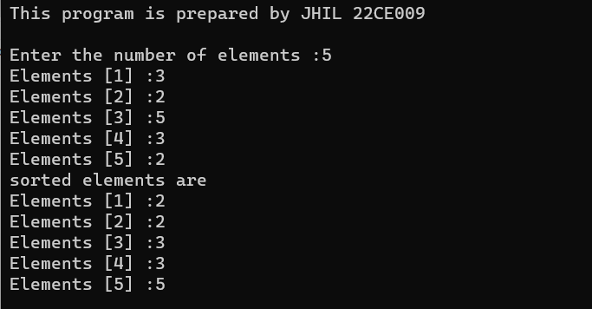

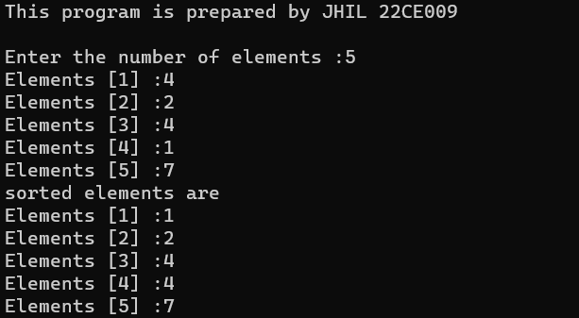

CONCLUSION:-

________ ________ _______

Student Signature Faculty Signature Marks