Bank Customer Retention Analytics
Data Analytics, Predictive Modeling & AI-Driven Insights
IBM SkillsBuild Data Analytics with AI Internship 2026
Submitted by: Jhil Patel

1. Abstract
Customer retention is an important area of analysis for banking organizations because customer exits can affect revenue, customer relationships and long-term business growth. Understanding customer behaviour can help organizations identify patterns associated with customer exits and develop appropriate retention strategies.
This project, Bank Customer Retention Analytics using AI, applies data analytics techniques to a bank customer dataset to understand customer exit patterns. The project focuses on exploratory data analysis, key performance indicators, customer segmentation, engagement patterns, account characteristics and other relevant factors.
The project follows a structured analytics workflow consisting of data collection, data cleaning, exploratory data analysis, KPI analysis, AI-assisted interpretation, visualization and business recommendations.
Artificial intelligence is used as an analytical assistance tool to help interpret already-computed analytical results and organize them into business-oriented insights. The numerical calculations and visualizations are performed using Python, while AI-assisted interpretation is validated against the analytical evidence.
The objective is not to build a predictive machine learning model, but to transform customer data into meaningful information, insights, risks, opportunities and practical business actions.

2. Problem Statement
How can data analytics and AI-assisted interpretation help a bank understand customer exit patterns and identify opportunities to improve customer retention?
Banks collect large amounts of customer information related to account activity, engagement, customer segments, balances, digital behaviour, loyalty levels and other characteristics.
However, raw customer data alone does not directly explain important business questions such as:
- How many customers have exited?
- What proportion of customers have exited?
- How does customer activity relate to exit patterns?
- Are exit patterns different across customer segments?
- How does engagement vary between customers who stayed and those who exited?
- Are there differences in customer characteristics across exit groups?
- What business risks or opportunities can be identified from these patterns?
This project addresses these questions through descriptive and exploratory analytics and uses AI-assisted interpretation to convert analytical findings into structured business insights and recommendations.

3. Objectives
- To understand the structure and characteristics of the bank customer dataset.
- To clean and prepare the dataset for analysis.
- To calculate important customer-retention KPIs.
- To analyse customer exit patterns using exploratory data analysis.
- To compare customer characteristics across exit and non-exit groups.
- To identify important patterns and potential business drivers associated with customer exits.
- To use AI-assisted interpretation for converting analytical evidence into business insights.
- To visualize important findings using appropriate charts.
- To identify potential business risks and opportunities.
- To provide practical recommendations based on the observed data patterns.

4. Dataset
The project uses a bank customer behaviour and churn dataset obtained from Kaggle.
Dataset Source:
https://www.kaggle.com/datasets/thuandao/bank-customer-behavior-and-churn-dataset
The dataset contains customer-level information related to banking behaviour, demographics, engagement, account characteristics and customer exit status.

5. Data Preparation
Identifiers and personal-information fields were not used for prediction. Dates were converted and transformed into account age and recency features. The supplied risk_score, risk_segment and cluster_group fields were excluded from predictive modeling because they appear to be pre-existing risk/cluster outputs. customer_segment was also excluded from the model because its construction is undocumented and it has a strong relationship with the target. last_transaction_month was excluded because its numeric values do not clearly match its field name.

6. Exploratory Analysis
The observed exit rate is 18.00%. There are 14,400 exited customers and 65,600 customers who stayed.
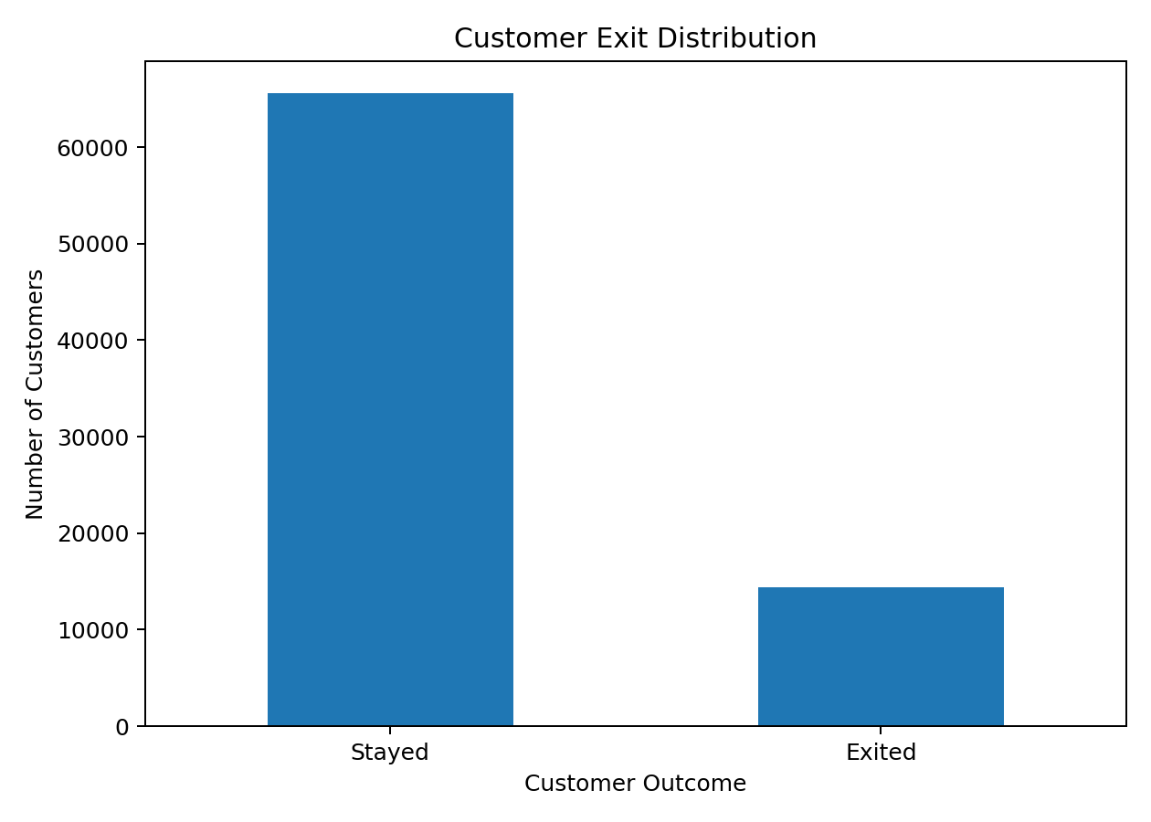
Figure 1. Customer exit distribution.
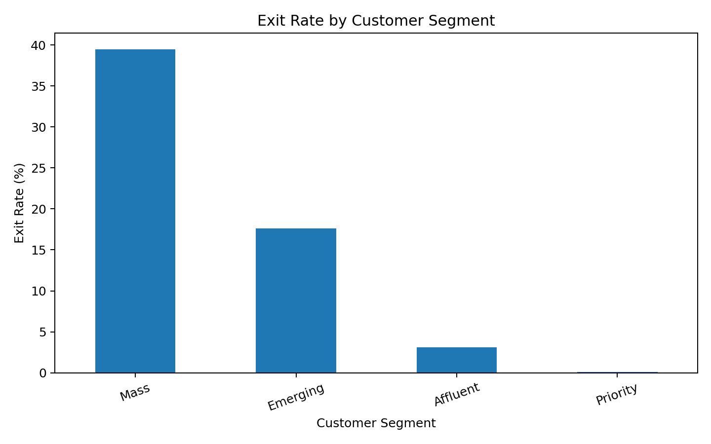
Figure 2. Exit rate by customer segment.
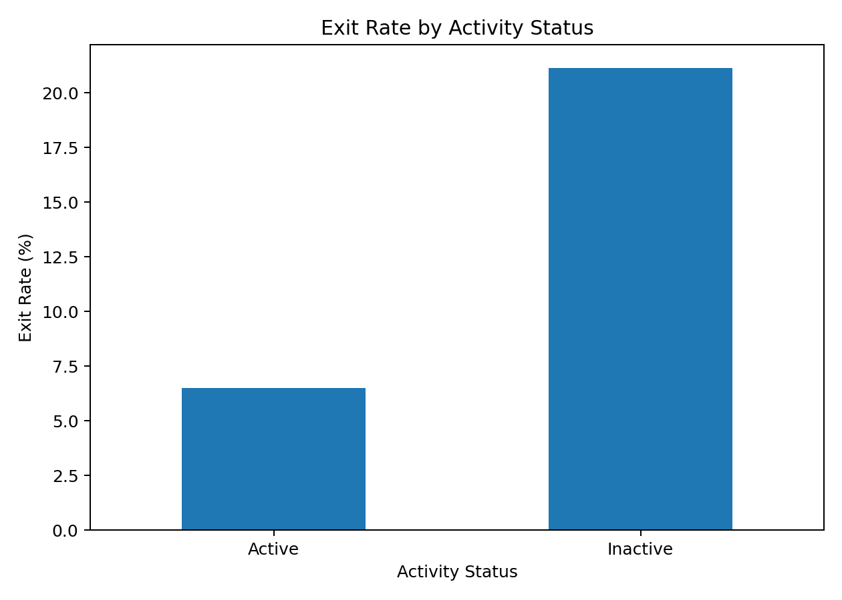
Figure 3. Exit rate by activity status.
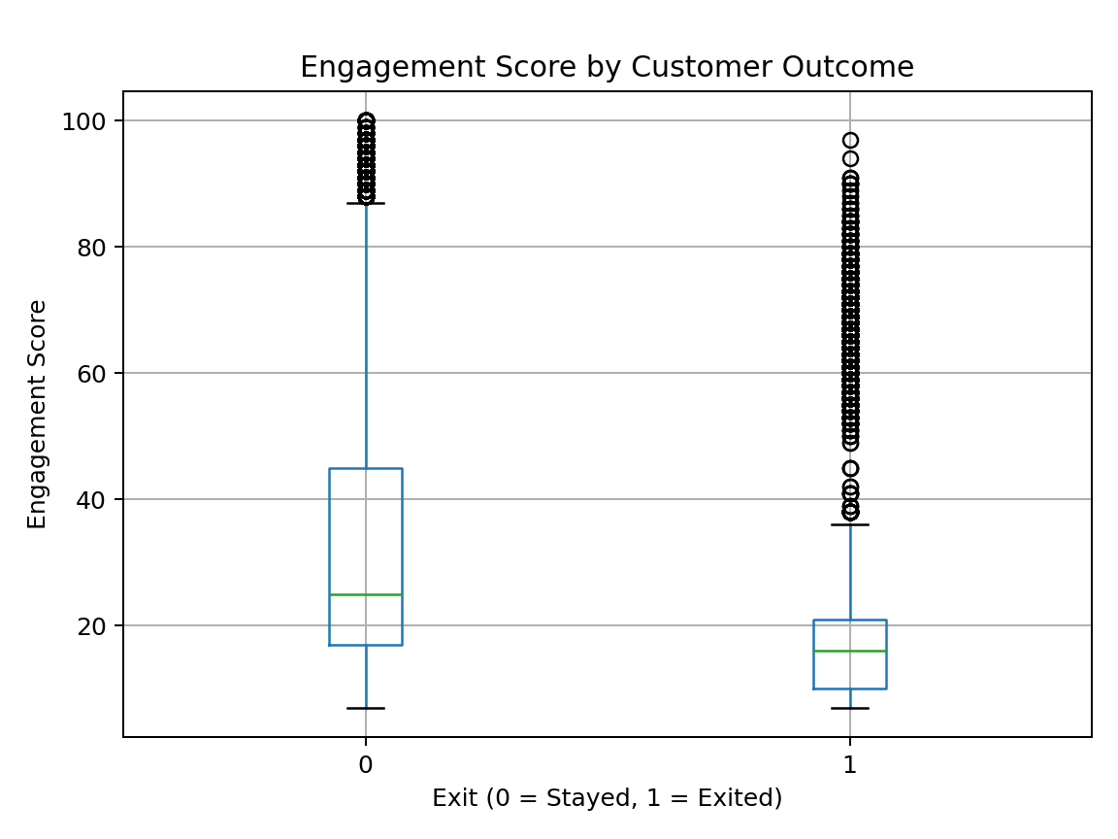
Figure 4. Engagement score by outcome.

7. Predictive Modeling
An 80/20 stratified train-test split was used. Categorical variables were one-hot encoded and numeric variables standardized within a preprocessing pipeline. Logistic Regression was used as a baseline and Random Forest as an ensemble model.
Model | Accuracy | Precision | Recall | F1 | ROC-AUC
Logistic Regression | 0.735 | 0.391 | 0.843 | 0.534 | 0.855
Random Forest | 0.753 | 0.406 | 0.805 | 0.539 | 0.853
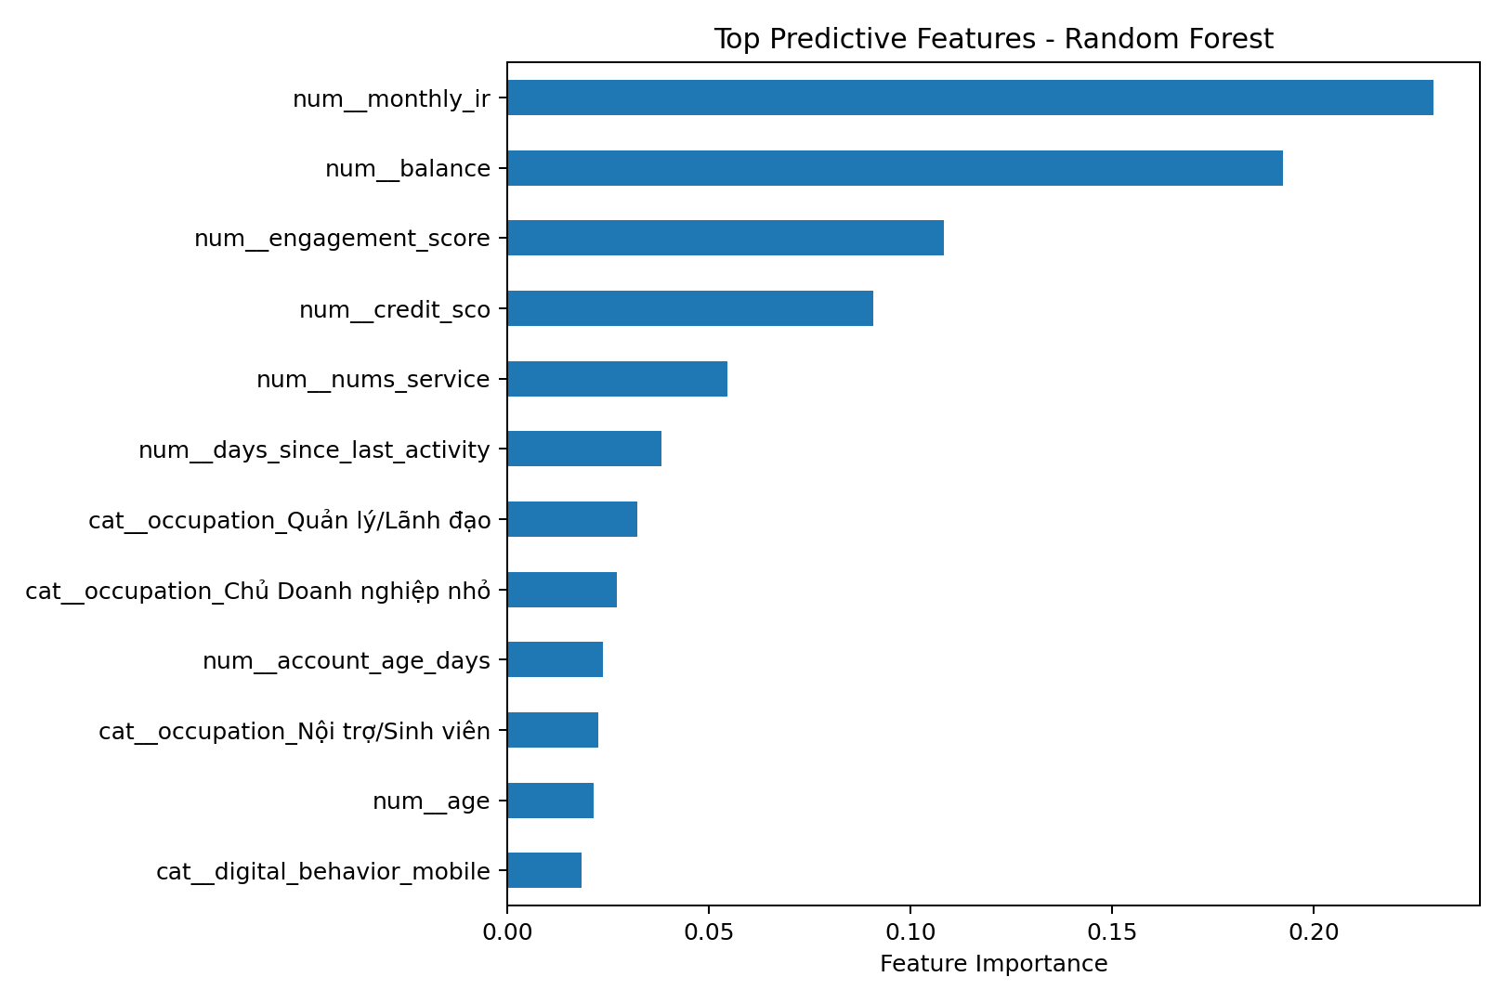
Figure 5. Top Random Forest predictive features.
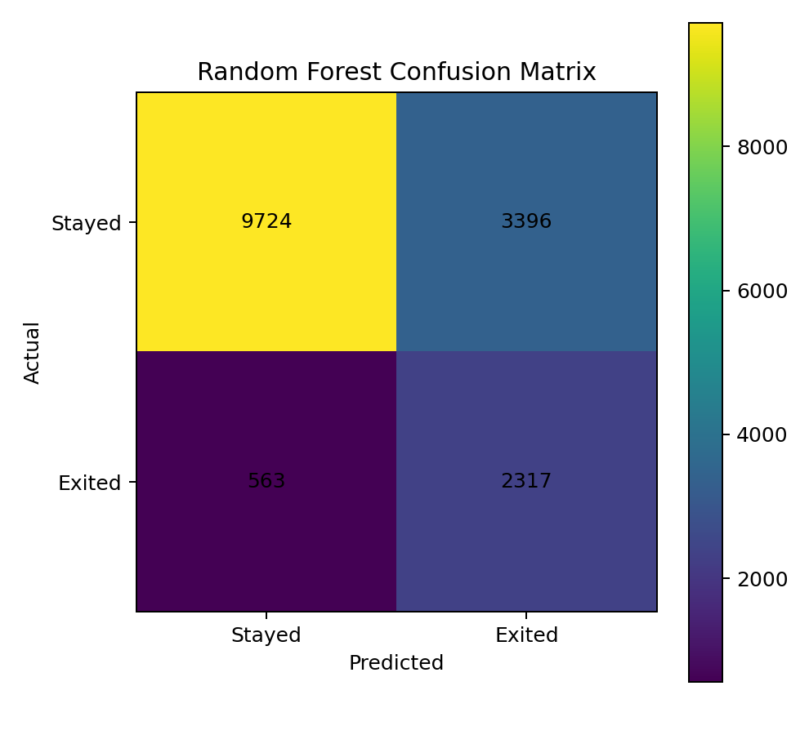
Figure 6. Random Forest confusion matrix.

8. Customer Segmentation
K-Means clustering was independently performed. Silhouette scores were evaluated on a 4,000-record sample for k=2 to k=5 and k=3 was selected. The final clustering model was then fitted to all customers.
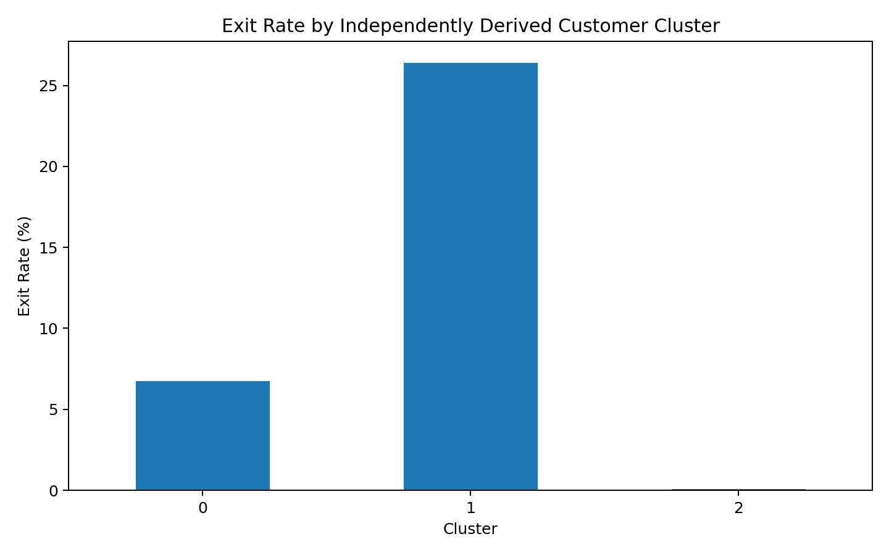
Figure 7. Exit rate by independently derived cluster.
new_cluster customers exit_rate avg_balance avg_engagement avg_age avg_products exit_rate_pct
0 16626 0.07 39192288.49 72.94 49.18 4.21 6.73
1 50282 0.26 35532793.60 17.87 49.09 2.86 26.40
2 13092 0.00 187624863.69 32.61 50.76 5.47 0.07

9. Customer Risk Scoring
Random Forest predicted churn probabilities were converted into Low, Medium and High bands using thresholds of 0.33 and 0.66. These are model-generated bands and are separate from the dataset's existing risk fields.
Predicted Risk Band | Customers
Low | 40,575
Medium | 22,392
High | 17,033

10. AI-Driven Insights
- The Mass segment has the highest observed exit rate (39.5%), while Priority has the lowest (0.1%).
- Inactive customers have an observed exit rate of 21.1% versus 6.5% for active customers.
- monthly_ir is the highest-importance predictive feature in the Random Forest among the selected inputs.
- Customers with high model-predicted churn probability can be prioritized for retention review.
- Independently derived clusters can support differentiated retention strategies.

11. Business Recommendations
- Prioritize high predicted-risk customers for retention review.
- Investigate inactivity as a potential early-warning signal.
- Tailor retention communication to customer segments and independently derived clusters.
- Monitor engagement and digital behavior over time.
- Use model outputs as decision-support signals rather than automatic decisions.

12. Limitations
- The analysis is based on the available dataset and may not represent the complete customer population of an actual bank.
- The project primarily focuses on descriptive and exploratory analytics.
- Observed relationships between variables should not be interpreted as proof of causation.
- Customer behaviour can be influenced by factors that are not available in the dataset.
- AI-assisted interpretations depend on the quality and completeness of the analytical evidence supplied to the AI tool.
- AI-generated insights were therefore reviewed against the original Python analysis rather than being treated as independent evidence.
- The project does not build a predictive machine learning model for future customer exits.
- Business recommendations should be validated using additional organizational data before being implemented in a real banking environment.

13. Conclusion
The Bank Customer Retention Analytics using AI project demonstrates how customer data can be transformed into useful business information through a structured data analytics workflow.
The project begins with data collection and preparation, followed by exploratory analysis and KPI calculation. Different customer characteristics, engagement patterns, activity levels, segments and account-related variables are examined to understand observed customer exit patterns.
AI is incorporated as an analytical assistance tool to help organize the findings into a structured format of Fact, Insight, Risk/Opportunity and Action. The AI-generated interpretations are checked against the analytical evidence to ensure that the final insights remain grounded in the dataset.
The project demonstrates the complete flow from:
Raw Data → Information → Insights → Business Actions
Rather than focusing on predictive modelling, the project emphasizes understanding what is happening in the available customer data, identifying meaningful patterns, recognizing potential risks and opportunities and translating analytical findings into practical business recommendations.

14. UN SDG Alignment
This project can be connected with the United Nations Sustainable Development Goals through the use of data-driven analysis to support responsible business decision-making.
SDG 8 – Decent Work and Economic Growth
Data analytics can support organizations in improving operational decision-making, customer relationships and business efficiency.
By analysing customer behaviour and identifying areas requiring attention, organizations can make more informed decisions regarding customer service and business processes.
SDG 9 – Industry, Innovation and Infrastructure
The project demonstrates the use of data analytics and artificial intelligence to support digital and data-driven business processes.
The combination of Python-based analytics, visualization and AI-assisted interpretation demonstrates how modern digital technologies can support organizational decision-making.

15. Submission Summary
The final submission consists of the complete Jupyter Notebook code, requirements.txt dependency file, this project report and README.md. The notebook should be run from top to bottom with bank_churn_dataset.csv available in the same directory.

