**Student Name:**

**Student ID:** **Marks:** **/15**

# Lab: Simple SELECT and Sorting Data

## Equipment and Materials

For this lab, you will need:

* A Windows computer with a minimum of 16GB RAM and 250GB of free disk space, capable of nested virtualization
* Access to ORACLE SQL*PLUS
* Really Cheap Vacations Database created as part of previous learning activities
* Physical model for Really Cheap Vacations as created during previous learning activities
* A copy of the Really Cheap Vacations database
  + Create the Really Cheap Vacations database by referring to the file ReallyCheapVacationsDB.zip in the course resource section of Brightspace.
* The file **Labskelelton.sql**,which is provided on Brightspace.

## Instructions

1. First, work through stages 2-5 individually. Then arrange a time to come together with your small group. As a group, create one solution based on the best individual script for each problem. Further refine the solution as a group as needed.
2. Review the Really Cheap Vacations Physical Model.
3. Review the Really Cheap Vacation Database.
4. Using **Labskelelton.sql**as a starting point, write a single script that satisfies all the requirements outlined in the Problem Set.
5. Review the Tips for Success and Marking Criteria sections. Adjust your script as needed.
6. See Brightspace for exact due dates.
7. Only one submission is required per group. The submission should include:
   1. One script file
   2. One spool file showing all results
   3. One attribution list that outlines the activities associated with completing this assignment. A sample attribution list is provided on Brightspace.

## Problem Set

1. Display all agents who specialize in US travel packages. Sort by last name.

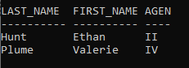

1. Find all tours in France and Spain that cost $100 or less. Sort by country, state, city and price. Line width should be 160, the destination desc column should be 80 characters, country 15 characters and city 10 characters wide.

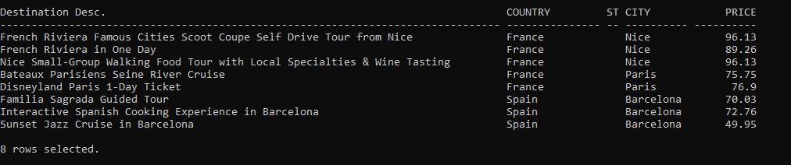

1. Find all customers in California with a phone # that starts with a ‘310’ area code. Sort by last name and first name.

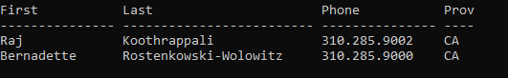

## Tips for Success

1. Use column aliases to create appropriate column headers.
2. Use **set linesize xxx,** where xxx is a number to set the width for the output.
3. Use the column command to set the size of the columns, e.g.:  
   **column “aliasname” format A40**

**column stagename format A30 heading ‘Customer Heading’**  
“A” means alphanumeric field, with a length of 30 characters in the example above.

1. For number columns use

**column “aliasname” format 9999.99**   
This will show four digits before the decimal point and two digits after the decimal point.

1. Use **clear columns** at the end of each query to reset the columns settings

## Marking Criteria

|  |  |  |  |  |  |
| --- | --- | --- | --- | --- | --- |
| **Categories** | **Missing 0** | **Needs Improvement 1** | **Good 2** | **Excellent 3** | **Score** |
| Correct results (e.g. # of rows, values) | N/A | 2+ questions incorrect | 1 question incorrect | Yes | **/3** |
| Output is formatted to match what is provided | No attempt to format output | 3+ formatting issues, lines wrap in output | 1-2 Formatted issues | Yes | **/3** |
| Solution will work on all datasets (e.g. no hard-coded values) | 4 questions will not work for all datasets | 2-3 questions will not work for all datasets | 1 question will not work for all datasets | Yes | **/3** |
| Attribution list provided | No | N/A | N/A | Yes | **/3** |
| Spool file provided with commands included |  | No |  | Yes | **/3** |
| **/15** | | | | | |