**hjStudent Name: Weight:**

**Student ID:** **Marks:** **/15**

# Lab: Unit 12 Using Joins

## Equipment and Materials

For this lab, you will need:

* A Windows computer with a minimum of 16GB RAM and 250GB free disk space, capable of nested virtualization
* Access to ORACLE SQL*PLUS.

## Problem Set

1. Show all the Customers and their vacation destinations for non-California customers. Remember is it possible for the customer province to be NULL if it is a European customer. Include destinations that have not been booked by any Customers. Solve using JOIN...USING. Remove any duplicate entries. Sort by last name, first name and destination description.

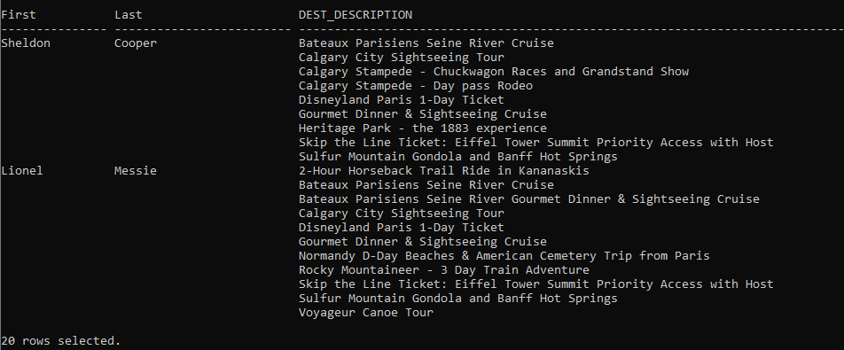

1. Solve the previous question using a traditional join (using WHERE instead of a JOIN clause).
2. Provide a list of Agents and all the vacation tours booked by them, and remove any duplicates. Solve using JOIN...ON. Include vacation tours that have yet to be booked by Agents for Customers. Clear any previous break commands before running this query. Sort by Agent last name, Agent first name, and rating description.  
     
   A screenshot of a computer program

   Description automatically generated
3. Provide a list of customers and the description of the tours they have booked. Remove any duplicates. Sort by Customer last name, Customer first name, and tour description.
4. A screenshot of a computer screen

   Description automatically generated

## Instructions

1. Use the Really Cheap Vacations database to solve these questions. The physical model is provided in the *Course Resources→Database Data Files* section of Brightspace.
2. Write a **single** script that answers all the questions in the problem set.
3. Use the ImprovedLabskeleton.sql script provided in the *Course Resources→Other Resources* as a starting point.
4. Solve all the problems INDIVIDUALLY first.
5. Arrange a time to come together as a small group to create a group submission based on the best individual solution for each question. Only ONE group submission is required.
6. Include and submit an attribution list that outlines the activities, time spent, and resources associated with completing this assignment. A sample attribution list is provided:

|  |  |  |  |
| --- | --- | --- | --- |
| Activity | Date | Resources | Tim spent (hours) |
| Initial group meeting | May 10, 2 PM | Dave, Fred, Kricket, Sara | 0.25 |
| Working through lab individually | May 11, 3 PM | Dave | 1 |
| Working through lab individually | May 11, 6 pm | Fred | 1 |
| Working through lab individually | May 12, 3 pm | Sara | 0.5 |
| Working through lab individually | May 12, 2 pm | Kricket | 0.5 |
| Final meeting to review individual submissions and create group submission | May 14, 3 PM | Dave, Fred, Kricket, Sara | 1.0 |
| Total Person Hours |  |  | 4.25 hours |

## Tips for Success

1. Use column aliases to create appropriate column headers.
2. Use **set linesize *xxx*** which ***xxx*** is a number to set the width for output.
3. Use the column command to set the size of the columns, e.g.:  
   **column "aliasname" format A40**

**column stagename format A30 heading "Stage Name"**  
“A” means alphanumeric field with a length of 40 characters. For number columns use

**column "alaisname" format 9999.99**   
to show 4 digits before the decimal point and 2 digits after the decimal point.

1. Use:  
   **clear columns**  
   at the end of each query to reset the column size.
2. Use the **BREAK ON** command to suppress the printing of duplicate values in a column.  
     
   For example, for Question 4, do this to have the names appear only the first time they are in the output:  
     
   **BREAK ON "Last" ON "First"**  
     
   Use **CLEAR BREAKS** after the query to undo this.  
     
   Details about **BREAKS** can be found on the [Oracle documentation site](https://docs.oracle.com/en/database/oracle/oracle-database/21/sqpug/BREAK.html#GUID-8C5811BC-01DF-4D95-A3A0-5C42C546534F).

## Marking Criteria

You must pass all categories to pass the activity.

|  |  |  |  |  |  |  |  |
| --- | --- | --- | --- | --- | --- | --- | --- |
| **Categories** | | **Missing 0** | | **Needs Improvement 1** | **Good 2** | **Excellent 3** | **Score** |
| Correct Results (e.g # of rows, and values) | | N/A | | 2+ questions incorrect | 1 question incorrect | Yes | **/3** |
| Output is formatted to match what is provided | | No attempt to format output | | 3+ formatting issues, lines wrap in output | 1-2 Formatting issues | Yes | **/3** |
| Solution will work on all datasets (e.g. no hard-coded values) | | 4 questions will not work for all datasets | | 2-3 questions will not work for all datasets | 1 question will not work for all datasets | Yes | **/3** |
| Attribution List Provided | | No | |  |  | Yes | **/3** |
| Spool File provided with commands included | | No | |  |  | Yes | **/3** |
|  |  | | **/15** | | | | |