**Name: Jhon Morales Carmona**

**Course: IASC 1P02**

**Assignment 4**

**Wireframe**

Homepage: <https://wireframe.cc/SQ82se>

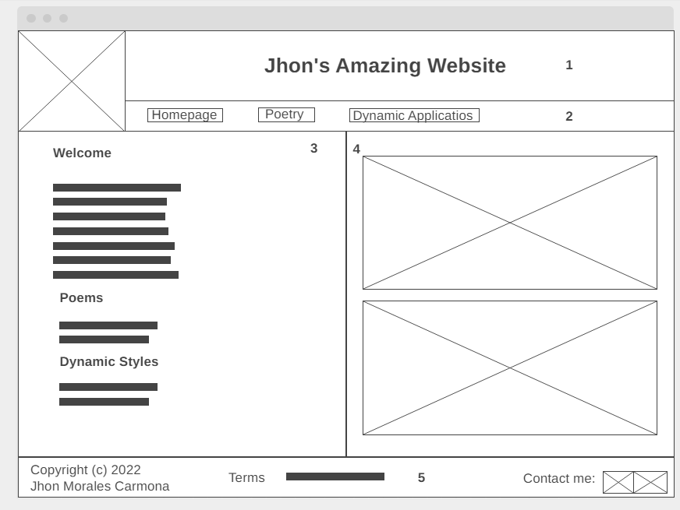

Poetry: <https://wireframe.cc/GMW4c6>

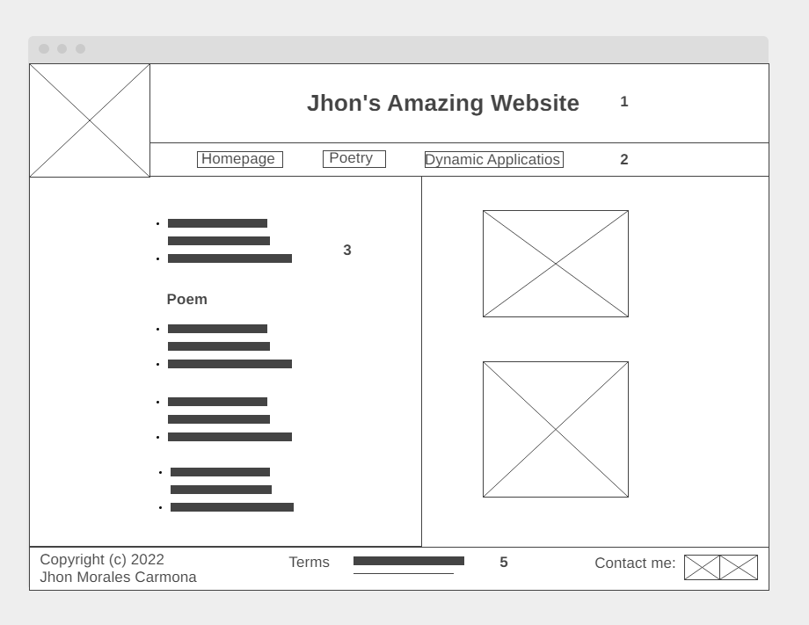

Dynamic Applications: <https://wireframe.cc/Tq6NV2>

