Child Protection Conference Scheduling
Staff guide to preparing and checking invitations
This guide explains how to use the email automation in your day-to-day work. The automation prepares two draft emails. You must check and complete them before sending.

Before the team starts using it
The flow is currently set up for testing. Ask the person responsible for the flow to confirm the receiving mailbox, where the drafts will appear, who should receive each version, and who will provide support. Do this before using it for real conference requests.
Complete these details and keep this guide with the team’s working instructions:
Send scheduling requests to: ______________________________
Find the drafts in this Outlook mailbox: _____________________
Children and family invitation recipients: ____________________
Children and police check invitation recipients: ______________
Person responsible for the flow and support contact: __________

What the automation does
It reads a scheduling email, copies selected information into tables and prepares two drafts. One includes children and parent or carer details. The other includes children and police check details.
It does not send the emails, book a conference or create a Teams meeting. The conference date, time, joining details and chair’s name still need to be completed.

You do not need to open Power Automate
For normal use, work in Outlook and use the agreed scheduling email or form. Pages 5 to 8 explain how an authorised team member can make simple changes in Power Automate.

1 Prepare the scheduling request
1. Use the usual form or email format
Use the agreed conference scheduling form or email template. Keep its headings and layout as they are. Do not rename sections or remove blank lines to tidy the email.
2. Check the information is complete
Check the venue, social worker’s email address, conference type, children’s details, family members’ details and police check information. Use the usual process for information that is missing.
3. Check the subject
The subject must contain the exact wording Child Protection Conference Scheduling, with the same capital letters. Other text can appear before or after it.
4. Send it to the agreed mailbox
Use the receiving mailbox recorded on the first page. The current test mailbox is IM&T-Generic@leics.gov.uk; the team must confirm whether this will remain the mailbox in use.

The current attachment requirement
The test setup only picks up emails that have an attachment. Ask the support contact whether this requirement has been removed before normal use. Do not add an unrelated attachment just to make an email run.

After sending the request
Allow time for the automation to process the email, then open the agreed mailbox in Outlook and check its Drafts folder. Receiving the request in the shared Inbox does not mean the drafts will be saved in that same mailbox.
Look for two drafts relating to the request. In the test setup, the first subject starts with Invite Created and the second subject is Test. These subjects may change when the team finishes setting up the flow.
Both drafts are currently addressed to Johnson.Oyegoke@leics.gov.uk for testing. Before sending any real invitation, replace test recipients with the agreed recipients for that version.

Do not send the request again straight away
If a draft is missing, check Drafts and ask the support contact to investigate. Sending the same request again may create duplicate drafts.

2 Check complete and send the drafts
Open each draft and compare it with the original scheduling request. Check both versions separately because they contain different tables.

Check the details copied from the request
- Children’s names, dates of birth and home addresses.
- Parent or carer names, relationships, parental responsibility and dates of birth in the family version.
- People listed for police checks, their details and the reasons for the checks in the police check version.
- Social worker’s email address, venue and conference type.
- All expected people are included, with no missing, repeated or mixed-up rows.

Complete the missing conference details
Fill in the family surname and reference details, phone number, conference date and time, Teams link and dial-in details where needed, and chair’s name. Use the confirmed conference information and your team’s usual process.
One draft has blank spaces. The other uses prompts such as [ENTER CONFERENCE DATE]. Replace every prompt and complete every required blank. The Police Check Required column also needs a Yes or No decision for each person, following the team’s usual procedure.

Check who will receive each version
Replace any testing address, check the subject and confirm the correct recipients for that version. Check that each recipient should receive the information included in that draft. Do not assume the two versions go to the same people.

Finish your review
Check the wording, links, signature and tables. Complete any team review or approval required before sending. When everything is correct, send each agreed invitation from Outlook.

If something is wrong
Do not send an incorrect or incomplete draft. Contact the support person with the original email’s subject, the time it arrived and what is missing or wrong. Use the team’s approved method for sharing case information. If urgent, follow the existing manual invitation process.

3 Quick help

No drafts have appeared
Check that the request went to the agreed mailbox, that its subject includes the exact required phrase, and whether the attachment requirement still applies. Check the agreed Drafts location. If there are still no drafts, contact support.

Only one draft has appeared
Keep the existing draft and contact support. The second draft may have failed. Check for duplicates before sending or asking for another attempt.

The names or table details are wrong
Compare the draft with the original request. Do not send it. Tell support which row or detail is wrong and whether the form or email layout has changed.

The draft still says Test or contains entry prompts
Test is the current subject of the second draft. Replace it with the agreed invitation subject. Fill in all required details and remove the entry prompts before sending.

You need a different mailbox or recipient list
Tell the person responsible for the flow which mailbox, recipient list or wording the team needs. They should update the setup and test it before the team uses the change.

For the person arranging the handover
Before staff begin, confirm and record the details on page 1. Arrange a sample request using made-up information and check that both drafts appear in the agreed place. Ask a staff member to follow this guide, complete the drafts and confirm that the instructions are clear.
Confirm that testing recipients and subjects have been replaced where required, and that the agreed wording and contact details are correct. Keep the support contact available for problems and future changes.

Before sending any invitation
Correct recipients. Correct people and details. Confirmed date and time. Working joining details where required. All blanks and entry prompts completed. Team review finished.

4 Open the flow to make a simple change
Use this section if you have permission to edit the flow. You can change the receiving mailbox, folder, draft recipients, subjects and ordinary email wording without editing formulas.
1. Open Power Automate
Go to make.powerautomate.com and sign in with your work account. Choose the correct environment from the selector at the top of the page. Ask the support contact which environment to use if you are unsure.
2. Find Granicus Flow
Select My flows, then look for Granicus Flow. If it was shared with you, check Shared with me where available. Select the flow name, then Edit. If you cannot find it or cannot edit it, ask the owner to give you access.
3. Find the box you need
The editor shows connected boxes. Click a box to open its settings on the left. Use the Parameters tab for the changes in this guide. Expand the Condition and its True branch if needed to reach the draft actions.
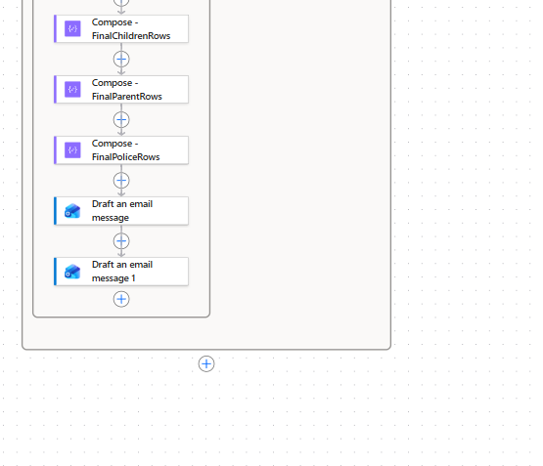
Your flow near the bottom of the True branch. Select either blue Draft an email message box to change that draft.
The purple Compose boxes and grey Apply to each boxes prepare the information. Leave their formulas and settings as they are when making the simple changes in this guide.

Before changing anything
Write down or take a screenshot of the current value so you can put it back if needed. Make one change at a time. A saved change affects future requests; it does not update drafts that already exist.

5 Change the receiving mailbox and folder
This controls which incoming emails start the automation. It does not choose where the finished drafts are saved.
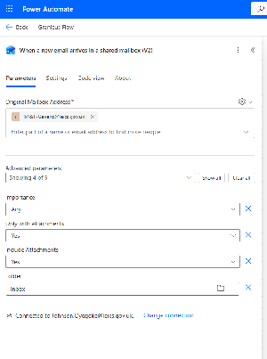
Your trigger settings. The fields to use are Original Mailbox Address and Folder. The screenshot also shows the attachment options.
1. Open the first box
Select When a new email arrives in a shared mailbox (V2) at the top of the flow, then select Parameters.
2. Change Original Mailbox Address
Remove the current test address IM&T-Generic@leics.gov.uk and enter the full shared mailbox email address the team will use. The connected work account must have access to it.
3. Choose the folder
In Folder, use the folder picker to choose Inbox or the folder where the scheduling emails arrive. Re-select the folder after changing the mailbox. If Folder is hidden, show it under Advanced parameters.
4. Check the attachment options
Only with Attachments is currently Yes. Set it to No if scheduling requests do not need an attachment. Include Attachments is also Yes; leave this as it is unless the flow owner agrees a change.
5. Save and test
Select Save at the top of the editor. Follow the test steps on page 8 using a new email sent to the new mailbox and selected folder.
If Power Automate cannot access the new mailbox or folder, ask the support contact to check access. The Connected to line at the bottom of the settings shows the account used by this connection.

6 Change the draft recipients and subjects
There are two draft actions. Change each one separately. The first contains children and family details; Draft an email message 1 contains children and police check details.
The two blue draft actions at the bottom of your flow.
1. Open the draft action
Click Draft an email message, then select Parameters. Find To, Subject and Body in the panel.
2. Change To
Remove Johnson.Oyegoke@leics.gov.uk and enter the agreed recipients for this version. Separate multiple email addresses with semicolons. Check that these recipients should receive the details in this draft.
3. Change Subject
For the first draft, you can change the plain text Invite Created while keeping the existing incoming Subject token. For the second draft, replace Test with the agreed subject wording.
4. Repeat for the second draft
Open Draft an email message 1 and check its To and Subject fields. Use the recipients and wording agreed for that version; do not assume they are the same as the first.
5. Save and check a new draft
Select Save, send a new sample request and check the actual recipients and subject in both generated drafts before normal use.

Keep the coloured tokens
A coloured token is a small box that inserts information automatically, such as the incoming subject. Keep these tokens when changing the words around them. If you accidentally delete one, restore the original field before saving or ask for help.

Changing where drafts are stored
Changing To changes who the email will go to when sent. It does not change the mailbox holding the draft. These draft actions have no shared mailbox address field. If drafts must move to another mailbox, ask the flow owner to arrange and test that change.

7 Change wording then save and test

Change ordinary words in the draft
Open either draft action, select Parameters and click in Body. You can change ordinary wording, the signature, contact details and instructions. Keep the coloured tokens and existing tables. Check the second draft too if the same wording appears there.
Keep prompts for details that vary for each conference, such as [ENTER CONFERENCE DATE]. Fill those in later in the generated Outlook draft. Typing one conference’s date into the flow makes it appear in every future draft.
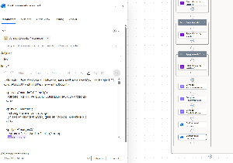
Your draft settings panel on the left of the flow. The original embedded screenshot has small text; use the To, Subject and Body field names described in this guide.

Save your change
Select Save at the top of the editor and wait for confirmation. If an error appears, do not assume the change has been saved. Restore the original value or contact support with the error message.

Test with a fresh sample request
1. Select Test at the top, choose Manually where offered, then follow the on-screen prompt to start the test.
2. Send a new sample email using the usual form layout and made-up people. Use the required subject phrase and the configured mailbox and folder. Include an attachment if that requirement is still Yes.
3. Check that the run completes, then find both drafts in the agreed Outlook mailbox. Compare their contents with the sample. A successful run alone does not prove that the invitation details are correct.
4. Check the exact thing you changed: mailbox or folder, recipients, subject or wording. Check that the tables and other details still look correct. Delete the sample drafts after checking them.

If the change does not work
Put back the original value you recorded, select Save and repeat the sample test. Contact support if the problem continues. Avoid repeatedly sending the same request because this can create duplicate drafts.
Editor buttons may look slightly different as Microsoft updates Power Automate. Microsoft guide to the flow editor

