• Background / Motivation: Why is this project relevant?

In this project, we are trying to establish an I04 production line for faster and smarter manufacturing of goods. This is done by using components in our production line. Using a warehouse and an automated guided vehicle, we can get parts from the warehouse to the assembly station automatically.

We will build skateboards for different distributors.

• Stakeholders: State whether you have external stakeholders or not. (If not applicable, describe how you handle not having any).

We do not have any external stakeholders. Instead, we will ourselves act as stakeholders. To help us be as objective as possible, we will use supervisor meetings. Being stakeholders and developers will inevitably lead to challenges.

• Aim: Short description of what you plan to achieve.
We will develop a component-based system that controls a manufacturing process. This will be done through a GUI. The system created will be able to monitor multiple production lines, so a manager can have an overview of the full production. The manager should also be able to create different combinations for different production lines, for example: One production line for making skateboards and another one for creating desk lamps. This should be a drag-and-drop system for the manager to change components (AGV, Assembly, Warehouse) or have different functions/features.
The system will have a login system that splits the system into two auths that allow the manager to monitor each employee, assign them to tasks in production, or unemploy them, and make it so the operator is only allowed to monitor one or more assigned production lines and make operations such as start and stop the production line.

• Objectives: Specific technical objectives that you wish to achieve; keep them brief but elaborate where relevant.

We want to have a login system that differentiates the different roles of the staff. So that the manager can register new employees and can assign tasks to the different employees (Operators).
On the other hand, there are operators who have the opportunity to assign themselves to a specific task, in case they get many different tasks assigned by the manager.
Therefore, a login system would be an excellent choice to show the difference between the different roles and responsibilities in production.

• Solutions: Detail different elements that are part of a software solution.

• Initial requirements analysis:
Provide an initial analysis of the requirements and prioritization of the requirements
(describe the factors that you consider when doing so), for example, by sketching
domain models and use case diagram (but *not* writing use cases at this point,
rather providing an overview of what you have in mind).

• Related research: Is there relevant background material that should be included?
Expert interview

• Methods: What will your approach be? e.g., Scrum. What technologies are you going to use?

Our approach will be Scrum. We will have 2-week sprints, sprint reviews, retrospectives, and daily scrum.
We will use FURPS+ for requirement planning-
We will use Jira as a planning tool, mainly for user stories

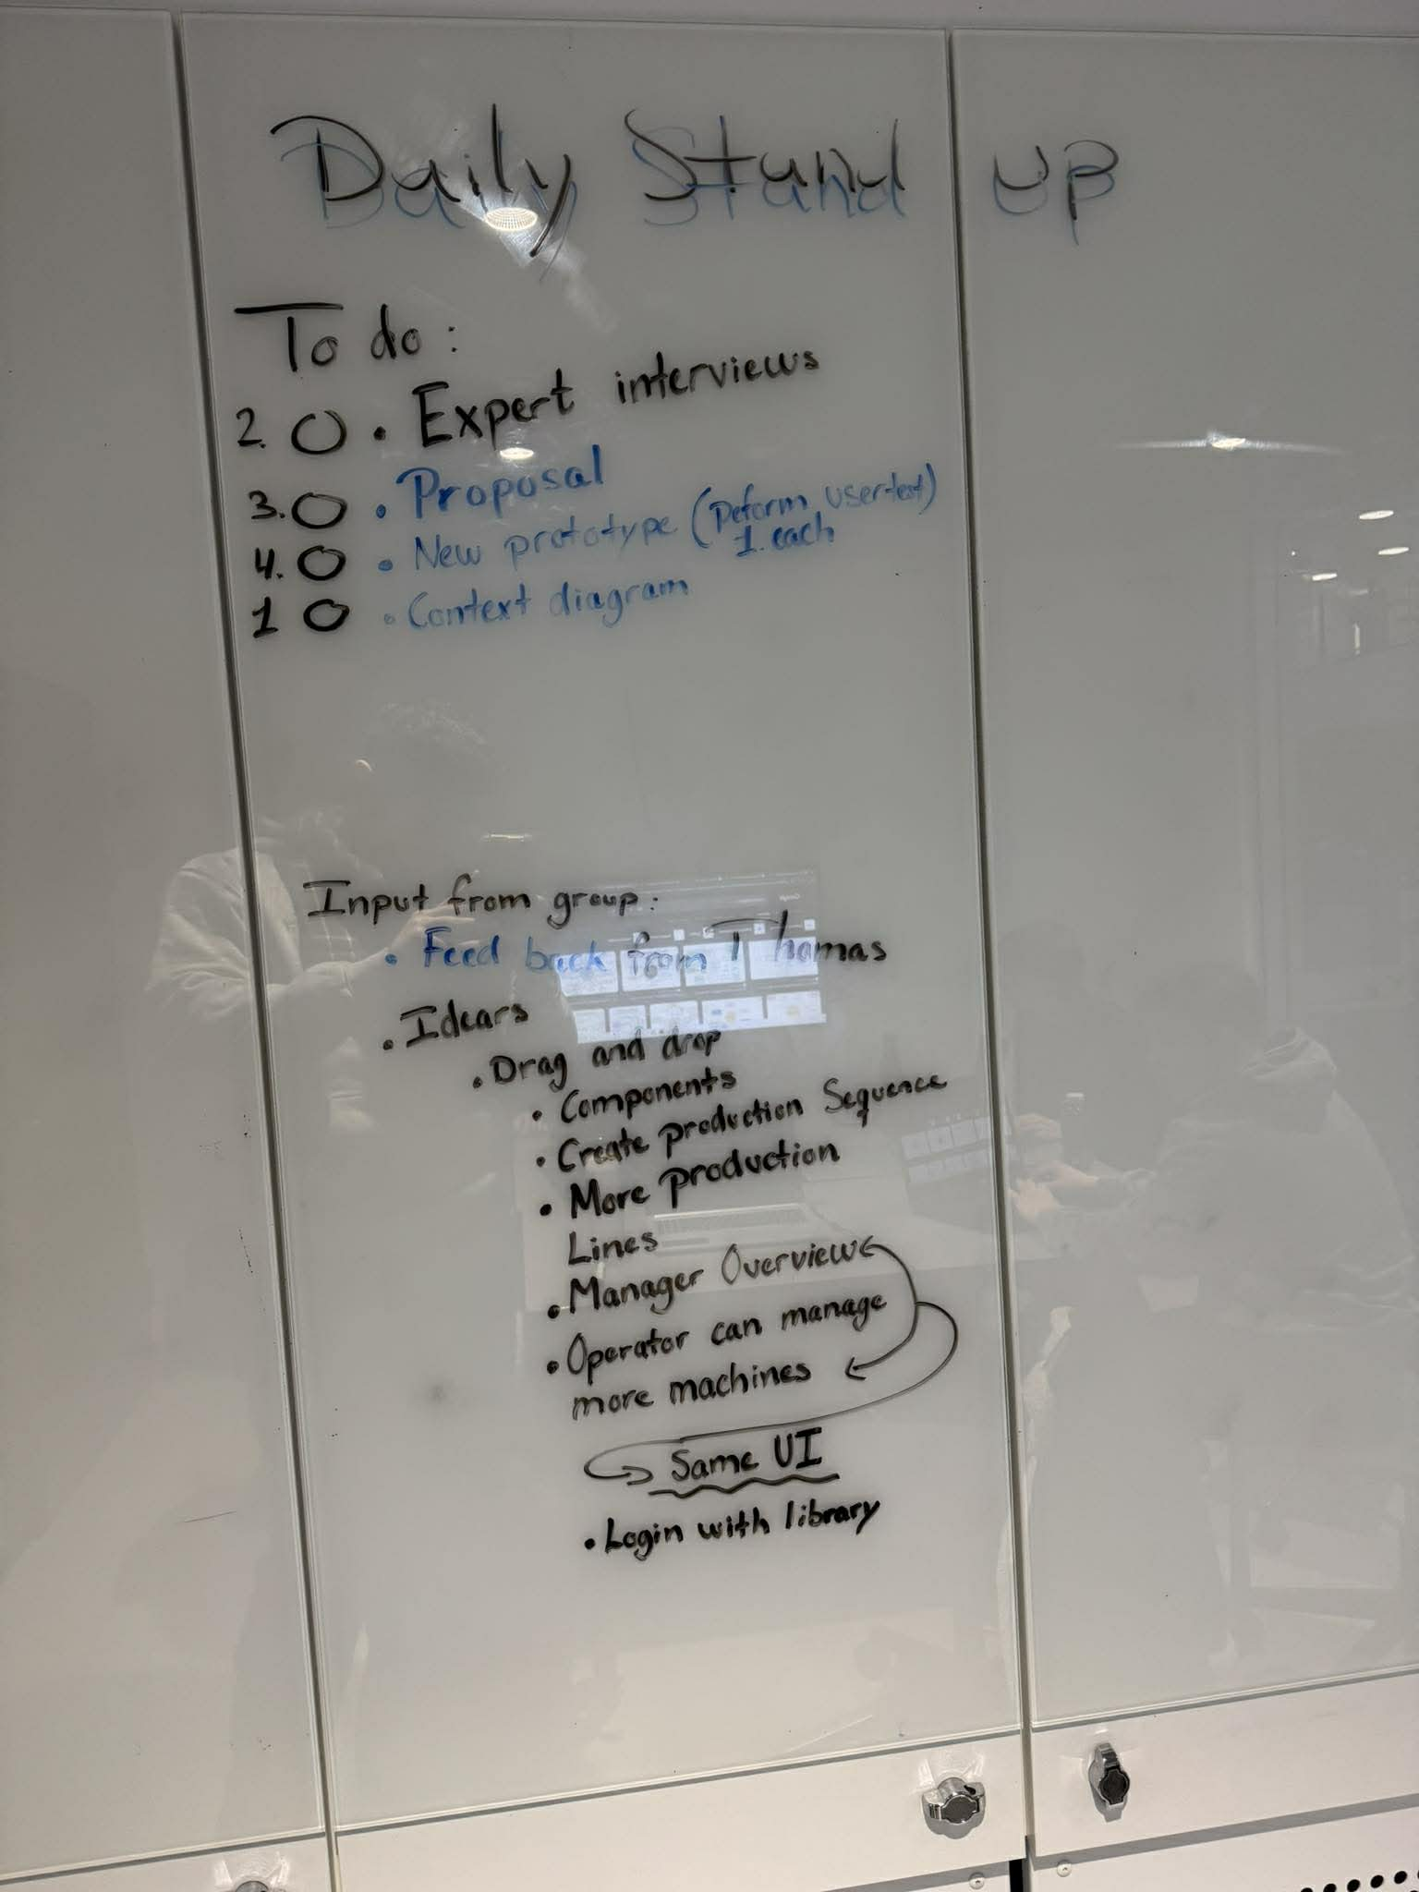
Example of stand up

• Risks: What poses a risk to the success of your project? What can you do to mitigate these risks?
Connection and handling of data to and from the machines. Each machine uses a different protocol, and we do not have much experience in using these.
Integrating backend and frontend. Especially since it’s component-based, and we want to be able to add and delete machines.

• Project Organization: How is work distributed across the team, and how do you organize your project work? Is there a project leader? Does anyone assume a special Scrum role?
The only special Scrum role we have is the Scrum Master. This role has been assigned to Andreas. Andreas's task in this role is to run meetings such as the daily scrum, sprint review, and retrospective. This does not mean that the rest of the group should not participate actively or have the chance to run meetings.

• Milestones: What are the key milestones throughout the project?

Setting up Docker Compose and connecting to machines.
Controlling machines individually.
Controlling multiple machines.
Controlling machines from a GUI.
Role-based system
Manager GUI
Operator GUI
Employee formula system.
Automatic production optimizing algorithm
Products auto-sorting system

• Project plan: How do you divide your work into iterations to help you achieve the milestones? What are the deliverables for each milestone?

We will use sprints. The first sprint is a design sprint, and after that, we will add epics and user stories to our backlog and add them to the sprints based on what we think is most important to work on.

• Deliverables: What will the concrete output be? e.g., a software prototype, well-defined requirements, etc.; this can include a sketch of the intended architecture, for example, using a UML deployment diagram.

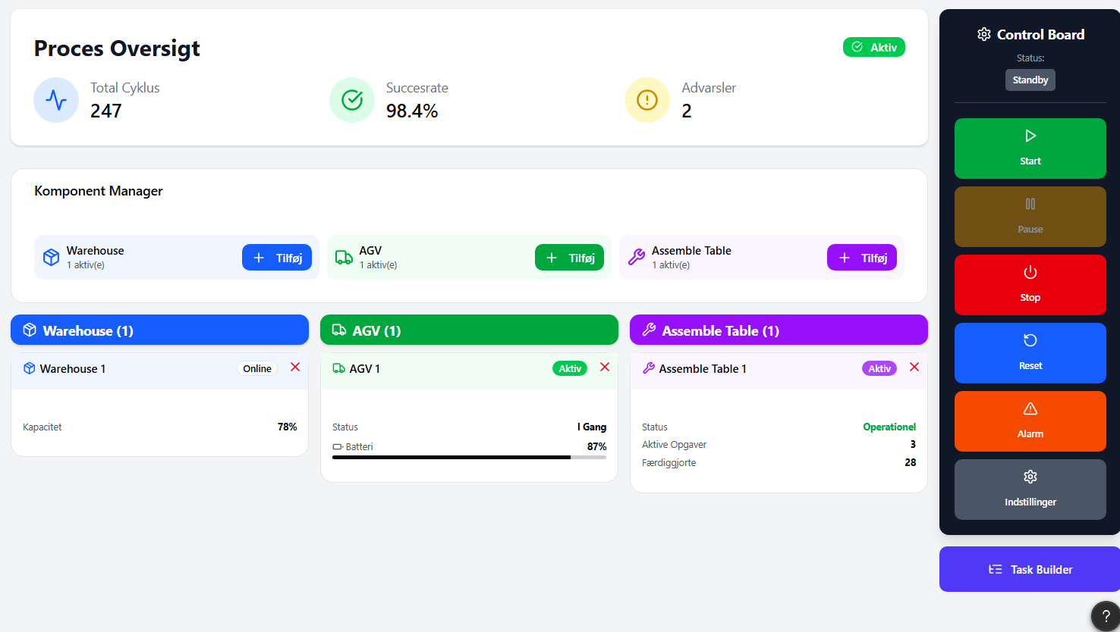
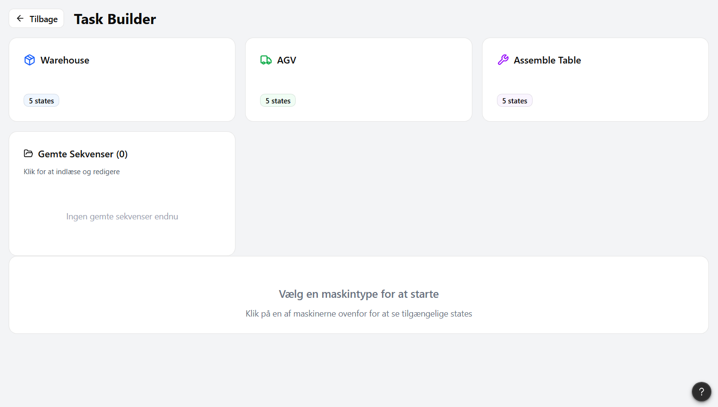

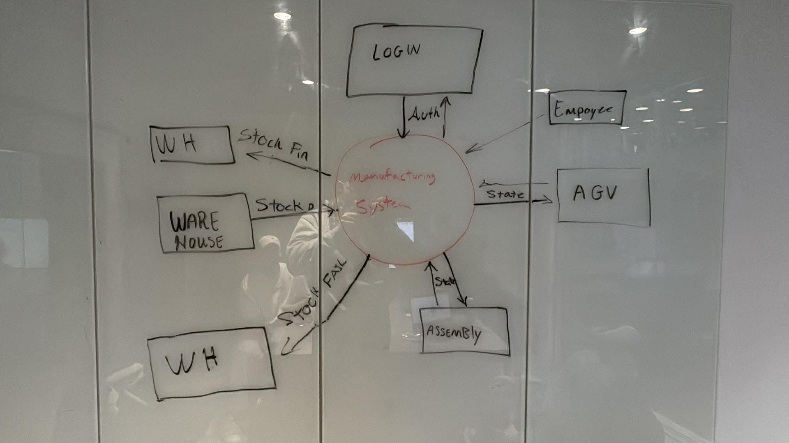

• Tentative outline for project report: How will you structure your report?
- Frontpage
- ToC
- Introduction
- Analysis
- Requirements
- Methodologies
- Design
- Implementation
- Discussion
- Conclusion

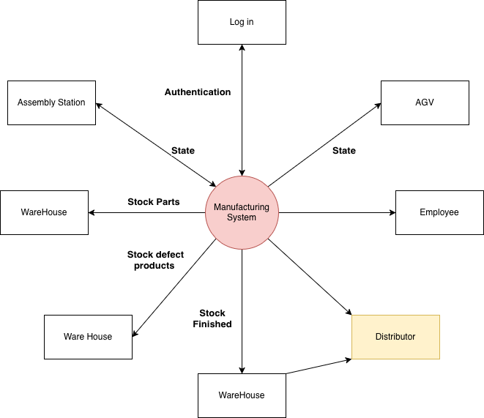

Requirements:

F# | Requirement | Description | Criteria | MoSCoW
F01 | Ability to add tasks | The user should be able to add machine tasks such as ‘go to warehouse’, ‘go to assembly station.’ |  | Must have
F02 | Add tasks to the queue | The user should be able to add a queue of tasks that can be done in a sequence |  | Must have
F03 | Add machines | The user should be able to add more machines, such as two Automated guided vehicles |  | Must have
F04 | Remove machines | The user should be able to remove more machines if only 1 of each is needed |  | Must have
F05 | Start button | The user should be able to start the process |  | Must have
F06 | Stop/pause button | “Normal stop.” The user should be able to stop/pause the process. It tells the software to finish its current logical step and then park the machine in a safe state. |  | Must have
F07 | Abort button | “Panic button.” The user should be able to abort the process by terminating the software. The execution thread is killed instantly; the software does not check if it's in the middle of a calculation or a movement. |  | Must have
F08 | Add employee | The manager should be able to add employees for multiple different operators |  | Should have
F09 | Remove employee | The manager should be able to remove employees |  | Should have
F10 | Save the task sequence for later use | The user should be able to save a previous queue for later use |  | Should have
F11 | Select the earlier task sequence | The user should be able to use a saved task sequence |  | Should have
F12 | Drag and drop | The system should have a drag-and-drop system that is compatible with the task scheduler/queue (F02). |  | Could have

