TA Recruitment System Prototype
Group 40
This medium-fidelity prototype demonstrates both physical user-interface design and logical user-interface design. It shows the layout of the key screens, the information structure behind them, the relationship between interface elements, and the core user flows for TA, MO, and Admin roles.

1. Prototyping Approach
The prototype addresses two complementary aspects of prototyping. The physical user-interface design presents the visual layout and arrangement of the main screens. The logical user-interface design explains which interface elements are required, how those elements are related to each other, what information they present, and how users manipulate them during the recruitment process.
As a medium-fidelity prototype, the design focuses on the core workflows and information architecture rather than detailed implementation. It is intended to support discussion, feedback, and validation before full development.

2. Overall Logical UI Structure
The system is organised around three user roles: Teaching Assistant applicant (TA), Module Organiser (MO), and Admin. After login, each role enters a different functional area with different permissions, page access, and task priorities.
The logical structure is role-based and workflow-driven. Profile information and uploaded CV files support later applications. Submitted applications are then visible in both the applicant interface and the organiser review interface. Final recruitment decisions made by the MO are reflected back to the TA through the application tracking pages. Admin users do not take part in the decision itself, but monitor workload distribution and system-level balance.

Role-based access logic
- TA users prepare profile information, upload CV documents, browse vacancies, apply for up to the permitted number of modules, and track outcomes.
- MO users create and manage vacancies, review applicants, compare evidence, and make recruitment decisions.
- Admin users inspect workload allocation, identify overload risks, and export system reports for monitoring and coordination.

Common design logic across the prototype
- Each dashboard acts as a starting point for the most frequent tasks of the current role.
- Lists and cards are used to support browsing and comparison, while detail views support review and action.
- Status tags, buttons, and forms provide clear action points and process feedback.
- Navigation is designed so that users can move from summary information to detailed information and then complete an action.

3. Login and Role-based Entry
The login screen is the common entry point for all users. It supports secure access and directs users to the correct interface according to the authenticated account permissions.

Logical UI design for login
- Key interface elements: username field, password field, sign-in button, role indicator, and system message area.
- Relationship between elements: the entered account information determines whether access is granted and which portal is opened after authentication.
- User interaction: users enter credentials, submit the form, and receive either a successful route to the correct dashboard or an error message.
- Navigation and information flow: Login -> TA Dashboard / MO Dashboard / Admin Dashboard.

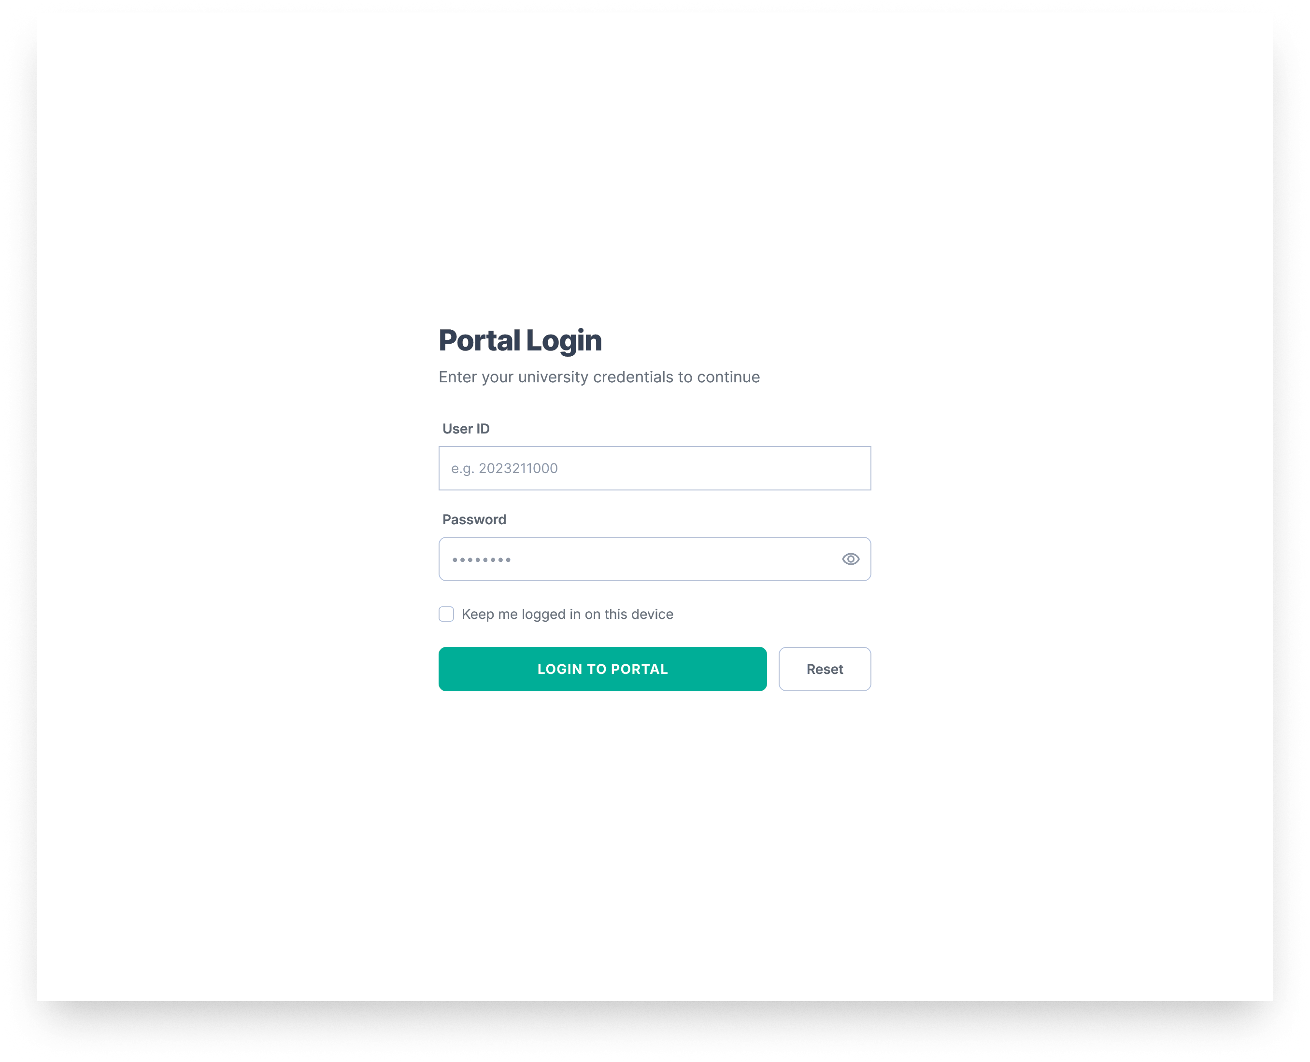

4. TA User Journey
The TA journey covers the full applicant-side workflow, from personal preparation to final application tracking.
Flow: Login -> Dashboard -> Browse Jobs -> View Job Details -> Apply -> My Applications -> My CV / Edit Profile.

TA Dashboard
- Key interface elements: quick navigation cards, application summary panel, profile completion prompt, and CV management entry.
- Relationship between elements: the dashboard summarises the applicant state and links directly to the next relevant task, such as completing a profile, browsing vacancies, or checking submitted applications.
- User interaction: the TA reviews current status and selects the next action from the dashboard shortcuts.
- Navigation and information flow: Dashboard -> Browse Jobs, My Applications, My CV, or Edit Profile.

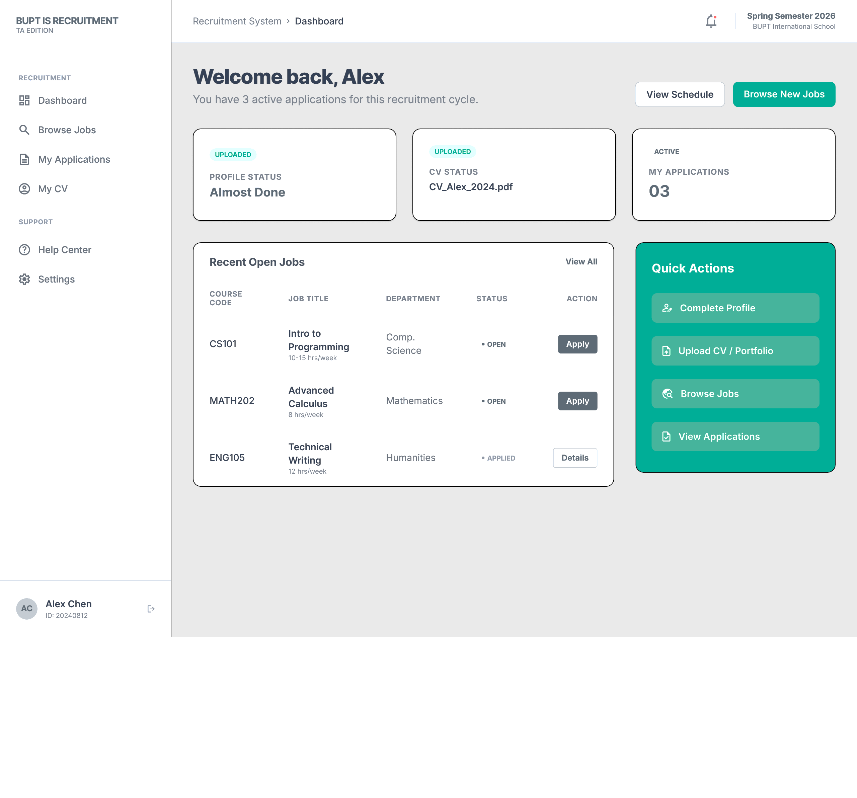

Browse Jobs and Job Details
- Key interface elements: search bar, filter controls, job cards, vacancy tags, job detail panel, and apply button.
- Relationship between elements: search and filters narrow the visible vacancy list; selecting a job card opens the corresponding detail view; the detail view contains the information required before application submission.
- User interaction: the TA searches by keyword, filters by conditions, opens a job, reviews responsibilities and requirements, and then proceeds to apply.
- Navigation and information flow: Job list -> selected job detail -> application form.

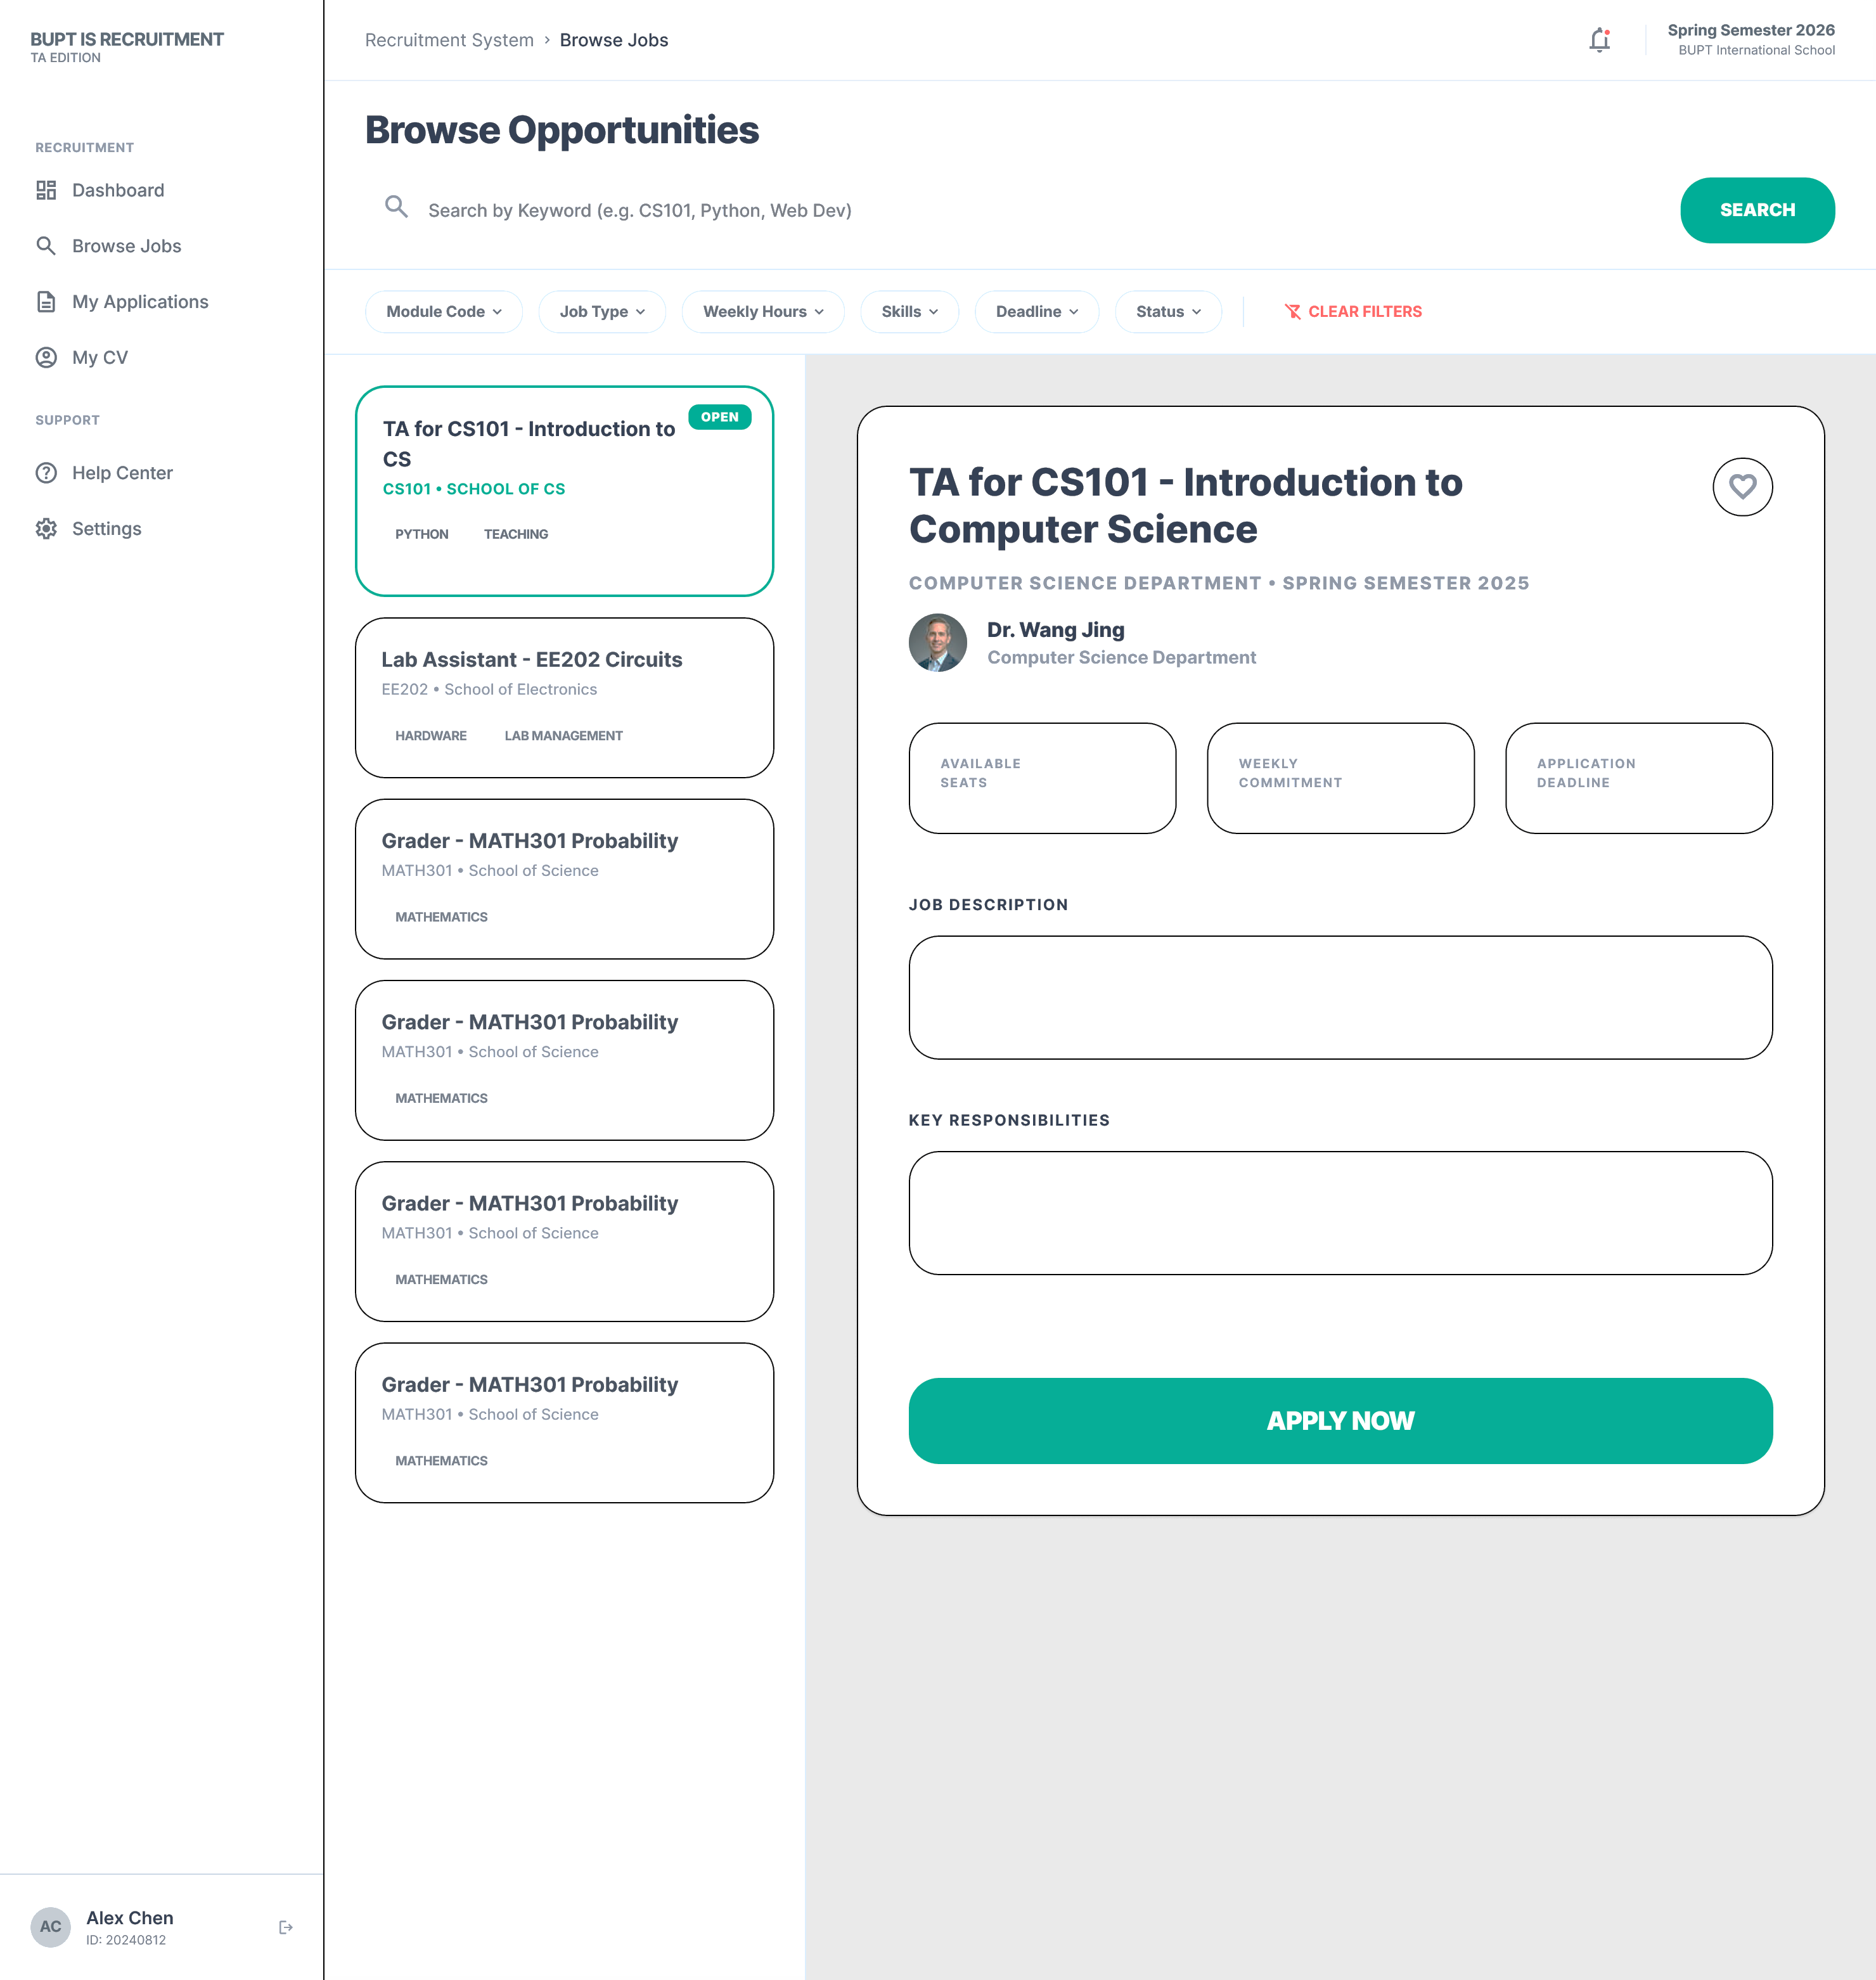

Application Tracking
- Key interface elements: application list, status labels, feedback area, detail drawer or page, and withdrawal control where permitted.
- Relationship between elements: each submitted application creates a trackable record with a current status and review notes; status changes made by the MO are reflected here.
- User interaction: the TA checks progress, opens detailed feedback, and decides whether to wait, revise supporting materials, or withdraw if allowed.
- Navigation and information flow: Submitted application -> status update -> applicant review page -> updated result shown back to TA.
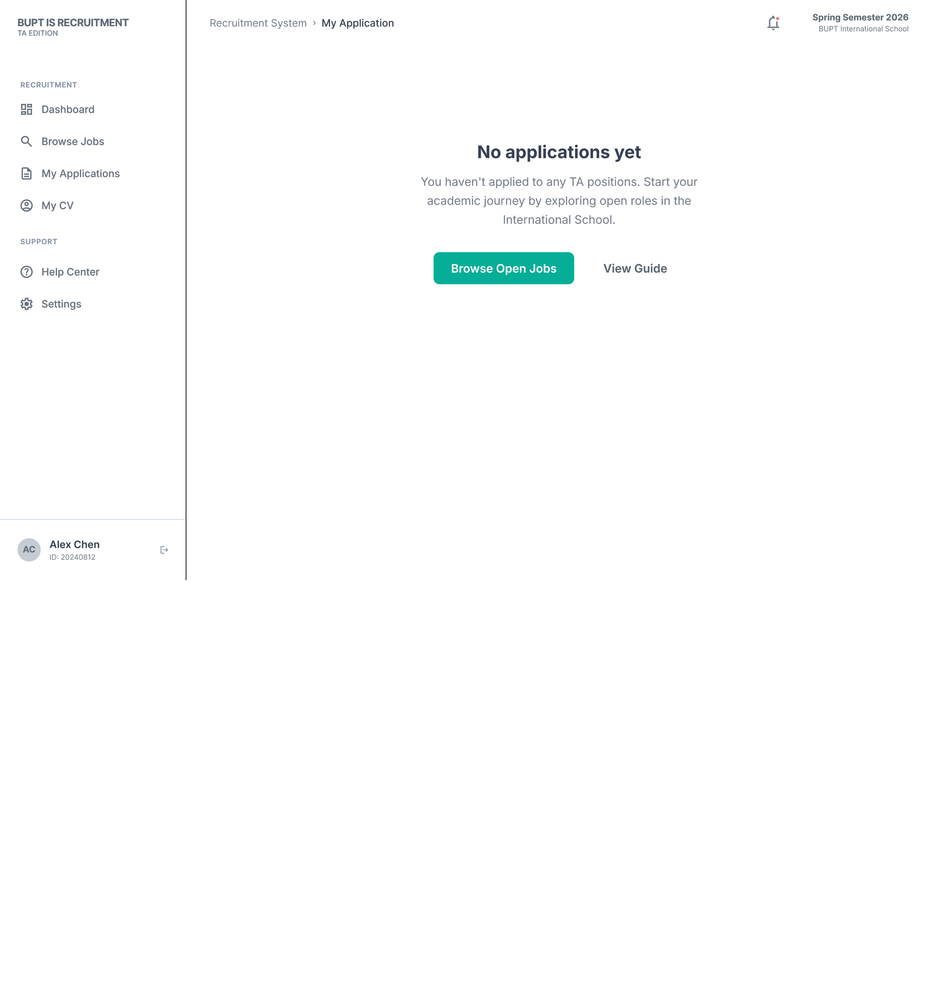
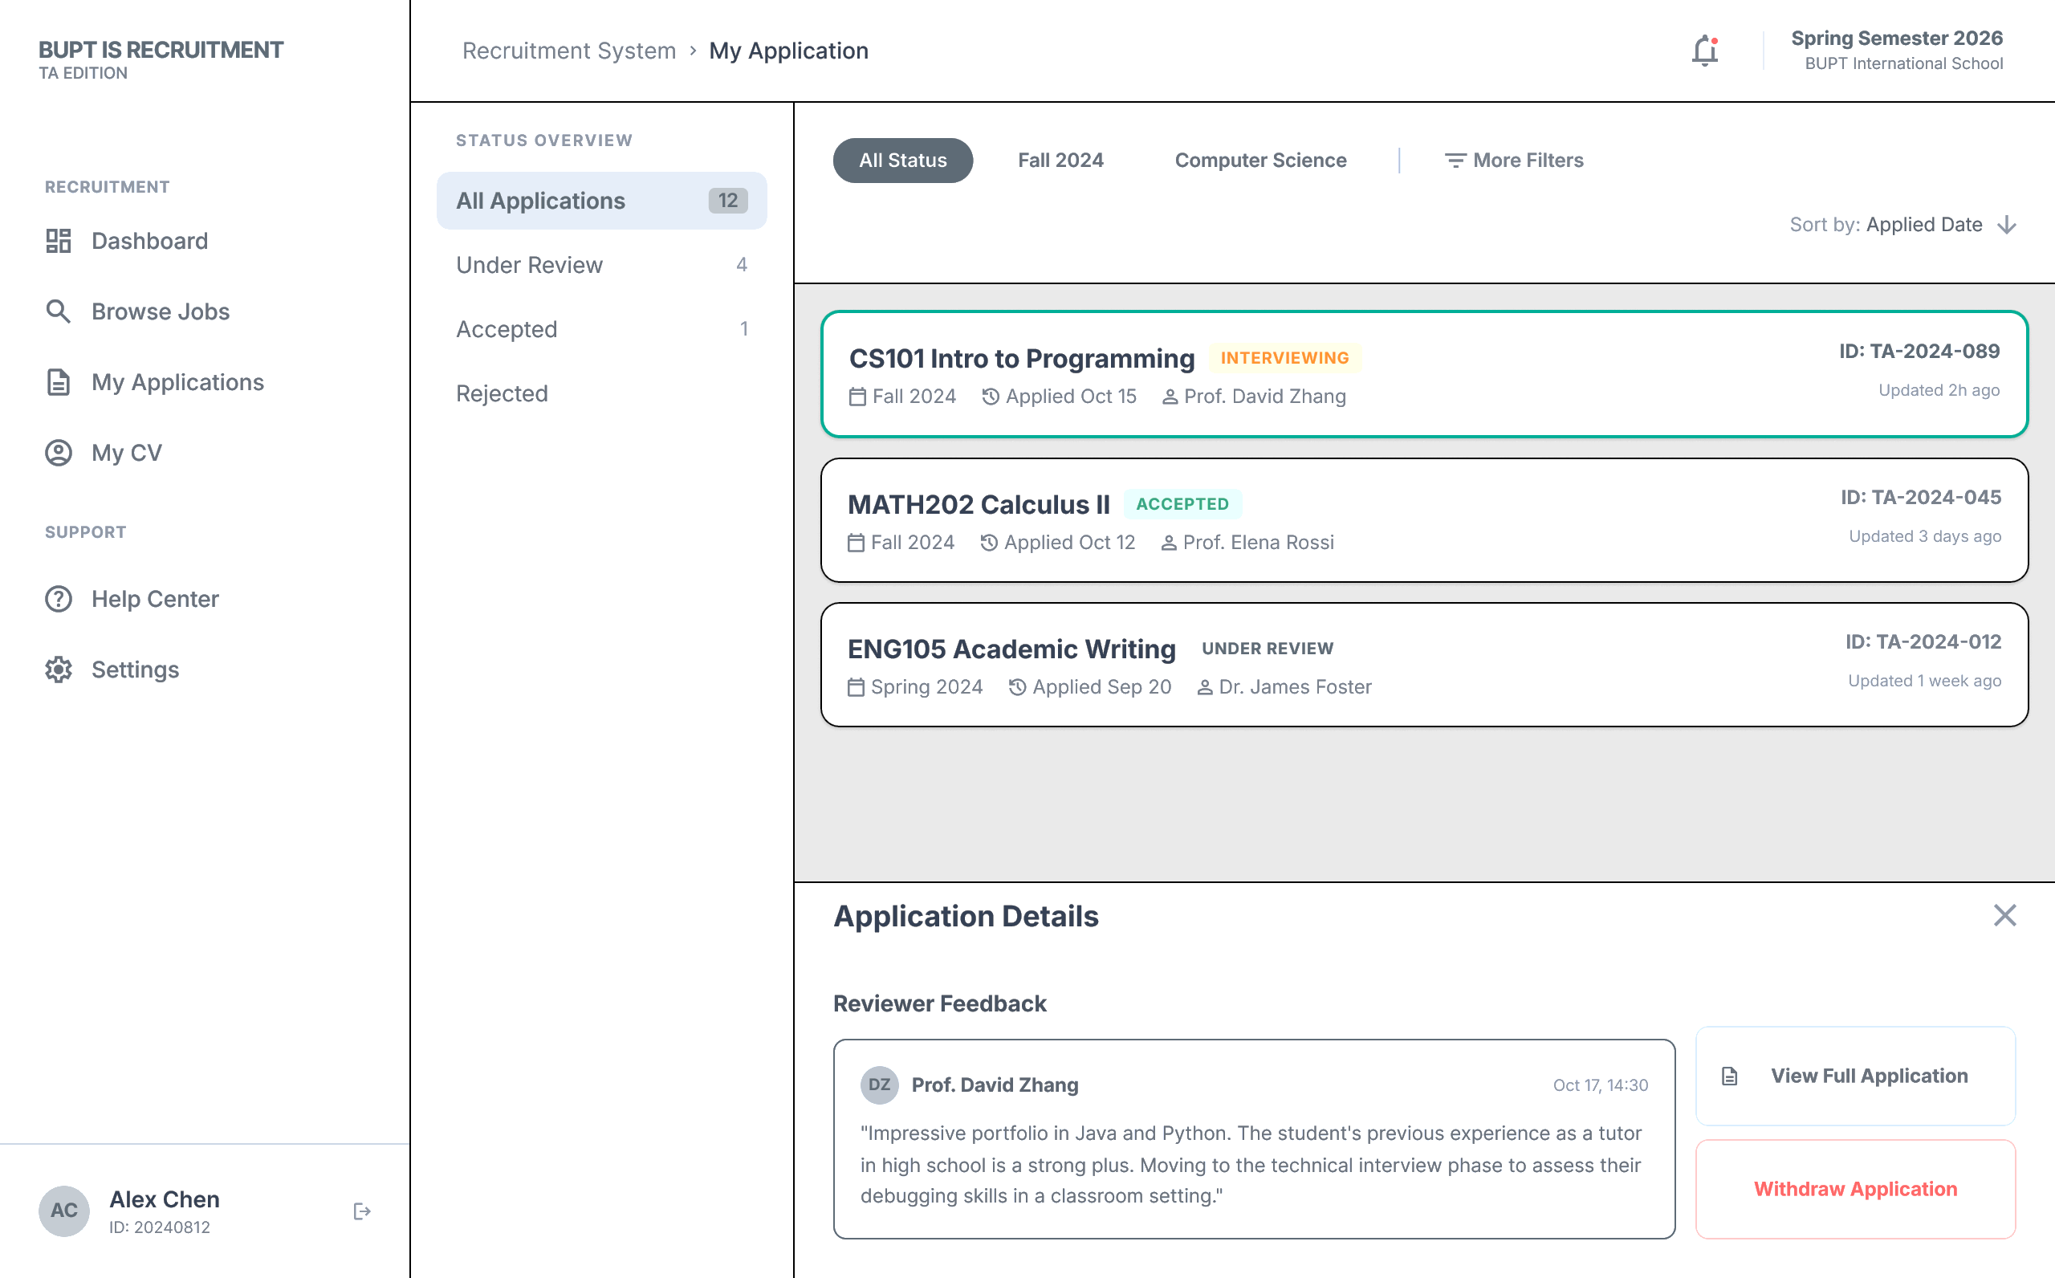

Profile and CV Management
- Key interface elements: profile form fields, academic information fields, contact details, campus preference options, supervisor information, and CV upload area.
- Relationship between elements: profile data and uploaded CV materials are stored as application-ready information and reused when the TA applies for vacancies.
- User interaction: the TA edits personal details, updates academic information, uploads or replaces a CV, and keeps the profile ready before submitting applications.
- Navigation and information flow: Edit Profile / My CV -> saved profile record -> reused in application submission.
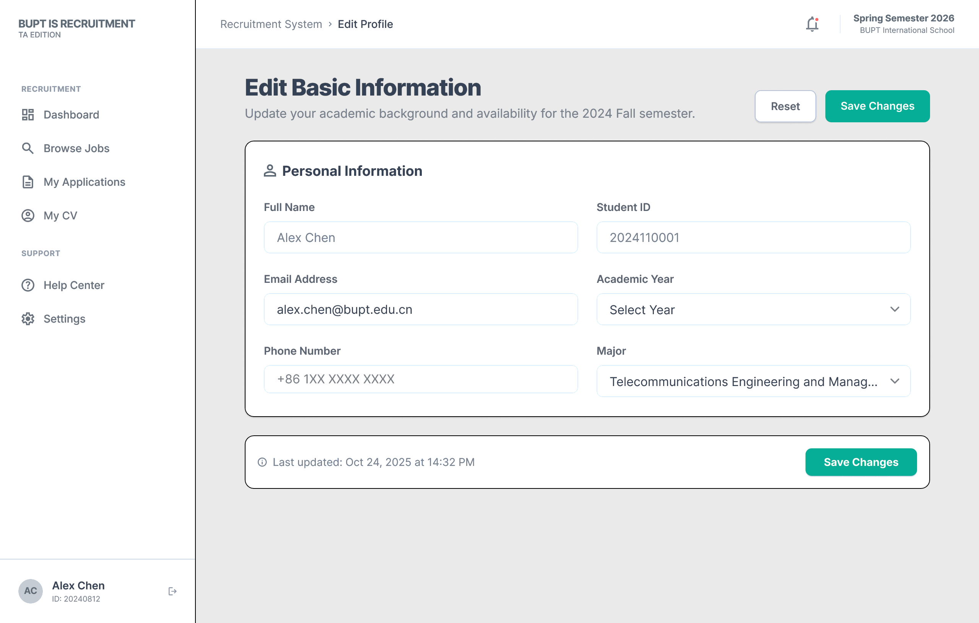
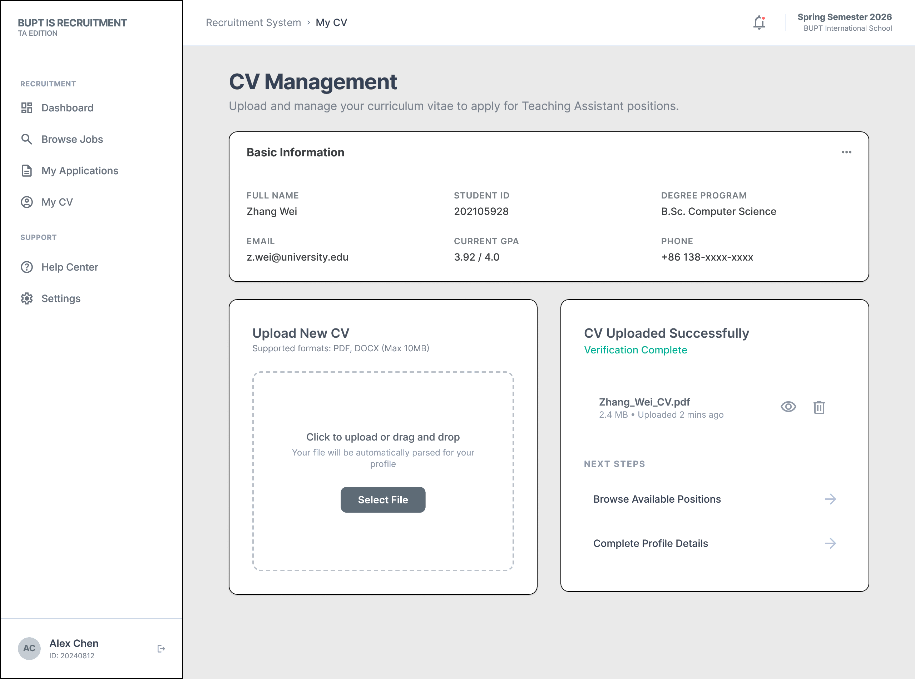

5. MO User Journey
The MO journey covers vacancy creation, vacancy maintenance, applicant screening, and final decision-making.
Flow: Login / Dashboard -> Job Management -> Edit Job Post -> Applicant List -> Applicant Details -> Accept / Reject.

MO Dashboard and Job Management
- Key interface elements: posted job summary cards, applicant count indicators, vacancy status markers, and shortcuts to edit or review applicants.
- Relationship between elements: the dashboard provides an overview of active vacancies, while the management page becomes the main working area for vacancy-level actions.
- User interaction: the MO reviews active postings, checks applicant volume, opens a vacancy, and moves to editing or applicant review.
- Navigation and information flow: Dashboard -> Job Management -> selected vacancy -> edit page or applicant list.
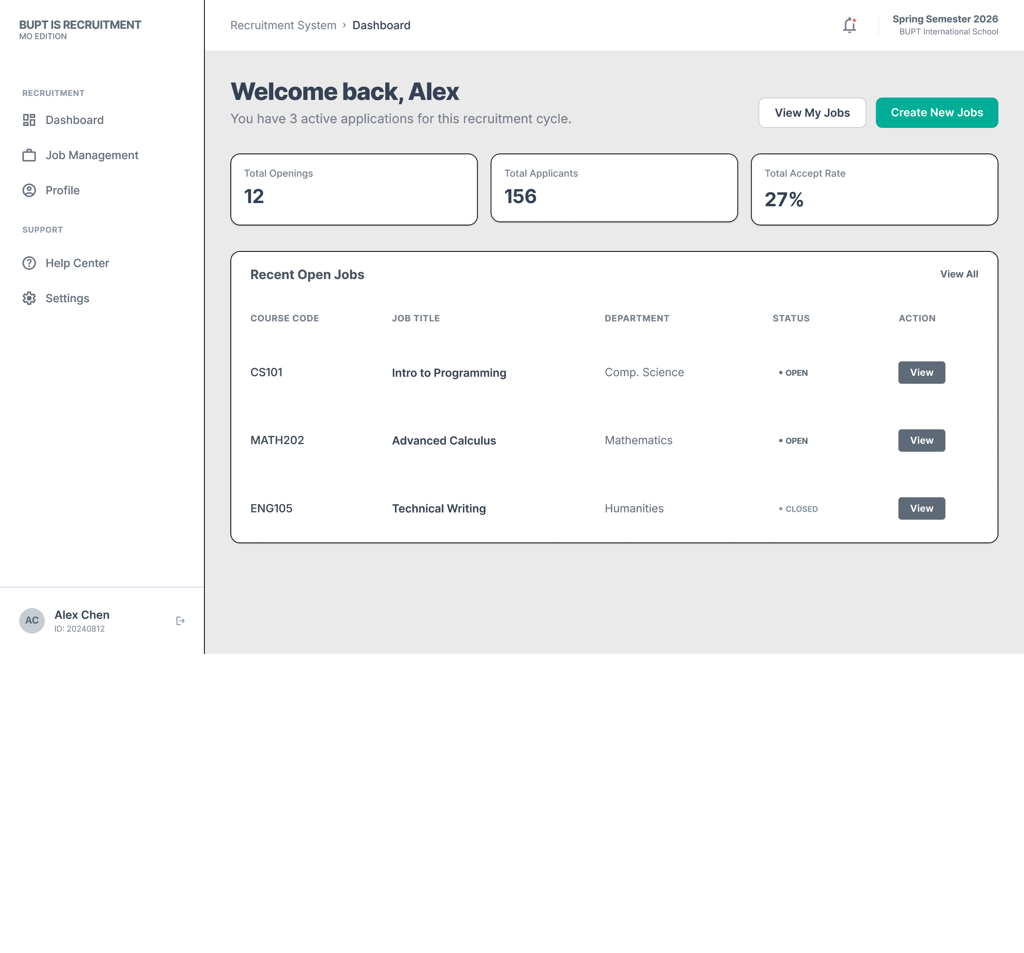
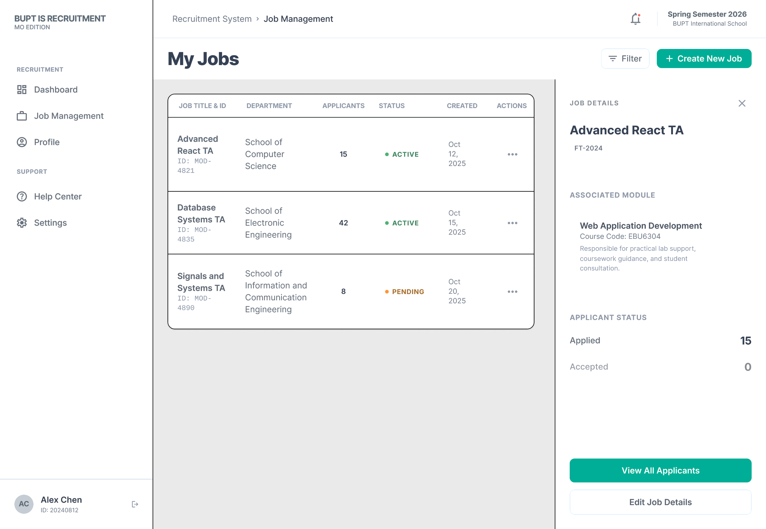

Create / Edit Job Posting
- Key interface elements: title field, department field, job description area, responsibilities section, requirements section, publish control, and save/update button.
- Relationship between elements: the vacancy form defines the information that later appears in the TA browsing pages and controls whether a post is visible to applicants.
- User interaction: the MO creates a new posting or edits an existing one, updates the vacancy information, and saves or publishes the result.
- Navigation and information flow: Vacancy form -> saved posting -> visible in MO management area and, if published, visible in TA job browsing.

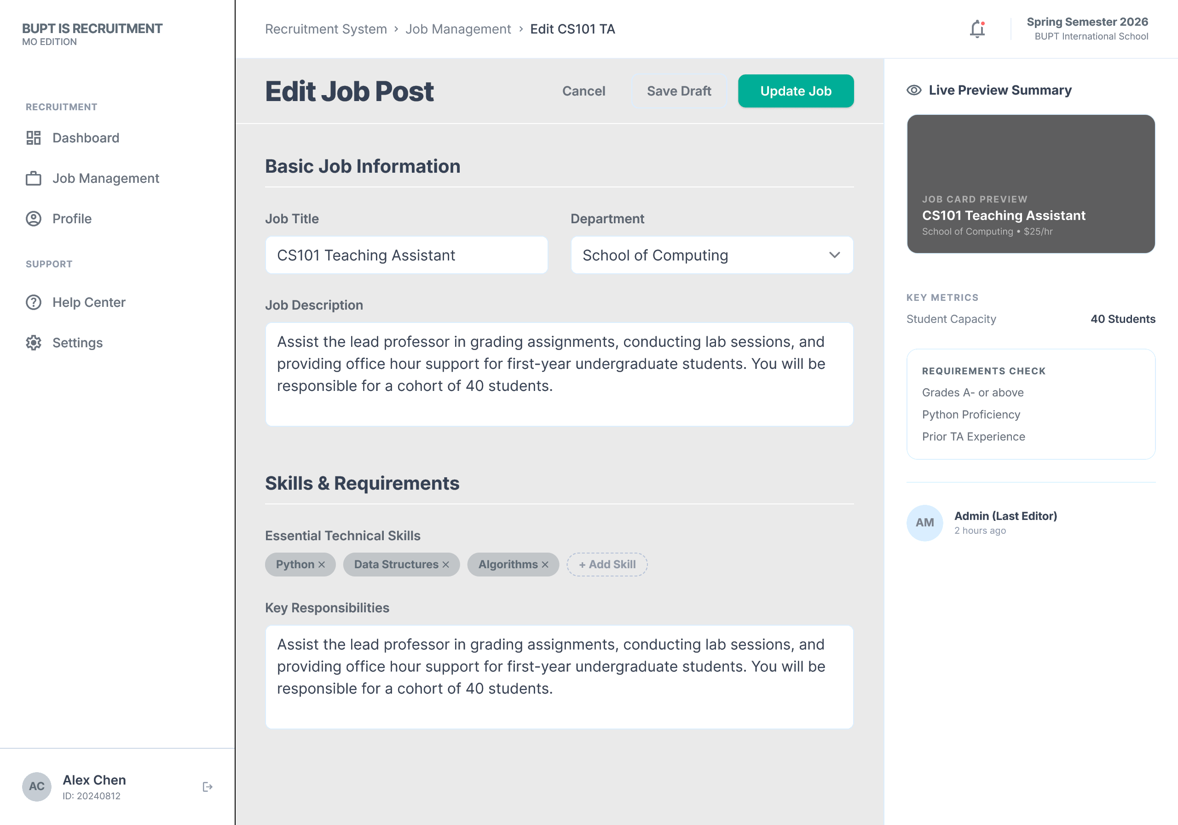

Applicant List and Screening
- Key interface elements: applicant cards or rows, shortlist markers, filter tools, stage labels, and side-panel summaries.
- Relationship between elements: the list supports comparison across candidates, while summary panels provide quick screening information before the MO opens a full review page.
- User interaction: the MO filters applicants, compares shortlisted candidates, and selects one applicant for a detailed review.
- Navigation and information flow: Applicant list -> selected candidate -> applicant detail review.

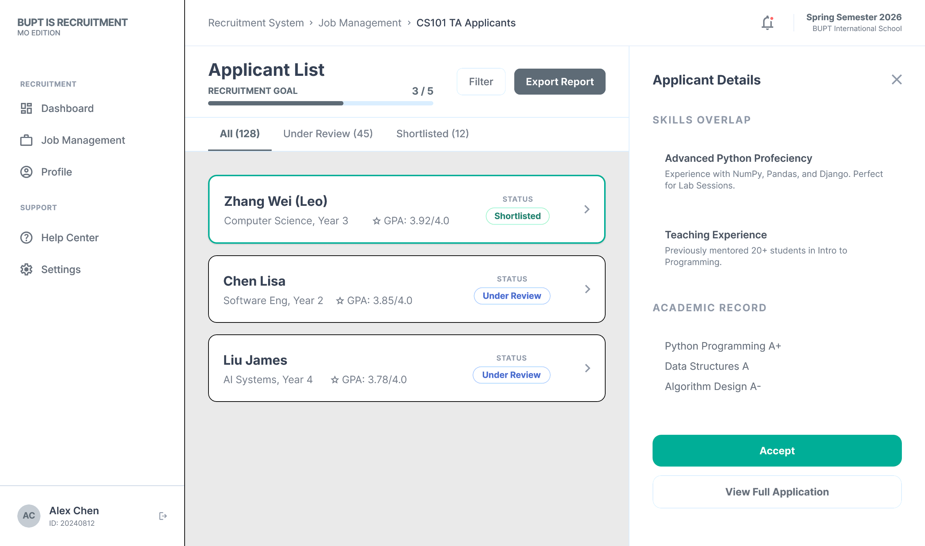

Applicant Details and Decision Making
- Key interface elements: applicant profile summary, GPA or academic evidence, skills list, uploaded attachments, decision notes area, and accept/reject buttons.
- Relationship between elements: this page brings together all evidence needed for the final decision; a decision changes the application status stored in the recruitment workflow.
- User interaction: the MO reviews the candidate in detail, records notes, and completes the final recruitment decision.
- Navigation and information flow: Applicant detail review -> decision recorded -> TA application status updated.

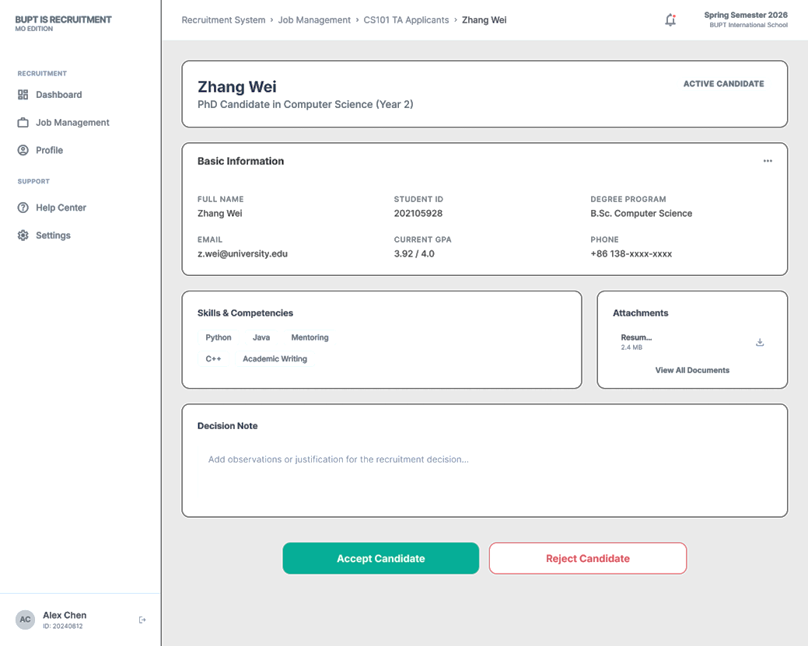

6. Admin Workload Monitoring
The Admin interface focuses on system-wide visibility rather than vacancy editing or applicant-side actions. Its purpose is to support fair TA allocation and operational oversight.

Logical UI design for admin monitoring
- Key interface elements: search bar, workload table, module summary, risk indicators, allocation statistics, and export controls.
- Relationship between elements: search and filters narrow the visible records; workload data drives the summary metrics and highlights high-risk or overloaded cases.
- User interaction: the Admin inspects workload distribution, compares records, identifies risk cases, and exports reports for administrative review.
- Navigation and information flow: Dashboard summary -> detailed workload records -> report export.

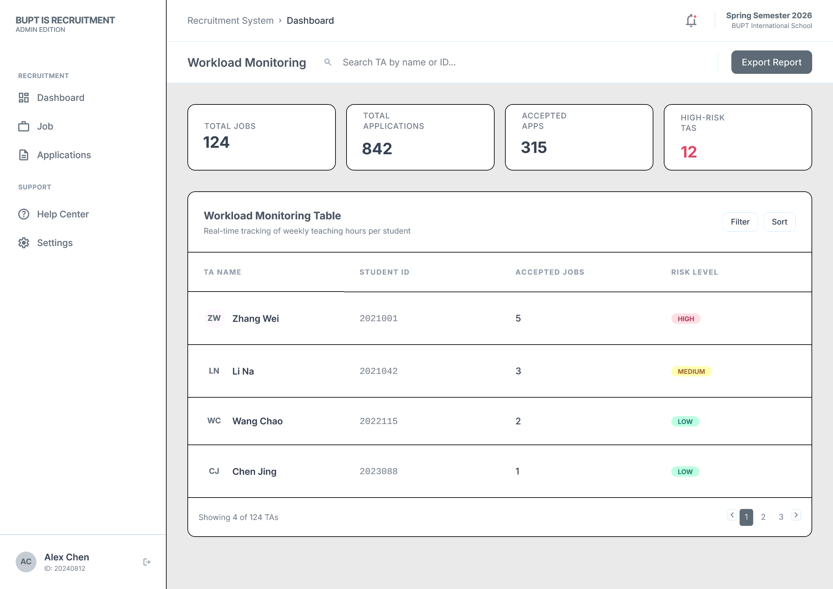

7. Prototype Summary
This prototype represents both the visual organisation of screens and the underlying information logic of the TA recruitment system. The pages are connected through clear user flows, and the relationship between data, interface elements, and user actions is reflected across all three roles.
The design therefore supports quick feedback on both appearance and interaction structure, which is the main purpose of prototyping at this stage.

