McKinsey & Company: Perspectives on advanced air mobility (Summary)

This issue of Perspectives on advanced air mobility consolidates some of our most interesting research from the past few years (McKinsey´s research and third party’s researches)

About the potential market:

The low prices of eVTOL´s vs a flying trip in helicopter is a key variable to fully understand traffic within major cities ($150 estimates by eVTOL vs $ 500-1500 Helicopter). This applies to massive cities.

Business model: A great question. Exhibit 1 provides a conservative estimate of the “base case” flying taxi market, revealing a pathway to an operator market of approximately $1.5 billion by 2040. In this scenario, flying vehicles will still be a luxury option and does not achieve scale. It’s a big market but not a **really big market**.

A key to get an annually market of $500 billion to $600 billion: an ecosystem of players including OEMs, suppliers, maintenance and charging companies, infrastructure players, investors, regulators, and policy makers coming together and overcome all challenges.

**Energy density:** A major point on eVTOLs. Batteries technology most improve performance to obtain approximately 200 watt-hours per kilogram with its respectives aviation-grade safety standars.

**Regulatory support:** Regulators will have to certify the new batteries. To address addresses noise and safety issues in a manner acceptable to all

**Air traffic control system:** Implement a safety UTM (Unmmaned traffic management ) to each eVTOL.

**Autonomous flight:** Technology and regulation must allow full autonomy for flying taxis. Again, the UTM is vital to eVTOLS.

**Physical infrastructure:** The concept of vertiport is a newborn term of the industry. A platform where eVTOLs will recharge, land and take off.

**Customer acceptance:** Customer need a quiet interioir, comfortable temperature. This, to eventually improve the customer acceptance. The scale of the market will hinge on customer acceptance.

The last items are key values to implement and make profits of eVTOLs market in the AAM industry. This effort will ultimately be limited by technologyes developments. In the other hand, this will be a challenging process but mos important; a one with a high potential income when it is compared with helicopter market. The next chart will show a comparasion of the two markets.

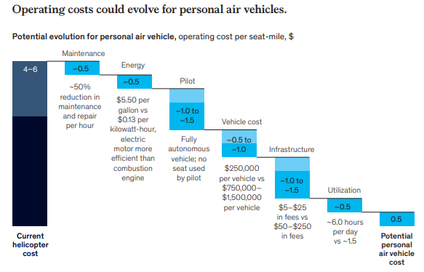

infrastructure density will likely play the biggest role in driving scale once the technology is ready and regulatory reform passes. More vertiports implies more trips and eventually, a bigger market size.

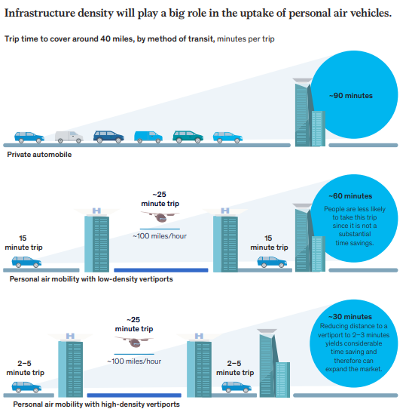

To make the flying taxis reals, it is needs the participation of diferetns players to get it happen.

Some of the key points:

Regulators: They will have the next route map: First, develop aircraft certification standards,second, implement UTM systems with traditional air traffic control networks, third; enable test-flight programs, fourth, create standards certification to autonomous flight and finllay, privides incentives and subsides for personal air mobility

Aerosapce: traditional aerospace incumbents have a head start in developing vehicle platforms due their expertise in the field.

Software and technology: A robust UTM system will require will require onboard software (detect and avoid), mapping and route-optimization tools, and external inputs such as real-time weather reports

Physical infractructure companies: Who will pay maintainence of vertiports? The collaborators must create high-throughput vertiports in dense urban environments, designing their networks and pricing access to pay off capital investments. These investments could range anywhere from $2 million for a small single-spot vertiport on an existing building to $200 million for a megahub woth ten to 20 spots, retail, services built.

**CUSTOMER TAKING TO THE AIR**

Regarding the AAM industry investmen; The uptick has been so rapid, in fact, that total disclosed investments exceeded $8 billion at the end of March 2021.

McKinsey made a survey to 4,800 persons in Brazil, China, Germany, india, Poland and UK.

**Consumer insight on flying taxis:** Use cases of potential consumer

Commuting to and from work, errands, business travel, short-distance leisure travel (such a cinema), long distance leisure travel, such as visits to family member in other cities, trip to and from airport as part of a longer journey.

1. Willingness to adopt passenger AAM and preferred use cases vary by country.  
   India and brazil were the country where the AAM would likely receive approbation from the costumers. 31 to 47 percent of India and 21-32 percent of Brazilian would definitely use AAM vehicle.

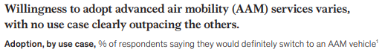  
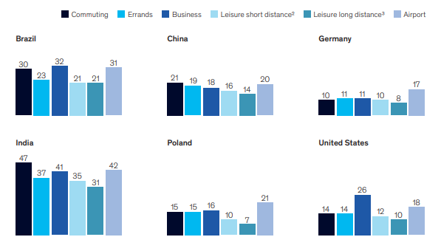  
So far, no clear winning use case for people moving has emerged; in each country, most use cases attracted somewhat similar levels of interest. Acording to the country, the AAM market will have to adapt to the consumer interest.

1. Consumer´s motivation for the manned services: The main interest of the respondents were the desire of shorter travel times. In particular, with countries with high congestion levels and time lost in traffic. The chart:

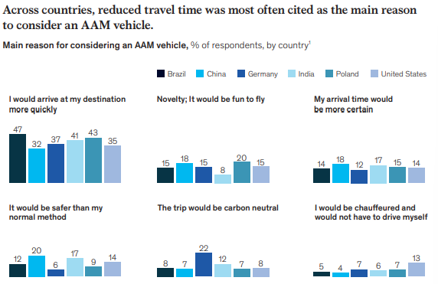

India and Brazil show the most willingness to pay for future flying-taxi offerings. Thirty-six percent of Indian consumers said they would definitely pay five times the price of their current transport mode to hop on an AAM vehicle for a trip to or from an airport, as did 30 percent of Brazilian respondents—the highest rates reported in our survey  
  
The survey suggests that consumers are willing to pay a premium for AAM service even for traveling very short distances.

Germany ranked lowest in willingness to pay  
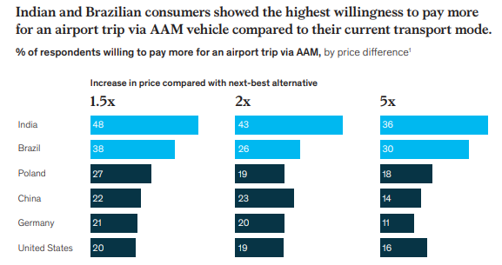

Today’s limousine and ride-hailing users might be first adopters.

The main consumer concerns about passenger AAM relate to safety and price. Across countries, more than 60 percent of respondents said safety was their top concern about AAM vehicles, making it the most important issue by far.

About 10 to 20 percent of respondents across countries reported concerns about ticket prices. These findings are in line with the fact that many respondents expressed willingness to pay a higher rate for AAM services.

Demographic trends provide hints about demand: only 8 percent of respondents in single-member households would consider a shift, compared with 22 percent of those in households with more than four people. This suggests that the most likely AAM adopter is between the ages of 18 and 29

1. Consumer insights on cargo-drone delivery: The survey have divided the main use cases, such as innercity and last-mile deliveries, into clusters, based on domain—public services, B2B, or B2C—and level of operational risk  
   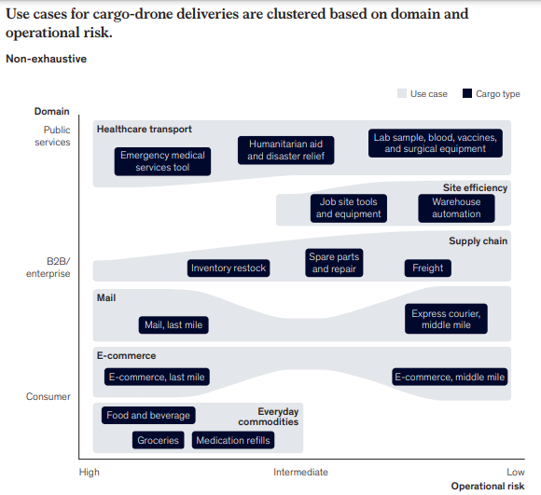
2. Pricing is the main lever for winning market share. Across most countries, our survey showed that cost would be the major consideration when respondents select a dedicated delivery mode. The share of respondents in most countries citing this as their top concern ranged from 39 to 59 percent. The only exception is China, where the largest share of respondents (43 percent) said their main consideration would be speed of delivery, compared with 26 percent selecting price.  
     
   The cargo market is wide open for new entrants. . In each country, delivery is relatively unimportant. less than 14 percent of respondents identified it as the main decision driver.  
     
   Stated interest in instant delivery varies widely across countries. About 76 percent of Indian respondents said they would be willing to pay extra to have items delivered within one to two hours by cargo drone, as did 74 percent of Chinese respondents.

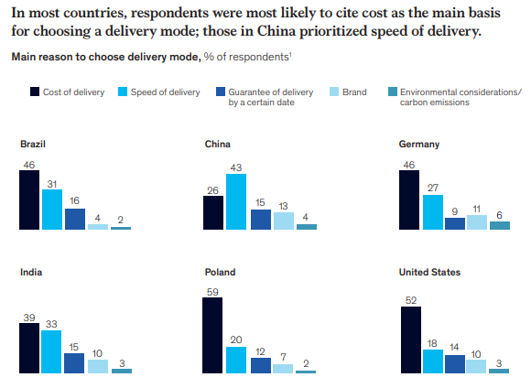

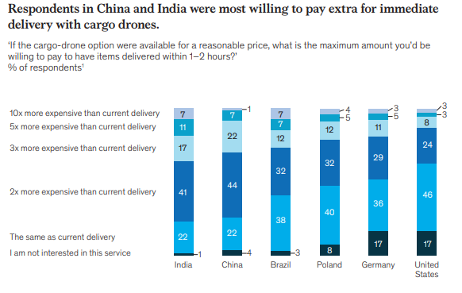

1. Convenience products, such as groceries and prepared food, could become the most promising use case for instant drone delivery  
     
   Safety is key for public acceptance, just as it is with people transport. In all countries, 40 percent or more of survey respondents had reservations about the safety of many small robotic aircraft flying overhead to make deliveries
2. 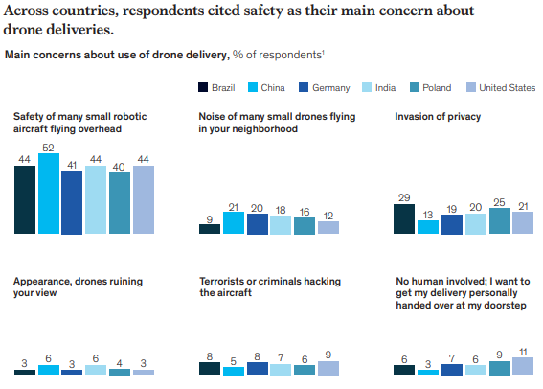

**PUTTING THE COSTUMER AT THE CENTER OF ADVANCED AIR MOBILITY**

The industry has focused on safely getting new types of electric aircraft in the air, but winners in this market will differentiate themselves based on customer experience. Much of the public attention around manned advanced air mobility (AAM) has focused on the development of electric vertical takeoff and landing vehicles (eVTOLs). As AAM operators think through the customer experience, five elements are worth considering.

1. Time saved could be less important than how people spend their time.