[1]

Proyecto Sistema de facturación de Foodtrucks Por: Jhonathan Pizarra

*Abstract*—Billing systems are found in the food businesses. In recent years, food businesses called foodtrucks have increased exponentially, however, it is important the computerized management of business billing transactions, both with users and with suppliers. It is necessary to design a database that will help us with this topic

***Resumen***—**Los Sistemas de facturación se encuentran en los negocios de comidas. En los últimos años, los negocios de comida denominados foodtrucks se han incrementado exponencialmente, sin embargo, es importante el manejo informático de las transacciones de facturación del negocio, tanto con los usuarios como con los proveedores. Se necesita diseñar una base de datos que nos ayude con esta temática.**

# INTRODUCTION

P

ower Designer es una herramienta para el análisis, diseño inteligente y construcción sólida de una base de datos y un desarrollo orientado a modelos de datos a nivel físico y conceptual, que da a los desarrolladores Cliente/Servidor la más firme base para aplicaciones de alto rendimiento. Existen además, otras herramientas que usaré para crear el proyecto entre ellas será SQL Server, y NetBeans, lo que se pretende hacer con el presente proyecto es enlazar conocimientos adquiridos de la materia *“Bases de Datos 1*” y “*Programación Avanzada*” para crear una aplicación que nos ayude a resolver el problema propuesto, “*Un sistema de facturación*” Rápidamente explicaré el uso y características de cada programa en este informe, aun así es posible que sienta “lagunas” y estaría en lo cierto, porque el presente informe no pretende enseñar conocimientos básicos de Java o PowerDesginer, más bien pretende enseñar cómo usar esos programas en este proyecto. [1]

# POWER DESIGNER

PowerDesigner es una herramienta para el análisis, diseño inteligente y construcción sólida de una base de datos y un desarrollo orientado a modelos de datos a nivel físico y conceptual, que da a los desarrolladores Cliente/Servidor la más firme base para aplicaciones de alto rendimiento. Comenzamos por crear un nuevo Modelo, para eso abrimos el programa y damos clic en la pestaña “File” y escogemos la opción “Nuevo Modelo”. Obsérvese la figura 1.

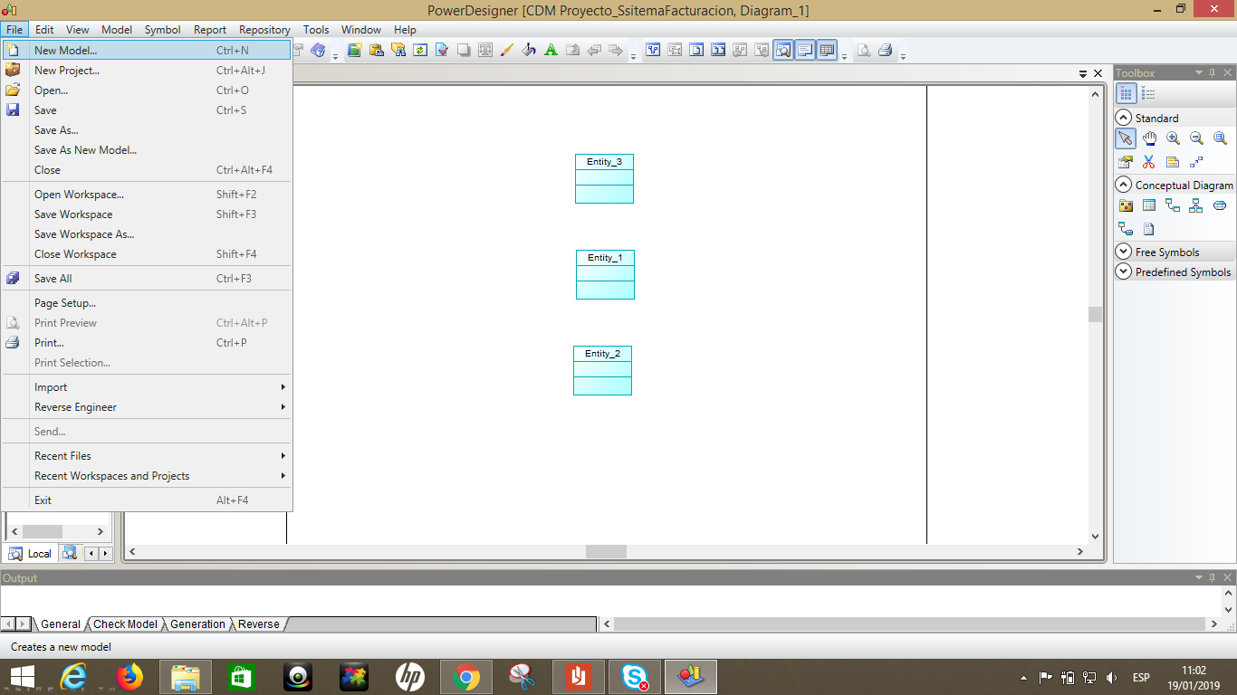

Fig. 1 Creacion de modelos

Escogemos en la sección información la opción “Conceptual Data” y enseguida le damos un nombre a nuestro modelo. Lo que habremos hecho es generar un espacio de trabajo el cual contendrá un diagrama. Pero antes nos es necesario hacer todo tal y como se pide en la Figura 2.

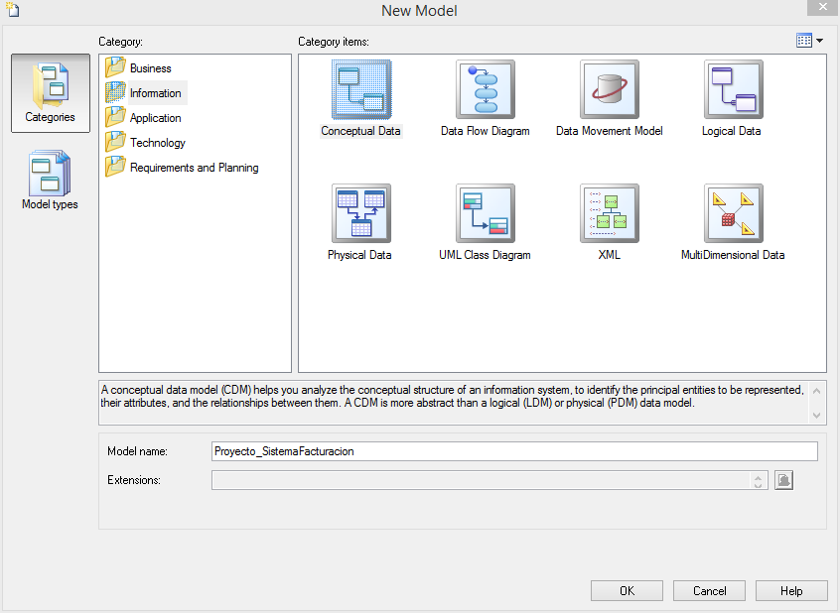

Fig. 2 Selección de Modelo

Luego de ello, aparecerá un espacio de trabajo, veremos dos cosas, a la parte izquierda un conjunto de accesorios (los cuales usaremos en toda la plantilla) y la derecha veremos en cambio todos los objetos existentes dentro de esta. Obsérvese la figura 3 y 4 respectivamente

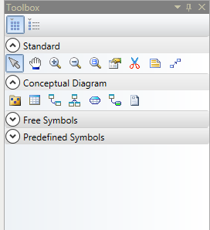

Fig. 3 Presentación de Herramientas

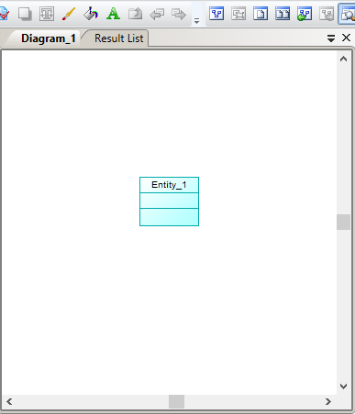

Fig. 4 Plantilla de trabajo

Si observamos el centro, vemos un cuadro “Entidad”, esa mismas fue arrastrada desde el componente “*enity”* de la figura 3, misma que está ubicada en el panel de *“Conceptual Diagrama”.* Lo que necesitamos hacer es doble clic en ese recuadro entity para que se nos abra una ventana como el de la figura 5.

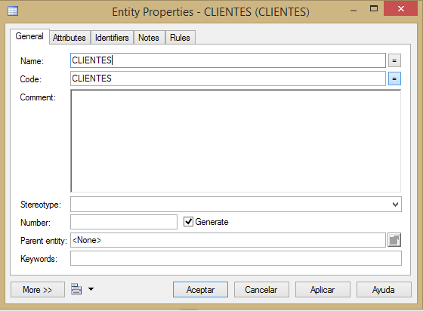

Fig. 5 Pestaña General

Vemos varias pestañas, en la general describimos el nombre, y podemos agregar un comentario sobre esta entidad, en mi caso solo le pondré el nombre de esta entidad y me desplazaré a la pestaña atributos, Figura 6

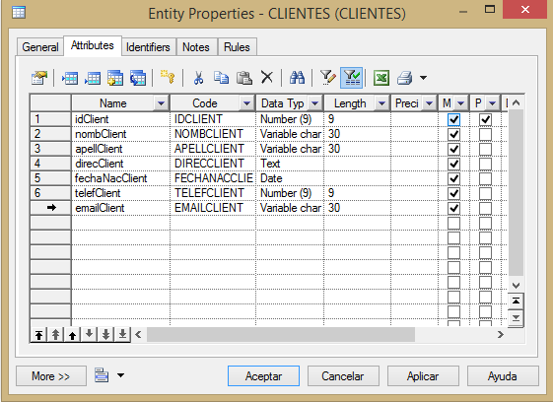

Fig. 6 Pestaña Atributos

En esta pestaña atributos definimos nombres de los atributos, tipos de datos de los mismos, algunas características adicionales como sería la longitud, la PK, y si son “*Mandatory*”. Y haremos lo mismo para con cualquier entidad que tengamos.

Luego de esto, nos desplazaremos a la pestaña “*Identifiers*” Figura 7.

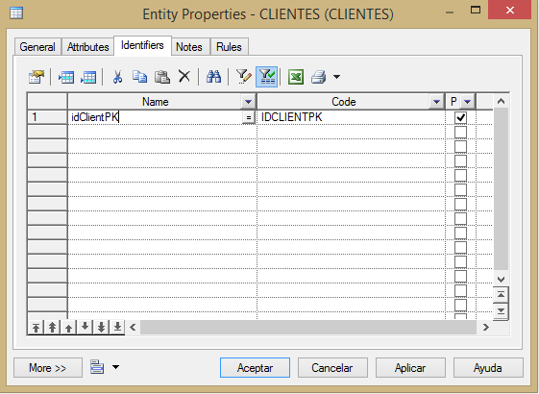

Fig.7 Pestaña Identifiers

Aquí lo que se hace es enfatizar a nuestra Pk, y listo, las siguietens pestañas son solo para agragar notas con respecto a esta entidad. Si pulsamos aceptar, y luego de haber establecido todo lo necesario en las pestañas anteriores, veremos una generacion de entidad/es como la de la/s figura 8 y 9.

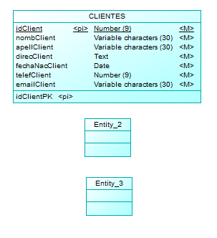

Fig. 8 Entidad diseñada

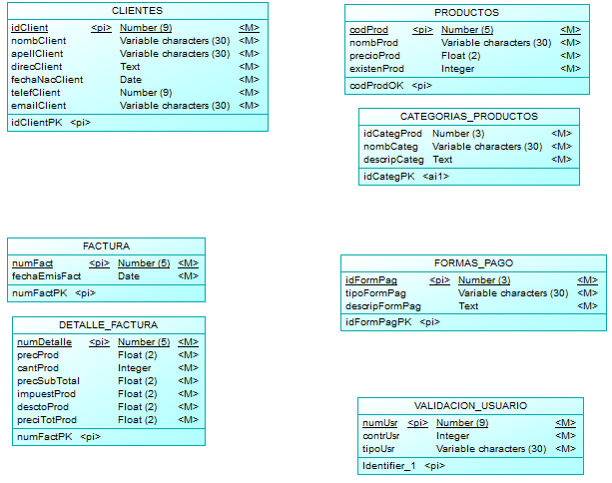

Fig. 9 Entidades diseñadas

Ahora crearemos lo que sería la relación, de hecho este diseño de modelo se denomina Modelo Entidad-Relación porque creamos dependencias y establecemos condiciones. Si hablamos de un sistema entonces hablamos de conexiones de cualquier forma, por lo que usando una de las herramientas (Que fueron presentadas en la figura 3) denominada “*Relationship*”, conectamos dos entidades desde sus centros, estas entidades deben tener relación una con otra y entonces podemos darle cardinalidades véase la figura 10:

* 1 a 1
* 1 a n
* n a 1
* n a n

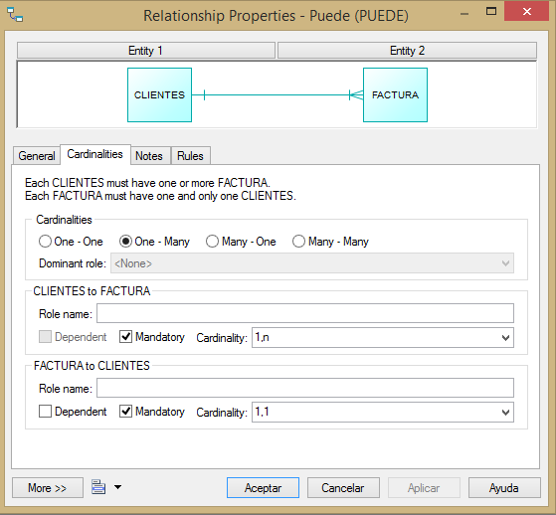

Fig. 10 Relacion de cardinalidad

Una vez hayamos hecho las relaciones habremos terminado con el primer inciso del proyecto, que era crear el modelo Entidad-Relación. Nos quedaría algo parecido a la figura 11.

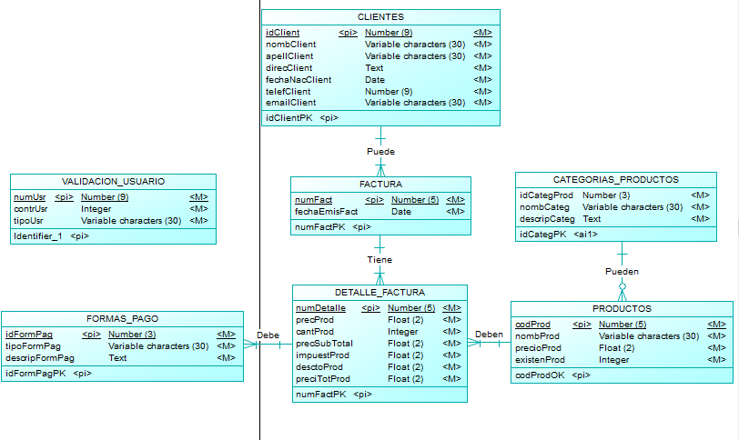

Fig. 11 Modelo Entudad-Relacion

## Script Tabla

(Próxoma entrega)

## Script Inserción Datos

(Próxima entrega)

# Some Common Mistakes

The word “data” is plural, not singular. The subscript for the permeability of vacuum µ0 is zero, not a lowercase letter “o.” The term for residual magnetization is “remanence”; the adjective is “remanent”; do not write “remnance” or “remnant.” Use the word “micrometer” instead of “micron.” A graph within a graph is an “inset,” not an “insert.” The word “alternatively” is preferred to the word “alternately” (unless you really mean something that alternates). Use the word “whereas” instead of “while” (unless you are referring to simultaneous events). Do not use the word “essentially” to mean “approximately” or “effectively.” Do not use the word “issue” as a euphemism for “problem.” When compositions are not specified, separate chemical symbols by en-dashes; for example, “NiMn” indicates the intermetallic compound Ni0.5Mn0.5 whereas “Ni–Mn” indicates an alloy of some composition NixMn1-x.

Be aware of the different meanings of the homophones “affect” (usually a verb) and “effect” (usually a noun), “complement” and “compliment,” “discreet” and “discrete,” “principal” (e.g., “principal investigator”) and “principle” (e.g., “principle of measurement”). Do not confuse “imply” and “infer.”

Prefixes such as “non,” “sub,” “micro,” “multi,” and “ultra” are not independent words; they should be joined to the words they modify, usually without a hyphen. There is no period after the “et” in the Latin abbreviation “*et al.*” (it is also italicized). The abbreviation “i.e.,” means “that is,” and the abbreviation “e.g.,” means “for example” (these abbreviations are not italicized).

A general IEEE styleguide is available at <http://www.ieee.org/web/publications/authors/transjnl/index.html>

# Conclusion

## A conclusion section is not required. Although a conclusion may review the main points of the paper, do not replicate the abstract as the conclusion. A conclusion might elaborate on the importance of the work or suggest applications and extensions.

References and Footnotes

## References

References need not be cited in text. When they are, number citations on the line, in square brackets inside the punctuation. Multiple references are each numbered with separate brackets. When citing a section in a book, please give the relevant page numbers. In text, refer simply to the reference number. Do not use “Ref.” or “reference” except at the beginning of a sentence: “Reference [3] shows ... .” Please do not use automatic endnotes in *Word*, rather, type the reference list at the end of the paper using the “References” style.

Reference numbers are set flush left and form a column of their own, hanging out beyond the body of the reference. The reference numbers are on the line, enclosed in square brackets. In all references, the given name of the author or editor is abbreviated to the initial only and precedes the last name. Use them all; use *et al*. only if names are not given. Use commas around Jr., Sr., and III in names. Abbreviate conference titles. When citing IEEE transactions, provide the issue number, page range, volume number, year, and/or month if available. When referencing a patent, provide the day and the month of issue, or application. References may not include all information; please obtain and include relevant information. Do not combine references. There must be only one reference with each number. If there is a URL included with the print reference, it can be included at the end of the reference.

Other than books, capitalize only the first word in a paper title, except for proper nouns and element symbols. For papers published in translation journals, please give the English citation first, followed by the original foreign-language citation See the end of this document for formats and examples of common references. For a complete discussion of references and their formats, see “The IEEE Style Manual,” available as a PDF link off the *Author Digital Toolbox* main page.

## Footnotes

Number footnotes separately in superscripts (Insert | Footnote).[2] Place the actual footnote at the bottom of the column in which it is cited; do not put footnotes in the reference list (endnotes). Use letters for table footnotes (see Table I).

References

*Basic format for books:*

1. J. K. Author, “Title of chapter in the book,” in *Title of His Published Book, x*th ed. City of Publisher, Country if not
2. USA: Abbrev. of Publisher, year, ch. *x*, sec. *x*, pp. *xxx–xxx.*

*Examples:*

1. G. O. Young, “Synthetic structure of industrial plastics,” in *Plastics,* 2nd ed., vol. 3, J. Peters, Ed. New York: McGraw-Hill, 1964, pp. 15–64.
2. W.-K. Chen, *Linear Networks and Systems.* Belmont, CA: Wadsworth, 1993, pp. 123–135.

*Basic format for periodicals:*

1. J. K. Author, “Name of paper,” *Abbrev. Title of Periodical*, vol. *x,* no. *x,* pp*. xxx-xxx,* Abbrev. Month, year.

*Examples:*

1. J. U. Duncombe, “Infrared navigation—Part I: An assessment   
   of feasibility,” *IEEE Trans. Electron Devices*, vol. ED-11, no. 1, pp. 34–39, Jan. 1959.
2. E. P. Wigner, “Theory of traveling-wave optical laser,” *Phys. Rev*.,   
   vol. 134, pp. A635–A646, Dec. 1965.
3. E. H. Miller, “A note on reflector arrays,” *IEEE Trans. Antennas Propagat*., to be published.

*Basic format for reports:*

1. J. K. Author, “Title of report,” Abbrev. Name of Co., City of Co., Abbrev. State, Rep. *xxx*, year.

*Examples:*

1. E. E. Reber, R. L. Michell, and C. J. Carter, “Oxygen absorption in the earth’s atmosphere,” Aerospace Corp., Los Angeles, CA, Tech. Rep. TR-0200 (4230-46)-3, Nov. 1988.
2. J. H. Davis and J. R. Cogdell, “Calibration program for the 16-foot antenna,” Elect. Eng. Res. Lab., Univ. Texas, Austin, Tech. Memo. NGL-006-69-3, Nov. 15, 1987.

*Basic format for handbooks:*

1. *Name of Manual/Handbook*, *x* ed., Abbrev. Name of Co., City of Co., Abbrev. State, year, pp. *xxx-xxx.*

*Examples:*

1. *Transmission Systems for Communications*, 3rd ed., Western Electric Co., Winston-Salem, NC, 1985, pp. 44–60.
2. *Motorola Semiconductor Data Manual*, Motorola Semiconductor Products Inc., Phoenix, AZ, 1989.

*Basic format for books (when available online):*

1. Author. (year, month day). *Title.* (edition) [Type of medium]. *volume (issue).* Available: site/path/file

*Example:*

1. J. Jones. (1991, May 10). *Networks.* (2nd ed.) [Online]. Available: [http://www.atm.com](http://www.atm.com/)

*Basic format for journals (when available online):*

1. Author. (year, month). Title. *Journal.* [Type of medium]. *volume (issue),* pages. Available: site/path/file

*Example:*

1. R. J. Vidmar. (1992, Aug.). On the use of atmospheric plasmas as electromagnetic reflectors. *IEEE Trans. Plasma Sci.* [Online]. *21(3),* pp. 876–880. Available:<http://www.halcyon.com/pub/journals/21ps03-vidmar>

*Basic format for papers presented at conferences (when available online):*

1. Author. (year, month). Title. Presented at Conference title. [Type of Medium]. Available: site/path/file

*Example:*

1. PROCESS Corp., MA. Intranets: Internet technologies deployed behind the firewall for corporate productivity. Presented at   
   INET96 Annual Meeting. [Online]. Available: <http://home.process.com/Intranets/wp2.htp>

*Basic format for reports and handbooks (when available online):*

1. Author. (year, month). Title. Comp an y . C ity, State or Country. [Type of Medium]. Available: site/path/file

*Example:*

1. S. L. Tall een. (1996 , Apr . ). The In t r an et Archi -tecture: M a nagi ng i n f o rm at i on i n t h e ne w paradigm. Amdahl Corp., CA. [Online]. Available:<http://www.amdahl.com/doc/products/bsg/intra/infra/html>

*Basic format for computer programs and electronic documents (when available online):* ISO recommends that capitalization follow the accepted practice for the language or script in which the information is given.

*Example:*

1. A. Harriman. (1993, June). Compendium of genealogical software. *Humanist.* [Online]. Available e-mail: [HUMANIST@NYVM.ORG](mailto:HUMANIST@NYVM.ORG) Message: get GENEALOGY REPORT

*Basic format for patents (when available online):*

1. Name of the invention, by inventor’s name. (year, month day). *Patent Number* [Type of medium]. Available: site/path/file

*Example:*

1. Musical toothbrush with adjustable neck and mirror, by L.M.R. Brooks. (1992, May 19). *Patent D 326 189*

[Online]. Available: NEXIS Library: LEXPAT File: DESIGN

*Basic format for conference proceedings (published):*

1. J. K. Author, “Title of paper,” in *Abbreviated Name of Conf.*, City of Conf., Abbrev. State (if given), year, pp. *xxxxxx.*

*Example:*

1. D. B. Payne and J. R. Stern, “Wavelength-switched pas- sively coupled single-mode optical network,” in *Proc. IOOC-ECOC,* 1985,   
   pp. 585–590.

*Example for papers presented at conferences (unpublished):*

1. D. Ebehard and E. Voges, “Digital single sideband detection for interferometric sensors,” presented at the 2nd Int. Conf. Optical Fiber Sensors, Stuttgart, Germany, Jan. 2-5, 1984.

*Basic format for patents:*

1. J. K. Author, “Title of patent,” U.S. Patent *x xxx xxx*, Abbrev. Month, day, year.

*Example:*

1. G. Brandli and M. Dick, “Alternating current fed power supply,”   
   U.S. Patent 4 084 217, Nov. 4, 1978.

*Basic format**for theses (M.S.) and dissertations (Ph.D.):*

1. J. K. Author, “Title of thesis,” M.S. thesis, Abbrev. Dept., Abbrev. Univ., City of Univ., Abbrev. State, year.
2. J. K. Author, “Title of dissertation,” Ph.D. dissertation, Abbrev. Dept., Abbrev. Univ., City of Univ., Abbrev. State, year.

*Examples:*

1. J. O. Williams, “Narrow-band analyzer,” Ph.D. dissertation, Dept. Elect. Eng., Harvard Univ., Cambridge, MA, 1993.
2. N. Kawasaki, “Parametric study of thermal and chemical nonequilibrium nozzle flow,” M.S. thesis, Dept. Electron. Eng., Osaka Univ., Osaka, Japan, 1993.

*Basic format for the most common types of unpublished references:*

1. J. K. Author, private communication, Abbrev. Month, year.
2. J. K. Author, “Title of paper,” unpublished.
3. J. K. Author, “Title of paper,” to be published.

*Examples:*

1. A. Harrison, private communication, May 1995.
2. B. Smith, “An approach to graphs of linear forms,” unpublished.
3. A. Brahms, “Representation error for real numbers in binary computer arithmetic,” IEEE Computer Group Repository, Paper R-67-85.

*Basic format for standards:*

1. *Title of Standard*, Standard number, date.

*Examples:*

1. IEEE Criteria for Class IE Electric Systems, IEEE Standard 308, 1969.
2. Letter Symbols for Quantities, ANSI Standard Y10.5-1968.

**First A. Author** (M’76–SM’81–F’87) and the other authors may include biographies at the end of regular papers. Biographies are often not included in conference-related papers. This author became a Member (M) of IEEE in 1976, a Senior Member (SM) in 1981, and a Fellow (F) in 1987. The first paragraph may contain a place and/or date of birth (list place, then date). Next, the author’s educational background is listed. The degrees should be listed with type of degree in what field, which institution, city, state, and country, and year the degree was earned. The author’s major field of study should be lower-cased.

The second paragraph uses the pronoun of the person (he or she) and not the author’s last name. It lists military and work experience, including summer and fellowship jobs. Job titles are capitalized. The current job must have a location; previous positions may be listed without one. Information concerning previous publications may be included. Try not to list more than three books or published articles. The format for listing publishers of a book within the biography is: title of book (city, state: publisher name, year) similar to a reference. Current and previous research interests end the paragraph.

The third paragraph begins with the author’s title and last name (e.g., Dr. Smith, Prof. Jones, Mr. Kajor, Ms. Hunter). List any memberships in professional societies other than the IEEE. Finally, list any awards and work for IEEE committees and publications. If a photograph is provided, the biography will be indented around it. The photograph is placed at the top left of the biography, and should be of good quality, professional-looking, and black and white (see above example). Personal hobbies will be deleted from the biography. Following are two examples of an author’s biography.

**Second B. Author** was born in Greenwich Village, New York City, in 1977. He received the B.S. and M.S. degrees in aerospace engineering from the University of Virginia, Charlottesville, in 2001 and the Ph.D. degree in mechanical engineering from Drexel University, Philadelphia, PA, in 2008.

From 2001 to 2004, he was a Research Assistant with the Princeton Plasma Physics Laboratory. Since 2009, he has been an Assistant Professor with the Mechanical Engineering Department, Texas A&M University, College Station. He is the author of three books, more than 150 articles, and more than 70 inventions. His research interests include high-pressure and high-density nonthermal plasma discharge processes and applications, microscale plasma discharges, discharges in liquids, spectroscopic diagnostics, plasma propulsion, and innovation plasma applications. He is an Associate Editor of the journal *Earth*, *Moon*, *Planets*, and holds two patents.

Mr. Author was a recipient of the International Association of Geomagnetism and Aeronomy Young Scientist Award for Excellence in 2008, the IEEE Electromagnetic Compatibility Society Best Symposium Paper Award in 2011, and the American Geophysical Union Outstanding Student Paper Award in Fall 2005.

**Third C. Author, Jr. (M’87)** received the B.S. degree in mechanical engineering from National Chung Cheng University, Chiayi, Taiwan, in 2004 and the M.S. degree in mechanical engineering from National Tsing Hua University, Hsinchu, Taiwan, in 2006. He is currently pursuing the Ph.D. degree in mechanical engineering at Texas A&M University, College Station.

From 2008 to 2009, he was a Research Assistant with the Institute of Physics, Academia Sinica, Tapei, Taiwan. His research interest includes the development of surface processing and biological/medical treatment techniques using nonthermal atmospheric pressure plasmas, fundamental study of plasma sources, and fabrication of micro- or nanostructured surfaces.

Mr. Author’s awards and honors include the Frew Fellowship (Australian Academy of Science), the I. I. Rabi Prize (APS), the European Frequency and Time Forum Award, the Carl Zeiss Research Award, the William F. Meggers Award and the Adolph Lomb Medal (OSA).

1.
2. It is recommended that footnotes be avoided (except for the unnumbered footnote with the receipt date on the first page). Instead, try to integrate the footnote information into the text.