Resilience measurement in a Supply Chain Simulation

José Gabriel Navarro de la Cruz ([jgnavarro@uninorte.edu.co](mailto:jgnavarro@uninorte.edu.co))

7/1/2020

## Introduction

Tukamuhabwa, B.R. et al. (2015) define resilience in a supply chain (SC) context as “The adaptive capability of a supply chain to prepare for and/or respond to disruptions, to make a timely and cost effective recovery, and therefore progress to a post-disruption state of operations – ideally, a better state than prior to the disruption” (p.5599). In this document, we address the measurement of disruptions through resilience metrics, which quantitatively measure the impact of disruptions in different dimensions of a supply chain simulated using R. The text is structured as follows. First the resilience metrics are briefly described. Second, the supply chain simulation itself is also described. Third, the main findings are presented and discussed. Finally, some conclusions regarding the simulation and results are presented.

## Resilience metrics

From the literature reviewed, seven resilience metrics which best fitted the SC Simulation were selected from various authors. In this sense, Muñoz & Dunbar (2015) introduce the following metrics:

### Impact:

It measures the magnitude of the disruption in the system through its performance level. $p_{2}$ stands for the system performance before the occurrence of the disruptive event and $p_{1}$ measures the performance drop product of this event. The metric is calculated as follows:

$$Impact=p_{2}-p_{1}$$

### Recovery:

It captures the time needed to resume activities with an performance of 95% in comparison to the performance before falling under this threshold, it is denoted as Recovery (Muñoz & Dunbar, 2015, p.6742). $t_{2}$ refers to the time point when the performance is reestablished and $t_{1}$ to the time point just before the disruptive event occurs. Its formula is the following:

$$Recovery=t_{2}-t_{1}$$

### Performance Loss:

It allows to measure the area above the performance curve from the moment a disruptive event occurs until the time that the system reaches 95% of the initial performance (Muñoz & Dunbar, 2015, p.6742). Its definition is similar to the metric employed by Melnyk et al. (2014) cited in Muñoz and Dunbar (2015). It is calculated as follows:

$$PerformanceLoss=(t_{2}-t_{1})*p_{1}-\int_{t_{1}}^{t_{2}}{p}(t)dt$$

Ojha et al (2018) cited in Hosseini et al. (2019) also propose their metric which is represented as $RI_{k}$.

### Resilience Index:

It quantifies the service loss after a disruptive event as a measure of supply chain resilience. It its formula, $w_{0}$ refers to the time period in which the disruptive event occurs, $w_{n}$ stands for the time in which the disruption ends plus the time to recover from the disruption. On the other hand, $SL_{k0}$ and $SL_{kw}$ are the service levels of node k prior and after the disruption.

$$RI_{k}=1-\frac{\sum_{w=w_{0}}^{w_{n}}{(}1-\frac{SL_{kw}}{SL_{k0}})}{(w_{n}-w_{0})}$$

Carvalho et al. (2010) propose two performance metrics to evaluate resilient response in different scenarios, one of those metrics is the Lead time ratio implemented in this simulation.

### Lead time ratio:

The Lead Time Ratio is the ratio between actual and promised lead time. This performance measure evaluates the ability of each SC entity to meet the expectations related to lead time of their first tier costumers (Carvalho et al., 2010, p.337). This metric can be implemented in simple supply chains as the analyzed in this text or in more complex one with many entities. In this metric, $J_{kt}$ represents the total number of orders delivered from entity $k$ to their direct customers, during time period $t$. $ActualLT(k,t)$) refers to the lead time that an entity $k$ actually employs to make a delivery to a customer on a time period $t$. Finally, $PromisedLT(k,t)$ as its name suggests, is the agreed lead time for an order to be delivered from entity $k$ to a customer on time period $t$ (Carvalho et al., 2010, p.337). The formula for the Lead time ratio is:

$$LeadTimeRatio(k,t)=\sum_{j=1}^{J_{kt}}{(}\frac{ActualLT(k,t)_{j}}{PromisedLT(k,t)_{j}}/J_{kt})*100$$

Romero (2020) proposes a resilience metric that combines the absorptive resilience capacities and restorative resilience capacity.

### Resilience metric 6 (Romero, 2020):

The combination of absorptive and restorative resilience capacity allows the metric to estimate the system resilience relative to the disruption intensity. In this metric, $I$ represents the disruption intensity, $X$ stands for the performance loss and $T$ is the recovery time. This metric is calculated as follows:

$$R=\frac{I^{2}}{XT}$$

In addition, Zobel (2011) cited in Romero (2020) introduces a resilience metric.

### Resilience metric 7 (Zobel, 2011):

The metric has been adapted to capture nonlinear recoveries, multiple disruptions and complex multidimensional systems (Romero, 2020, p. 4). For this metric, $X$ is the initial performance loss, $T$ represents the recovery time and $T^{*}$ is the study period or control time. The formula is presented as:

$$R=1-\frac{XT}{2T^{*}}$$

## Supply Chain simulation design

The simulation is designed to represent a simple supply chain with 1 supplier and 1 retailer, that means, it only has two levels. The retailer follows a continuous review system for its inventory management and the disruptions take place in the supplier, which implies that it is unable to satisfy its demand during the disruption. The simulation represents a year of daily operations for the supply chain in which there is only one disruption. To explore multiple supply chain configurations, the simulation creates 100 instances which are a combination of parameters such as:

* Failure intensity (in days).
* Q value (in units).
* Lead time (in days).
* Service level (as a proportion; SL).

In addition, to capture the variability of the system, it also generates 30 replications for each instance. The metrics computed at the end of every instance are the mean of the metrics computed in each one of the 30 replications. These values and additional operative information are stored in matrices at the end of the simulation. Finally, to give a better insight in the supply chain resilience performance and functioning, plots regarding the inventory positioning and service levels are displayed and for each metric a plot is built so that it can be graphically appreciated how this resilient response evolves as the disruption intensity increases.

## Results and discussion

The tables and plots generated after the simulation is finished allow to see an expected behavior of a supply chain operation under disruption. To ilustrate the results, instance 100 is analyzed.

This instance has the following parameters:

## Failure Intensity Q value Lead Time SL   
## 23.000 4.000 1.000 0.802

Among the main outputs for this instance include a matrix with information regarding the daily supply chain operation. It is structured as follows:

## Demand Inv. Pos On-Hand In-transit Orders Loss Sales Service Level  
## [1,] 104.26094 454.7391 454.7391 0 0 0.00000 1.000000  
## [2,] 80.72370 374.0154 374.0154 0 0 0.00000 1.000000  
## [3,] 98.10132 275.9140 275.9140 0 0 0.00000 1.000000  
## [4,] 98.39598 177.5180 177.5180 0 0 0.00000 1.000000  
## [5,] 107.19265 470.3254 70.3254 400 400 0.00000 1.000000  
## [6,] 102.64009 400.0000 400.0000 0 0 32.31469 0.685165  
## Safety Stock  
## [1,] 159  
## [2,] 159  
## [3,] 159  
## [4,] 159  
## [5,] 159  
## [6,] 159

Demand represents the consumer demand, Inv. Pos refers to the inventory positioning which includes the On-hand inventory and also in-trainsit inventory. Orders stands for the number of units ordered to the supplier when the On-hand inventory is lower than the Safety stock.

For this instance, the inventory positioning follows a behavior showed in Figure 1. Here, a normal functioning is evident until day 123 when the failure in the supplier occurs and it can not satisfy the retailer demand of products, this yields an inventory positioning of 0 during 23 days, which is the length of the failure. Then, the inventory positioning increases again rapidly given the short lead time of the supply chain (1 day).

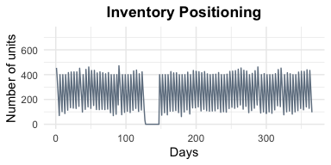

Figure 1: Inventory positioning

The service level is presented in Figure 2. It is noticeable that the disruption caused a total lost of service level from day 128 to 149 when the supply chain is able to recover its normal functioning. In other periods, an adequate service level is observed.

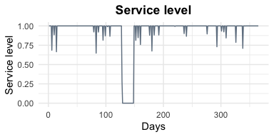

Figure 2: Service level

Regarding the resilience metrics. Figure 3 shows the relationship between the performance level loss and the disruption intensity. It is evident that any disruption have a significant impact on system performance. In addition, it is noticeable that the greater the intensity, the greater the performance level loss since disruptions under 10 days have a less prominent impact that more intense disruptions.

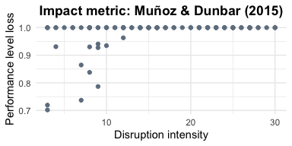

Figure 3: Impact metric: Muñoz & Dunbar (2015)

Additionally, Figure 4 shows the Recovery metric as a function of disruption intensity. It is evident a proportional increase in recovery time as the intensity increases. The behavior of the recovery metric is expected since a system may require more time to recover from more violent disruptions.

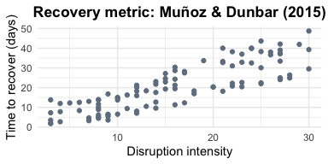

Figure 4: Recovery metric: Muñoz & Dunbar (2015)

Figure 5 presents the resilience metric introduced by Romero (2020). Here, a positive proportional relationship is evident between the resilient response and the disruption intensity. It is expected since the metric allows to estimate the system resilience relative to the disruption intensity, therefore, a system have a greater resilience if it can recover from disruptions with higher intensities.

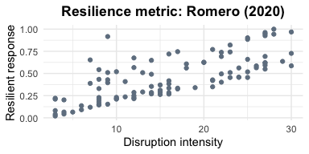

Figure 5: Resilience metric: Romero (2020)

The resilience metric presented by Zobel (2011) is shown in Figure 6 plotted against disruption intensity. Since it does not include the disruption intensity as an input variable, a decreasing trend is observed as intensity increases. It suggests that a system taking more time to recover from highly disruptive events may seem to have lower resilience. This can result in misleading conclusions if the intensity is not addressed or included in the analysis.

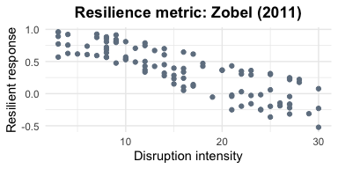

Figure 6: Resilience metric: Zobel (2011)

The metric proposed by Ojha et al. (2018) is presented in Figure 7 against the disruption intensity. This metric compares the system performance before and after the disruption. That means that it does not include the intensity in its input variables, therefore, it shows an approximately constant resilient response regardless of variations in the intensity.

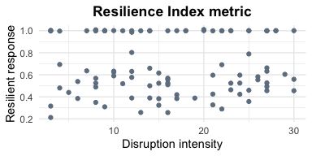

Figure 7: Resilience metric: Ojha et al. (2018)

Figure 8 presents the performance loss metric introduced by Muñoz and Dunbar (2015). There is a direct relationship between the disruption intensity and the performance loss, which is expected since a high intensity disruptive event may have a greater impact in supply chain operations. In addition, the performance loss appears to have a greater variability as intensity increases.

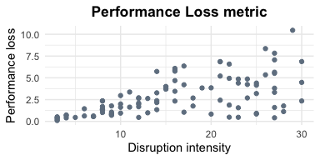

Figure 8: Performance Loss metric: Muñoz and Dunbar (2015)

Finally, the lead time ratio metric introduced by Carvalho et al (2010) is showed in Figure 9. Here a modest increase in the lead time ratio is evident as the intensity increases. This suggests that the lead time of the products tends to increased as the disruption intensifies.

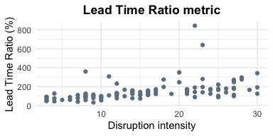

Figure 9: Lead time ratio metric: Carvalho et al (2010)

## Conclusion

As Romero (2020) points out, resilience measurement is fundamental to improve a system response to disruptive events. To understand this concept, accurate measurements of resilience are required (pp. 2,3). In this document, some resilience metrics found in a literature review are implemented in a supply chain simulation. Results yield multiple insights on the resilient response according to the variety of metrics. The convenience of one or another may be determined by the context of the system and the information available at the moment of measurement.

* Ocupado: Corresponde a la persona que durante el período de referencia trabajó por lo menos una hora remunerada en la semana de referencia; no trabajó la semana de referencia pero tenía un trabajo, y que sea trabajador familiar sin remuneración y trabajó en la semana de referencia por lo menos 1 hora.

|  |  |  |  |  |
| --- | --- | --- | --- | --- |
| Genero | Y_modelo4 | Frecuencia | Proporcion | Proporcion.Total |
| Femenino | Desocupado | 1839 | 0.194007806730668 | 0.0870244 |
| Femenino | Informal | 6179 | 0.651862010760629 | 0.2924002 |
| Femenino | Ocupado | 1461 | 0.154130182508703 | 0.0691369 |
| Masculino | Desocupado | 1126 | 0.096627477902686 | 0.0532841 |
| Masculino | Informal | 7755 | 0.665493864240968 | 0.3669790 |
| Masculino | Ocupado | 2772 | 0.237878657856346 | 0.1311755 |