LABORATORY EXERCISE 9

SEARCH AND FILTERING SYSTEM

Learning Objectives
By the end of this laboratory exercise, students should be able to:
- Implement client-side search filtering using jQuery for dynamic user experience.
- Develop server-side search functionality using CodeIgniter's database queries.
- Create a responsive search interface using Bootstrap components.
- Integrate AJAX techniques to display search results without page reload.
- Understand the differences between client-side and server-side search approaches.

Prerequisite student experiences and knowledge
Before starting this exercise, students should have:
- Completed Laboratory Exercise 8 (Real-time Notifications with jQuery).
- Solid understanding of CodeIgniter's MVC architecture and database operations.
- Proficiency in writing jQuery and JavaScript code for DOM manipulation.
- Experience with AJAX requests and handling JSON responses.
- Familiarity with Bootstrap form components and grid system.
- Knowledge of SQL queries, particularly LIKE operators for search functionality.

Background
An effective search system is crucial for any Learning Management System (LMS) to help users quickly find relevant courses and content. This exercise focuses on implementing a dual-approach search system: client-side filtering for immediate feedback and server-side searching for comprehensive results. jQuery provides the tools for dynamic client-side filtering, while CodeIgniter's database class enables efficient server-side search using SQL LIKE queries. The combination creates a seamless user experience where search results update in real-time without page refreshes, enhancing the overall usability of the application.

Materials/Resources
- Personal Computer with Internet Access
- XAMPP/WAMP/LAMP server installed
- CodeIgniter Framework
- Visual Studio Code or any code editor
- Git and GitHub Account
- Web Browser (Chrome, Firefox, etc.)
Laboratory Activity
Step 1: Project Setup
- Open your existing ITE311-LASTNAME CodeIgniter project.
- Ensure your database has a courses table with sample data for testing search functionality.
- Verify that your course listing page is functional from previous exercises.

Step 2: Create Search Controller Method
- Navigate to your Course.php controller in app/Controllers/.
- Add a new method named search():
  - This method should accept GET or POST requests with a search term parameter.
  - Use CodeIgniter's Query Builder to search the courses table using LIKE queries.
  - Return the results as JSON for AJAX requests or render a view for regular requests.
- Implement the search logic
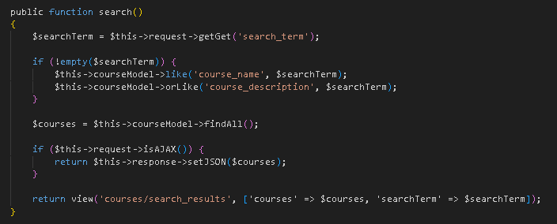

Step 3: Add Search Route
- Open app/Config/Routes.php.
- Add routes for the search functionality:
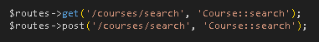

Step 4: Create Search Interface
- Modify your courses view file (app/Views/courses/index.php).
- Add a search form with Bootstrap styling
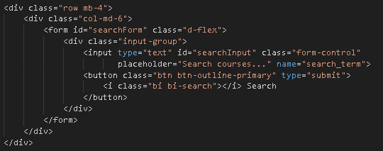

Step 5: Implement Client-Side Filtering with jQuery
- Add jQuery script for instant client-side filtering
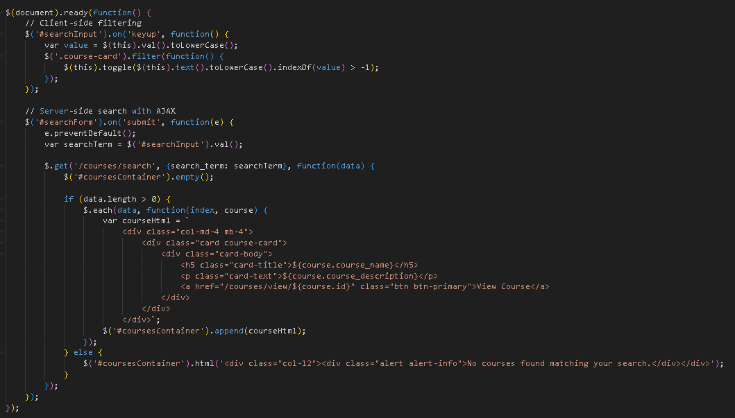

Step 6: Update Courses View Structure
- Modify your courses listing to work with the search functionality
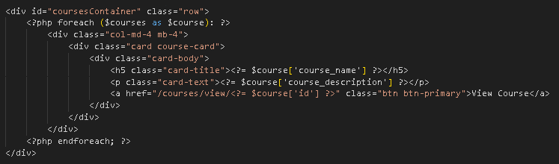
- To simulate real-time updates, you can set an interval to fetch notifications every 60 seconds (optional advanced task).

Step 7: Test the Search Functionality
- Load the courses page in your browser.
- Test the client-side filtering by typing in the search box courses should filter instantly.
- Test the server-side search by submitting the form results should load via AJAX without page refresh.
- Verify that both empty search results and successful searches display appropriate messages.

Step 9: Push to GitHub
- Stage and commit your search functionality
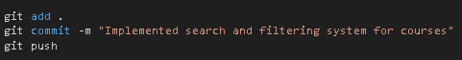

Output / Results
- Screenshot of the courses page with the search interface implemented.
- Screenshot showing filtered courses during client-side search.
- Screenshot of browser Developer Tools Network tab showing AJAX request to server-side search.
- Screenshot of search results displaying when no courses match the search term.
- Screenshot of GitHub repository with the latest commit.

QUESTIONS:
- What are the advantages and limitations of client-side filtering compared to server-side search?
- The advantage of client-side filtering is that the filtering is performed by the browser without the contact being required to the server and the user is assured of instant results. It is however constrained by the fact that it only filters data that has already been loaded on the page and it can be slow on the browser when working with large datasets. Conversely, server-side search is more efficient with large volumes of data, but it involves communicating with the server, which can lead to minimal delays.
- How does using AJAX for search improve the user experience compared to traditional form submission?
- AJAX enhances the end-user experience because it enables the search results to update in real-time without loading the entire webpage and makes the interface more responsive and, therefore, faster. Contrary to the conventional form submission, AJAX is able to transmit and receive limited data volumes and therefore consumes less load time and the current state of the user page is maintained.
- What security considerations should be taken when implementing search functionality with user input?
- When applying search functionality, one should ensure that the user input is validated and sanitized to avoid SQL injection attacks and also to make sure that the system only handles safe characters. Also, one can help to withstand the malicious querying of the application by limiting the number of returned data, using prepared statements, and avoiding exposing vulnerable information.

Output / Results
Screenshot of the courses page with the search interface implemented.
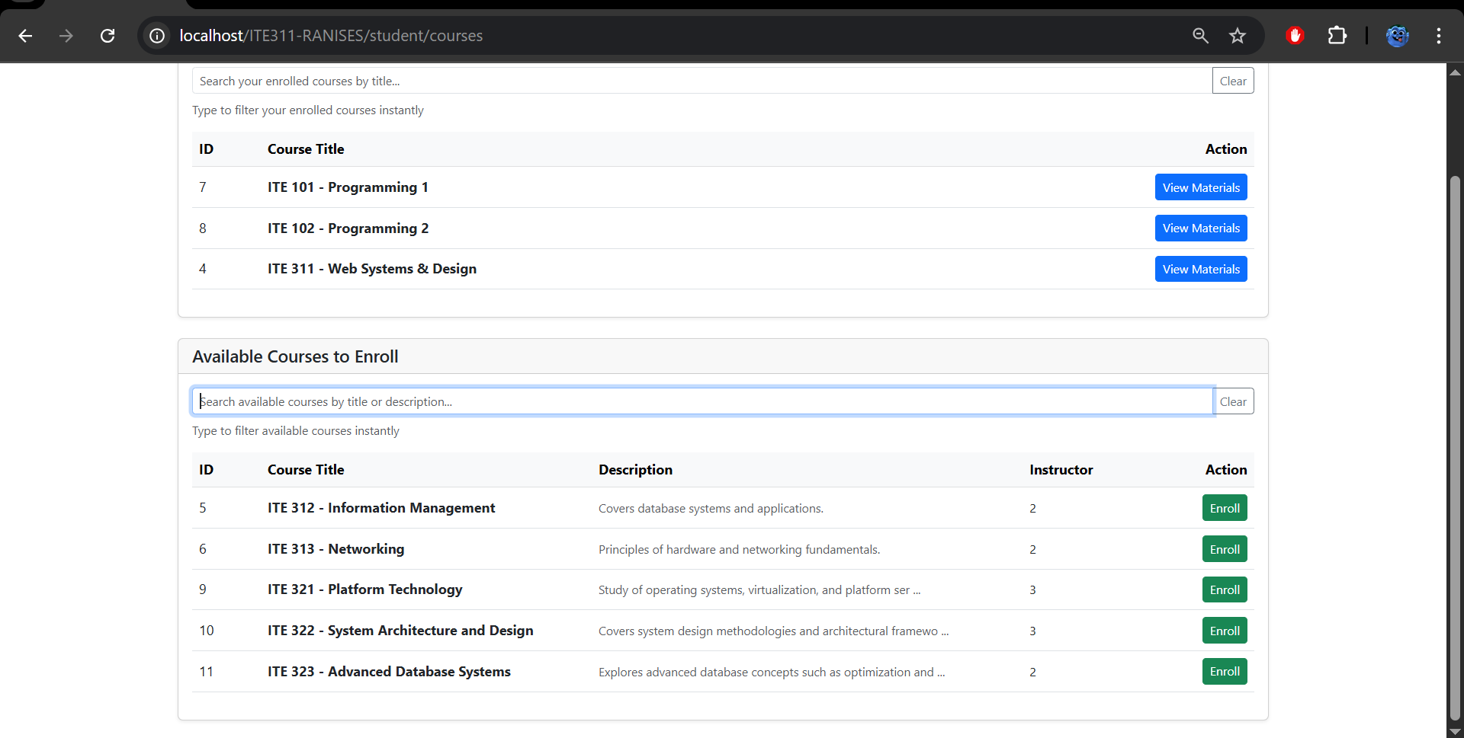
Screenshot showing filtered courses during client-side search.
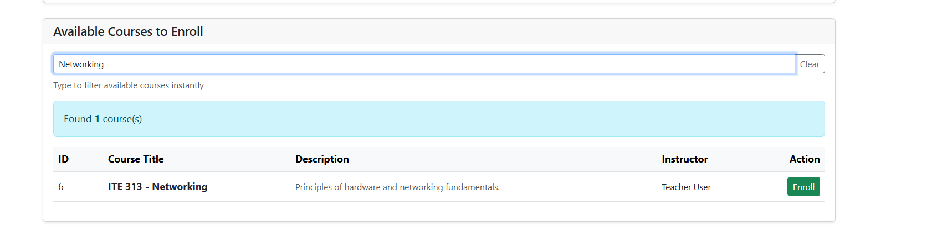
Screenshot of browser Developer Tools Network tab showing AJAX request to server-side search.
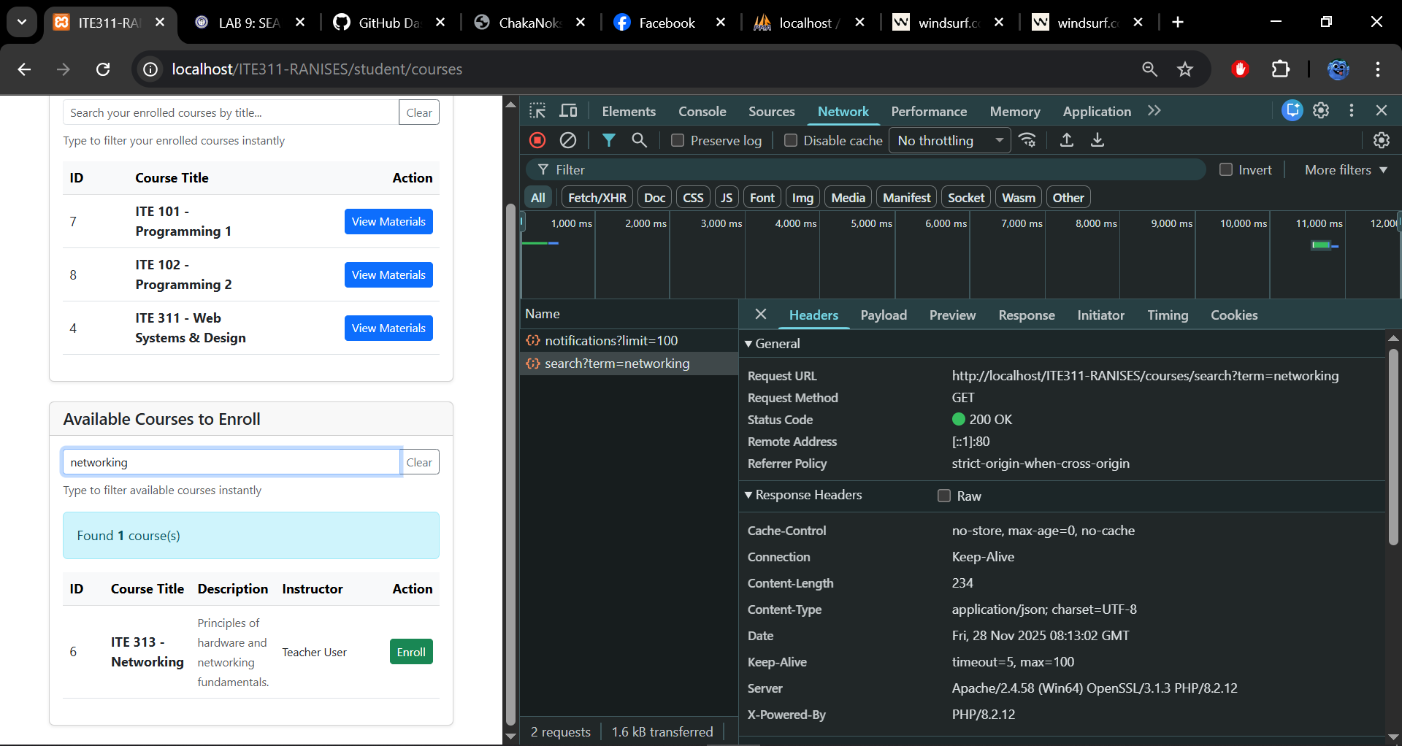
Screenshot of search results displaying when no courses match the search term.
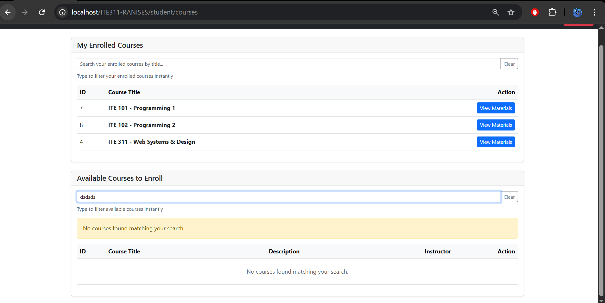

Screenshot of GitHub repository with the latest commit.
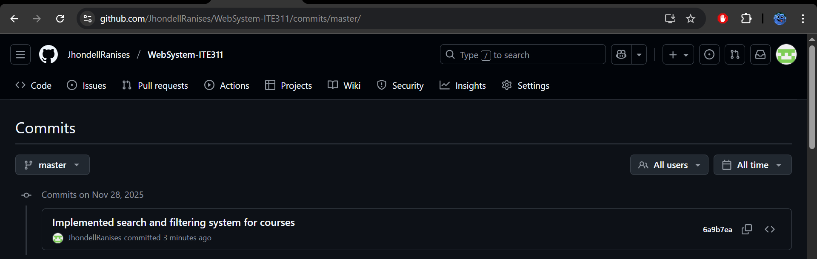

Conclusion
The given activity allowed me to comprehend the interaction between client-side and server-side search to provide an efficient and responsive user experience. I came to know how to use jQuery to filter the results immediately at the page, and CodeIgniter to make more profound and precise searching at the database. AJAX was also used to give the impression of speed as the page is not required to reload any longer. All in all, this exercise enhanced my practical search feature construction and further understanding of how usability is enhanced by real-world systems where systems are dynamic and efficient in search features.

