LABORATORY EXERCISE 9

SEARCH AND FILTERING SYSTEM

Learning Objectives
By the end of this laboratory exercise, students should be able to:
- Implement client-side search filtering using jQuery for dynamic user experience.
- Develop server-side search functionality using CodeIgniter's database queries.
- Create a responsive search interface using Bootstrap components.
- Integrate AJAX techniques to display search results without page reload.
- Understand the differences between client-side and server-side search approaches.

Prerequisite student experiences and knowledge
Before starting this exercise, students should have:
- Completed Laboratory Exercise 8 (Real-time Notifications with jQuery).
- Solid understanding of CodeIgniter's MVC architecture and database operations.
- Proficiency in writing jQuery and JavaScript code for DOM manipulation.
- Experience with AJAX requests and handling JSON responses.
- Familiarity with Bootstrap form components and grid system.
- Knowledge of SQL queries, particularly LIKE operators for search functionality.

Background
An effective search system is crucial for any Learning Management System (LMS) to help users quickly find relevant courses and content. This exercise focuses on implementing a dual-approach search system: client-side filtering for immediate feedback and server-side searching for comprehensive results. jQuery provides the tools for dynamic client-side filtering, while CodeIgniter's database class enables efficient server-side search using SQL LIKE queries. The combination creates a seamless user experience where search results update in real-time without page refreshes, enhancing the overall usability of the application.

Materials/Resources
- Personal Computer with Internet Access
- XAMPP/WAMP/LAMP server installed
- CodeIgniter Framework
- Visual Studio Code or any code editor
- Git and GitHub Account
- Web Browser (Chrome, Firefox, etc.)
Laboratory Activity
Step 1: Project Setup
- Open your existing ITE311-LASTNAME CodeIgniter project.
- Ensure your database has a courses table with sample data for testing search functionality.
- Verify that your course listing page is functional from previous exercises.

Step 2: Create Search Controller Method
- Navigate to your Course.php controller in app/Controllers/.
- Add a new method named search():
  - This method should accept GET or POST requests with a search term parameter.
  - Use CodeIgniter's Query Builder to search the courses table using LIKE queries.
  - Return the results as JSON for AJAX requests or render a view for regular requests.
- Implement the search logic
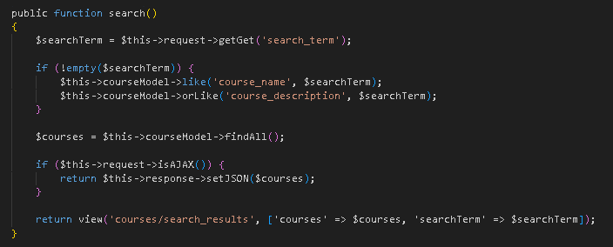

Step 3: Add Search Route
- Open app/Config/Routes.php.
- Add routes for the search functionality:
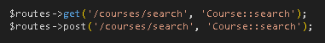

Step 4: Create Search Interface
- Modify your courses view file (app/Views/courses/index.php).
- Add a search form with Bootstrap styling
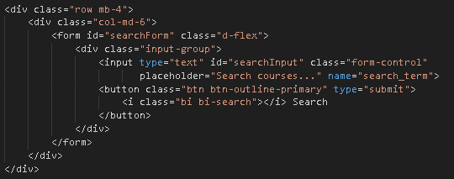

Step 5: Implement Client-Side Filtering with jQuery
- Add jQuery script for instant client-side filtering
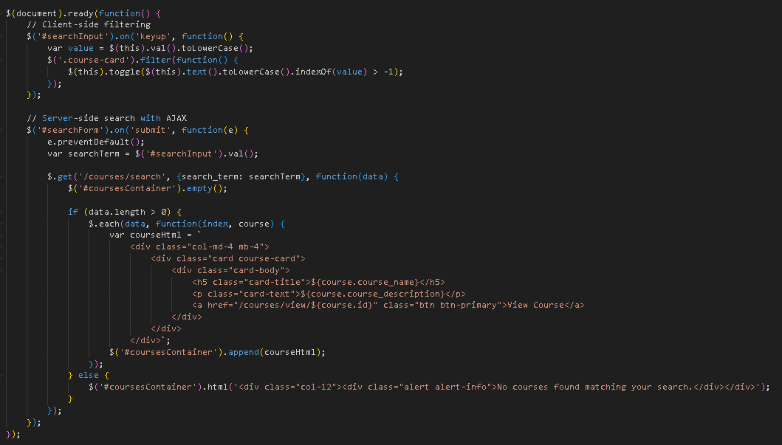

Step 6: Update Courses View Structure
- Modify your courses listing to work with the search functionality
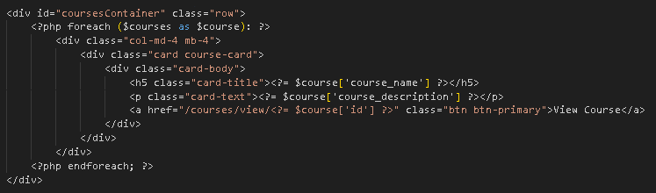
- To simulate real-time updates, you can set an interval to fetch notifications every 60 seconds (optional advanced task).

Step 7: Test the Search Functionality
- Load the courses page in your browser.
- Test the client-side filtering by typing in the search box courses should filter instantly.
- Test the server-side search by submitting the form results should load via AJAX without page refresh.
- Verify that both empty search results and successful searches display appropriate messages.

Step 9: Push to GitHub
- Stage and commit your search functionality
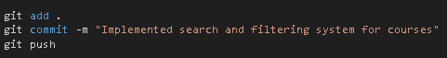

Output / Results
- Screenshot of the courses page with the search interface implemented.
- Screenshot showing filtered courses during client-side search.
- Screenshot of browser Developer Tools Network tab showing AJAX request to server-side search.
- Screenshot of search results displaying when no courses match the search term.
- Screenshot of GitHub repository with the latest commit.

QUESTIONS:
- What are the advantages and limitations of client-side filtering compared to server-side search?

- Despite these advantages, server-side search also has limitations. Every search request requires communication with the server, which can introduce delays and make the response feel slower compared to instant client-side filtering. This approach also increases the server’s workload, especially when many users perform frequent searches. Furthermore, server-side search cannot function without an active internet connection, making it unsuitable for offline use. If not implemented with techniques like AJAX, the user experience may also feel less smooth due to page reloads or slower data updates.

- How does using AJAX for search improve the user experience compared to traditional form submission?

- Using AJAX for search significantly improves the user experience compared to traditional form submission because it allows data to be fetched and updated dynamically without reloading the entire webpage. In a traditional form submission, whenever a user performs a search, the browser sends the request to the server and then reloads or navigates to a new page to display the results. This process can feel slow and disruptive, especially when users need to refine or repeat their search multiple times. The constant page reloads interrupt the user’s workflow, cause delays, and often create a less interactive and modern feel.

- What security considerations should be taken when implementing search functionality with user input?

- When implementing search functionality that accepts user input, security becomes a critical concern because improperly handled input can expose the system to various attacks. One of the most important considerations is protecting the application from injection attacks, particularly SQL injection. Since search features often involve querying a database, any user-provided text must be properly sanitized and handled with prepared statements or parameterized queries. This ensures that attackers cannot manipulate the query by inserting harmful code that could modify, delete, or access sensitive data. Sanitizing and validating user input prevents malicious characters or scripts from influencing how the server processes the search.

Output / Results

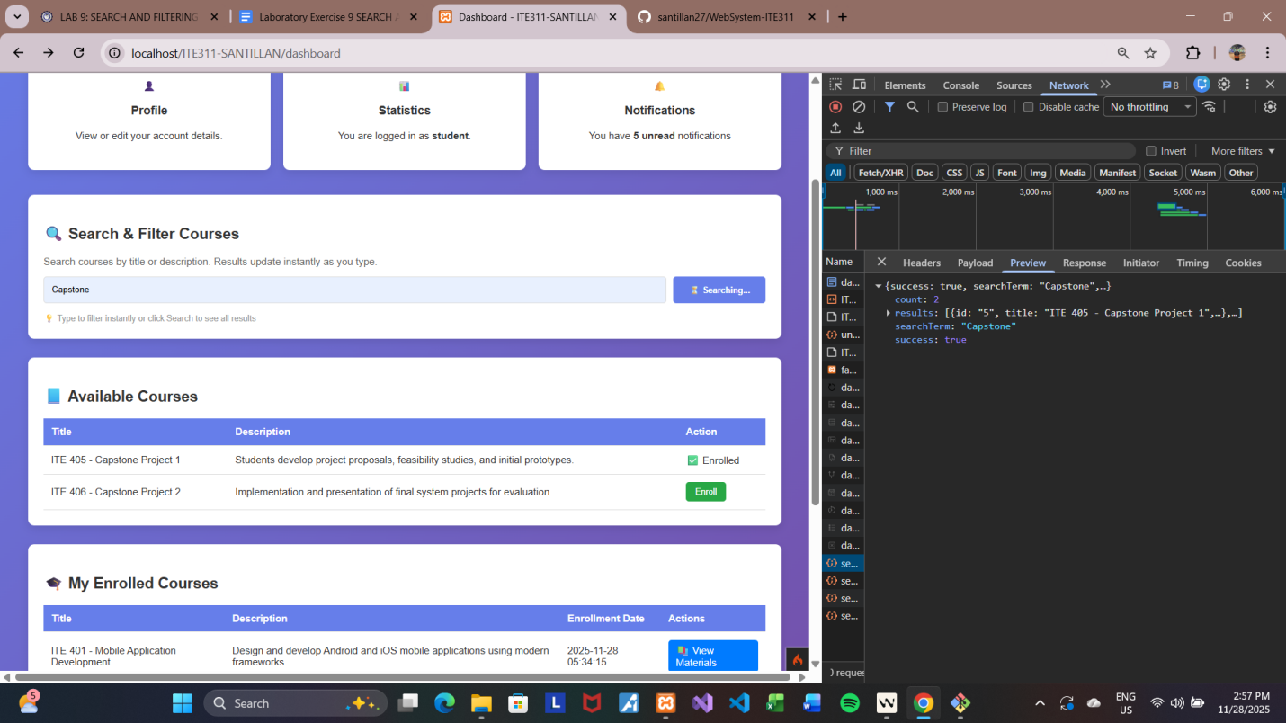

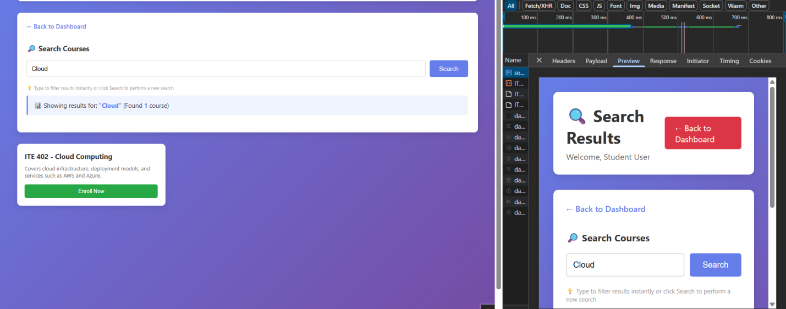

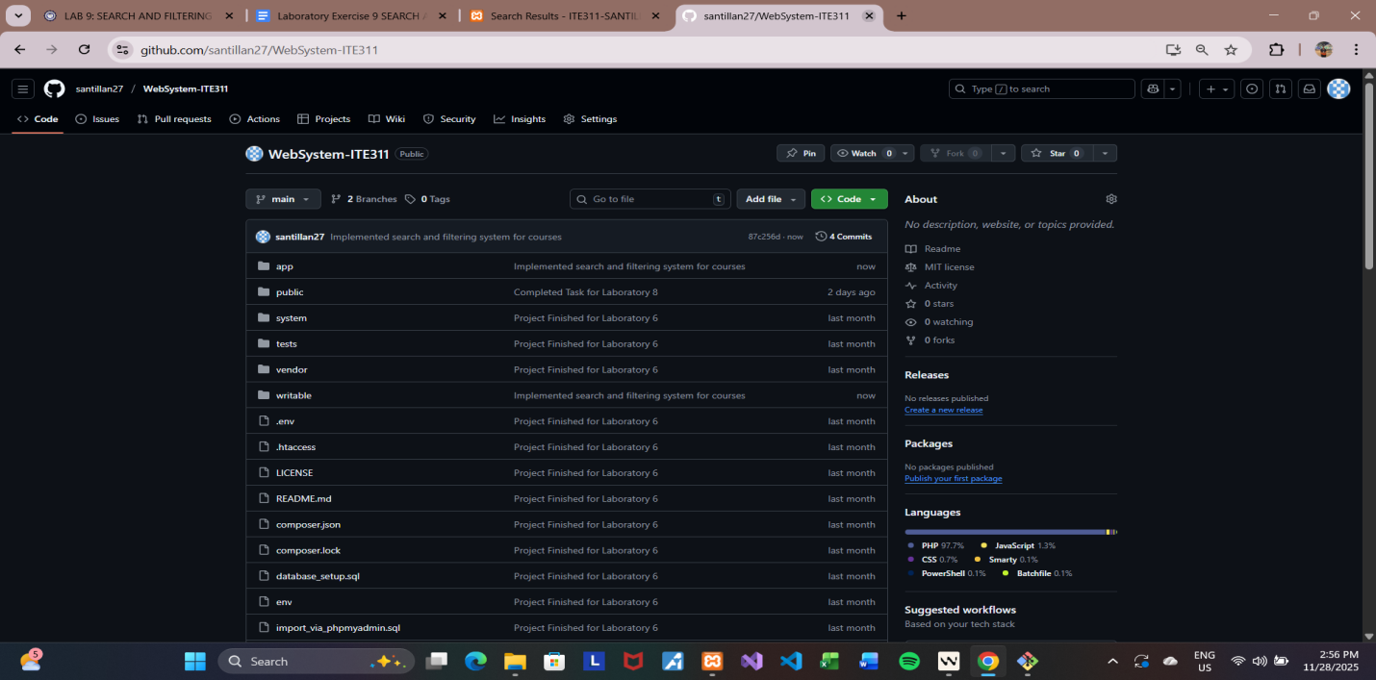

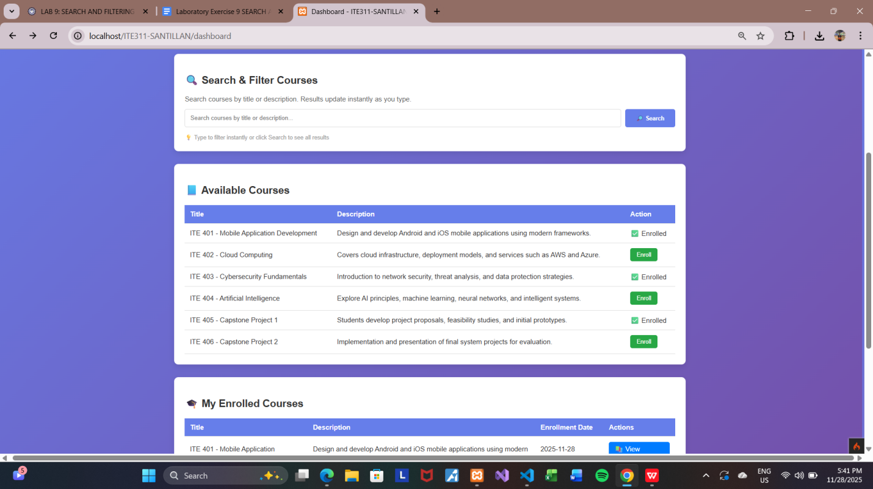
Conclusion

In this laboratory exercise, we successfully explored and implemented a complete search and filtering system using both client-side and server-side approaches. Through client-side filtering with jQuery, we achieved instant, real-time results that enhance user interactivity without requiring communication with the server. Meanwhile, server-side search using CodeIgniter’s Query Builder allowed us to handle larger datasets efficiently, perform secure database queries, and return accurate results through AJAX without reloading the page. Integrating AJAX into the search process improved the overall user experience by making the interface smoother, faster, and more responsive—similar to modern web applications.

This activity also reinforced key concepts such as MVC workflow, proper routing, Bootstrap interface design, and JSON-based data handling. Additionally, it emphasized the importance of security when dealing with user input, including the need to prevent SQL injection, XSS attacks, and misuse of the search endpoint. Overall, Laboratory Exercise 9 provided practical experience in building dynamic, responsive, and secure search functionality—skills essential for developing professional and user-friendly web systems.

