Jhondell Ranises BSIT 3
Web System & Design
Announcement (student)
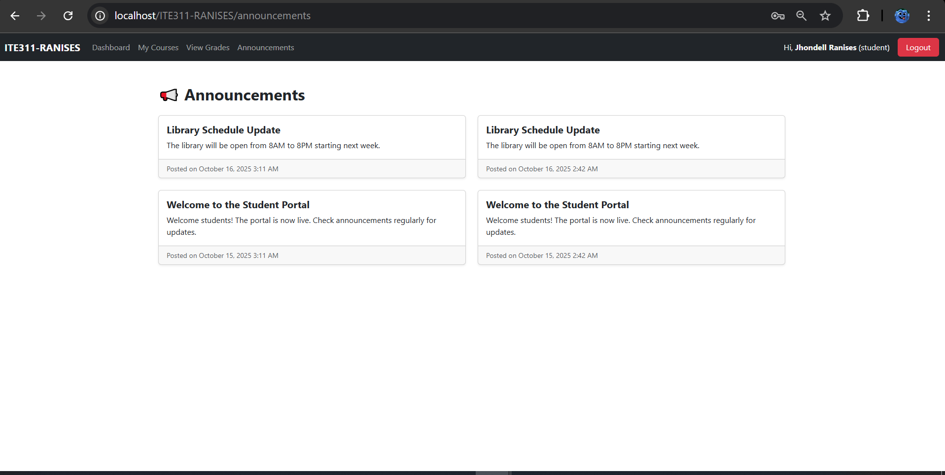
Teacher Dashboard
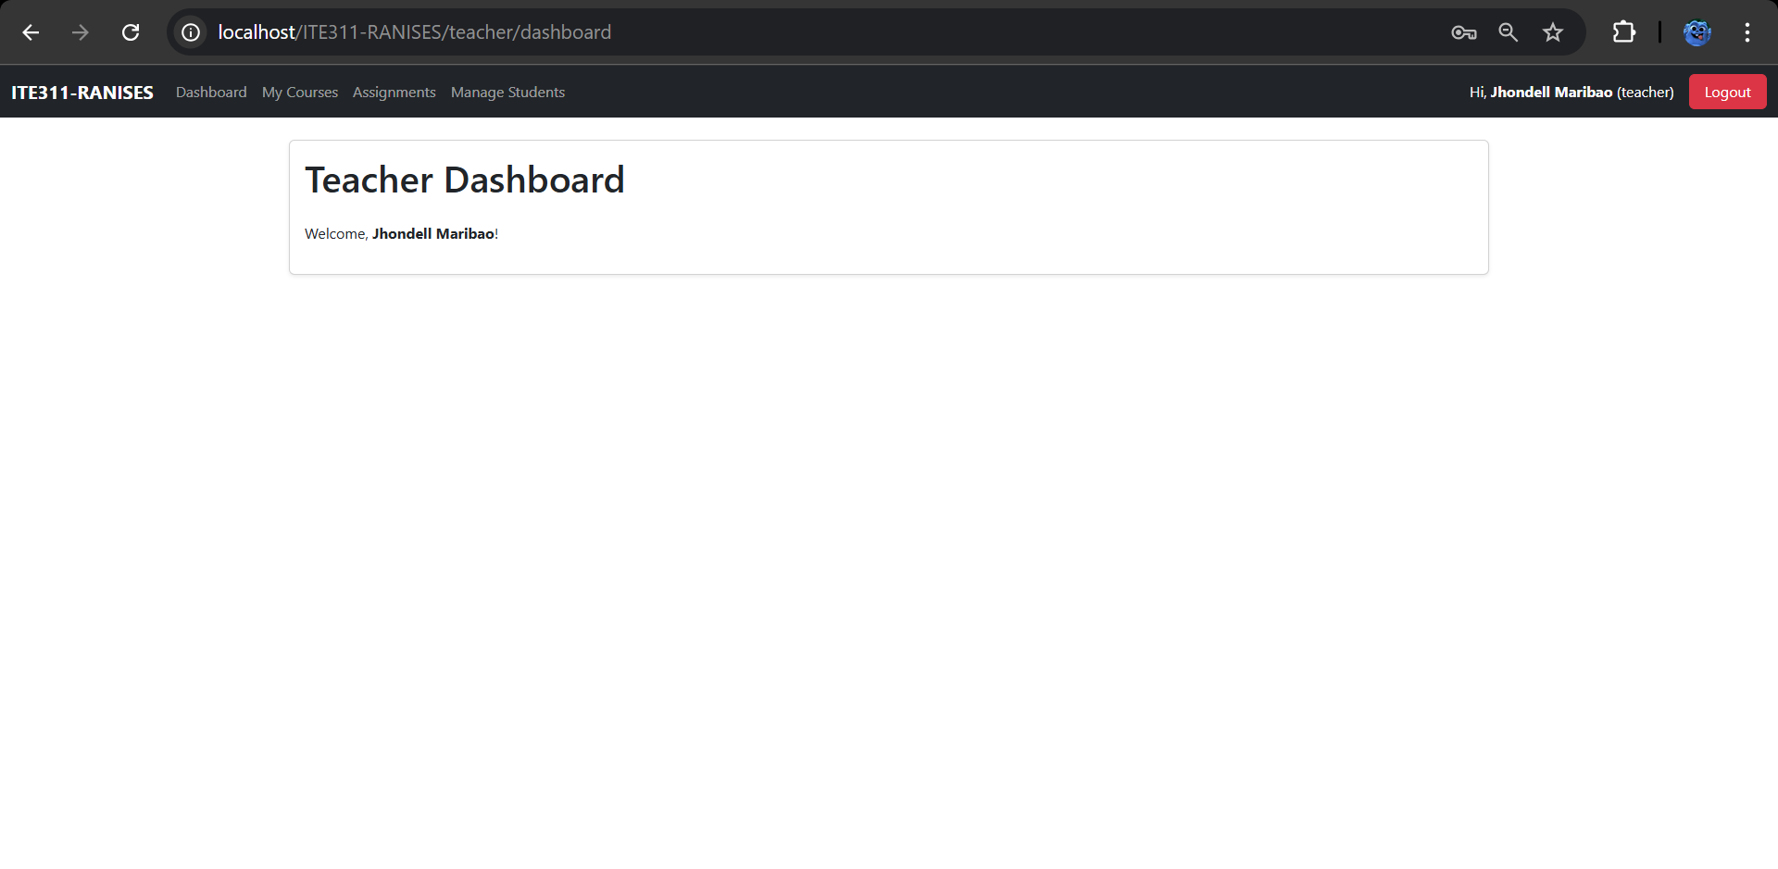
Admin Dashboard
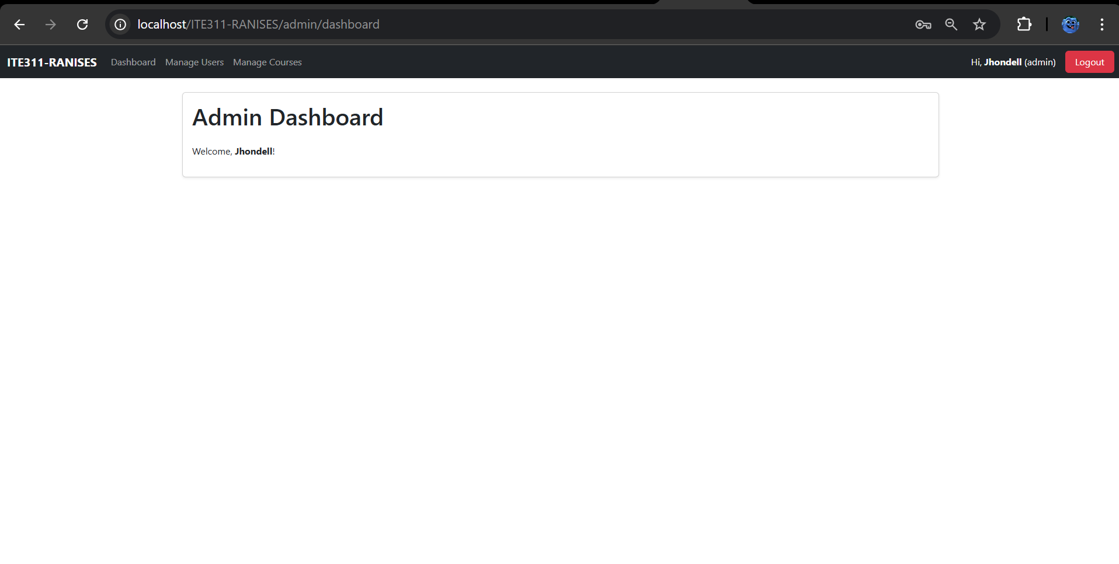
GitHub Commit
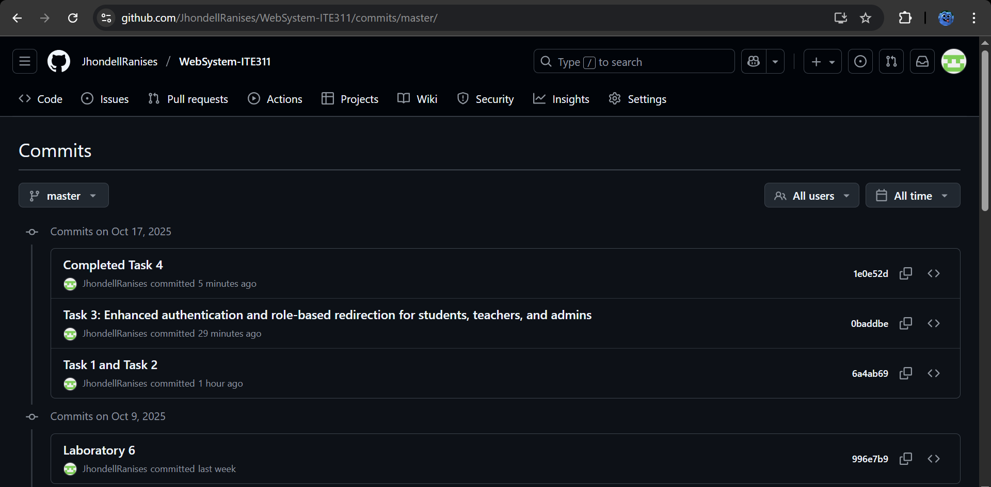
GitHub Link
https://github.com/JhondellRanises/WebSystem-ITE311/commits/master/

