LABORATORY EXERCISE 8

REAL-TIME NOTIFICATIONS WITH JQUERY

Learning Objectives
By the end of this laboratory exercise, students should be able to:
- Implement AJAX functionality using jQuery to fetch data from the server without refreshing the page.
- Create a dynamic notification system that displays real-time updates to the user.
- Update the user interface (UI) based on server-side data, specifically by managing a notification badge.
- Utilize Bootstrap components for styling interactive alerts and badges.
- Manage application state by marking notifications as "read" via an AJAX call.

Prerequisite student experiences and knowledge
Before starting this exercise, students should have:
- Completed Laboratory Exercise 7 (File Uploads for Course Materials).
- A solid understanding of the CodeIgniter MVC structure and database operations.
- Proficiency in writing basic jQuery and JavaScript code.
- Experience with handling jQuery AJAX requests (GET, POST).
- Familiarity with manipulating the DOM with jQuery (e.g., showing/hiding elements, updating text).
- Knowledge of Bootstrap classes for badges and alerts.

Background
A key feature of modern, interactive web applications is the ability to provide real-time feedback and updates to users. Notifications inform users of important events, such as new course enrollments or available materials, without requiring a page reload. jQuery's AJAX methods allow the client-side browser to asynchronously communicate with the server, fetching new data in the background. This data can then be dynamically inserted into the webpage, creating a seamless user experience. This exercise will guide you in building a notification system that displays a badge count in the navigation bar and a dropdown list of alerts, all styled with Bootstrap.

Materials/Resources
- Personal Computer with Internet Access
- XAMPP/WAMP/LAMP server installed
- CodeIgniter Framework (latest version)
- Visual Studio Code or any code editor
- Git and GitHub Account
- Web Browser (Chrome, Firefox, etc.)
Laboratory Activity
Step 1: Database Setup for Notifications
- Create a new migration file for a notifications table.
Run: php spark make: migration CreateNotificationsTable
- Open the new migration file in app/Database/Migrations/.
  - In the up() method, define the table with the following fields:
    - id (primary key, auto-increment)
    - user_id (int, foreign key to users table)
    - message (varchar, e.g., "You have been enrolled in [Course Name]")
    - is_read (tinyint, default 0)
    - created_at (datetime)
- In the down() method, drop the notifications table.
- Run the migration: php spark migrate

Step 2: Create a Notification Model
- Navigate to app/Models/ and create a file named NotificationModel.php.
- Create methods for:
  - getUnreadCount($userId)
    - Fetches the count of unread notifications for a user.
  - getNotificationsForUser($userId)
    - Fetches the latest notifications (e.g., limit 5) for a user.
  - markAsRead($notificationId)
    - Updates a specific notification's is_read field to 1.

Step 3: Update the Base Controller/Layout
- To display the notification badge on all pages, we need to fetch the unread count for the logged-in user and make it available to the main layout.
- In your base controller (or a custom controller that others extend), add logic to load the unread notification count and pass it to the view. Alternatively, you can create a view fragment that uses an AJAX call to get the count (more complex but more efficient).
- For simplicity, modify your main layout file (e.g., app/Views/templates/header.php) to include a placeholder for the notification badge..

Step 4: Create a Notifications Controller and API Endpoints
- Create a controller named Notifications.php in app/Controllers/.
- Add the following methods:
  - get()
    - A method that returns a JSON response containing the current user's unread notification count and list of notifications. This will be called via AJAX.
  - mark_as_read($id)
    - A method that accepts a notification ID via POST and marks it as read. Returns a success/failure JSON response.
- Ensure these routes are added to app/Config/Routes.php:
  - \$routes-\>get('/notifications', 'Notifications::get');
  - \$routes-\>post('/notifications/mark_read/(:num)', 'Notifications::mark_as_read/$1');.

Step 5: Build the Notification UI with jQuery and Bootstrap
- In your main layout file (e.g., header.php), add the Bootstrap-styled notification dropdown to the navigation bar.
- Include a badge (`<span class="badge bg-danger">...</span>`) to show the unread count. Initially, it can be hidden or show 0.
- Create the dropdown menu structure to list notifications. It can initially be empty.
- Write a jQuery function (in a separate .js file or within a `<script>` tag) that uses `$.get()` to call your /notifications endpoint.
- In the AJAX success callback, update the badge count with the returned data. If the count is 0, hide the badge; otherwise, show it.
- Populate the dropdown menu with the list of notifications. Use Bootstrap's alert classes (e.g., `alert alert-info`) for each notification item to improve styling.
- For each notification, add a Mark as Read button/link that triggers another jQuery function.
  - This function should use $.post() to call the /notifications/mark_read/[id] endpoint and, upon success, remove the notification from the list and update the badge count.

Step 6: Trigger Notification Updates
- Call your jQuery notification-fetching function when the page loads (`$(document).ready()`).
- To simulate real-time updates, you can set an interval to fetch notifications every 60 seconds (optional advanced task).

Step 7: Generate Test Notifications
- Temporarily modify your course enrollment logic (from a previous lab) to create a new notification in the notifications table for the student when they enroll in a course.

Step 8: Test the Functionality
- Log in as a student and enroll in a new course (or create a notification manually in the database).
- Refresh the page and verify that the notification badge appears with the correct count.
- Click the notification dropdown and verify the list is populated correctly.
- Click the Mark as Read button on a notification and verify that it disappears from the list and the badge count decreases.

Step 9: Push to GitHub
- Commit and push your completed notification system code to your GitHub repository.

Output / Results
- Screenshot of the `notifications` table schema from your database (phpMyAdmin or equivalent).
- Screenshot of the browser's Developer Tools "Network" tab showing the successful AJAX call to the `/notifications` endpoint and its JSON response.
- Screenshots of the navigation bar:
- With the notification badge visible (showing a count > 0).
- With the dropdown open, showing the list of notifications styled with Bootstrap alerts.
- After marking a notification as read, showing the updated badge and list.

QUESTIONS:
- What are the benefits of using AJAX to load notifications compared to loading them directly with the initial page load in PHP?
- The benifits of using AJAX is that notifications are loaded without the need to refresh the page. It lowers the load on a server, updates data asynchronously, and makes the system more responsive and faster in comparison to loading notifications with the initial load of the PHP page.
- Explain the role of the JSON format in the communication between your jQuery code and the CodeIgniter controller.
- JSON format assists the client and server to exchange data. An AJAX request made by jQuery is tackled by the server controller and it gives a well-lightweight and easy-to-read reply in the form of a JSON. This allows on-the-fly updates to the page, such as loading notifications or messages, without having to reload the page, allowing the communication between the front and the backend to be quicker and more structured.
- In a production environment, what are more scalable alternatives to using a simple database query and page polling (intervals) for real-time notifications?
- Scalable options would be WebSockets, Firebase, or Pusher that would enable realtime communication between the client and the server. These technologies transmit updates immediately without repeating database calls and this reduces the load on the server as well as enhancing the performance in real time notification of the production environment.

Output / Results
Screenshot of the browser's Developer Tools "Network" tab showing the successful AJAX call to the `/notifications` endpoint and its JSON response.
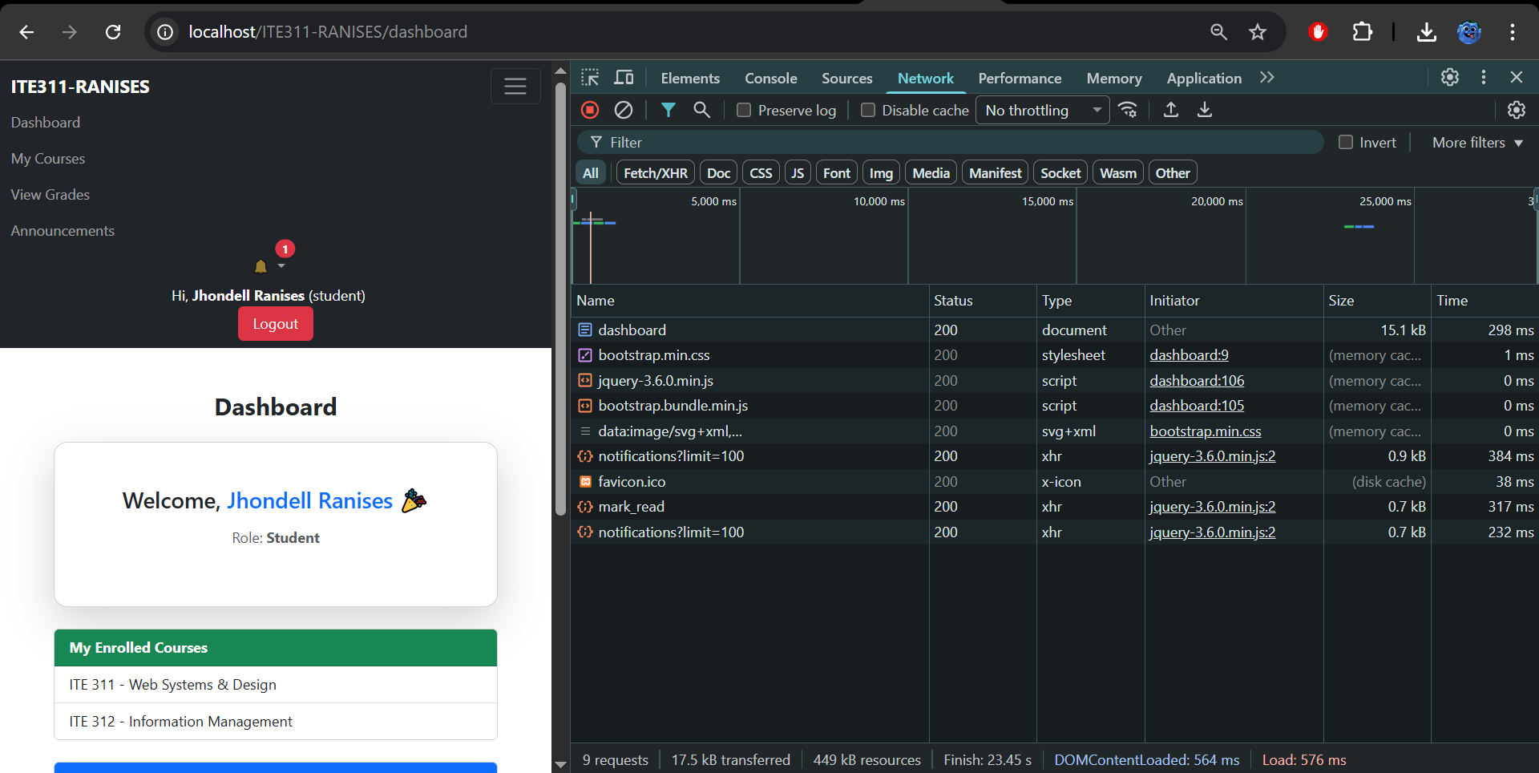
Screenshots of the navigation bar:
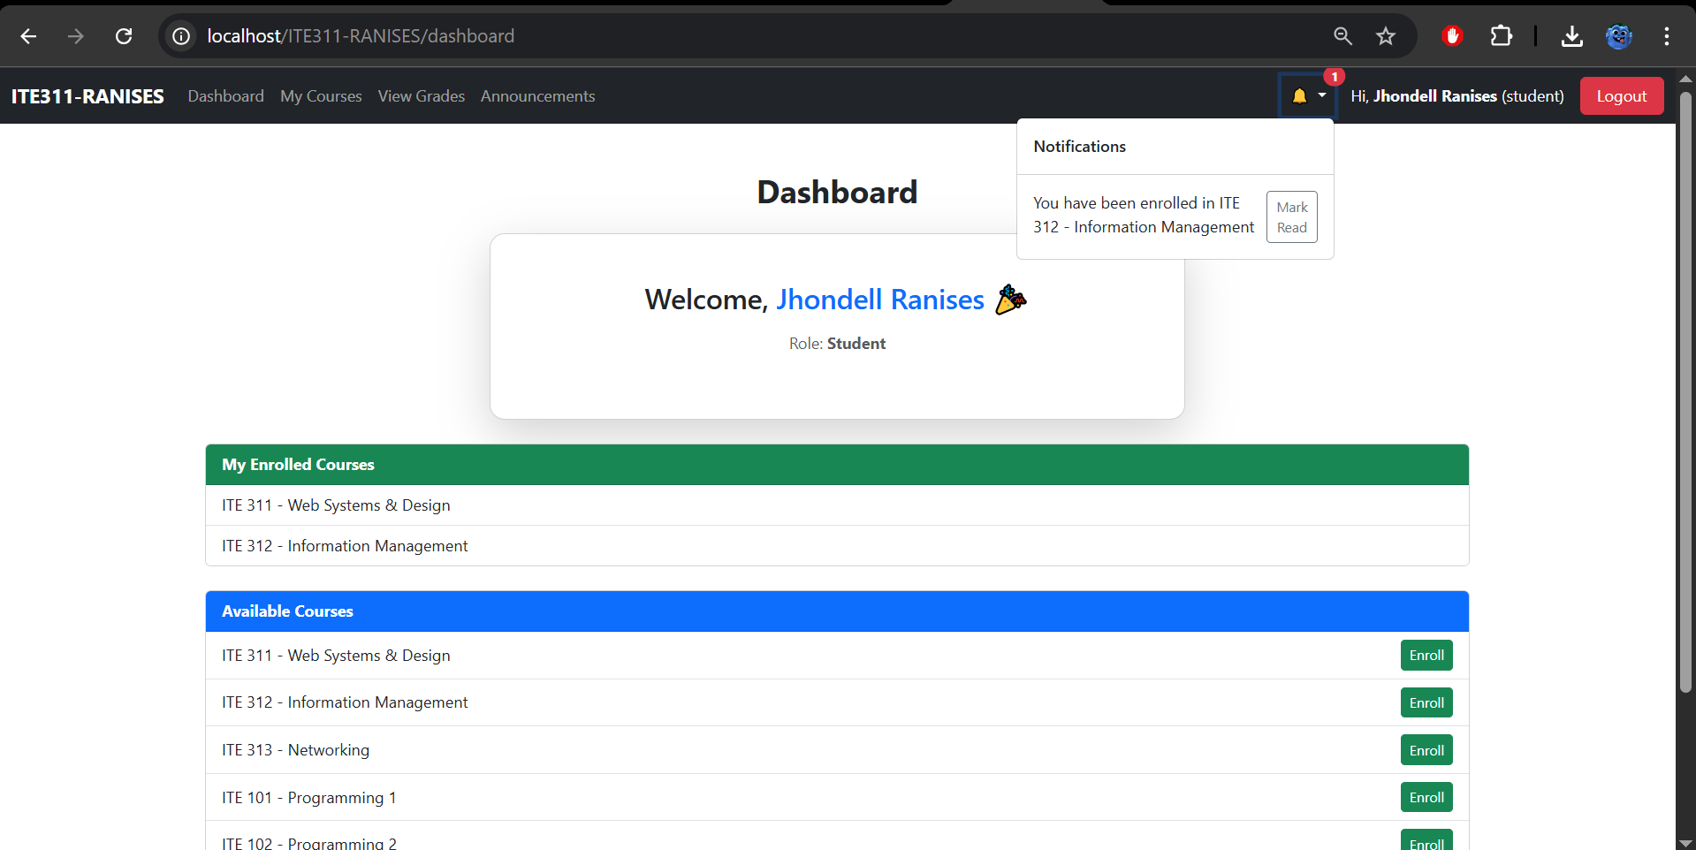

With the notification badge visible (showing a count > 0).
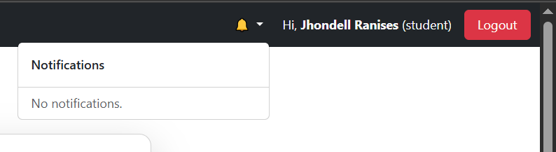
With the dropdown open, showing the list of notifications styled with Bootstrap alerts.
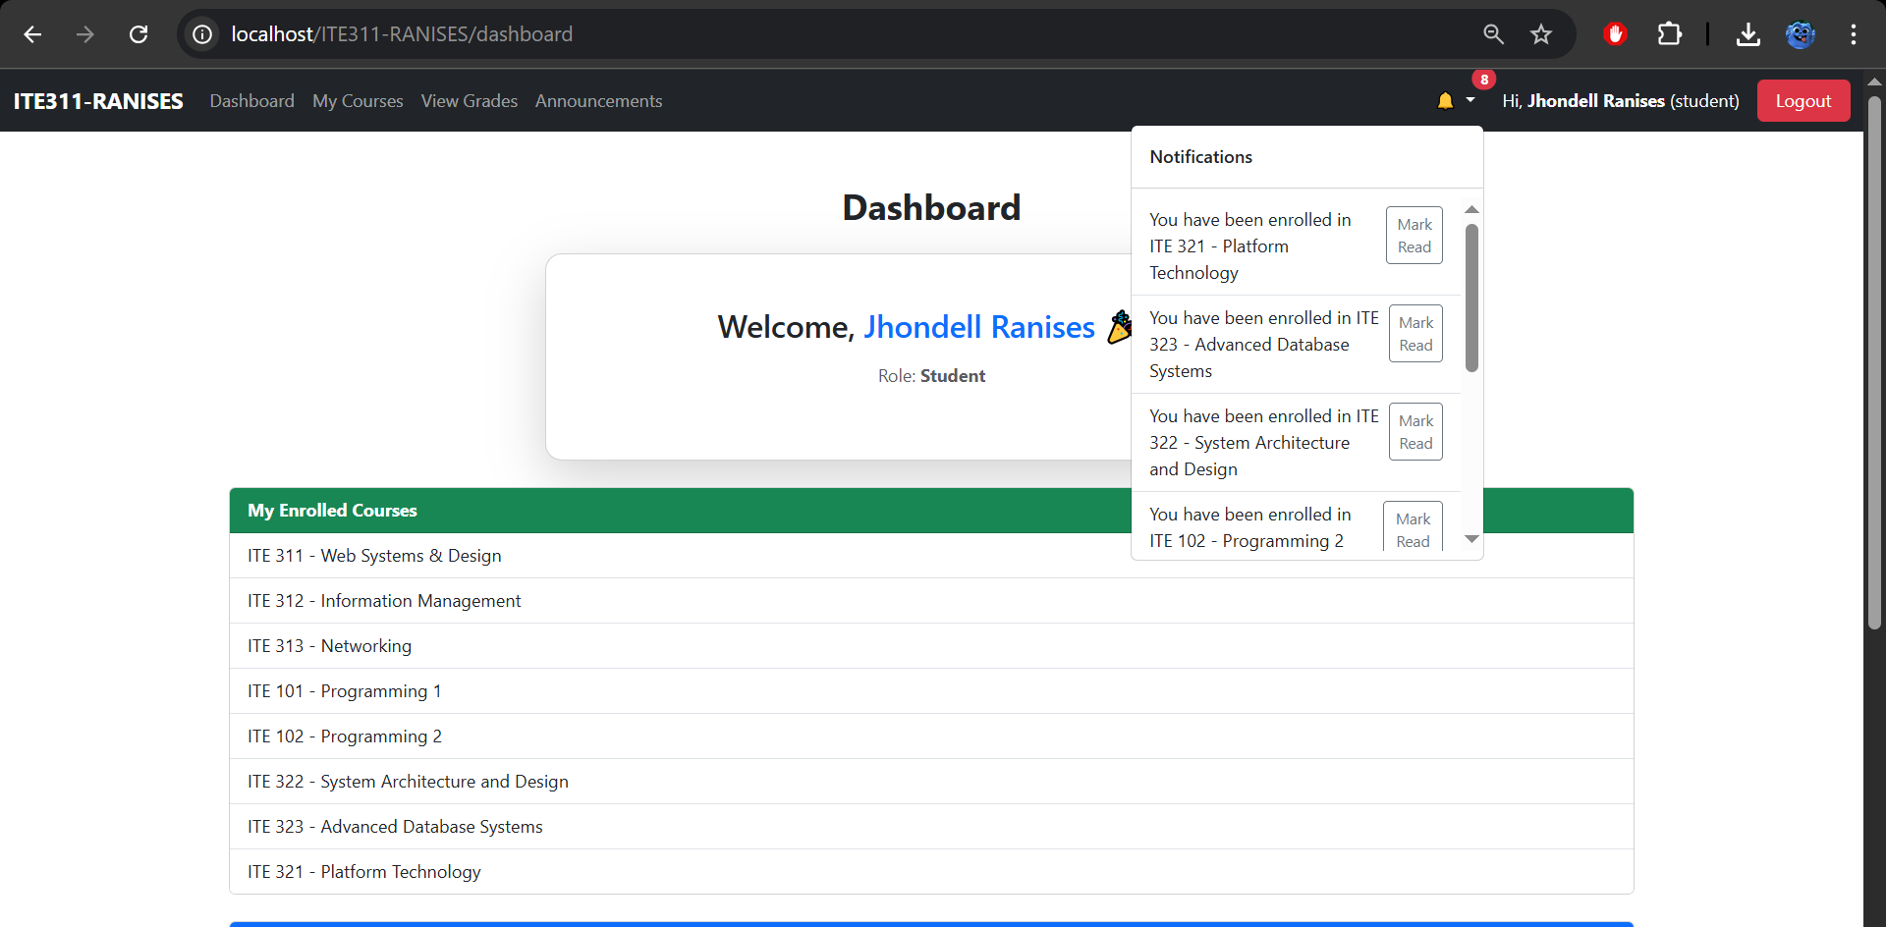After marking a notification as read, showing the updated badge and list.
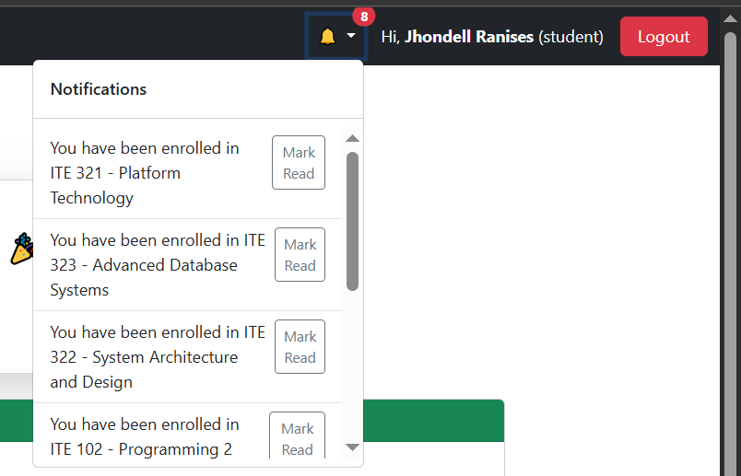
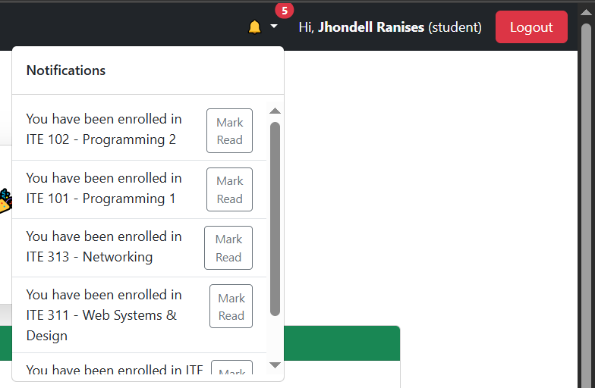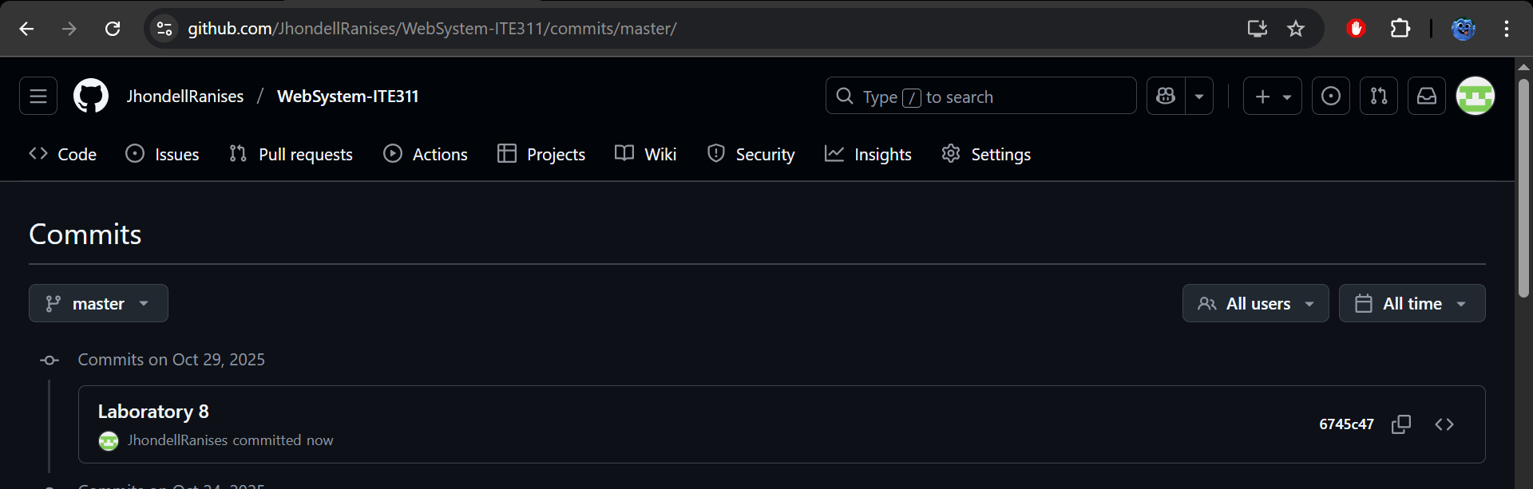

Conclusion
In this laboratory exercise, I learned how to use jQuery and AJAX to create real-time notifications without reloading the page. I also understood how JSON helps exchange data between the client and server, making the system faster, interactive, and more efficient for a better user experience.

