Nama : Jhoner Lou

NIM : 2702353272

1. Home page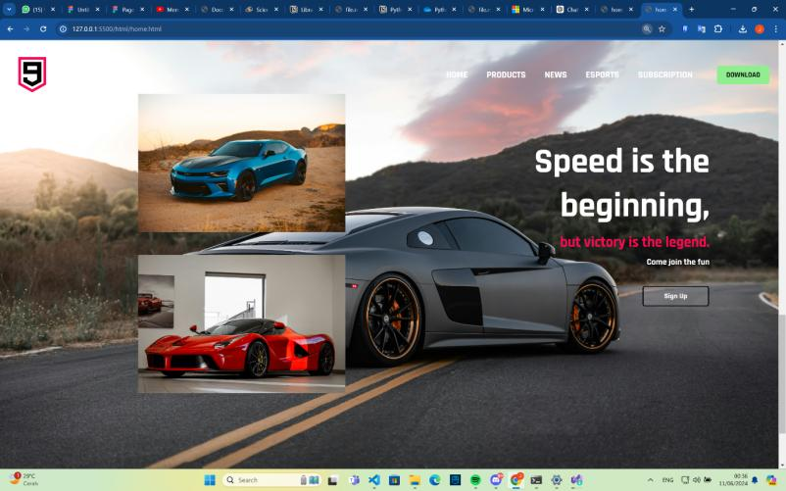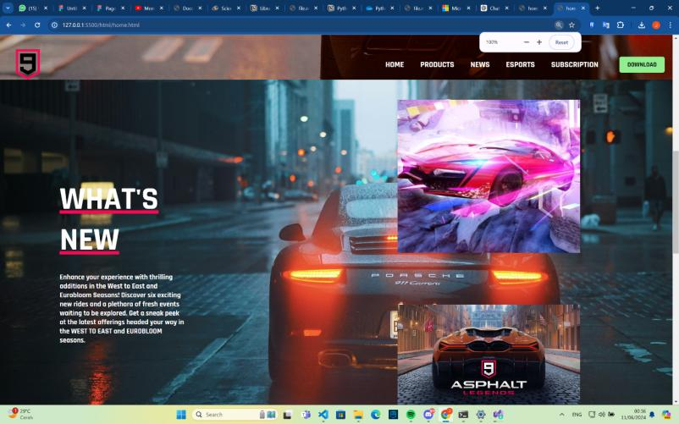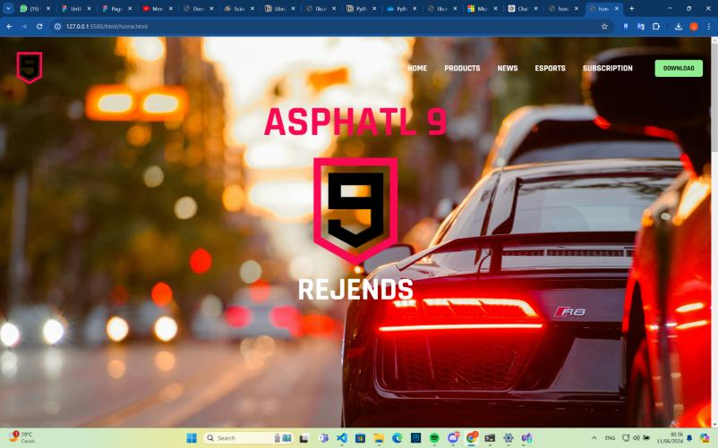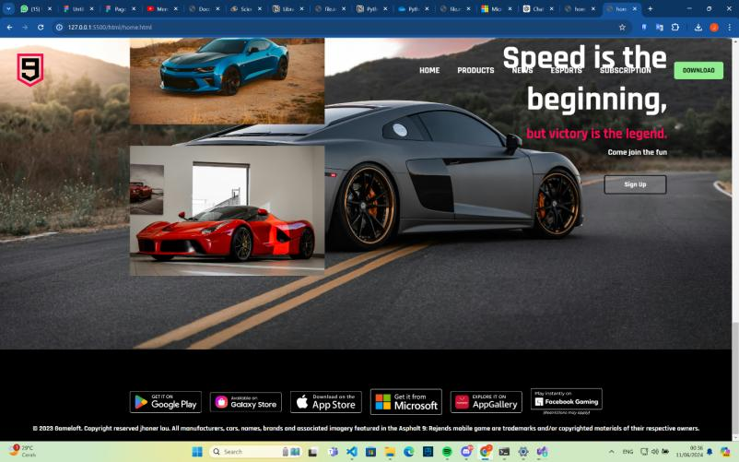

Ini adalah halaman bagian homepage yang dimana user dapat melihat halaman awal dari website dan juga perkenalan untuk website.

2. Product page

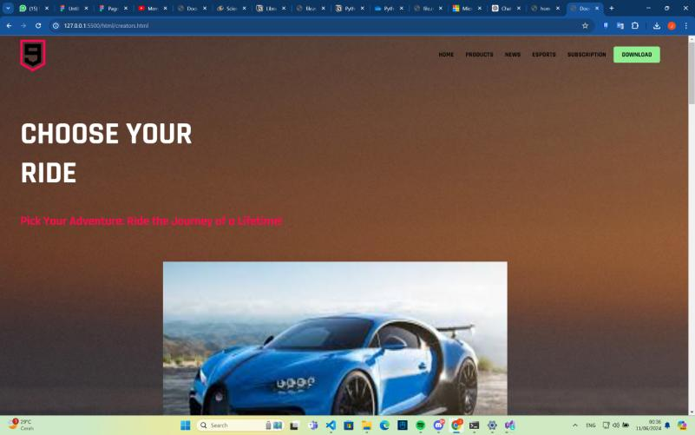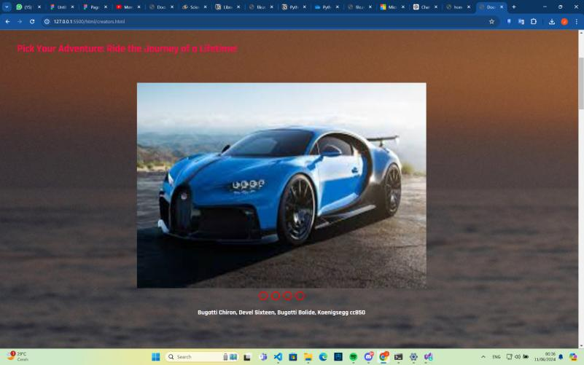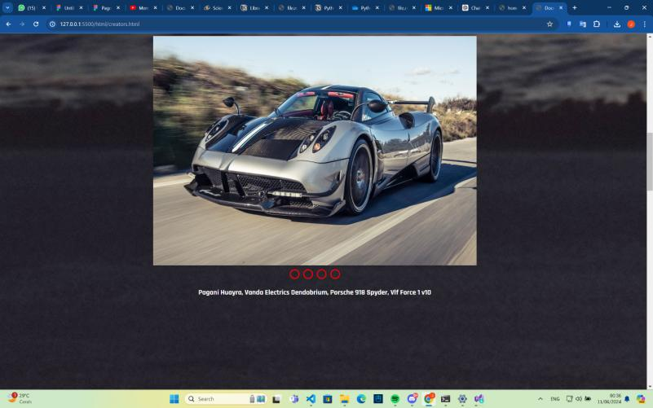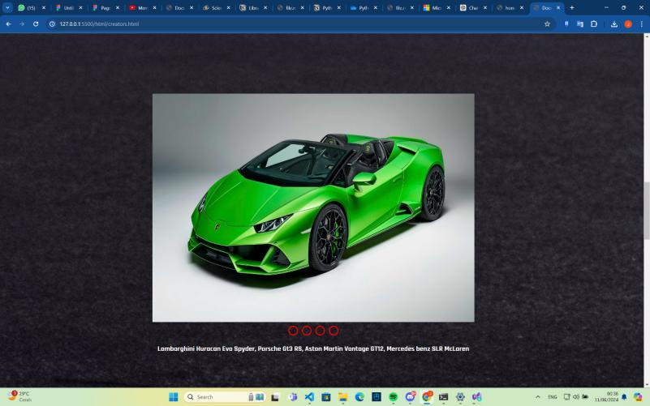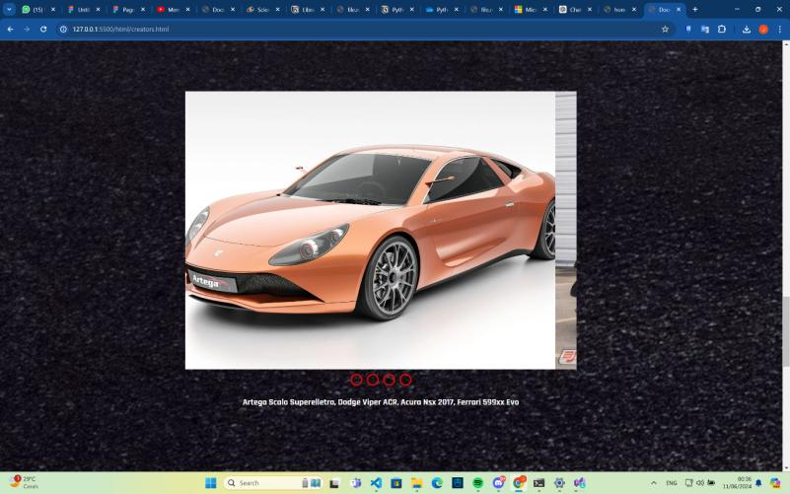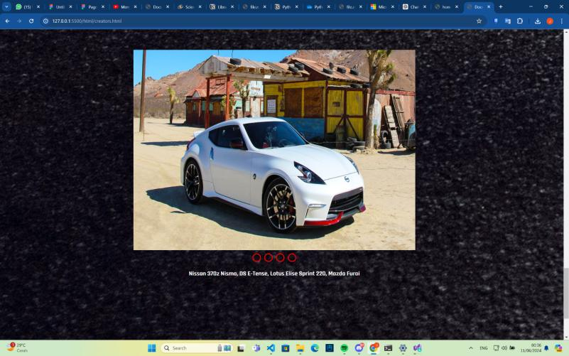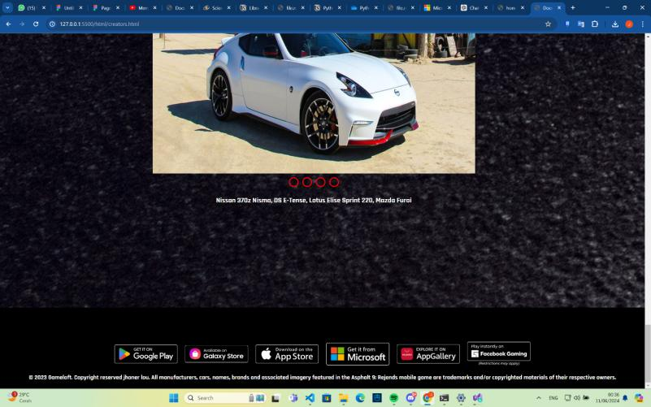

DIsini adalah halaman website dimana user dapat melihat kendaraan yang tersedia dalam website dan gambar-gambarnya

3. News page

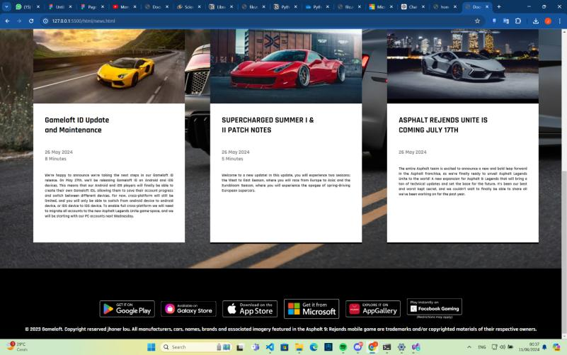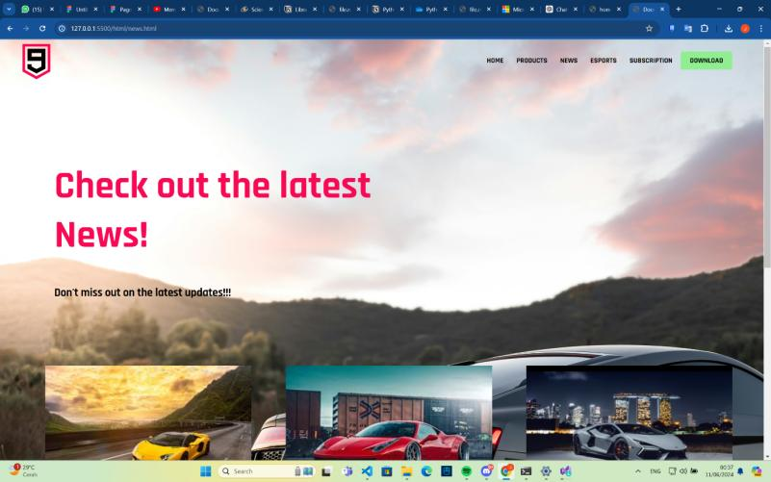

Disini adalah halaman dimana user dapat melihat berita dan juga update terbaru dari website tersebut

4. Esports page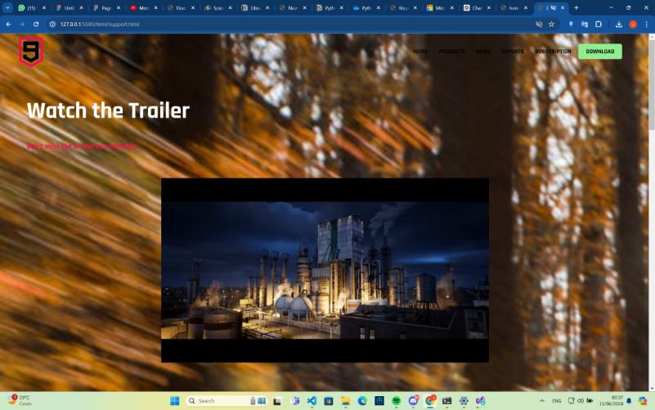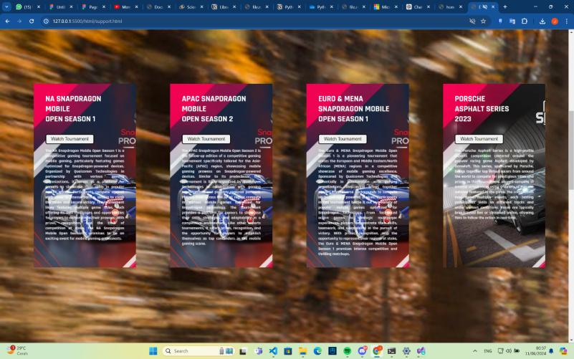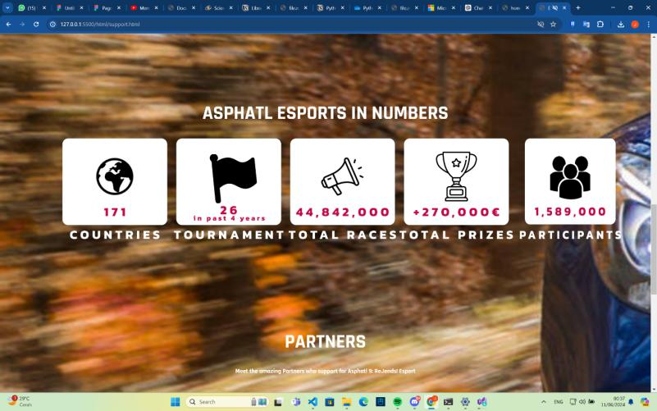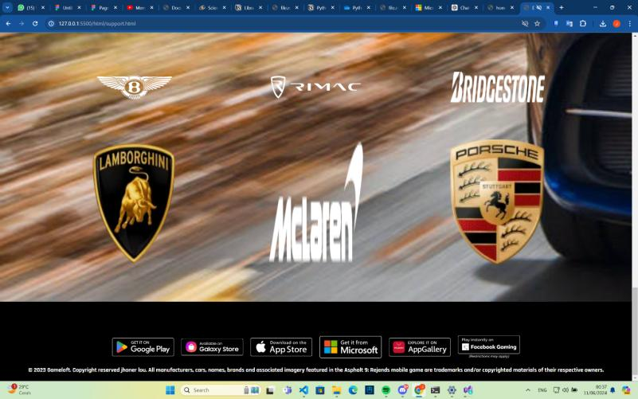

Disini adalah halaman dimana user dapat melihat informasi tentang turnamen yang sedang berlangsung, jumlah-jumlah turnamen dan juga sponsor-sponsor dari website tersebut

5. subscription page

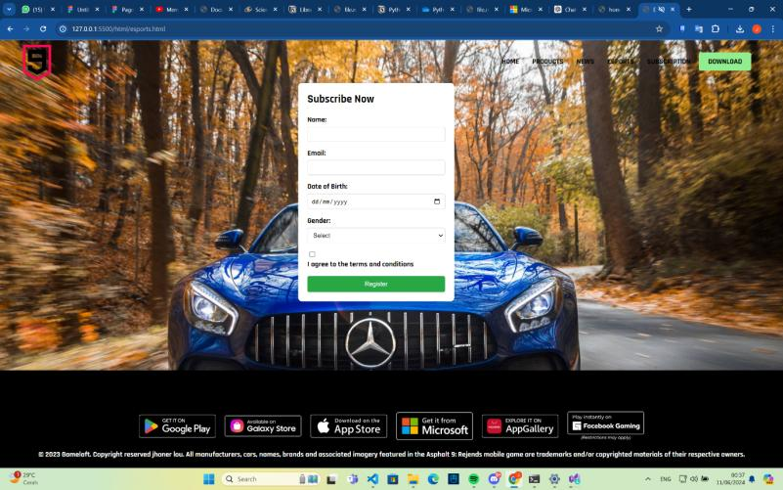

Disini adalah halaman dimana user dalam melakukan registrasi untuk menjadi subscriber pada website tersebut.

Assets:



https://images.unsplash.com/photo-1471479917193-f00955256257?w=600&auto=format&fit=crop&q=60&ixlib=rb-4.0.3&ixid=M3wxMjA3fDB8MHxzZWFyY2h8MzR8fGNhcnxlbnwwfHwwfHx8MA%3D%3D

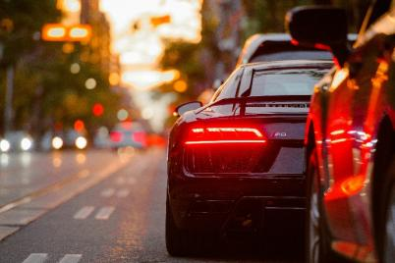

https://unsplash.com/photos/black-audi-r8-parked-beside-road-aiwuLjLPFnU

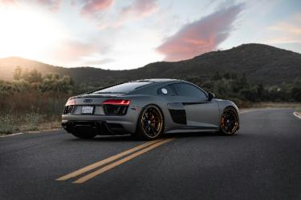

<https://unsplash.com/photos/black-bmw-m-3-on-road-during-daytime-d1Jum1vVLew>

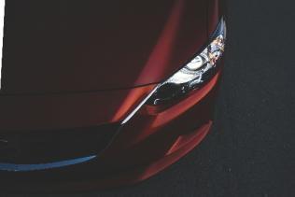

<https://unsplash.com/photos/red-vehicle-headlight-EVk5QOg-8j4>

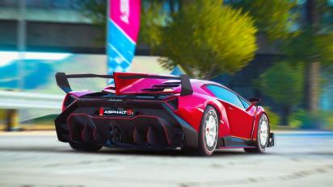

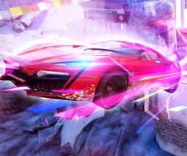





<https://www.google.com/imgres?q=asphalt%209&imgurl=https%3A%2F%2Fmkt-web.gameloft.com%2Fstatic%2F1ddc4483aed7158c41b078a7ea77c43f.jpg&imgrefurl=https%3A%2F%2Fmkt-web.gameloft.com%2Fen%2Fgame%2Fasphalt-9&docid=_K3T62fXX7MWIM&tbnid=6w_lbblh2BpuGM&vet=12ahUKEwj75IP-5tGGAxWrT2wGHYG-BAAQM3oECF0QAA..i&w=1024&h=768&hcb=2&ved=2ahUKEwj75IP-5tGGAxWrT2wGHYG-BAAQM3oECF0QAA>

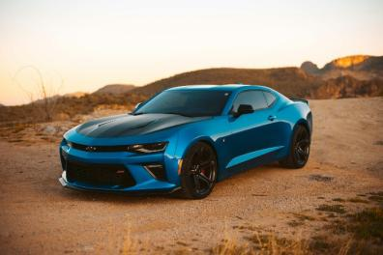

https://www.businessmole.com/exploring-the-chevrolet-camaro-a-muscle-car-legend/





<https://discord.com/channels/@me/1245307304622948405/1245307603559649290>

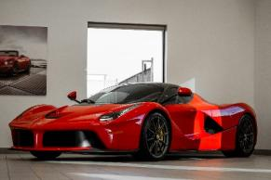

<https://www.peakpx.com/en/hd-wallpaper-desktop-fgntu>



<https://www.google.com/imgres?q=car%204k&imgurl=https%3A%2F%2Fimages3.alphacoders.com%2F133%2F1335169.png&imgrefurl=https%3A%2F%2Fwall.alphacoders.com%2Fbig.php%3Fi%3D1335169&docid=mjwc_ePTO8Vf1M&tbnid=bdv5Rejg7aiQ1M&vet=12ahUKEwjsx4bu5NGGAxV3TmwGHXvcDaQQM3oFCIEBEAA..i&w=5376&h=3072&hcb=2&ved=2ahUKEwjsx4bu5NGGAxV3TmwGHXvcDaQQM3oFCIEBEAA>

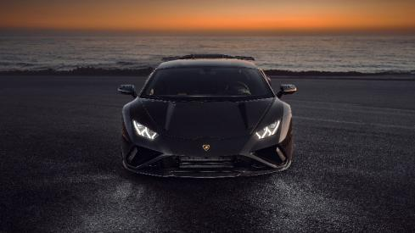

<https://www.google.com/imgres?q=car%204k&imgurl=https%3A%2F%2Fwww.hdwallpapers.in%2Fdownload%2Flamborghini_huracan_evo_sport_black_car_4k_hd_cars-3840x2160.jpg&imgrefurl=https%3A%2F%2Fwww.hdwallpapers.in%2Flamborghini_huracan_evo_sport_black_car_4k_hd_cars-wallpapers.html&docid=eEtWCs6q5W4EhM&tbnid=V8HoyagAAi8UJM&vet=12ahUKEwjsx4bu5NGGAxV3TmwGHXvcDaQQM3oECGkQAA..i&w=3840&h=2160&hcb=2&ved=2ahUKEwjsx4bu5NGGAxV3TmwGHXvcDaQQM3oECGkQAA>

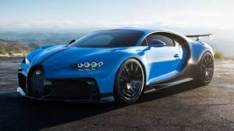

<https://www.google.com/imgres?q=bugatti%20chiron&imgurl=https%3A%2F%2Fcdn.motor1.com%2Fimages%2Fmgl%2FxW8K2%2Fs3%2Fbugatti-chiron-pur-sport.jpg&imgrefurl=https%3A%2F%2Fid.motor1.com%2Fnews%2F455285%2Fbugatti-chiron-pur-sport-boros%2F&docid=gg0A0DdMU9_nTM&tbnid=sNjMnRiNkk73hM&vet=12ahUKEwjcwMms6NGGAxUKbWwGHTJzDEkQM3oECBcQAA..i&w=1280&h=720&hcb=2&ved=2ahUKEwjcwMms6NGGAxUKbWwGHTJzDEkQM3oECBcQAA>

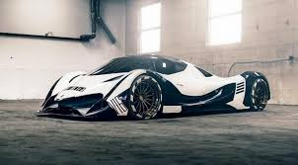

<https://www.google.com/imgres?q=devel%20sixteen&imgurl=https%3A%2F%2Fwww.carscoops.com%2Fwp-content%2Fuploads%2F2018%2F10%2F2535dfae-devel-sixteen--1024x555.jpg&imgrefurl=https%3A%2F%2Fwww.carscoops.com%2F2018%2F10%2Funsurprisingly-insane-devel-sixteen-put-hold%2F&docid=V7E6YQ9nNDZXgM&tbnid=TtGT5zT_peZNLM&vet=12ahUKEwjN8c616NGGAxUnXGwGHS-ZC4MQM3oECFQQAA..i&w=1024&h=555&hcb=2&ved=2ahUKEwjN8c616NGGAxUnXGwGHS-ZC4MQM3oECFQQAA>

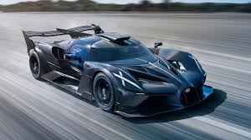

<https://driven.site/news/the-bugatti-bolide-offers-blistering-f1-pace>

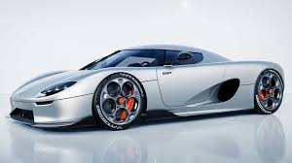

<https://www.gridoto.com/read/223453625/koenigsegg-rilis-mobil-baru-koenigsegg-cc850-langsung-sold-out>

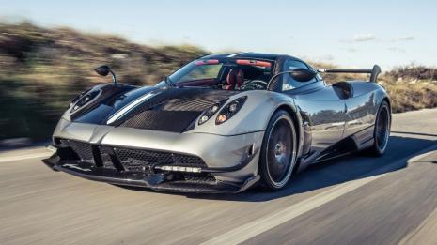

<https://www.google.com/imgres?q=pagani%20huayra&imgurl=https%3A%2F%2Fwww.topgear.com%2Fsites%2Fdefault%2Ffiles%2Fcars-car%2Fimage%2F2016%2F08%2Frh_huayrabc-67.jpg&imgrefurl=https%3A%2F%2Fwww.topgear.com%2Fcar-reviews%2Fpagani%2Fhuayra&docid=1omKxCwXLhpfQM&tbnid=xKh5kSQOHMqE_M&vet=12ahUKEwiU77mC6dGGAxUt3TgGHboyBeAQM3oECGQQAA..i&w=1959&h=1102&hcb=2&ved=2ahUKEwiU77mC6dGGAxUt3TgGHboyBeAQM3oECGQQAA>

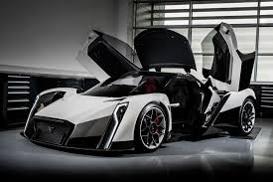

<https://www.google.com/imgres?q=vanda%20electrics%20dendrobium&imgurl=https%3A%2F%2Fcar-images.bauersecure.com%2Fwp-images%2F1892%2Fvanda_dendrobium_0001.jpg&imgrefurl=https%3A%2F%2Fwww.carmagazine.co.uk%2Fcar-news%2Fmotor-shows-events%2Fgeneva%2F2017%2Fvanda-electrics-dendrobium-electric-hypercar-revealed-in-pictures%2F&docid=BaHJ1nU4ofMZvM&tbnid=UD_lKjvk_09wvM&vet=12ahUKEwip4eqS6dGGAxX-xDgGHfBRB54QM3oECBMQAA..i&w=1700&h=1132&hcb=2&ved=2ahUKEwip4eqS6dGGAxX-xDgGHfBRB54QM3oECBMQAA>

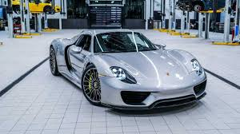

<https://www.google.com/imgres?q=porsche%20918%20spyder&imgurl=https%3A%2F%2Fcdn.motor1.com%2Fimages%2Fmgl%2Fg40OZP%2Fs3%2F2015-porsche-918-spyder.jpg&imgrefurl=https%3A%2F%2Fid.motor1.com%2Fnews%2F556934%2Fporsche-spyder-mildhybrid-seperti-baru%2F&docid=9VIPMHdteXT1eM&tbnid=EDqyepoUUTVoYM&vet=12ahUKEwiuz4bm6NGGAxW_2TgGHY4VBtEQM3oECHsQAA..i&w=1280&h=720&hcb=2&ved=2ahUKEwiuz4bm6NGGAxW_2TgGHY4VBtEQM3oECHsQAA>

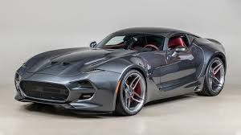

<https://www.google.com/imgres?q=vlf%20force%201%20v10&imgurl=https%3A%2F%2Fimboldn.com%2Fwp-content%2Fuploads%2F2020%2F02%2F2018-VLF-Force-1-V10-main.jpg&imgrefurl=https%3A%2F%2Fimboldn.com%2F2018-vlf-force-1-v10%2F&docid=IpqdvBdPL-6GhM&tbnid=KF8mXUsXws-G2M&vet=12ahUKEwjkkeTL6dGGAxUXTWwGHe6jCA8QM3oECHkQAA..i&w=1600&h=900&hcb=2&ved=2ahUKEwjkkeTL6dGGAxUXTWwGHe6jCA8QM3oECHkQAA>

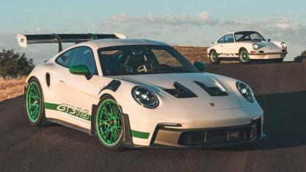

<https://www.google.com/imgres?q=porsche%20gt3%20rs&imgurl=https%3A%2F%2Fcdn.motor1.com%2Fimages%2Fmgl%2FzxxMzK%2Fs3%2F2023-porsche-911-gt3-rs.jpg&imgrefurl=https%3A%2F%2Fwww.motor1.com%2Fnews%2F604945%2F2023-porsche-911-gt3-rs%2F&docid=qj7l8LZ26O4QVM&tbnid=JyMA4Fpg8QaNpM&vet=12ahUKEwizm9jX6dGGAxVgU2wGHWCcF0gQM3oECGwQAA..i&w=1280&h=720&hcb=2&ved=2ahUKEwizm9jX6dGGAxVgU2wGHWCcF0gQM3oECGwQAA>

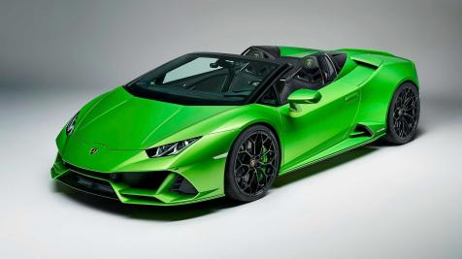

<https://www.google.com/imgres?q=lamborghini%20huracan%20evo%20spyder&imgurl=https%3A%2F%2Fwww.lamborghiniwashington.com%2Fstatic%2Fdealer-14437%2FModel_pages%2Fevo_spyder_exterior_front.webp&imgrefurl=https%3A%2F%2Fwww.lamborghiniwashington.com%2Flamborghini-huracan-evo-spyder-sterling-va&docid=kNHFK7RDtExU9M&tbnid=bWLizl_7QbqQ7M&vet=12ahUKEwi4nevp6dGGAxWaTmwGHcKkCRIQM3oECBkQAA..i&w=1481&h=467&hcb=2&ved=2ahUKEwi4nevp6dGGAxWaTmwGHcKkCRIQM3oECBkQAA>

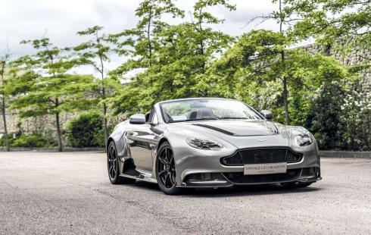

<https://www.google.com/url?sa=i&url=https%3A%2F%2Fcarvaganza.com%2Faston-martin-vantage-gt12-roadster-ultra-limited-edition%2F&psig=AOvVaw03e4_xWYyEZ1tcOB7uc81n&ust=1718136166468000&source=images&cd=vfe&opi=89978449&ved=0CBIQjRxqFwoTCOCD-JLq0YYDFQAAAAAdAAAAABAE>

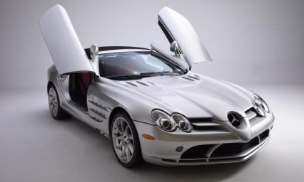

<https://www.google.com/imgres?q=mercedez%20benz%20slr%20mclaren&imgurl=https%3A%2F%2Fnewportcarmuseum.org%2Fwp-content%2Fuploads%2F2023%2F04%2F25_Mercedes-McLaren-2-silver82-scaled-1000x600.jpg&imgrefurl=https%3A%2F%2Fnewportcarmuseum.org%2F2008-mercedes-benz-slr-mclaren%2F&docid=-WhDH0DmmVtiyM&tbnid=Dz3jUwCcWeu0GM&vet=12ahUKEwjRwKmb6tGGAxV1a2wGHYymCKsQM3oECEcQAA..i&w=1000&h=600&hcb=2&ved=2ahUKEwjRwKmb6tGGAxV1a2wGHYymCKsQM3oECEcQAA>

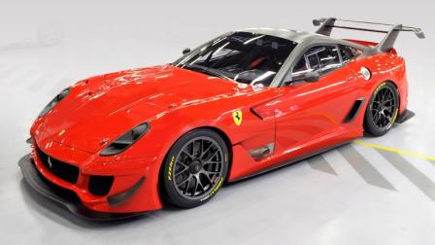

<https://www.google.com/imgres?q=ferrari%20599xx%20evo&imgurl=https%3A%2F%2Fcimg2.ibsrv.net%2Fibimg%2Fhgm%2F1600x900-1%2F100%2F392%2Fferrari-599xx-evo-to-be-auctioned-off-for-italys-2012-earthquake-victims_100392494.jpg&imgrefurl=https%3A%2F%2Fwww.motorauthority.com%2Fnews%2F1076754_ferrari-reveals-599xx-evo-and-other-items-being-auctioned-for-earthquake-victims&docid=yzEtceHqFuUQTM&tbnid=FIMqrlpJx_iinM&vet=12ahUKEwi1oJer6tGGAxXCbmwGHSyHDzkQM3oECHAQAA..i&w=1600&h=900&hcb=2&ved=2ahUKEwi1oJer6tGGAxXCbmwGHSyHDzkQM3oECHAQAA>



<https://www.google.com/imgres?q=acura%20nsx%202017&imgurl=https%3A%2F%2Fcdn.motor1.com%2Fimages%2Fmgl%2FEO9zv%2Fs1%2F4x3%2F2017-acura-nsx.webp&imgrefurl=https%3A%2F%2Fwww.motor1.com%2Freviews%2F62927%2Ffirst-drive-2017-acura-nsx%2F&docid=O0JNkTf2sH_wWM&tbnid=Rbj1L3remPBTuM&vet=12ahUKEwjJrfTS6tGGAxWvfGwGHSHZDlQQM3oECHAQAA..i&w=1440&h=1080&hcb=2&ved=2ahUKEwjJrfTS6tGGAxWvfGwGHSHZDlQQM3oECHAQAA>

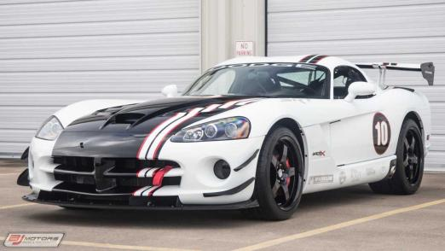

<https://www.google.com/imgres?q=dodge%20viper%20acr&imgurl=https%3A%2F%2Fcdn.motor1.com%2Fimages%2Fmgl%2FP1lkW%2Fs3%2F2010-dodge-viper-acr-x-for-sale.jpg&imgrefurl=https%3A%2F%2Fwww.motor1.com%2Fnews%2F406808%2Fdodge-viper-acr-x-for-sale%2F&docid=PvZRcPXAPcumjM&tbnid=dp20UTC17HkfAM&vet=12ahUKEwjMuKXf6tGGAxWEfGwGHfg9DEoQM3oECE0QAA..i&w=1280&h=720&hcb=2&ved=2ahUKEwjMuKXf6tGGAxWEfGwGHfg9DEoQM3oECE0QAA>



<https://www.google.com/imgres?q=artega%20scalo&imgurl=https%3A%2F%2Fcdn.motor1.com%2Fimages%2Fmgl%2F7VQQW%2Fs1%2F4x3%2F2017-artega-scalo-superelletra.webp&imgrefurl=https%3A%2F%2Fuk.motor1.com%2Fnews%2F138191%2Fartega-scalo-superelletra-geneva-debut%2F&docid=XUHdnNmF7KK0-M&tbnid=PdBESchswBpw7M&vet=12ahUKEwj289ro6tGGAxUfcmwGHfgiAOgQM3oFCIIBEAA..i&w=1440&h=1080&hcb=2&ved=2ahUKEwj289ro6tGGAxUfcmwGHfgiAOgQM3oFCIIBEAA>

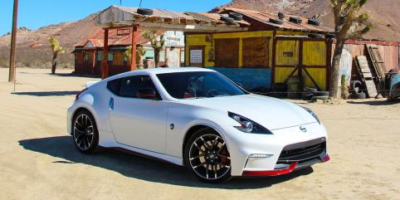

[https://www.google.com/imgres?q=nissan%20370z%20nismo&imgurl=https%3A%2F%2Fhips.hearstapps.com%2Fhmg-prod%2Famv-prod-cad-assets%2Fimages%2F14q4%2F638369%2F2015-nissan-370z-nismo-automatic-review-car-and-driver-photo-644432-s-original.jpg%3Ffill%3D2%3A1%26resize%3D1200%3A*&imgrefurl=https%3A%2F%2Fwww.caranddriver.com%2Freviews%2Fa15108723%2F2015-nissan-370z-nismo-automatic-review%2F&docid=JolbvsK4kLkuNM&tbnid=pjv4r5Xq3cQXuM&vet=12ahUKEwjJouH86tGGAxUITGwGHQBNC0cQM3oECGMQAA..i&w=1200&h=600&hcb=2&ved=2ahUKEwjJouH86tGGAxUITGwGHQBNC0cQM3oECGMQAA](https://www.google.com/imgres?q=nissan%20370z%20nismo&imgurl=https%3A%2F%2Fhips.hearstapps.com%2Fhmg-prod%2Famv-prod-cad-assets%2Fimages%2F14q4%2F638369%2F2015-nissan-370z-nismo-automatic-review-car-and-driver-photo-644432-s-original.jpg%3Ffill%3D2%3A1%26resize%3D1200%3A*&imgrefurl=https%3A%2F%2Fwww.caranddriver.com%2Freviews%2Fa15108723%2F2015-nissan-370z-nismo-automatic-review%2F&docid=JolbvsK4kLkuNM&tbnid=pjv4r5Xq3cQXuM&vet=12ahUKEwjJouH86tGGAxUITGwGHQBNC0cQM3oECGMQAA..i&w=1200&h=600&hcb=2&ved=2ahUKEwjJouH86tGGAxUITGwGHQBNC0cQM3oECGMQAA)

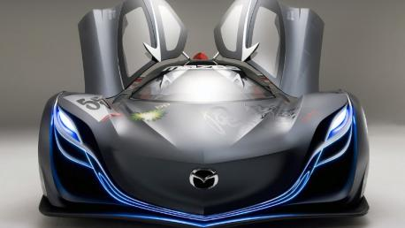

<https://www.google.com/imgres?q=mazda%20furai&imgurl=https%3A%2F%2Fwww.topgear.com%2Fsites%2Fdefault%2Ffiles%2Fnews-listicle%2Fimage%2Fmazda_furai_concept_front_0.jpg&imgrefurl=https%3A%2F%2Fwww.topgear.com%2Fcar-news%2Fconcept%2Fconcepts-time-forgot-mazda-furai&docid=pOwiCMAZy2eMmM&tbnid=GlAUBBJYe8NmzM&vet=12ahUKEwjMsfDM69GGAxUC-TgGHYwJC14QM3oECGQQAA..i&w=1200&h=675&hcb=2&ved=2ahUKEwjMsfDM69GGAxUC-TgGHYwJC14QM3oECGQQAA>

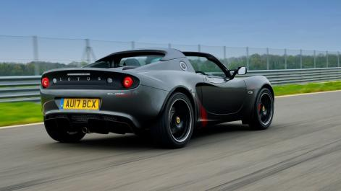

<https://www.google.com/imgres?q=lotus%20elise%20sprint%20220&imgurl=https%3A%2F%2Fcar-images.bauersecure.com%2Fwp-images%2F12193%2Flotus-elise-sprint-04.jpg&imgrefurl=https%3A%2F%2Fwww.carmagazine.co.uk%2Fcar-reviews%2Flotus%2Flotus-elise-sprint-220-2017-review%2F&docid=Q45YAuwUL5_ZBM&tbnid=rbTIdSKEEIFWxM&vet=12ahUKEwjuoefq69GGAxW47zgGHawaB0gQM3oECEIQAA..i&w=1700&h=956&hcb=2&ved=2ahUKEwjuoefq69GGAxW47zgGHawaB0gQM3oECEIQAA>

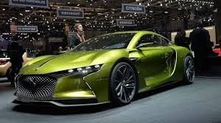

[https://www.google.com/imgres?q=ds%20automobiles%20e%20tense&imgurl=https%3A%2F%2Fcdn.motor1.com%2Fimages%2Fmgl%2FKAvqR%2Fs3%2Fds-e-tense-concept1.jpg&imgrefurl=https%3A%2F%2Fid.motor1.com%2Fnews%2F566049%2Fds-e-tense-performance-concept%2F&docid=BmeTq6s3gWW-nM&tbnid=j-ALJoPb5Ozi8M&vet=12ahUKEwjioN3z69GGAxWdoGMGHW99AM4QM3oECFUQAA..i&w=1280&h=720&hcb=2&ved=2ahUKEwjioN3z69GGAxWdoGMGHW99AM4QM3oECFUQAA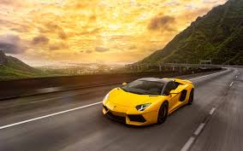](https://www.google.com/imgres?q=ds%20automobiles%20e%20tense&imgurl=https%3A%2F%2Fcdn.motor1.com%2Fimages%2Fmgl%2FKAvqR%2Fs3%2Fds-e-tense-concept1.jpg&imgrefurl=https%3A%2F%2Fid.motor1.com%2Fnews%2F566049%2Fds-e-tense-performance-concept%2F&docid=BmeTq6s3gWW-nM&tbnid=j-ALJoPb5Ozi8M&vet=12ahUKEwjioN3z69GGAxWdoGMGHW99AM4QM3oECFUQAA..i&w=1280&h=720&hcb=2&ved=2ahUKEwjioN3z69GGAxWdoGMGHW99AM4QM3oECFUQAA)

<https://www.google.com/imgres?q=cars%204k&imgurl=https%3A%2F%2Fmrwallpaper.com%2Fimages%2Fhd%2Fcar-4k-yellow-lamborghini-aventador-om5lbmwb8gdrmumw.jpg&imgrefurl=https%3A%2F%2Fmrwallpaper.com%2Fwallpapers%2Fcar-4k-yellow-lamborghini-aventador-om5lbmwb8gdrmumw.html&docid=dzH_Mqv1prOERM&tbnid=C8lEctD5ebzn_M&vet=12ahUKEwiM6Mr469GGAxVX-TgGHc-UAzUQM3oECHMQAA..i&w=1920&h=1200&hcb=2&ved=2ahUKEwiM6Mr469GGAxVX-TgGHc-UAzUQM3oECHMQAA>

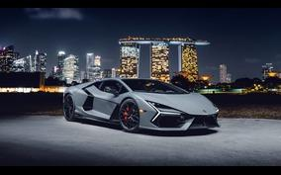

https://www.google.com/imgres?q=car%204k&imgurl=https%3A%2F%2Fwww.hdwallpapers.in%2Fdownload%2F2024_lamborghini_revuelto_car_4k_5k_hd_cars-1920x1080.jpg&imgrefurl=https%3A%2F%2Fwww.hdwallpapers.in%2F2024_lamborghini_revuelto_car_4k_5k_hd_cars-wallpapers.html&docid=g68w1nPwJP_ldM&tbnid=lraD46hmvywDHM&vet=12ahUKEwjZsPfc7NGGAxWFxDgGHcqCDugQM3oECFMQAA..i&w=1920&h=1080&hcb=2&ved=2ahUKEwjZsPfc7NGGAxWFxDgGHcqCDugQM3oECFMQAA

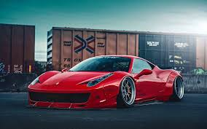

https://www.pinterest.com/pin/liberty-walk-ferrari-458-italia-on-pur-wheels-might-not-be-everybodys-cup-of-tea--227150374940740717/

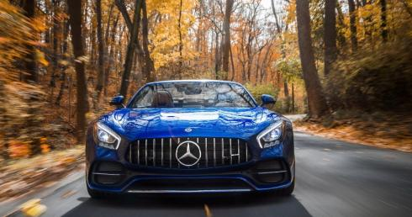

<https://www.google.com/imgres?q=car%204k&imgurl=https%3A%2F%2Fwallpapers.com%2Fimages%2Ffeatured%2F4k-car-g6a4f0e15hkua5oa.jpg&imgrefurl=https%3A%2F%2Fwallpapers.com%2F4k-car&docid=8WPB9nyKFx5aAM&tbnid=H_NyR_YElVgP6M&vet=12ahUKEwjZsPfc7NGGAxWFxDgGHcqCDugQM3oECBsQAA..i&w=1920&h=1013&hcb=2&ved=2ahUKEwjZsPfc7NGGAxWFxDgGHcqCDugQM3oECBsQAA>

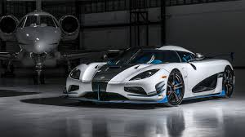

https://www.google.com/imgres?q=cars%204k&imgurl=https%3A%2F%2Flookaside.fbsbx.com%2Flookaside%2Fcrawler%2Fmedia%2F%3Fmedia_id%3D443635886268966&imgrefurl=https%3A%2F%2Fwww.facebook.com%2F4khdcarwallpapers%2F&docid=WQZ9uEc9El9w3M&tbnid=URzaiL423rXqFM&vet=12ahUKEwiM6Mr469GGAxVX-TgGHc-UAzUQM3oECEoQAA..i&w=1920&h=1080&hcb=2&ved=2ahUKEwiM6Mr469GGAxVX-TgGHc-UAzUQM3oECEoQAA