Nama : Jhoner Lou
NIM : 2702353272

1. Home page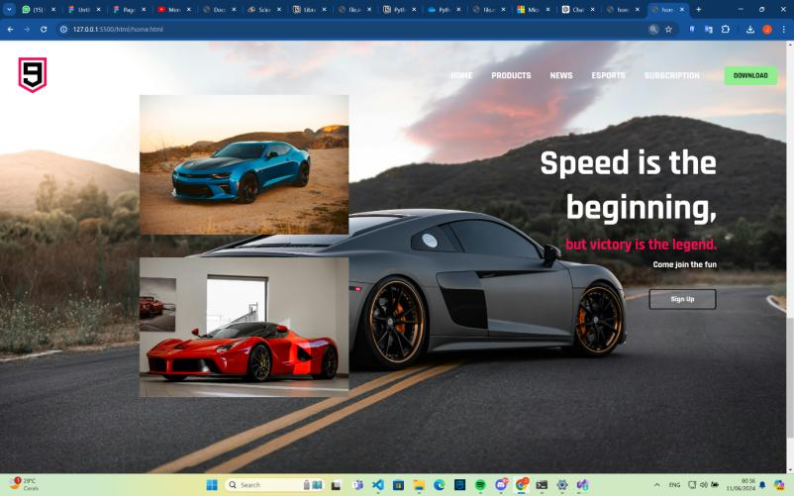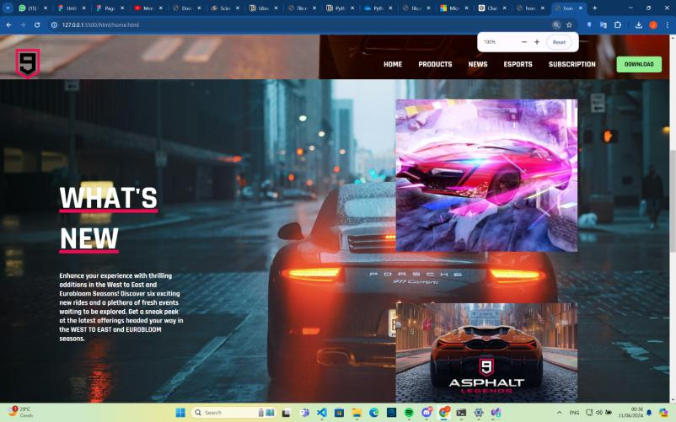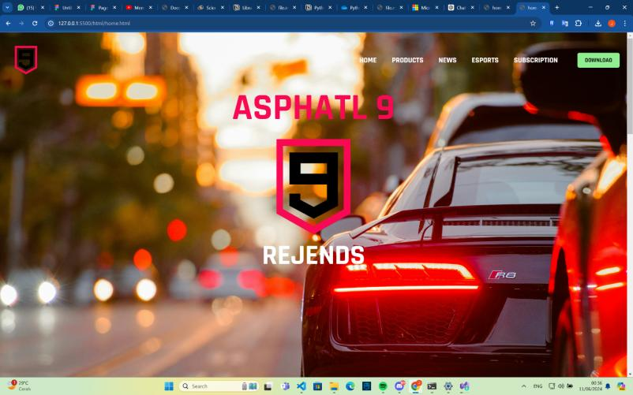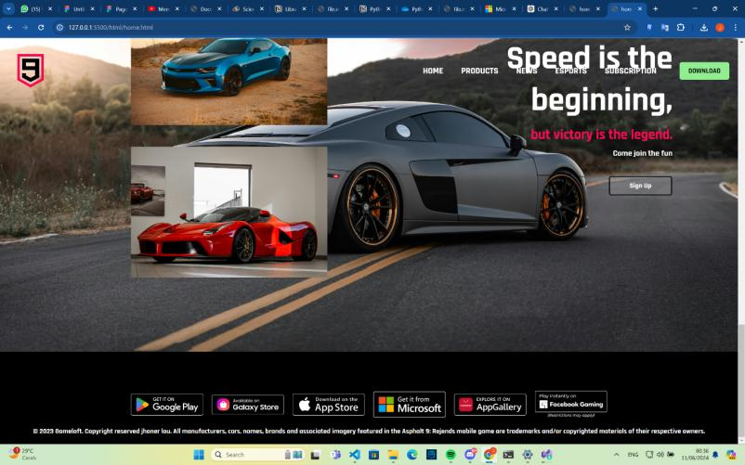

Ini adalah halaman bagian homepage yang dimana user dapat melihat halaman awal dari website dan juga perkenalan untuk website.

2. Product page
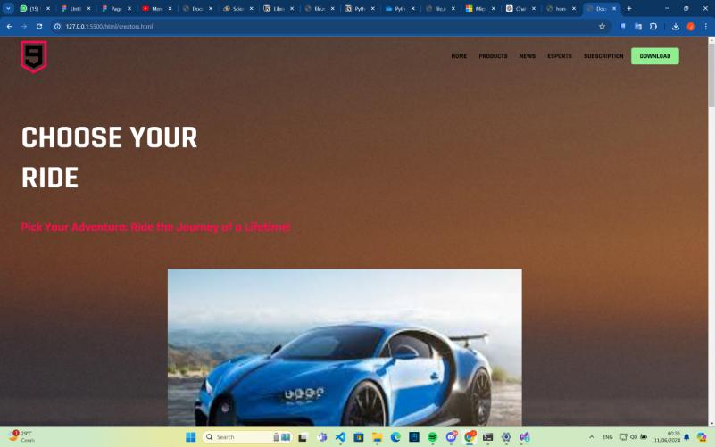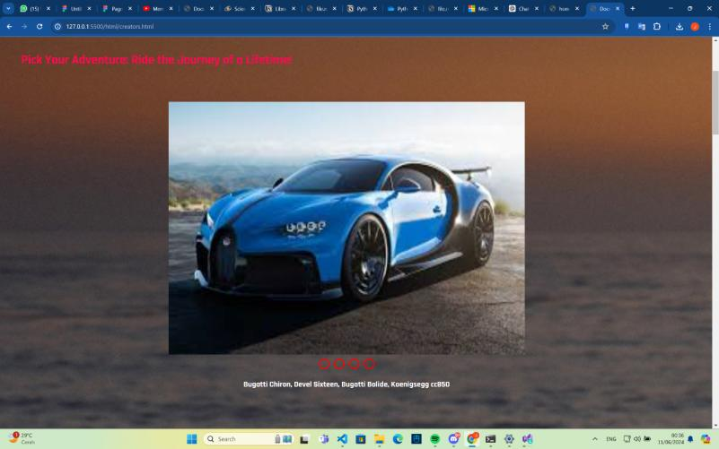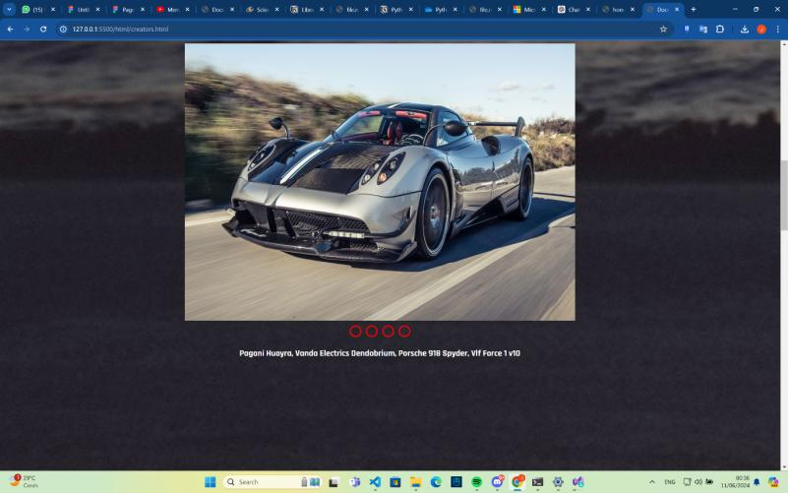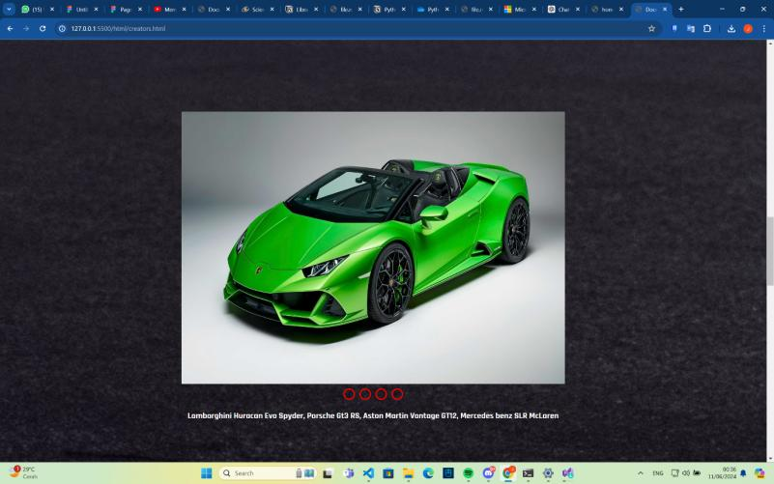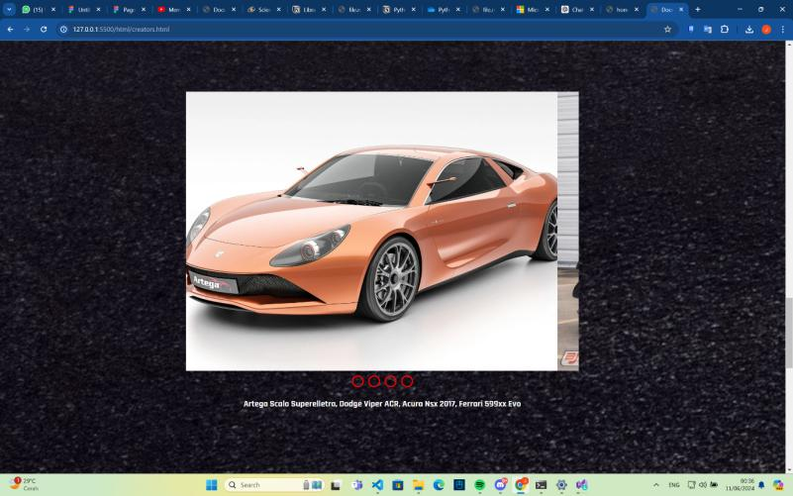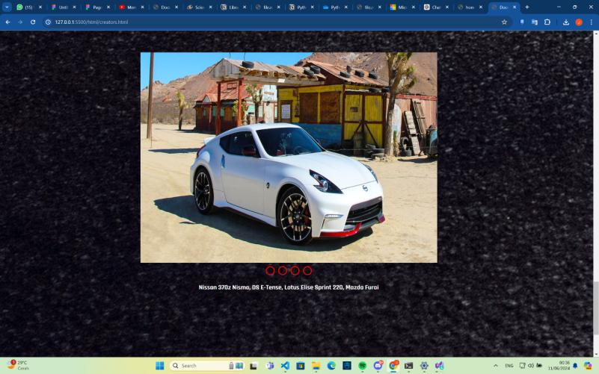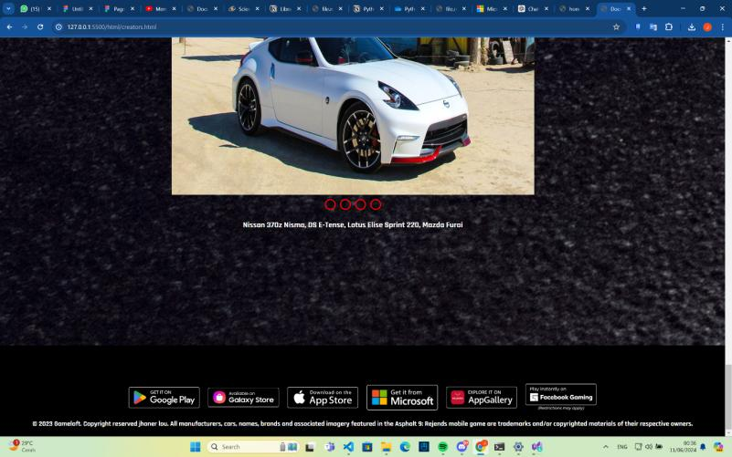
DIsini adalah halaman website dimana user dapat melihat kendaraan yang tersedia dalam website dan gambar-gambarnya
3. News page
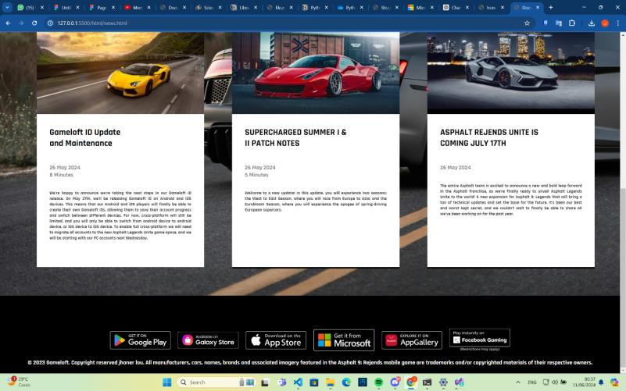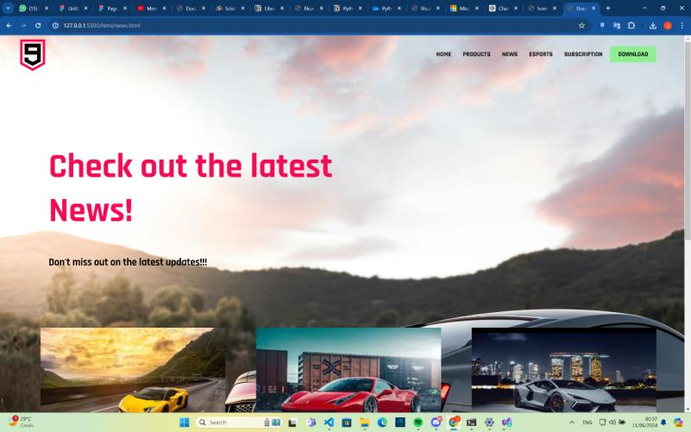
Disini adalah halaman dimana user dapat melihat berita dan juga update terbaru dari website tersebut
4. Esports page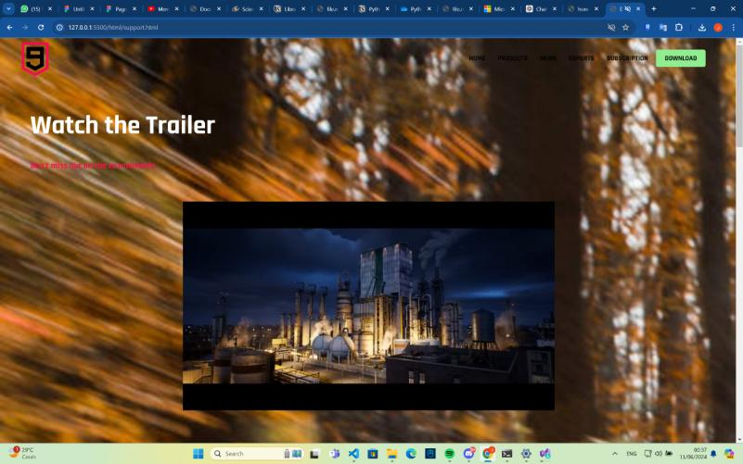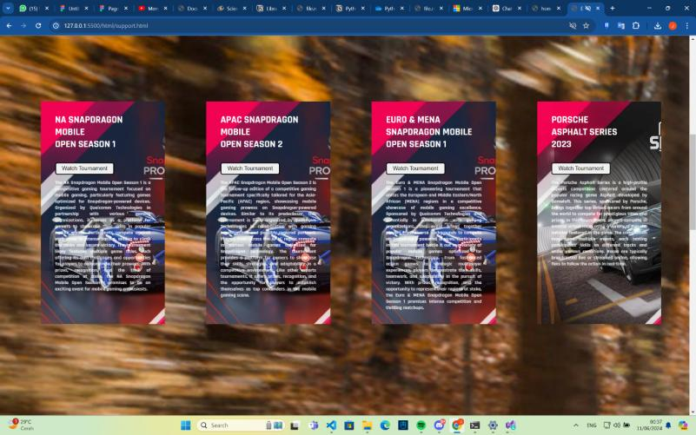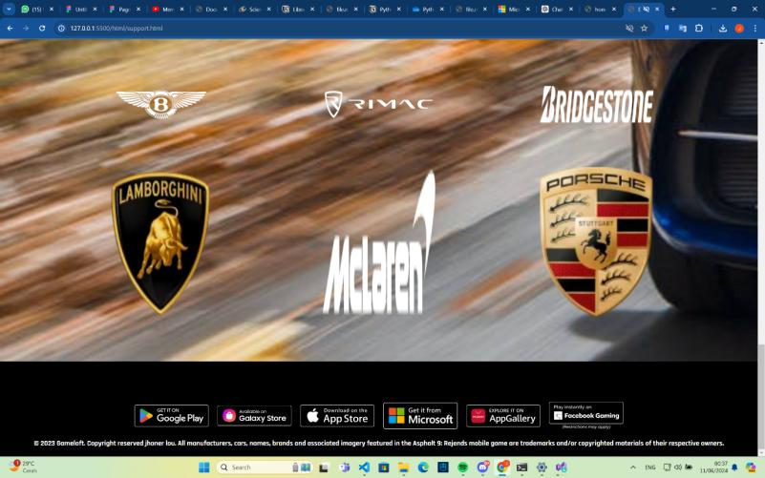
Disini adalah halaman dimana user dapat melihat informasi tentang turnamen yang sedang berlangsung, jumlah-jumlah turnamen dan juga sponsor-sponsor dari website tersebut
5. subscription page
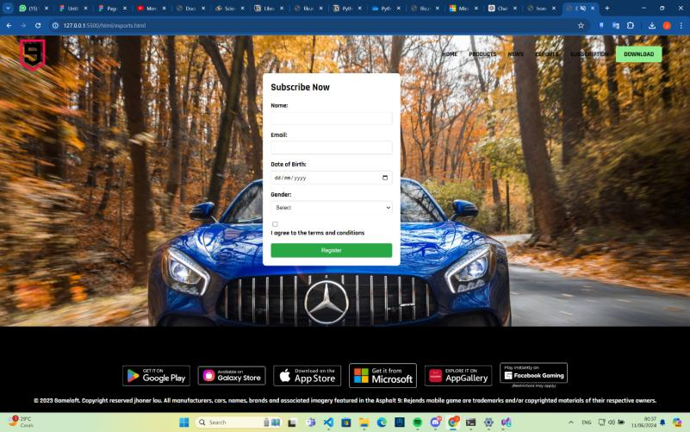
Disini adalah halaman dimana user dalam melakukan registrasi untuk menjadi subscriber pada website tersebut.

Assets:

https://images.unsplash.com/photo-1471479917193-f00955256257?w=600&auto=format&fit=crop&q=60&ixlib=rb-4.0.3&ixid=M3wxMjA3fDB8MHxzZWFyY2h8MzR8fGNhcnxlbnwwfHwwfHx8MA%3D%3D
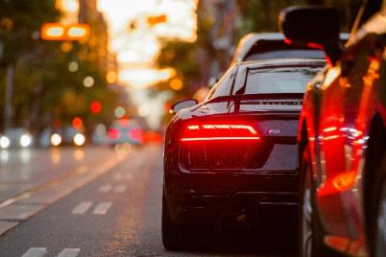
https://unsplash.com/photos/black-audi-r8-parked-beside-road-aiwuLjLPFnU
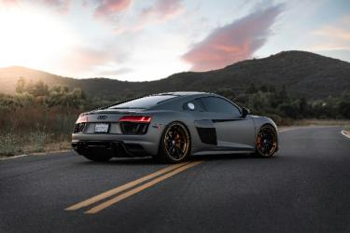
https://unsplash.com/photos/black-bmw-m-3-on-road-during-daytime-d1Jum1vVLew
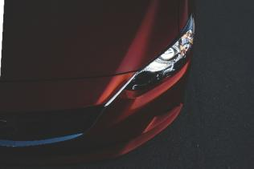
https://unsplash.com/photos/red-vehicle-headlight-EVk5QOg-8j4
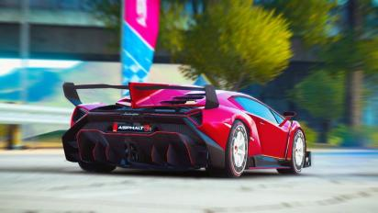



https://www.google.com/imgres?q=asphalt%209&imgurl=https%3A%2F%2Fmkt-web.gameloft.com%2Fstatic%2F1ddc4483aed7158c41b078a7ea77c43f.jpg&imgrefurl=https%3A%2F%2Fmkt-web.gameloft.com%2Fen%2Fgame%2Fasphalt-9&docid=_K3T62fXX7MWIM&tbnid=6w_lbblh2BpuGM&vet=12ahUKEwj75IP-5tGGAxWrT2wGHYG-BAAQM3oECF0QAA..i&w=1024&h=768&hcb=2&ved=2ahUKEwj75IP-5tGGAxWrT2wGHYG-BAAQM3oECF0QAA
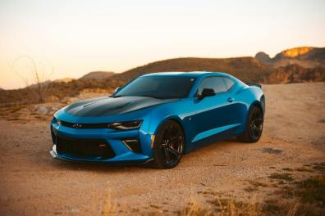
https://www.businessmole.com/exploring-the-chevrolet-camaro-a-muscle-car-legend/
https://discord.com/channels/@me/1245307304622948405/1245307603559649290
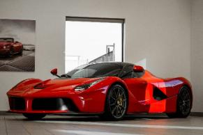
https://www.peakpx.com/en/hd-wallpaper-desktop-fgntu

https://www.google.com/imgres?q=car%204k&imgurl=https%3A%2F%2Fimages3.alphacoders.com%2F133%2F1335169.png&imgrefurl=https%3A%2F%2Fwall.alphacoders.com%2Fbig.php%3Fi%3D1335169&docid=mjwc_ePTO8Vf1M&tbnid=bdv5Rejg7aiQ1M&vet=12ahUKEwjsx4bu5NGGAxV3TmwGHXvcDaQQM3oFCIEBEAA..i&w=5376&h=3072&hcb=2&ved=2ahUKEwjsx4bu5NGGAxV3TmwGHXvcDaQQM3oFCIEBEAA
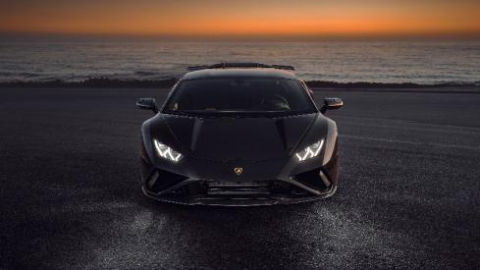
https://www.google.com/imgres?q=car%204k&imgurl=https%3A%2F%2Fwww.hdwallpapers.in%2Fdownload%2Flamborghini_huracan_evo_sport_black_car_4k_hd_cars-3840x2160.jpg&imgrefurl=https%3A%2F%2Fwww.hdwallpapers.in%2Flamborghini_huracan_evo_sport_black_car_4k_hd_cars-wallpapers.html&docid=eEtWCs6q5W4EhM&tbnid=V8HoyagAAi8UJM&vet=12ahUKEwjsx4bu5NGGAxV3TmwGHXvcDaQQM3oECGkQAA..i&w=3840&h=2160&hcb=2&ved=2ahUKEwjsx4bu5NGGAxV3TmwGHXvcDaQQM3oECGkQAA
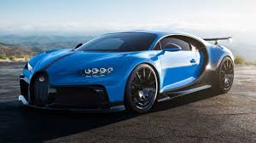
https://www.google.com/imgres?q=bugatti%20chiron&imgurl=https%3A%2F%2Fcdn.motor1.com%2Fimages%2Fmgl%2FxW8K2%2Fs3%2Fbugatti-chiron-pur-sport.jpg&imgrefurl=https%3A%2F%2Fid.motor1.com%2Fnews%2F455285%2Fbugatti-chiron-pur-sport-boros%2F&docid=gg0A0DdMU9_nTM&tbnid=sNjMnRiNkk73hM&vet=12ahUKEwjcwMms6NGGAxUKbWwGHTJzDEkQM3oECBcQAA..i&w=1280&h=720&hcb=2&ved=2ahUKEwjcwMms6NGGAxUKbWwGHTJzDEkQM3oECBcQAA
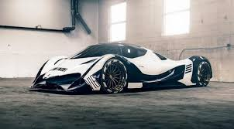
https://www.google.com/imgres?q=devel%20sixteen&imgurl=https%3A%2F%2Fwww.carscoops.com%2Fwp-content%2Fuploads%2F2018%2F10%2F2535dfae-devel-sixteen--1024x555.jpg&imgrefurl=https%3A%2F%2Fwww.carscoops.com%2F2018%2F10%2Funsurprisingly-insane-devel-sixteen-put-hold%2F&docid=V7E6YQ9nNDZXgM&tbnid=TtGT5zT_peZNLM&vet=12ahUKEwjN8c616NGGAxUnXGwGHS-ZC4MQM3oECFQQAA..i&w=1024&h=555&hcb=2&ved=2ahUKEwjN8c616NGGAxUnXGwGHS-ZC4MQM3oECFQQAA
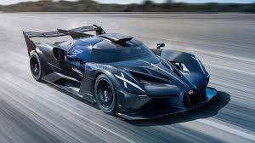
https://driven.site/news/the-bugatti-bolide-offers-blistering-f1-pace
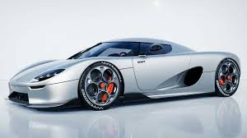
https://www.gridoto.com/read/223453625/koenigsegg-rilis-mobil-baru-koenigsegg-cc850-langsung-sold-out
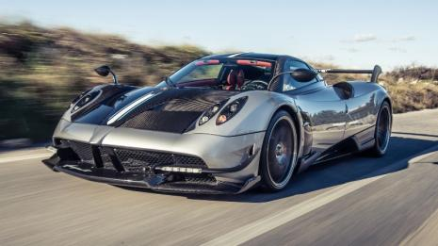
https://www.google.com/imgres?q=pagani%20huayra&imgurl=https%3A%2F%2Fwww.topgear.com%2Fsites%2Fdefault%2Ffiles%2Fcars-car%2Fimage%2F2016%2F08%2Frh_huayrabc-67.jpg&imgrefurl=https%3A%2F%2Fwww.topgear.com%2Fcar-reviews%2Fpagani%2Fhuayra&docid=1omKxCwXLhpfQM&tbnid=xKh5kSQOHMqE_M&vet=12ahUKEwiU77mC6dGGAxUt3TgGHboyBeAQM3oECGQQAA..i&w=1959&h=1102&hcb=2&ved=2ahUKEwiU77mC6dGGAxUt3TgGHboyBeAQM3oECGQQAA
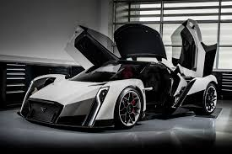
https://www.google.com/imgres?q=vanda%20electrics%20dendrobium&imgurl=https%3A%2F%2Fcar-images.bauersecure.com%2Fwp-images%2F1892%2Fvanda_dendrobium_0001.jpg&imgrefurl=https%3A%2F%2Fwww.carmagazine.co.uk%2Fcar-news%2Fmotor-shows-events%2Fgeneva%2F2017%2Fvanda-electrics-dendrobium-electric-hypercar-revealed-in-pictures%2F&docid=BaHJ1nU4ofMZvM&tbnid=UD_lKjvk_09wvM&vet=12ahUKEwip4eqS6dGGAxX-xDgGHfBRB54QM3oECBMQAA..i&w=1700&h=1132&hcb=2&ved=2ahUKEwip4eqS6dGGAxX-xDgGHfBRB54QM3oECBMQAA
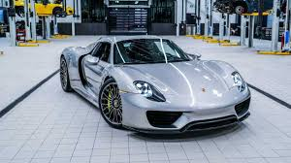
https://www.google.com/imgres?q=porsche%20918%20spyder&imgurl=https%3A%2F%2Fcdn.motor1.com%2Fimages%2Fmgl%2Fg40OZP%2Fs3%2F2015-porsche-918-spyder.jpg&imgrefurl=https%3A%2F%2Fid.motor1.com%2Fnews%2F556934%2Fporsche-spyder-mildhybrid-seperti-baru%2F&docid=9VIPMHdteXT1eM&tbnid=EDqyepoUUTVoYM&vet=12ahUKEwiuz4bm6NGGAxW_2TgGHY4VBtEQM3oECHsQAA..i&w=1280&h=720&hcb=2&ved=2ahUKEwiuz4bm6NGGAxW_2TgGHY4VBtEQM3oECHsQAA
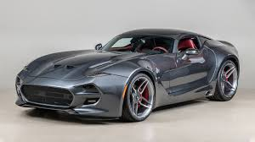
https://www.google.com/imgres?q=vlf%20force%201%20v10&imgurl=https%3A%2F%2Fimboldn.com%2Fwp-content%2Fuploads%2F2020%2F02%2F2018-VLF-Force-1-V10-main.jpg&imgrefurl=https%3A%2F%2Fimboldn.com%2F2018-vlf-force-1-v10%2F&docid=IpqdvBdPL-6GhM&tbnid=KF8mXUsXws-G2M&vet=12ahUKEwjkkeTL6dGGAxUXTWwGHe6jCA8QM3oECHkQAA..i&w=1600&h=900&hcb=2&ved=2ahUKEwjkkeTL6dGGAxUXTWwGHe6jCA8QM3oECHkQAA
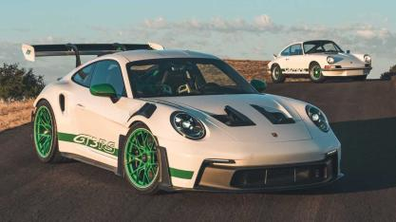
https://www.google.com/imgres?q=porsche%20gt3%20rs&imgurl=https%3A%2F%2Fcdn.motor1.com%2Fimages%2Fmgl%2FzxxMzK%2Fs3%2F2023-porsche-911-gt3-rs.jpg&imgrefurl=https%3A%2F%2Fwww.motor1.com%2Fnews%2F604945%2F2023-porsche-911-gt3-rs%2F&docid=qj7l8LZ26O4QVM&tbnid=JyMA4Fpg8QaNpM&vet=12ahUKEwizm9jX6dGGAxVgU2wGHWCcF0gQM3oECGwQAA..i&w=1280&h=720&hcb=2&ved=2ahUKEwizm9jX6dGGAxVgU2wGHWCcF0gQM3oECGwQAA
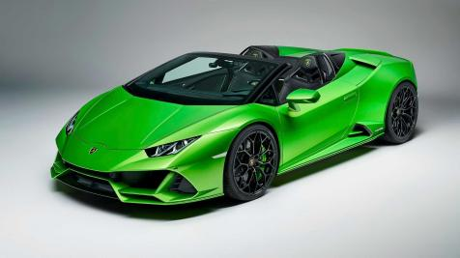
https://www.google.com/imgres?q=lamborghini%20huracan%20evo%20spyder&imgurl=https%3A%2F%2Fwww.lamborghiniwashington.com%2Fstatic%2Fdealer-14437%2FModel_pages%2Fevo_spyder_exterior_front.webp&imgrefurl=https%3A%2F%2Fwww.lamborghiniwashington.com%2Flamborghini-huracan-evo-spyder-sterling-va&docid=kNHFK7RDtExU9M&tbnid=bWLizl_7QbqQ7M&vet=12ahUKEwi4nevp6dGGAxWaTmwGHcKkCRIQM3oECBkQAA..i&w=1481&h=467&hcb=2&ved=2ahUKEwi4nevp6dGGAxWaTmwGHcKkCRIQM3oECBkQAA
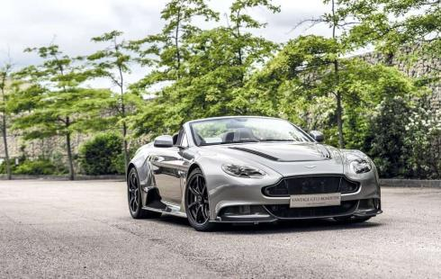
https://www.google.com/url?sa=i&url=https%3A%2F%2Fcarvaganza.com%2Faston-martin-vantage-gt12-roadster-ultra-limited-edition%2F&psig=AOvVaw03e4_xWYyEZ1tcOB7uc81n&ust=1718136166468000&source=images&cd=vfe&opi=89978449&ved=0CBIQjRxqFwoTCOCD-JLq0YYDFQAAAAAdAAAAABAE
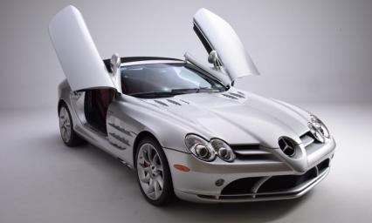
https://www.google.com/imgres?q=mercedez%20benz%20slr%20mclaren&imgurl=https%3A%2F%2Fnewportcarmuseum.org%2Fwp-content%2Fuploads%2F2023%2F04%2F25_Mercedes-McLaren-2-silver82-scaled-1000x600.jpg&imgrefurl=https%3A%2F%2Fnewportcarmuseum.org%2F2008-mercedes-benz-slr-mclaren%2F&docid=-WhDH0DmmVtiyM&tbnid=Dz3jUwCcWeu0GM&vet=12ahUKEwjRwKmb6tGGAxV1a2wGHYymCKsQM3oECEcQAA..i&w=1000&h=600&hcb=2&ved=2ahUKEwjRwKmb6tGGAxV1a2wGHYymCKsQM3oECEcQAA
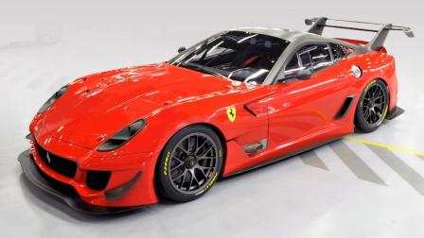
https://www.google.com/imgres?q=ferrari%20599xx%20evo&imgurl=https%3A%2F%2Fcimg2.ibsrv.net%2Fibimg%2Fhgm%2F1600x900-1%2F100%2F392%2Fferrari-599xx-evo-to-be-auctioned-off-for-italys-2012-earthquake-victims_100392494.jpg&imgrefurl=https%3A%2F%2Fwww.motorauthority.com%2Fnews%2F1076754_ferrari-reveals-599xx-evo-and-other-items-being-auctioned-for-earthquake-victims&docid=yzEtceHqFuUQTM&tbnid=FIMqrlpJx_iinM&vet=12ahUKEwi1oJer6tGGAxXCbmwGHSyHDzkQM3oECHAQAA..i&w=1600&h=900&hcb=2&ved=2ahUKEwi1oJer6tGGAxXCbmwGHSyHDzkQM3oECHAQAA
https://www.google.com/imgres?q=acura%20nsx%202017&imgurl=https%3A%2F%2Fcdn.motor1.com%2Fimages%2Fmgl%2FEO9zv%2Fs1%2F4x3%2F2017-acura-nsx.webp&imgrefurl=https%3A%2F%2Fwww.motor1.com%2Freviews%2F62927%2Ffirst-drive-2017-acura-nsx%2F&docid=O0JNkTf2sH_wWM&tbnid=Rbj1L3remPBTuM&vet=12ahUKEwjJrfTS6tGGAxWvfGwGHSHZDlQQM3oECHAQAA..i&w=1440&h=1080&hcb=2&ved=2ahUKEwjJrfTS6tGGAxWvfGwGHSHZDlQQM3oECHAQAA
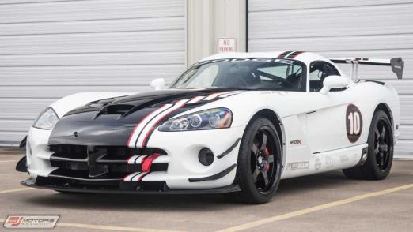
https://www.google.com/imgres?q=dodge%20viper%20acr&imgurl=https%3A%2F%2Fcdn.motor1.com%2Fimages%2Fmgl%2FP1lkW%2Fs3%2F2010-dodge-viper-acr-x-for-sale.jpg&imgrefurl=https%3A%2F%2Fwww.motor1.com%2Fnews%2F406808%2Fdodge-viper-acr-x-for-sale%2F&docid=PvZRcPXAPcumjM&tbnid=dp20UTC17HkfAM&vet=12ahUKEwjMuKXf6tGGAxWEfGwGHfg9DEoQM3oECE0QAA..i&w=1280&h=720&hcb=2&ved=2ahUKEwjMuKXf6tGGAxWEfGwGHfg9DEoQM3oECE0QAA
https://www.google.com/imgres?q=artega%20scalo&imgurl=https%3A%2F%2Fcdn.motor1.com%2Fimages%2Fmgl%2F7VQQW%2Fs1%2F4x3%2F2017-artega-scalo-superelletra.webp&imgrefurl=https%3A%2F%2Fuk.motor1.com%2Fnews%2F138191%2Fartega-scalo-superelletra-geneva-debut%2F&docid=XUHdnNmF7KK0-M&tbnid=PdBESchswBpw7M&vet=12ahUKEwj289ro6tGGAxUfcmwGHfgiAOgQM3oFCIIBEAA..i&w=1440&h=1080&hcb=2&ved=2ahUKEwj289ro6tGGAxUfcmwGHfgiAOgQM3oFCIIBEAA
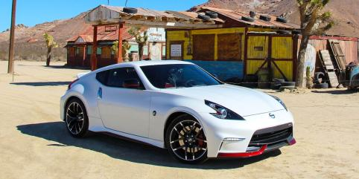
https://www.google.com/imgres?q=nissan%20370z%20nismo&imgurl=https%3A%2F%2Fhips.hearstapps.com%2Fhmg-prod%2Famv-prod-cad-assets%2Fimages%2F14q4%2F638369%2F2015-nissan-370z-nismo-automatic-review-car-and-driver-photo-644432-s-original.jpg%3Ffill%3D2%3A1%26resize%3D1200%3A*&imgrefurl=https%3A%2F%2Fwww.caranddriver.com%2Freviews%2Fa15108723%2F2015-nissan-370z-nismo-automatic-review%2F&docid=JolbvsK4kLkuNM&tbnid=pjv4r5Xq3cQXuM&vet=12ahUKEwjJouH86tGGAxUITGwGHQBNC0cQM3oECGMQAA..i&w=1200&h=600&hcb=2&ved=2ahUKEwjJouH86tGGAxUITGwGHQBNC0cQM3oECGMQAA
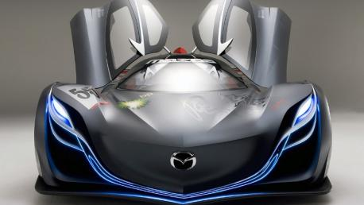
https://www.google.com/imgres?q=mazda%20furai&imgurl=https%3A%2F%2Fwww.topgear.com%2Fsites%2Fdefault%2Ffiles%2Fnews-listicle%2Fimage%2Fmazda_furai_concept_front_0.jpg&imgrefurl=https%3A%2F%2Fwww.topgear.com%2Fcar-news%2Fconcept%2Fconcepts-time-forgot-mazda-furai&docid=pOwiCMAZy2eMmM&tbnid=GlAUBBJYe8NmzM&vet=12ahUKEwjMsfDM69GGAxUC-TgGHYwJC14QM3oECGQQAA..i&w=1200&h=675&hcb=2&ved=2ahUKEwjMsfDM69GGAxUC-TgGHYwJC14QM3oECGQQAA
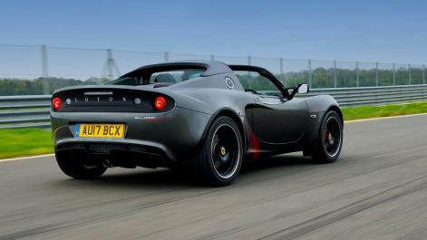
https://www.google.com/imgres?q=lotus%20elise%20sprint%20220&imgurl=https%3A%2F%2Fcar-images.bauersecure.com%2Fwp-images%2F12193%2Flotus-elise-sprint-04.jpg&imgrefurl=https%3A%2F%2Fwww.carmagazine.co.uk%2Fcar-reviews%2Flotus%2Flotus-elise-sprint-220-2017-review%2F&docid=Q45YAuwUL5_ZBM&tbnid=rbTIdSKEEIFWxM&vet=12ahUKEwjuoefq69GGAxW47zgGHawaB0gQM3oECEIQAA..i&w=1700&h=956&hcb=2&ved=2ahUKEwjuoefq69GGAxW47zgGHawaB0gQM3oECEIQAA
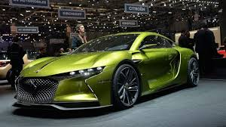
https://www.google.com/imgres?q=ds%20automobiles%20e%20tense&imgurl=https%3A%2F%2Fcdn.motor1.com%2Fimages%2Fmgl%2FKAvqR%2Fs3%2Fds-e-tense-concept1.jpg&imgrefurl=https%3A%2F%2Fid.motor1.com%2Fnews%2F566049%2Fds-e-tense-performance-concept%2F&docid=BmeTq6s3gWW-nM&tbnid=j-ALJoPb5Ozi8M&vet=12ahUKEwjioN3z69GGAxWdoGMGHW99AM4QM3oECFUQAA..i&w=1280&h=720&hcb=2&ved=2ahUKEwjioN3z69GGAxWdoGMGHW99AM4QM3oECFUQAA
https://www.google.com/imgres?q=cars%204k&imgurl=https%3A%2F%2Fmrwallpaper.com%2Fimages%2Fhd%2Fcar-4k-yellow-lamborghini-aventador-om5lbmwb8gdrmumw.jpg&imgrefurl=https%3A%2F%2Fmrwallpaper.com%2Fwallpapers%2Fcar-4k-yellow-lamborghini-aventador-om5lbmwb8gdrmumw.html&docid=dzH_Mqv1prOERM&tbnid=C8lEctD5ebzn_M&vet=12ahUKEwiM6Mr469GGAxVX-TgGHc-UAzUQM3oECHMQAA..i&w=1920&h=1200&hcb=2&ved=2ahUKEwiM6Mr469GGAxVX-TgGHc-UAzUQM3oECHMQAA
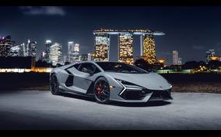
https://www.google.com/imgres?q=car%204k&imgurl=https%3A%2F%2Fwww.hdwallpapers.in%2Fdownload%2F2024_lamborghini_revuelto_car_4k_5k_hd_cars-1920x1080.jpg&imgrefurl=https%3A%2F%2Fwww.hdwallpapers.in%2F2024_lamborghini_revuelto_car_4k_5k_hd_cars-wallpapers.html&docid=g68w1nPwJP_ldM&tbnid=lraD46hmvywDHM&vet=12ahUKEwjZsPfc7NGGAxWFxDgGHcqCDugQM3oECFMQAA..i&w=1920&h=1080&hcb=2&ved=2ahUKEwjZsPfc7NGGAxWFxDgGHcqCDugQM3oECFMQAA
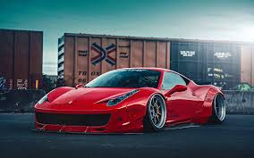
https://www.pinterest.com/pin/liberty-walk-ferrari-458-italia-on-pur-wheels-might-not-be-everybodys-cup-of-tea--227150374940740717/
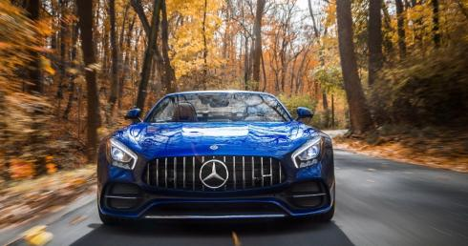
https://www.google.com/imgres?q=car%204k&imgurl=https%3A%2F%2Fwallpapers.com%2Fimages%2Ffeatured%2F4k-car-g6a4f0e15hkua5oa.jpg&imgrefurl=https%3A%2F%2Fwallpapers.com%2F4k-car&docid=8WPB9nyKFx5aAM&tbnid=H_NyR_YElVgP6M&vet=12ahUKEwjZsPfc7NGGAxWFxDgGHcqCDugQM3oECBsQAA..i&w=1920&h=1013&hcb=2&ved=2ahUKEwjZsPfc7NGGAxWFxDgGHcqCDugQM3oECBsQAA
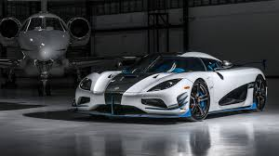
https://www.google.com/imgres?q=cars%204k&imgurl=https%3A%2F%2Flookaside.fbsbx.com%2Flookaside%2Fcrawler%2Fmedia%2F%3Fmedia_id%3D443635886268966&imgrefurl=https%3A%2F%2Fwww.facebook.com%2F4khdcarwallpapers%2F&docid=WQZ9uEc9El9w3M&tbnid=URzaiL423rXqFM&vet=12ahUKEwiM6Mr469GGAxVX-TgGHc-UAzUQM3oECEoQAA..i&w=1920&h=1080&hcb=2&ved=2ahUKEwiM6Mr469GGAxVX-TgGHc-UAzUQM3oECEoQAA

