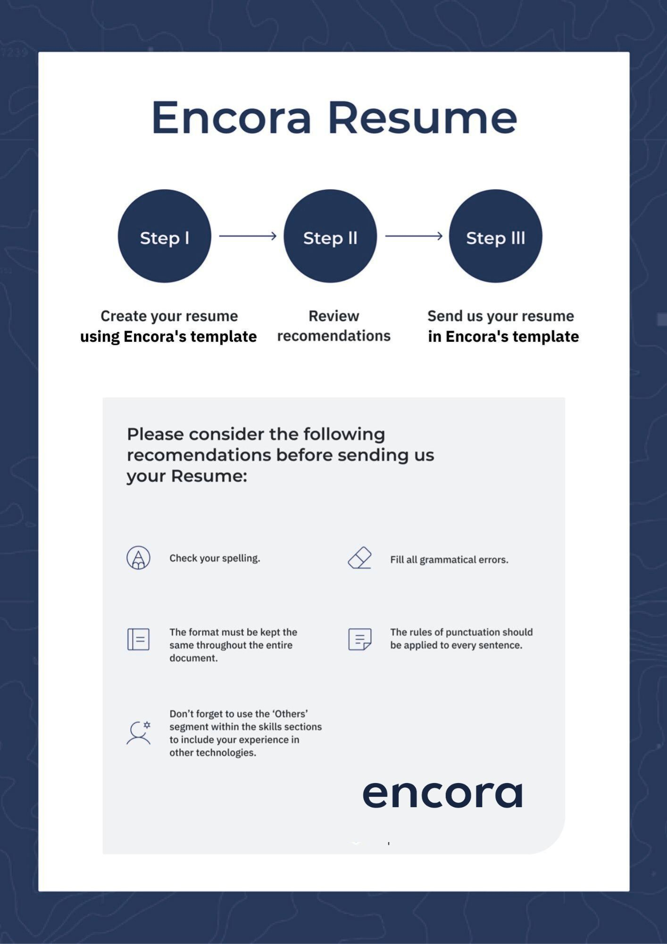
JHON ORJUELA
Integration Support Specialist
Integration Support Specialist with 4+ years of experience in enterprise banking systems, specialized in IBM technologies (App Connect Enterprise, DataPower, MQ), Java Spring, and cloud platforms. Proven track record building scalable financial systems serving 50,000+ customers, including credit card tokenization integrated with Google Pay and Apple Wallet. Experienced in troubleshooting complex integration issues, maintaining 99.9% uptime, and collaborating with cross-functional teams. AWS, Azure, and Oracle Cloud certified professional with strong communication skills and remote work capabilities.

SKILLED IN
Platforms | Windows, Linux (Ubuntu).
Technologies | IBM App Connect Enterprise (ACE12), IBM Integration Bus (IIB10), IBM DataPower, IBM MQ, IBM DataStage, SAP, UNIX, EDI Formats (EDIFACT, ISO 8583, NACHA, NACHA-M, XML, JSON,), IDocs (Intermediate Documents), Python, REST APIs, SOAP, SOA Architecture, Microservices, Spring Framework (Boot, Security, Cloud, Data, JPA), React.js, JavaScript, HTML5, CSS3, Git, Unit Testing, Docker, Kubernetes, GitHub Actions, AWS, Azure, Kafka.
Databases | Oracle, PostgreSQL, SQLite, MongoDB, ChromaDB.
Others | Jira, Confluence, Slack, Zoom, Microsoft Teams, Agile/Scrum, Kanban.

COMPLEMENTARY KNOWLEDGE
Technical Knowledge | Oracle Cloud Infrastructure, Machine Learning, RAG Systems, LangChain, FastAPI.

WORK EXPERIENCE
BANCO DE OCCIDENTE S.A.  IBM Integration Developer | BOGOTA, COLOMBIA  (2022 – Present)

Banco de Occidente is one of Colombia’s leading financial institutions, part of Grupo Aval, providing comprehensive banking services to over 2 million customers nationwide.

During this time I participated in the following projects:
- Project: Credit Card Tokenization System (2023 – 2025)
Development of a secure tokenization system for credit cards integrated with Google Pay and Apple Wallet, serving 50,000+ active customers. Team size: 15 members.
Main tasks executed in the project:
- Designed and implemented secure tokenization APIs for Google Pay and Apple Wallet integration. Developed encryption workflows using IBM DataPower. Reduced payment processing time by 40% and fraud incidents by 60%.
Major Contribution: Led the technical design of the tokenization architecture, enabling the bank to offer mobile wallet payments to 50,000+ customers while significantly improving security and reducing fraud-related losses.
Technologies: IBM App Connect Enterprise, IBM Integration BUS, IBM DataPower, IBM MQ, REST/SOAP APIs, SAP, EDI Formats (EDIFACT, XML, JSON, NACHA-M, ISO 8583), Oracle Database, Git, GitHub, Jenkins, OAUTH Authentication, SOAP UI, JMeter.

- Project: Bre-B Instant Payment System Integration (2024 – 2025)
Integration of Colombia’s central bank real-time payment system (Bre-B) enabling instant 24/7 interbank transfers using ISO 20022 messaging standards. Team size: 9 members.

Main tasks executed in the project:
- Developed integration services connecting bank systems to Banco de la República’s Bre-B infrastructure. Implemented “llave” (key) registration and validation workflows. Built real-time transaction processing with sub-20-second settlement. Achieved 99.8% system availability during controlled rollout phase.
Major Contribution: Build API integrations with ACH Colombia’s instant payment node, enabling the bank to participate in Colombia’s national interoperable payment ecosystem serving 35+ million registered users.
Technologies: IBM App Connect Enterprise, IBM Integration BUS, IBM DataPower, IBM MQ, REST/SOAP, EDI Formats (EDIFACT, XML, JSON, ISO 8583, ISO 20022), APIs, Oracle Database, Git, GitHub, Jenkins, OAUTH Authentication, SOAP UI, JMeter.
- Project: Debit Card Tokenization System (2025 - Current)
Extension of tokenization capabilities to debit cards for Google Pay and Apple Wallet integration, expanding secure mobile payment options. Team size: 9 members.
Main tasks executed in the project:
- Adapting existing credit card tokenization architecture for debit card requirements. Implementing real-time balance validation workflows. Building secure token lifecycle management services. Target: 30,000+ active debit card users in first quarter.
Major Contribution: Leading the technical design to extend proven tokenization patterns to debit cards while addressing unique requirements like real-time balance checks and daily spending limits.
Technologies: IBM App Connect Enterprise, IBM Integration BUS, IBM DataPower, IBM MQ, SAP, EDI Formats (XML, JSON, ISO 8583), REST/SOAP APIs, Oracle Database, Git, GitHub, Jenkins, OAUTH Authentication, SOAP UI, JMeter.
- Project: Financial Credit Portfolio Migration (2023)
Large-scale migration of credit portfolios from acquired financial entities, including customer data, loan terms, payment histories, and collateral information. Team size: 6 members.
Main tasks executed in the project:
- Built ETL integration flows using IBM DataStage for data transformation. Implemented data validation and reconciliation services. Migrated 120,000+ credit accounts with zero data loss. Reduced migration timeline by 35% through automated validation workflows.
Major Contribution: Designed the data transformation architecture ensuring regulatory compliance and data integrity across heterogeneous source systems while maintaining service continuity for migrated customers on record time.
Technologies: IBM DataStage, ETL, IBM MQ, Oracle Database, Git, GitHub, SOAP UI, JMeter, XML.

WILANDINFORMATICA  Full Stack Developer | BOGOTA, COLOMBIA  (2020 – 2022)

Independent consulting and PC components store.

During this time I participated in the following projects:
- Project: Full e-commerce website (2020 - 2022)
End-to-end e-commerce platform development for a tech startup, featuring product catalog, shopping cart, secure checkout, user authentication, and order management.
Main tasks executed in the project:
- Built responsive frontend using React with Vite bundler, implementing React Router, Context API, and custom hooks for state management. Developed RESTful backend with Spring Framework following Clean Architecture patterns. Implemented JWT authentication with refresh tokens and secure session handling. Designed PostgreSQL database with proper constraints, ACID compliance, and optimized indexing for query performance.
Major Contribution: Delivered a production-ready, scalable e-commerce solution enabling the startup to launch their online business with a modern tech stack and cloud-native deployment architecture.
Technologies: React, Vite, npm, JavaScript, Spring Framework, JWT, PostgreSQL, Clean Architecture, Vercel, Railway, Supabase, Git.

EDUCATION
2025 | AWS Cloud Practitioner | Amazon Web Services
2025 | Azure Fundamentals (AZ-900) | Microsoft
2024 | C1 Business English | American School Way
2023 | ICAgile Professional Certification | International Consortium for Agile
2021 – 2026 (In Progress) | Computer Science Professional | Corp. Univ. Republicana

LANGUAGES
Spanish: Native | English: B2

About ENCORA:
Encora - www.encora.com - provides software engineering services with a nearshore advantage. As a global software and digital engineering company, Encora is the preferred innovation partner to some of the world’s leading fast-growing tech companies that are driving innovation and growth in industries such as d AI-first software engineering solutions, FinTech, Digital Commerce Platforms, Health tech & Insure Tech, EdTech, Hi-tech, Identity and Access Management (IAM) & Cybersecurity, Supply Chain & Logistics, and Telecom. Encora has nearshore capabilities, in the same time zone as the U.S., and engineering centers across Latin America (Costa Rica, Peru, Bolivia, Colombia, Mexico, and Brazil), as well as centers in India, Singapore, Malaysia, Philippines, and Europe (Romania and Macedonia). Encora's model is highly collaborative, utilizing Agile, the English language, on-demand engineering resources, and quality engineering across the Product Development Lifecycle.








