Numero

Entero = -?(/d)+

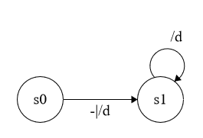

Identificador = (_|/L)(/L|/d|-|_)*

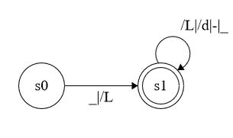

Literal = "/d|<|>|:|;|,|/|'"

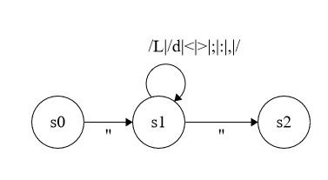

Comentarios = // (/L|/d)* \n

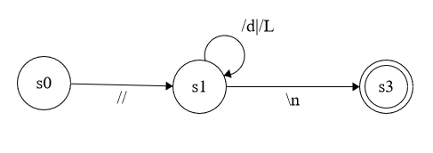

GENERAL

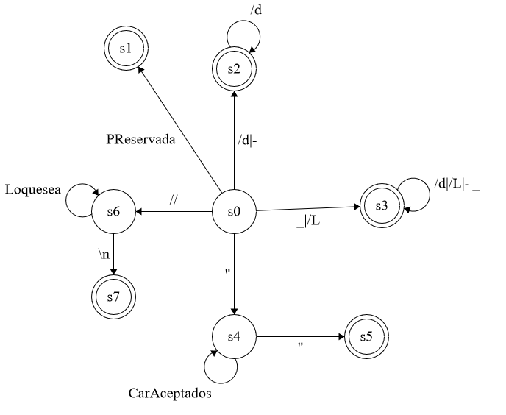

* PReservada = ESCRIBIR, FIN, REPETIR, INICIAR, SI, VERDADERO, FALSO, ENTONCES

Transitions

|  |  |  |
| --- | --- | --- |
| ∂(0,PReserv) = 1 | ∂(0,-) = 2 | ∂(0,/d) = 2 |
| ∂(0,_) = 3 | ∂(0,/L) = 3 | ∂(0,") = 4 |
| ∂(0,//) = 6 | ∂(2,/d) = 2 | ∂(3,/d) = 3 |
| ∂(3,/L) = 3 | ∂(3,-) = 3 | ∂(3,_) = 3 |
| ∂(4,CarAcept) = 4 | ∂(4,") = 5 | ∂(6,LQSEA) = 3 |
| ∂(6,\n) = 7 |  |  |

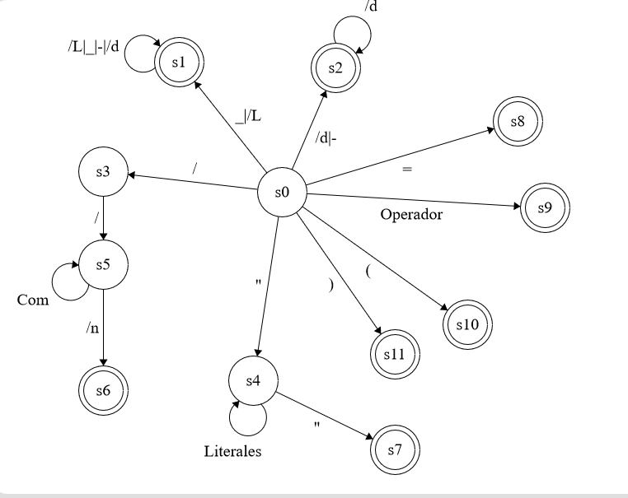

Análisis Semántico

**ESTRUCTURA ESCRITURA**

G = (N,T,P,S)

N ={Escritura,A}

T = {FIN,Id,Numero,Literal,Escribir}

S = { Escritura }

P =

Escritura 🡪 Escribir A FIN

A-🡪 Literal | Numero | Identificador

|  |  |  |
| --- | --- | --- |
| NoTerminal | Primero | Siguiente |
| Escritura | Escribir | $ |
| A | Literal,Numero,Identificador | FIN |

Tabla de Analisis

|  |  |  |  |  |  |  |
| --- | --- | --- | --- | --- | --- | --- |
|  | Escribir | Literal | Numero | Identificador | Fin | $ |
| ESCRITURA | EscribirAFIN |  |  |  |  |  |
| A |  | Literal | Numero | Identificador |  |  |

ESTRUCTURA REPETIR

G = (N,T,P,S)

N ={R,B,P,Escritura,A}

T = {Num,Identificador,Literal,ESCRIBIR,FIN,Inicio,REPETIR}

S = {R}

P= R🡪Repetir B Inicio P FIN

B-> Num | Identificador

P-> Escritura P | ε

Escritura 🡪 Escribir A FIN

A-🡪 Literal | Numero | Identificador

|  |  |  |
| --- | --- | --- |
| NoTerminal | Primeros | Siguientes |
| R | Repetir | $ |
| B | Num,Identificador | Inicio |
| P | Escritura,e | FIN |
| Escritura | Escribir | id,num,literal,FIN |
| A | LiteraL,Num,Identificador | FIN |

TABLA DE ANALISIS

|  |  |  |  |  |  |  |  |  |
| --- | --- | --- | --- | --- | --- | --- | --- | --- |
| NoTerminal | REPETIR | Num | Id | Literal | ESCRIBIR | FIN | INICIO | $ |
| R | REPETIRBINICIOPFIN |  |  |  |  |  |  |  |
| B |  | Num | Id |  |  |  |  |  |
| P |  |  |  |  | ESCRITURAP | e |  |  |
| Escritura |  |  |  |  | ESCRIBIRAFIN |  |  |  |
| A |  | Num | Id | Literal |  |  |  |  |

ESTRUCTURA CONDICIONAL

G = (N,T,P,S)

N ={W,V,Condicional,Escritura,A}

T = {SI,ENTONCES,FIN,ESCRIBIR,FIN,Literal,Numero,Identificador,VERDADERO,FALSO}

S = {Condicional}

P=

{

Condicional -> SI W ENTONCES V FIN

W -> VERDADERO | FALSO

V-> Escritura | ε

Escritura -> ESCRIBIR A FIN

A -> Literal|Numero|Identificador

}

|  |  |  |
| --- | --- | --- |
| NoTerminal | Primeros | Siguientes |
| Condicional | SI | $ |
| W | VERDADERO,FALSO | ENTONCES |
| V | e,ESCRIBIR | FIN |
| Escritura | ESCRIBIR | FIN |
| A | Literal,Num,Id | FIN |

|  |  |  |  |  |  |  |  |  |  |  |
| --- | --- | --- | --- | --- | --- | --- | --- | --- | --- | --- |
|  | SI | ESCRIBIR | ENTONCES | VERDADERO | FALSO | Literal | Num | Id | Fin | $ |
| Condicional | SIWENTONCESVFIN |  |  |  |  |  |  |  |  |  |
| W |  |  |  | VERDADERP | FALSO |  |  |  |  |  |
| V |  | ESCRITURA |  |  |  |  |  | e |  |  |
| Escritura |  | ESCRIBIRAFIN |  |  |  |  |  |  |  |  |
| A |  |  |  |  |  | Literal | Num | Id |  |  |

ESTRUCTURA EXPRESION

G = (N,T,P,S)

N ={X,T,X’,T’,E}

T = {(,),Id,Num }

S = {X}

P=

X -> TX’

T -> ET’ | ε

T’ -> *ET | ε

X’ -> +TX’ | ε

E -> Id | ( X ) | Num

|  |  |  |
| --- | --- | --- |
| NoTerminal | Primeros | Siguientes |
| X | e,Id,(,Num | $,) |
| T | e,Id,(,Num | +,$,) |
| X' | +,e | $.) |
| T' | *,e | +,$,) |
| E | id,num,( | *,+,$,),Id,num,(,),$ |

TABLA ANALISIS

|  |  |  |  |  |  |  |  |
| --- | --- | --- | --- | --- | --- | --- | --- |
|  | **Id** | **Num** | **(** | **)** | **+** | **\*** | **$** |
| **X** | TX' | TX' | TX' | e |  |  | e |
| **T** | ET' | ET' | ET' | e | e |  | e |
| **X'** |  |  |  | e | +TX' |  | e |
| **T'** |  |  |  | e | e | *ET | e |
| **E** | Id | Num | ( |  |  |  |  |

**EXPRESION ASIGNACION**

G = (N,T,P,S)

N ={Asignacion,Expresion,T,X’,T’,E}

T = {Identificador,=,FIN,(,),Num}

S = {Asignacion}

P=

Asignacion -> Identificador = Expresion Fin

Expresion -> TX’

T -> ET’ | ε

T’ -> *ET | ε

X’ -> +TX’ | ε

E -> Id | ( Expresion ) | Num.

|  |  |  |
| --- | --- | --- |
| NoTerminal | Primeros | Siguientes |
| Asignacion | Identificador | $ |
| Expresion | e,Id,(,Num | FIN,) |
| T | e,Id,(,Num | +,FIN,) |
| X' | +,e | FIN,) |
| T' | *,e | +,FIN,) |
| E | id,num,( | *,FIN,+,),id,(,num |

|  |  |  |  |  |  |  |  |  |  |
| --- | --- | --- | --- | --- | --- | --- | --- | --- | --- |
|  | Id | Num | = | FIN | ( | ) | + | * | $ |
| Asignacion | Id=ExpresionFin |  |  |  |  |  |  |  |  |
| Expresion | TX' | TX' |  | e | TX' | e |  |  |  |
| T | ET' | ET' |  |  | ET' |  |  |  |  |
| X' |  |  |  | e |  | e | +TX' |  |  |
| T' |  |  |  | e |  | e | e | *ET |  |
| E | Id | Num |  |  | ( |  |  |  |  |

**EXPRESION GENERAL**

G = (N,T,P,S)

N ={ S,Escritura,R,Condicional,Expresion,Asignacion,A,B,P,W,V,T,X’,T’,E

T = {(,),Id,Num,+,*,Literal,=}

S = {X}

P=

S -> EscrituraS | RS | CondicionalS | ExpresionS | AsignacionS | ε

Escritura -> Escribir A FIN

A -> Literal | Numero | Identificador

R -> REPETIR B INICIO P FIN

B -> Num | Identificador

P -> Escritura P | ε

Condicional -> SI W ENTONCES V FIN

W -> VERDADERO | FALSO

V -> Escritura | ε

Expresion -> TX’

T -> ET’ | ε

X’ -> +TX’ | ε

T’ -> *ET | ε

E -> Id | Num | ( Expresion )

Asignacion -> Identificador = Expresion FIN

|  |  |  |
| --- | --- | --- |
|  | PRIMEROS | SIGUIENTES |
| S | ε,Escribir,Repetir,Si,id,num,( | $ |
| ESCRITURA | Escribir | ε,Escribir,Repetir,Si,id,num,(,$ |
| R | Repetir | ε,Escribir,Repetir,Si,id,num,(,$ |
| CONDICIONLA | Si | ε,Escribir,Repetir,Si,id,num,(,$ |
| EXPRESION | Id,num,(,e | ε,Escribir,Repetir,Si,id,num,(,$,FIN,) |
| ASIGNACION | id | ε,Escribir,Repetir,Si,id,num,(,$ |
| A | Literal,num,id | FIN |
| B | Num,id | INICIO |
| P | Escribir,ε | FIN |
| W | Verdadero,falso | ENTONCES |
| V | Escribir,e | FIN |
| T | Id,num,(,e | ε,Escribir,Repetir,Si,id,num,(,$,+,) |
| T' | *,ε | ε,Escribir,Repetir,Si,id,num,(,$,+,FIN,) |
| X' | +,ε | ε,Escribir,Repetir,Si,id,num,(,$,FIN,) |
| E | Id,num,( | ε,Escribir,Repetir,Si,id,num,(,$,+,* |

|  |  |  |  |  |  |  |  |  |  |  |  |  |  |  |  |  |  |
| --- | --- | --- | --- | --- | --- | --- | --- | --- | --- | --- | --- | --- | --- | --- | --- | --- | --- |
|  | Num | Identificador | + | * | Literal | ( | ) | = | ESCRIBIR | FIN | SI | VERD | FALSO | REPETIR | INICIO | ENTONC | $ |
| S | ExpresionS | EXP/ASIG |  |  |  | ExpresionS |  |  | EscrituraS |  | CondicionalS |  |  | RS |  |  | e |
| ESCRITURA |  |  |  |  |  |  |  |  | Escribir-A-FIN |  |  |  |  |  |  |  |  |
| R |  |  |  |  |  |  |  |  |  |  |  |  |  | REPETIR-B-INICIO-P-FIN |  |  |  |
| CONDICIONAL |  |  |  |  |  |  |  |  |  |  | SI-W-ENT-V-FIN |  |  |  |  |  |  |
| EXPRESION | TX' | TX' |  |  |  | TX' |  |  |  |  |  |  |  |  |  |  |  |
| ASIGNACION |  | Id=ExpresionFin |  |  |  |  |  |  |  |  |  |  |  |  |  |  |  |
| A | Num | Id |  |  | Literal |  |  |  |  |  |  |  |  |  |  |  |  |
| B | Num | id |  |  |  |  |  |  |  |  |  |  |  |  |  |  |  |
| P |  |  |  |  |  |  |  |  | ESCRITURA-P | e |  |  |  |  |  |  |  |
| W |  |  |  |  |  |  |  |  |  |  |  | VERD | FALSO |  |  |  |  |
| V |  |  |  |  |  |  |  |  | ESCRITURA | e |  |  |  |  |  |  |  |
| X´ | e | e | +TX' |  |  | e | e |  | e | e | e |  |  | e |  |  | e |
| T | ET' | ET' | e |  |  | ET' |  |  | e |  | e |  |  | e |  |  | e |
| T´ | e | e | e | *ET' |  |  | e |  | e | e | e |  |  | e |  |  | e |
| E | num | Id |  |  |  | (EXPRESION) |  |  |  |  |  |  |  |  |  |  |  |

TABLA ANALISIS AUTOMATA PILA