**Supplemental Figure 1:** Workflow for SCRS of isolated lymphoid and myeloid immune cell populations from ccRCC subjects and computational analysis. SCRS data across ccRCC and data derived from 10x Genomics and EGAS00001002325 were integrated using SCTtransform approach to form a UMAP of 37,055 from 7 different samples and acting as a basis for subclustering and further analysis by cell type.

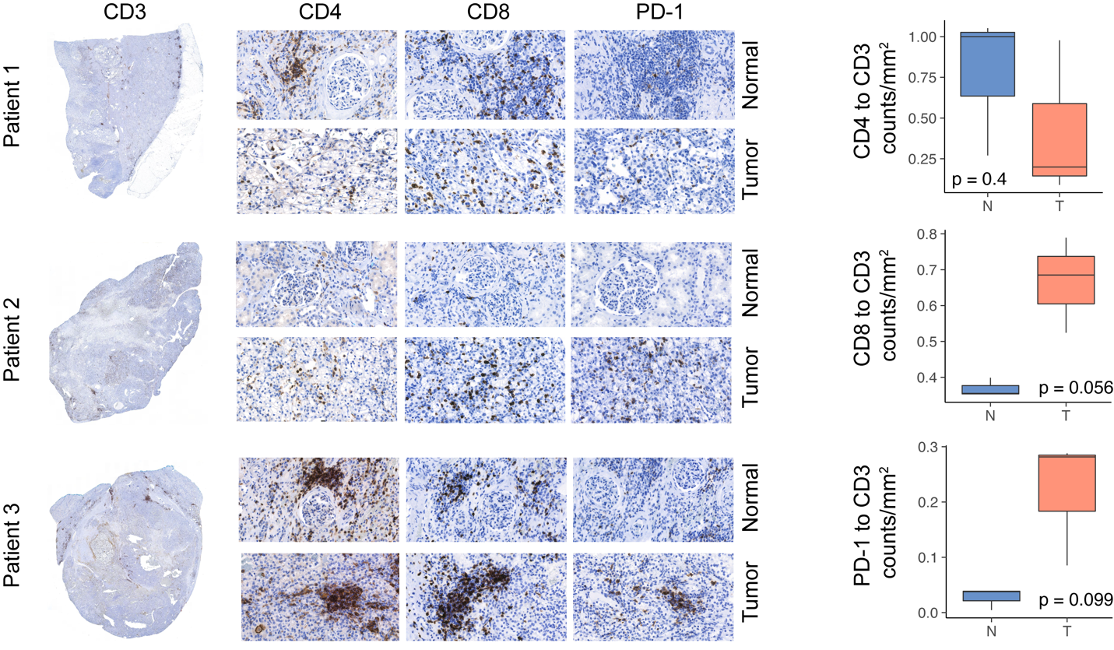

**Supplemental Figure 2:** Immunohistochemical results for T cell staining in paired normal and tumor tissue with quantified ratios of counts per unit area.

**Supplemental Figure 3:** Top clonotypes for CD8+ T cells for each patient by proportion in each subcluster.

**Supplemental Figure 4: A**. UMAP subclustering of myeloid cells (original clusters 4, 6, 10, 13, 15, and 20). **B**. Normalized correlation values for predicted immune cell phenotypes based on the SingleR R package for selected subclusters. **C**. Percent of cells expressing canonical immune cell markers across the UMAP.

**Supplemental Figure 5:** Z-transformed normalized enrichment scores from ssGSEA for MHC-related gene sets in the C5 library of the Molecular Signature Database by APC/Myeloid subcluster.

**Supplemental Figure 6**: A. mRNA expression of signature genes for CD8_6 (upper panel) and TAM_3 (lower panel) by histological grade (x-axis) and k-nearest neighbor model prediction.

**Supplemental Methods**

*Highthroughput IHC quantification*

Normal and ccRCC tumor samples from the 3 patients were formalin-fixed and paraffin-embedded samples. After antigen-retrieval, samples were stained for the following antibodies: . Digital images of 24 IHC-stained slides were obtained using the 3DHistech P1000 Panoramic Scanner (3DHistech, Budapest, Hungary). Each slide was annotated in CaseViewer (3DHistech) for tumor and or normal tissue. Areas with abundant artifact were annotated and subtracted. Image-based algorithms were created for detecting positive cells based on stain intensity using QuantCenter Image Analysis Framework software (3DHistech) and normalized per area analyzed.

*Normal Renal SCRS*

Normal renal SCRS was derived from previously published work (1) and downloaded from the GEO Omnibus under the accession GSE131685. Data was processed and integrated as described in the manuscript. The dimensional reduction to form the UMAP utilized the top 40 calculated dimensions and a resolution of 0.7.

**References**

1. Liao J, Yu Z, Chen Y, Bao M, Zou C, Zhang H, et al. Single-cell RNA sequencing of human kidney. Sci data. Nature Publishing Group; 2020;7:1–9.