**Leave Approval**

This letter serves as a formal certification of leave approval for **Zhuo Wei**, a student of the School of Intelligent Systems Engineering at Sun Yat-sen University. Zhuo Wei has been granted permission to travel to Austria from May 6, 2024, to May 12, 2024, for the purpose of attending The Twelfth International Conference on Learning Representations (ICLR). According to the schedule, he will stay in there for almost 7 days. All the expenses including the transportation, the accommodation, the meals and the health insurance will be furnished by himself. He will abide by the laws in Schengen countries and will return to China as soon as his trip is over.

Name Gender Date of Birth Passport-No.

Zhuo Wei Male 13.12.1994 EA8383719

Yours sincerely;

Name of the leader: Tan Guang

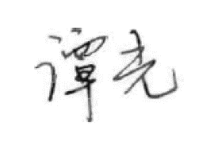Position of the leader: Vice Dean

Signature:

Sun Yat-sen University

Tel: 0755-23260166

Add: No.66, Gongchang Road, Guangming District, Shenzhen, Guangdong 518107, P.R.China