山 东 师 范 大 学

实 验 报 告
课 程 计算机操作系统 班 级 计联培1901
实验号数 1 姓 名 姬彬荃
实验日期 2020.11.13 题 目 进程调度FSFC和SJF算法 教师签字

- 实验目的
先来先服务FCFS和短作业优先SJF进程调度算法。
- 实验内容
1、FCFS算法C++模拟。
2、SJF算法C++模拟。
- 具体实验过程
- /*************************************************
- ** 功能 : 先来先服务FCFS和短作业优先SJF进程调度算法
- ** 作者 : 2019Jibinquan
- ** 创建 : 2020-11-18 / 14:41
- ** 版权 : 431263064@qq.com
- /**************************************************/

- #include <iostream>
- #include <cstdio>
- #include <cmath>
- #include <algorithm>
- #include <cstring>
- #include <queue>
- #include <stack>
- #include <vector>
- #include <map>
- #include <set>
- #include <sstream>
- #define ios ios::sync_with_stdio(false);cin.tie(0);cout.tie(0);
- #define debug(a) cout << #a << " " << a << endl
- using namespace std;
- typedef long long ll;
- const double pi = acos(-1);
- const double eps = 1e-8;
- const int inf = 0x3f3f3f3f;
- const int maxn = 100007;//1e5+7
- const ll mod = 1000000007;//1e9+7

- struct proc {
- int id;
- int arr_tim;
- int sta_tim;
- int sev_tim;
- int end_tim;
- int turn_tim;
- double wit_tim;
- bool operator<(const proc& a) const
- {
- return sev_tim > a.sev_tim;
- }
- }lis[maxn];

- int n;
- int Time;

- /*----------------------------------*
- Function Definition
- *-----------------------------------*/

- void inital()
- {
- Time = 0;
- memset(lis, 0, sizeof(lis));
- }

- bool cmp(proc a, proc b)
- {
- if (a.arr_tim != b.arr_tim) {
- return a.arr_tim < b.arr_tim;
- }
- else {
- return a.sev_tim < b.sev_tim;
- }
- }

- void input()
- {
- cout << "请输入进程数：" << endl;
- cin >> n;
- cout << "请输入到达时间" << endl;
- for (int i = 1; i <= n; i++) {
- cin >> lis[i].arr_tim;
- }
- cout << "请输入服务时间:" << endl;
- for (int i = 1; i <= n; i++) {
- cin >> lis[i].sev_tim;
- }
- for (int i = 1; i <= n; i++) {
- lis[i].id = i;
- }
- }

- string sc[5];

- string trans(int nu)
- {
- stringstream ss;
- ss << nu;
- return ss.str();
- }

- void FCFS()
- {
- sort(lis + 1, lis + 1 + n, cmp);
- queue<proc>que;
- queue<proc>ans;
- int zz = 1;
- int sk = 1;
- int run_tim = 0;
- proc runing;
- bool flag = 0;
- runing.arr_tim = -1;
- while (run_tim <= maxn - 7) {
- int tp = 0;
- while (lis[zz].arr_tim == run_tim) {
- sc[++tp] = " 进程" + trans(lis[zz].id) + "到达队列";
- que.push(lis[zz]);
- zz++;
- }
- if (runing.arr_tim != -1) {
- if (runing.end_tim == run_tim) {
- sc[++tp] = " 进程" + trans(runing.id) + "执行完毕";
- ans.push(runing);
- runing.arr_tim = -1;
- if (ans.size() == n) {
- flag = 1;
- }
- }
- }
- if (runing.arr_tim == -1) {
- if (que.size()) {
- runing = que.front();
- que.pop();
- runing.sta_tim = run_tim;
- runing.end_tim = runing.sta_tim + runing.sev_tim;
- runing.turn_tim = runing.end_tim - runing.arr_tim;
- runing.wit_tim = runing.turn_tim * 1.0 / runing.sev_tim;
- sc[++tp] = " 进程" + trans(runing.id) + "开始执行";
- }
- }
- if (tp) {
- cout << "时刻" << sk++ << ": " << run_tim << ": " << endl;
- for (int i = 1; i <= tp; i++) {
- cout << sc[i] << endl;
- }
- cout << endl;
- }
- if (flag) {
- cout << endl << "作业全部结束,执行顺序：" << endl << endl;
- double t_sum = 0, w_sum = 0;
- while (!ans.empty()) {
- proc nw = ans.front();
- ans.pop();
- cout << " 作业" << nw.id << ": " << " 到达时间：" << nw.arr_tim << " 开始时间：" << nw.sta_tim << " 运行时间：" << nw.sev_tim << " 结束时间：" << nw.end_tim << " 周转时间：" << nw.turn_tim << " 带权周转时间：" << nw.wit_tim << endl;
- t_sum += nw.turn_tim;
- w_sum += nw.wit_tim;
- }
- cout << endl << " 平均周转时间：" << t_sum / n << " 平均带权周转时间：" << w_sum / n << endl;
- break;
- }
- run_tim++;
- }
- }

- void SJF()
- {
- sort(lis + 1, lis + 1 + n, cmp);
- priority_queue<proc>que;
- queue<proc>ans;
- int zz = 1;
- int sk = 1;
- int run_tim = 0;
- proc runing;
- runing.arr_tim = -1;
- bool flag = 0;
- while (run_tim <= maxn - 7) {
- int tp = 0;
- while (lis[zz].arr_tim == run_tim) {
- sc[++tp] = " 进程" + trans(lis[zz].id) + "到达队列";
- que.push(lis[zz]);
- zz++;
- }
- if (runing.arr_tim != -1) {
- if (runing.end_tim == run_tim) {
- sc[++tp] = " 进程" + trans(runing.id) + "执行完毕";
- ans.push(runing);
- runing.arr_tim = -1;
- if (ans.size() == n) {
- flag = 1;
- }
- }
- }
- if (runing.arr_tim == -1) {
- if (que.size()) {
- runing = que.top();
- que.pop();
- runing.sta_tim = run_tim;
- runing.end_tim = runing.sta_tim + runing.sev_tim;
- runing.turn_tim = runing.end_tim - runing.arr_tim;
- runing.wit_tim = runing.turn_tim * 1.0 / runing.sev_tim;
- sc[++tp] = " 进程" + trans(runing.id) + "开始执行";
- }
- }
- if (tp) {
- cout << "时刻" << sk++ << ": " << run_tim << ": " << endl;
- for (int i = 1; i <= tp; i++) {
- cout << sc[i] << endl;
- }
- cout << endl;
- }
- if (flag) {
- cout << endl << "作业全部结束,执行顺序：" << endl << endl;
- double t_sum = 0, w_sum = 0;
- while (!ans.empty()) {
- proc nw = ans.front();
- ans.pop();
- cout << " 作业" << nw.id << ": " << " 到达时间：" << nw.arr_tim << " 开始时间：" << nw.sta_tim << " 运行时间：" << nw.sev_tim << " 结束时间：" << nw.end_tim << " 周转时间：" << nw.turn_tim << " 带权周转时间：" << nw.wit_tim << endl;
- t_sum += nw.turn_tim;
- w_sum += nw.wit_tim;
- }
- cout << endl << " 平均周转时间：" << t_sum / n << " 平均带权周转时间：" << w_sum / n << endl;
- break;
- }
- run_tim++;
- }
- }

- void choose_Algorithm()
- {
- int op;
- cout << "请选择算法类别：0为FCFS，1为SJF,-1结束：" << endl;
- while (cin >> op) {
- if (op == 1) {
- cout << endl << "SJF算法：" << endl << endl;
- SJF();
- cout << endl << endl;
- }
- else if (op == 0) {
- cout << endl << "FCFS算法：" << endl << endl;
- FCFS();
- cout << endl << endl;
- }
- else if(op == -1) {
- break;
- }
- else {
- cout << "指令错误！" << endl;
- }
- cout << "请选择算法类别：0为FCFS，1为SJF,-1结束：" << endl;
- }
- }

- /*----------------------------------*
- Main Function
- *-----------------------------------*/

- int main()
- {
- inital();
- input();
- choose_Algorithm();
- system("pause");
- return 0;
- }
实验结果：
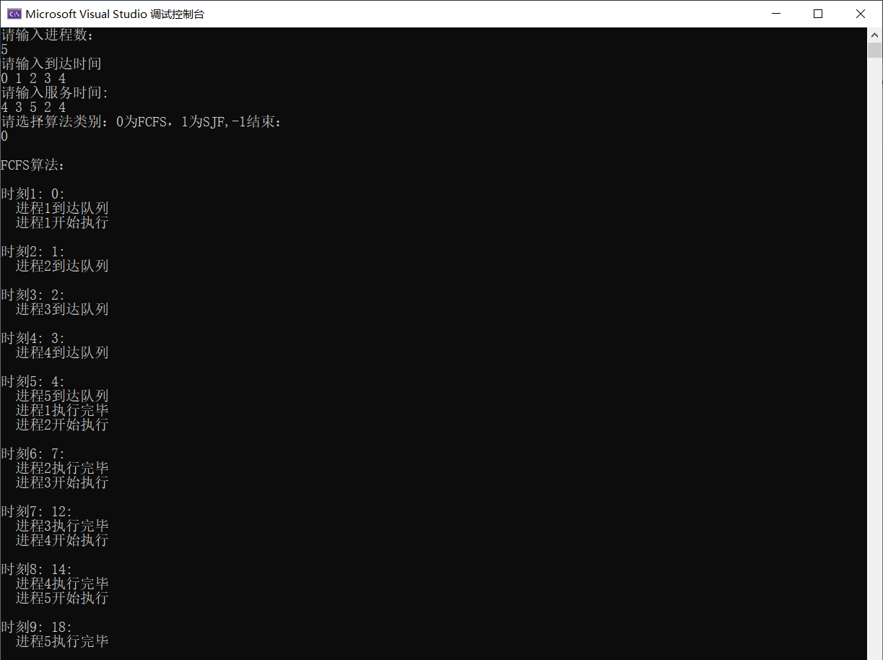
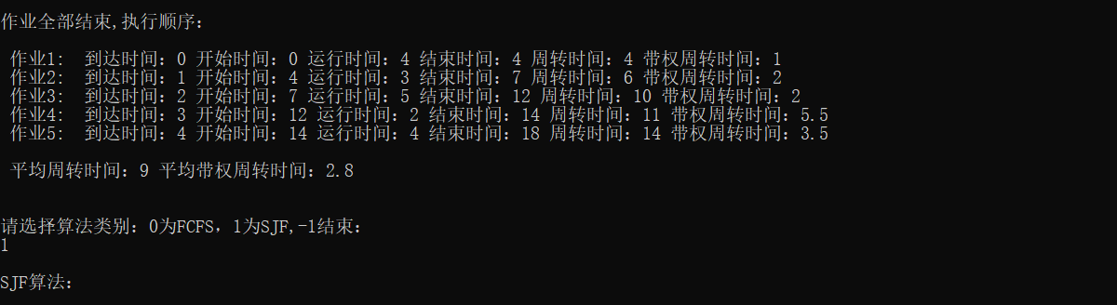
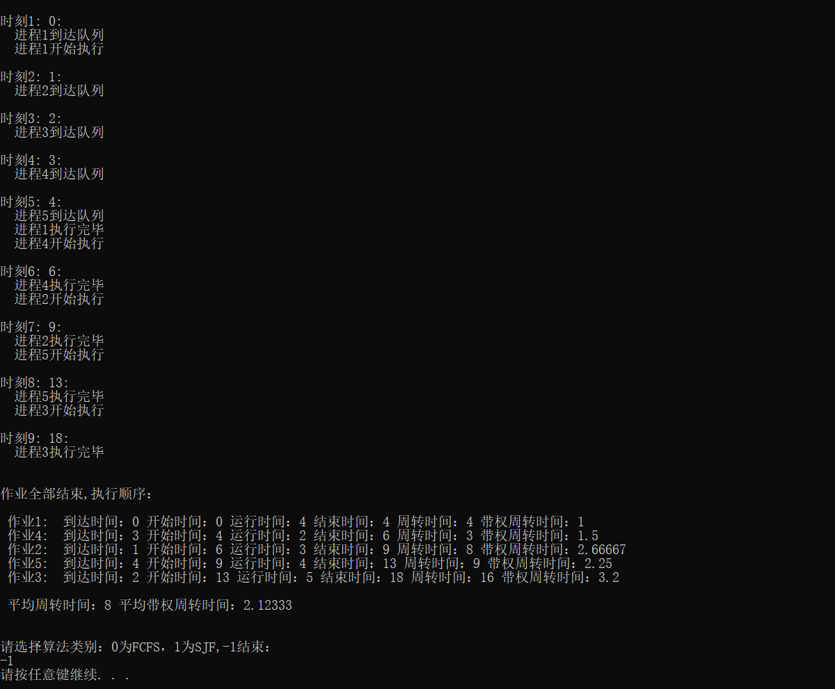
- 总结
通过本次实验熟悉了先来先服务FCFS和短作业优先SJF进程调度算法。

