**叽里咕噜组**

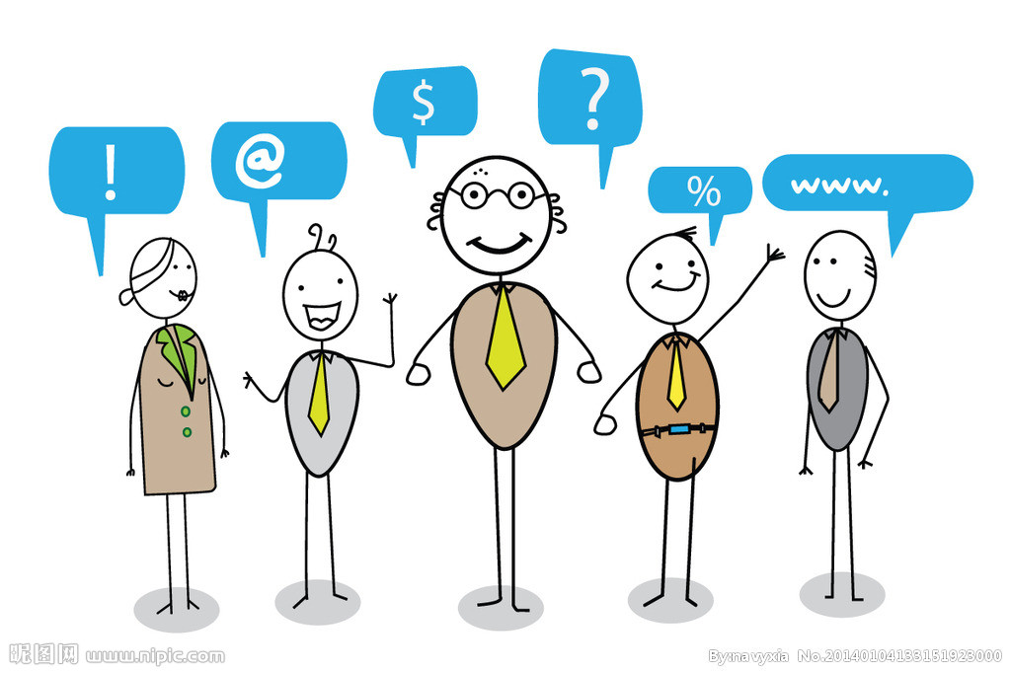

**"叽里咕噜啦...叽里咕噜啦"**

**快来听听他们在讨论什么？**

**Project conception**

**Panel presentation**