# CDC

Change Data Capture

starting with 2008

原理机制

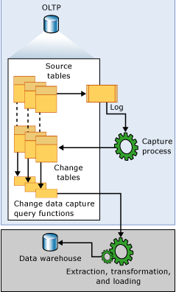

参考：<https://docs.microsoft.com/en-us/sql/relational-databases/track-changes/about-change-data-capture-sql-server?view=sql-server-2017>

# 发布订阅

Starting with 2000

能实现数据库的实时同步

向后兼容参考：<https://docs.microsoft.com/zh-cn/sql/relational-databases/replication/replication-backward-compatibility?view=sql-server-2017>

# Awayson

Starting with 2012

参考：<https://docs.microsoft.com/zh-cn/sql/database-engine/availability-groups/windows/always-on-availability-groups-sql-server?view=sql-server-2017>