intelligent-protector User Guide

**Revision: A**

**Prepared By:**

**Reviewed By:**

**Approved By:**

2018-2-2

Revision Record

| **Date** | **Revision Version** | **Change Description** | **Author** |
| --- | --- | --- | --- |
| 2018-02-02 | 1.00 | Completed the initial draft. |  |

Contents

1 Overview 2

1.1 Purpose 2

1.2 Applicable To 2

1.3 Introduction 2

1.4 Disclaimer 2

2 Obtaining the Source Code 2

3 Preparing for Compiling 2

3.1 Preparing the Windows Environment 2

3.1.1 Installing Microsoft Visual Studio 2010 2

3.1.2 Installing ActiveTcl 6

3.1.3 Installing Perl 9

3.1.4 Installing 7-Zip 13

3.1.5 Gawk 15

3.2 Compiling the Linux Environment 15

3.2.1 Tool List 15

3.2.2 Viewing System Tools 16

3.2.3 Installing gcc 17

3.2.4 Installing UUID 20

3.2.5 Installing tclsh 20

4 Performing the Compilation 20

4.1 Compiling the Windows Environment 20

4.2 Compiling the Linux Environment 22

5 FAQ During the Compilation 24

5.1 Q: If user AgentComp exists when creating the user directory, that is, directory /home/AgentComp exists, what can I do? 24

5.2 Q: What can I do if I cannot find directory AGENT_PACK_TEMP after the Agent is packaged? 24

5.3 Q: What can I do after Make: Must be a separator on rules line *xxx* is displayed when I try to package the software? 25

5.4 Q: What can I do after the following information displayed during the yum tool installation? 25

5.5 Q: What can I do after the following message is displayed when I try to package the software? 25

5.6 Q: What can I do when I cannot find some RPM packages and the following information is displayed after running find ./ "libppl.so7*"? 25

6 Install 25

6.1 Installing the intelligent-protector on a Linux-based Host 25

6.2 Installing intelligent-protector on a Windows-based Host 29

# Overview

## Purpose

This document helps users set up the compilation environment and compile the **intelligent-protector** package.

## Applicable To

Delivery reviewers

## Introduction

Objects to be compiled are the code of **intelligent-protector**. The product deliverables include downstream product packages and their related documents.

## Disclaimer

Links provided in this document may become outdated.

Charging software involved in this document must be purchased by customers.

note

The software version varies with the system version. Choose a proper one based on site conditions.

# Obtaining the Source Code

Download the source code of **intelligent-protector** from the official website of GitHub.

ssh: [git@github.com:wangguitao/intelligent-protector.git](mailto:git@github.com:wangguitao/intelligent-protector.git)

https: <https://github.com/wangguitao/intelligent-protector.git>

# Preparing for Compiling

## Preparing the Windows Environment

The compilation environment is Windows Server 2008 R2 Enterprise.

### Installing Microsoft Visual Studio 2010

Download Microsoft Visual Studio 2010 at:

[https://www.visualstudio.com](https://www.visualstudio.com/zh-hans/)

Go to the installation directory.

Double-click **autorun**.

Click **Install Microsoft Visual Studio 2010**.

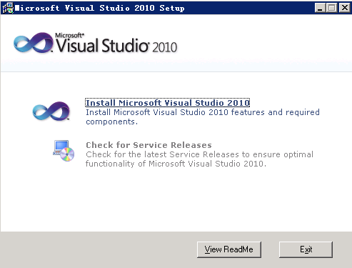

Click **Next**.

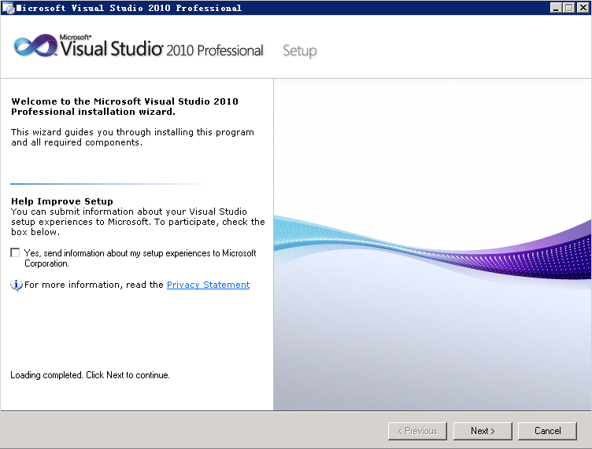

Click **Next**.

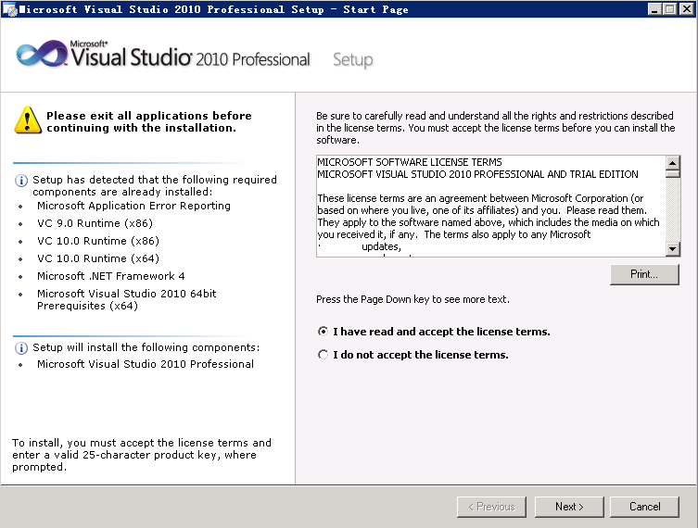

Click **Install**.

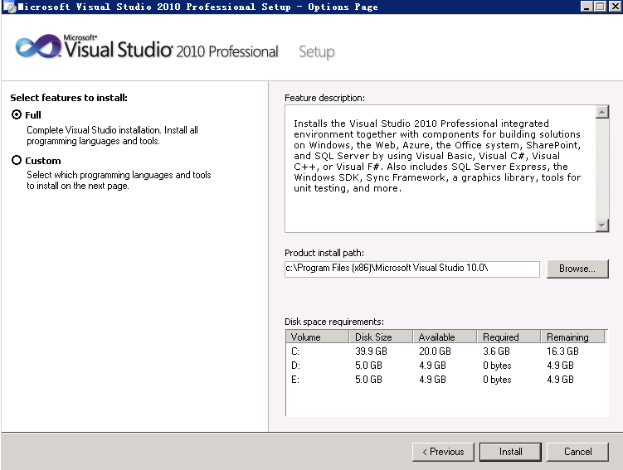

Click **Finish** to complete the installation.

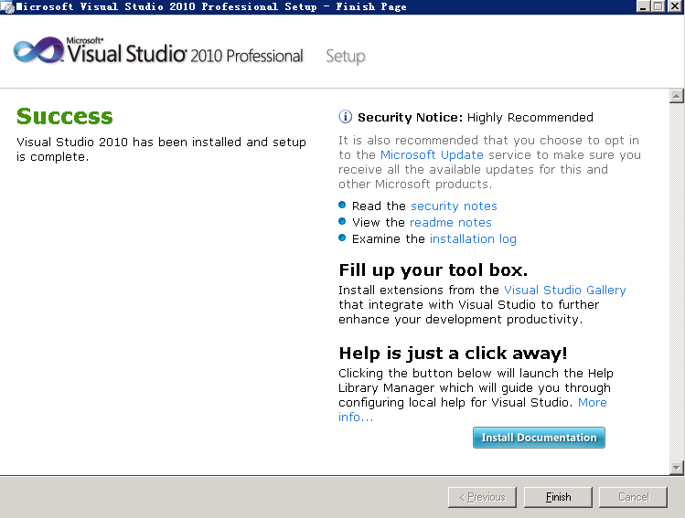

----End

### Installing ActiveTcl

ActiveTcl address: <https://www.activestate.com/activetcl/downloads>

Double-click **ActiveTcl8.5.5.0.287690-win32-ix86-threaded**.

Click **Next**.

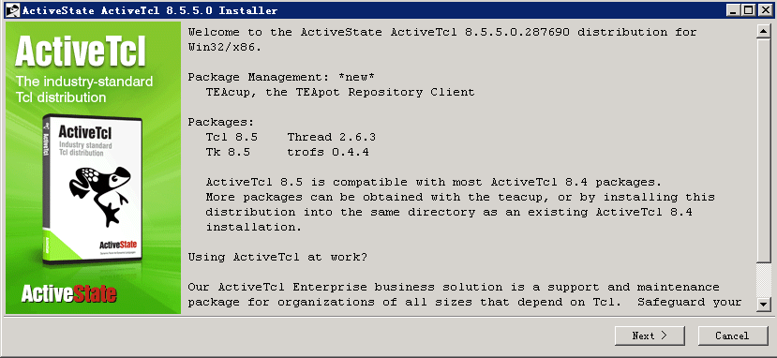

Click **Next**.

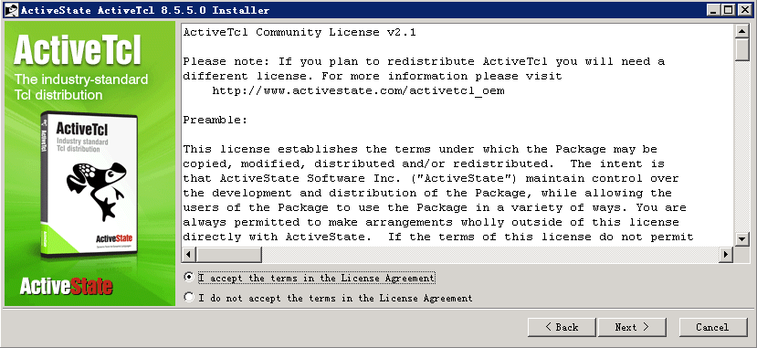

Click **Next**.

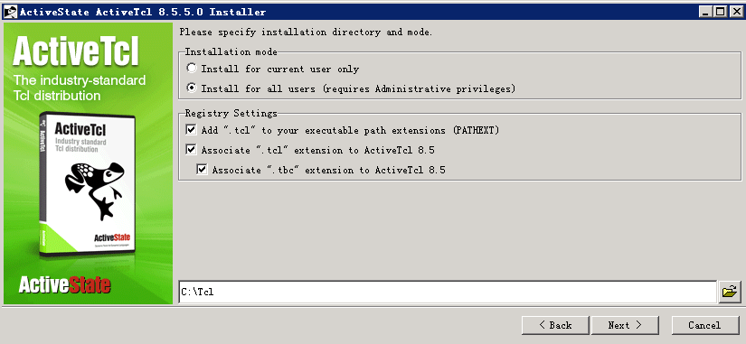

Click **Next**.

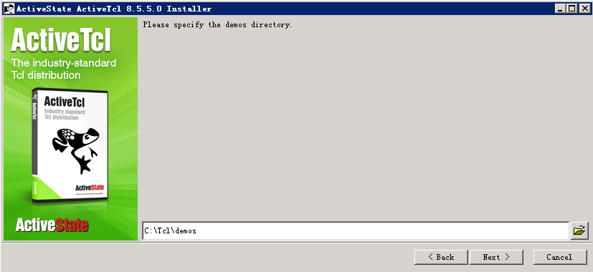

Click **Next**.

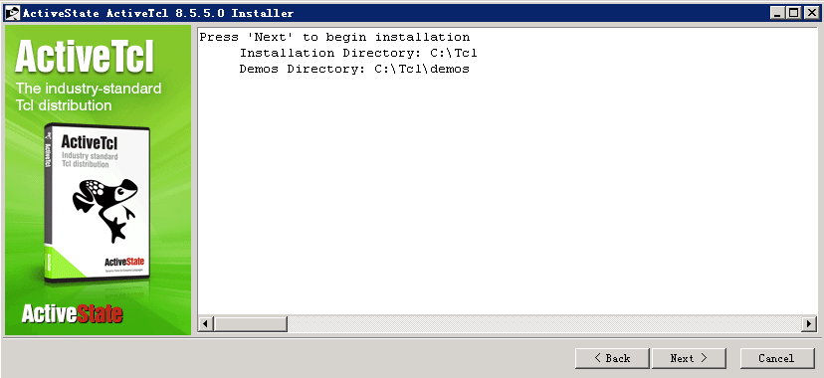

Click **Next**.

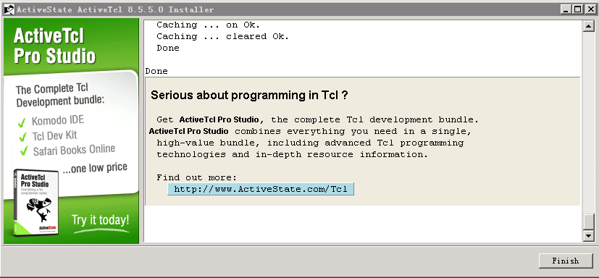

After the installation is successful, check whether **Tcl** has been added to the path of **Environment Variables**. If **Tcl** has not been added to the path, add it to the path manually.

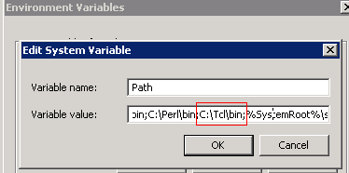

----End

### Installing Perl

Address: <https://www.activestate.com/activetcl/downloads>

Double-click **ActivePerl-5.16.3.1603-MSWin32-x86-296746**.

Click **Next**.

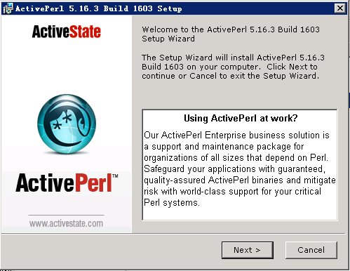

Click **Next**.

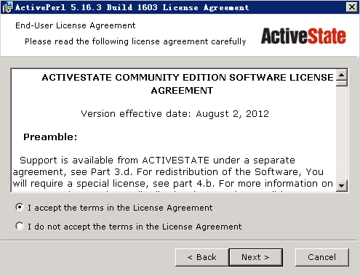

Click **Next**.

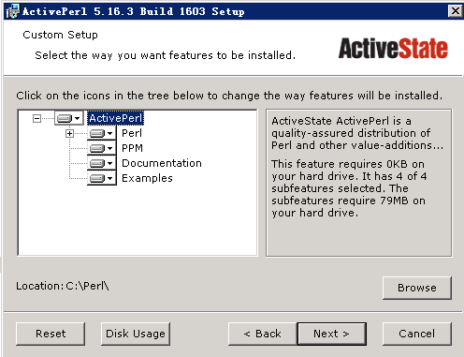

Click **Next**.

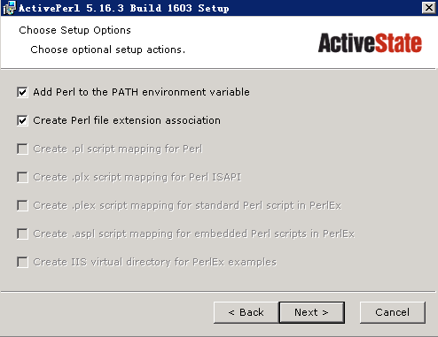

Click **Next**.

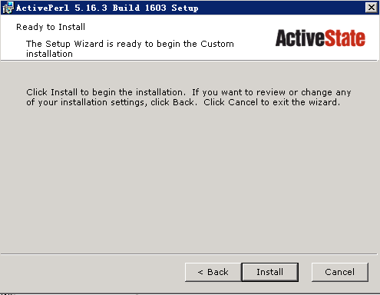

Click **Next**.

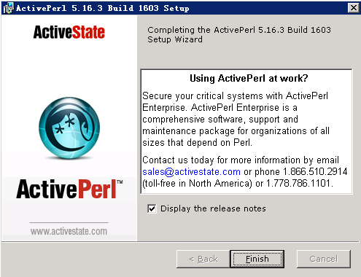

After the installation is successful, check whether **Tcl** has been added to the path of **Environment Variables**. If **Tcl** has not been added to the path, add it to the path manually. The **prel.exe** must be stored in the path.

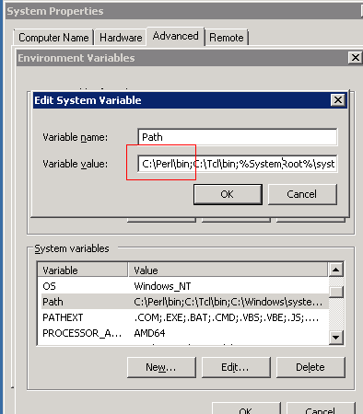

----End

### Installing 7-Zip

Address: <http://www.7-zip.org>.

Double-click **7z920**.

Install **7-Zip** to **C:\Program Files (x86)\7-Zip** and click **Install**.

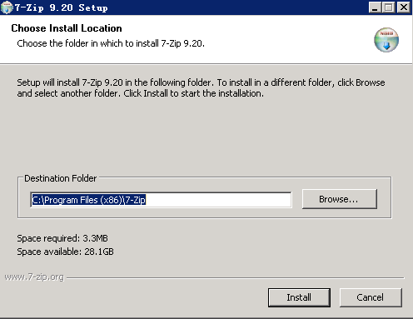

Click **Finish** to complete the installation.

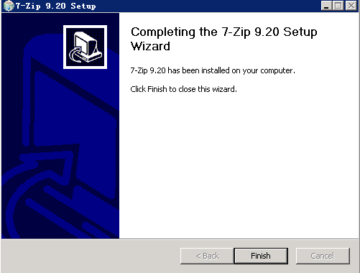

----End

### Gawk

Address:

<https://sourceforge.net/projects/gnuwin32/files/gawk/3.1.6-1/gawk-3.1.6-1-bin.zip/download?use_mirror=ncu&download>=

Put **gawk** (no installation required) into directory **C:\gawk**.

Set the save path to be an environmental variable.

The Windows environment is well prepared.

----End

## Compiling the Linux Environment

The Agent can be installed in the following Linux environments:

| **Operating System Version** | **gcc Version** | **Perl Version** | **tclsh Version** | **UUID Path** |
| --- | --- | --- | --- | --- |
| SUSE Linux Enterprise Server 11 SP1 (x86_64) | gcc4.3.4 | ActivePerl5.10.0 | Tclsh8.5.5 | /usr/include/uuid/uuid.h /lib64/libuuid.so.1.3.0 |
| SUSE Linux Enterprise Server 12 SP0 (x86_64) | gcc4.8.3 | ActivePerl5.18.2 | Tclsh8.6.1 | /usr/include/uuid/uuid.h |

### Tool List

Tools required on the Linux platform:

| **Compilation Tool and Compilation Environment** | **gcc** | **Perl** | **tclsh** | **UUID** |
| --- | --- | --- | --- | --- |
| SUSE Linux Enterprise Server 11 SP2 (x86_64) | 1. gcc-4.3-62.198.x86_64.rpm 2. gcc-c++-4.3-62.198.x86_64.rpm | Installed by default | Installed by default | libuuid-devel-2.16-6.8.2.x86_64.rpm |
| SUSE Linux Enterprise Server 12 SP0 (x86_64) | 1. gcc-4.8-6.189.x86_64.rpm 2. gcc-c++-4.8-6.189.x86_64.rpm | Installed by default | Installed by default | libuuid-devel-2.16-6.8.2.x86_64.rpm |

note

The system versions and installation methods of corresponding operating system versions are for reference only and are subject to the actual conditions. You can obtain relevant installation packages using the image file or Internet.

The following figure shows how to query the operating system version

SUSE Linux Enterprise Server 11 SP1 (x86_64)

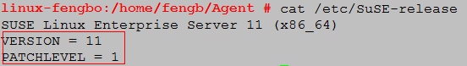

SUSE Linux Enterprise Server 12 SP0 (x86_64)

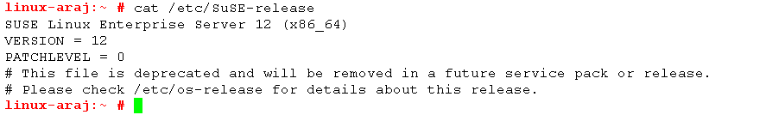

### Viewing System Tools

Install the tools as instructed in the following.

Run **gcc -v** to check the **gcc** version.

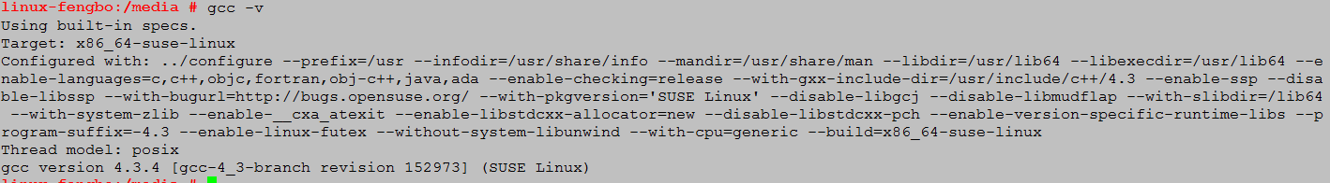

If information in the preceding figure is displayed, the tool has been installed.

Run **perl -v** to check the **perl** version.

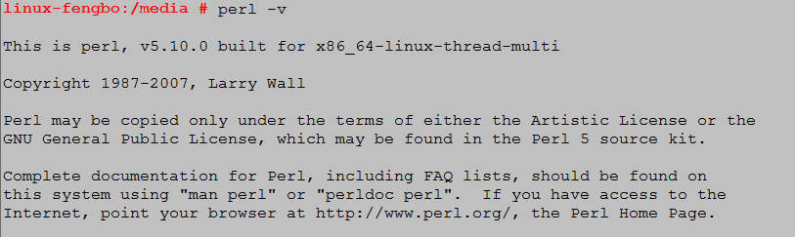

If information in the preceding picture is displayed, the tool has been installed.

Run **tclsh** to check the **tclsh** version.

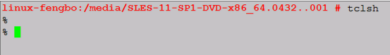

If information in the preceding picture is displayed, the tool has been installed.

Run **man 3 uuid** to check whether UUID is installed.

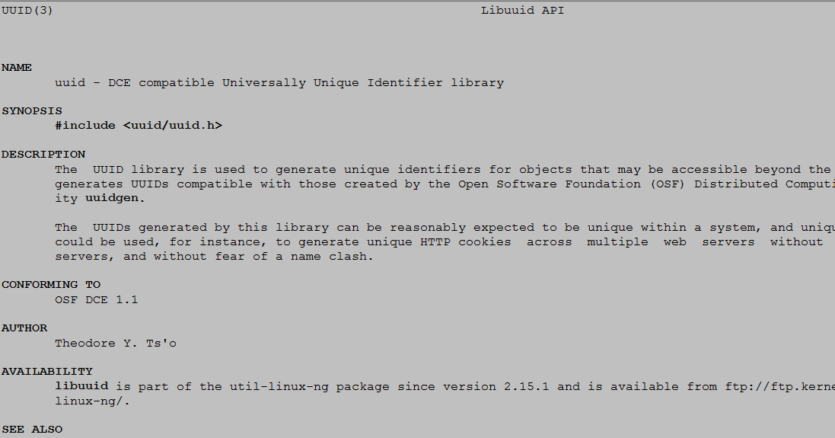

If information in the preceding picture is displayed, the tool has been installed.

### Installing gcc

Obtain the **gcc** installation package in the **ISO** image of the operating system.

Go to the directory where the **rpm** package resides and install **gcc**.

The following is an example of installing **SUSE Linux Enterprise Server 11 SP1 (x86_64)**.

rpm -ivh linux-kernel-headers-2.6.32-1.4.13.noarch.rpm

rpm -ivh glibc-devel-2.11.1 -0.17.4.x86_64.rpm

rpm -ivh gcc43-4.3.4_20091019-0.7.35.x86_64.rpm

rpm -ivh gcc-4.3-62.198.x86_64.rpm

rpm -ivh libstdc++43-devel-4.3.4_20091019-0.7.35.x86_64.rpm

rpm -ivh gcc43-c++-4.3.4_20091019-0.7.35.x86_64.rpm

rpm -ivh libstdc++-devel-4.3-62.198.x86_64.rpm

rpm -ivh gcc-c++-4.3-62.198.x86_64.rpm

Installation example: rpm -ivh gcc-c++-4.3-62.198.x86_64.rpm.

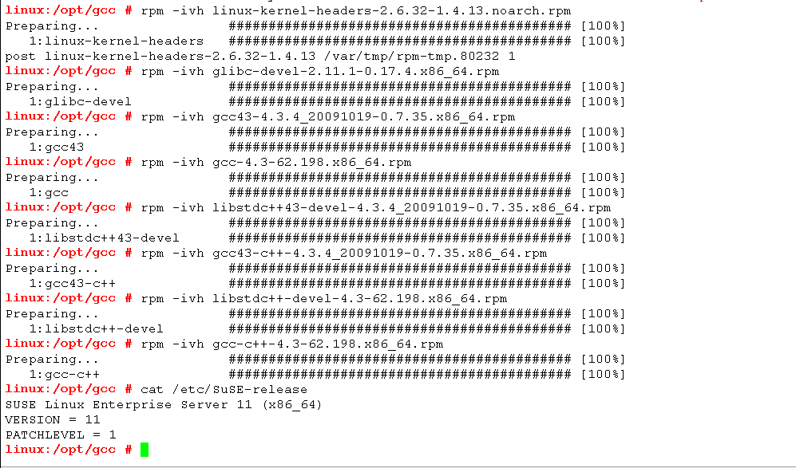

The installation of **Suse12 Linux Enterprise Server 11 SP0** is shown in the following figure.

All **rpm**s used to install **gcc** can be found in the **ISO** image file of Suse12. The following shows the installation procedure.

rpm -ivh linux-glibc-devel-3.12-3.98.noarch.rpm

rpm -ivh glibc-devel-2.19-17.72.x86_64.rpm

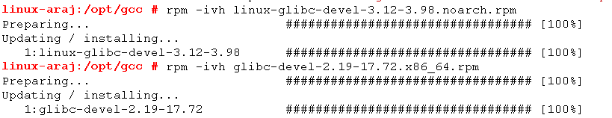

Install dependency packages.

rpm -ivh libasan0-4.8.3+r212056-6.3.x86_64.rpm

rpm -ivh libatomic1-4.8.3+r212056-6.3.x86_64.rpm

rpm -ivh libgomp1-4.8.3+r212056-6.3.x86_64.rpm

rpm -ivh libitm1-4.8.3+r212056-6.3.x86_64.rpm

rpm -ivh libtsan0-4.8.3+r212056-6.3.x86_64.rpm

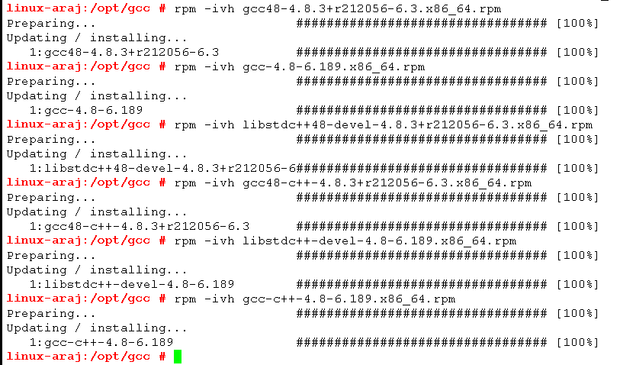

Install **gcc** and **gcc++**.

rpm -ivh gcc48-4.8.3+r212056-6.3.x86_64.rpm

rpm -ivh gcc-4.8-6.189.x86_64.rpm

rpm -ivh libstdc++48-devel-4.8.3+r212056-6.3.x86_64.rpm

rpm -ivh gcc48-c++-4.8.3+r212056-6.3.x86_64.rpm

rpm -ivh libstdc++-devel-4.8-6.189.x86_64.rpm

rpm -ivh gcc-c++-4.8-6.189.x86_64.rpm



note

Install the RPM packages mentioned in the installation tool list. You can find the related RPM packages based on the system prompts. The following shows an example by running **find ./ -name "ppl*"**.



----End

### Installing UUID

Downloading path: <https://pkgs.org/download/libuuid-devel>

Installation command of **SUSE Linux Enterprise Server 11 SP1 (x86_64)**:

**rpm -ivh libuuid-devel-2.16-6.8.2.x86_64.rpm**



Run the following installation commands of **SUSE Linux Enterprise Server 12 SP0 (x86_64)** to create a link file again.

**rpm -ivh libuuid-devel-2.16-6.8.2.x86_64.rpm --nodeps**

**[ -f "/usr/lib64/libuuid.so" ] && mv /usr/lib64/libuuid.so /usr/lib64/libuuid.so.bk**

**ln -f -s /usr/lib64/libuuid.so.1.3.0 /usr/lib64/libuuid.so**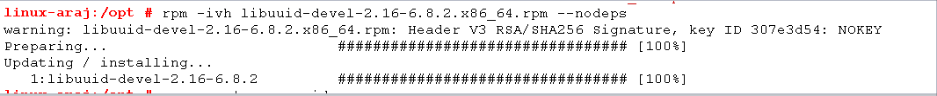

note

The installation method varies with the system version. Choose a proper one based on site conditions. For details, see section 3.2.1 "Tool List".

### Installing tclsh

Run **find ./ -name "*tcl*"** to find relevant RPM packages and install the **rpm –ivh** package.

Command used to install **tclsh** in Suse11:

**rpm -ivh tcl-8.5.5-2.81.x86_64.rpm**

Command used to install **tclsh** in Suse12:

**rpm -ivh tcl-8.6.1-2.10.x86_64.rpm**

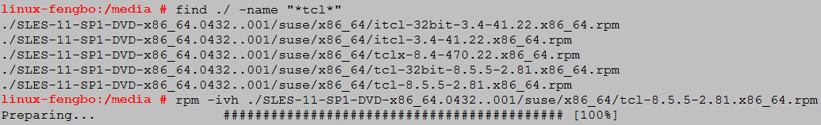

# Performing the Compilation

## Compiling the Windows Environment

Update the source code to **D:\AgentComp\Agent**.

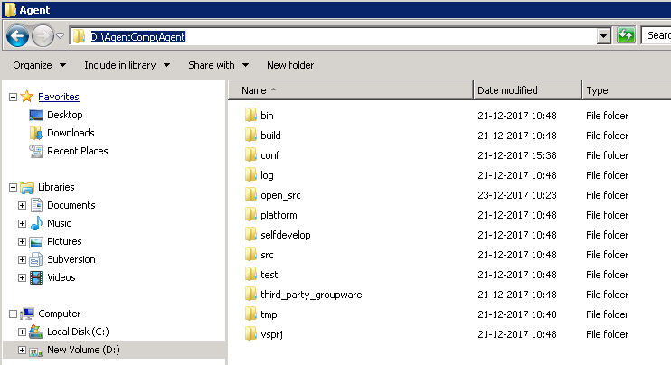

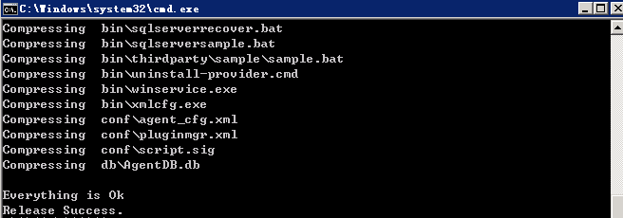

Go to directory **D:\AgentComp\Agent\build\ms** and run script **agent_pack.bat**.

After the **cmd** view is exited, the compilation is completed. View the **build.log** file in path **D:\AgentComp\Agent\build\ms\**. If the information shown in the following figure is displayed, the compilation succeeds.

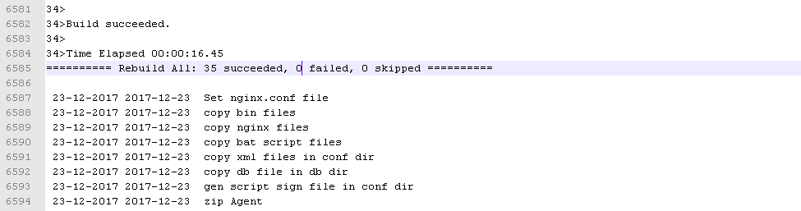

note

If no such information is displayed after 30 minutes, stop all **MSBuild.exe*32** processes, repeat Step 2, and open the task manager, as shown in the following figure.

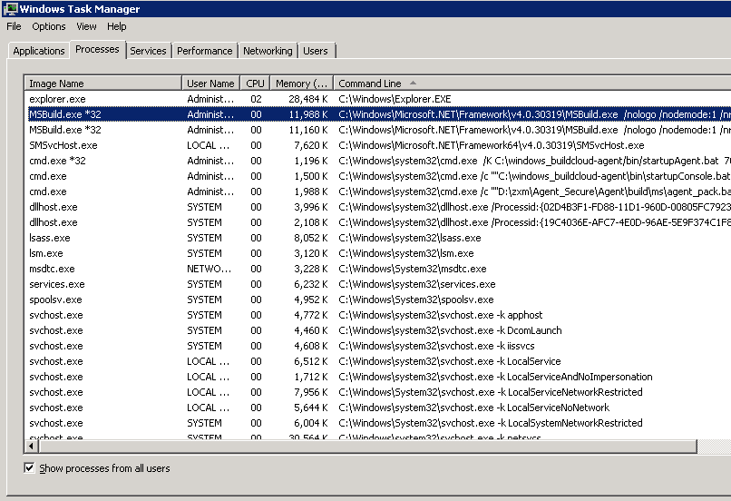

Because SQLite is cleared during the compilation, **No such file or directory** is displayed. This will not affect the compilation. After the compilation is complete, a package dedicated to Windows is generated in path **D:\AgentComp\Agent\build\ms\package**.

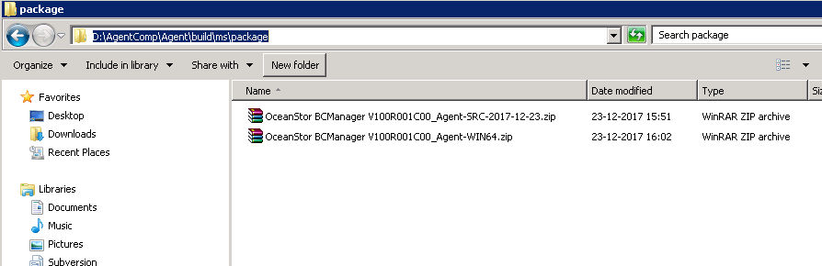

**OceanStor BCManager V100R001C00_Agent-WIN64.tar.gz** is the installation package.

**OceanStor BCManager V100R001C00_Agent-SRC-***date***.tar.gz** is the package of the source code.

----End

## Compiling the Linux Environment

Run **useradd -m -d /home/AgentComp -s /bin/bash AgentComp** to create user **AgentComp**.



Switch to directory **/home/AgentComp**. Under this directory, create directory **mkdir Agent** for the Agent.



Save the source code of the Agent to directory **/home/AgentComp/Agent**.



Run **chown -R AgentComp:users Agent** to change the owning group and owning user of the source code to the desired ones (user group **users** and user **AgentComp** are used as an example).

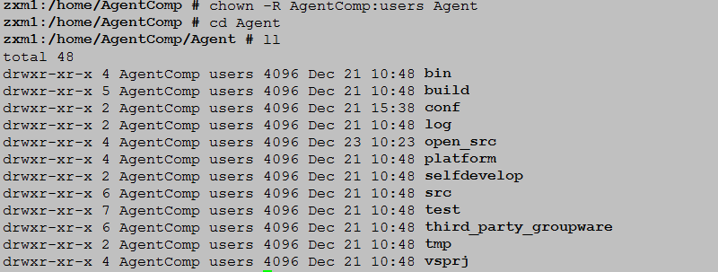

Run **su - AgentComp** to switch the user to **AgentComp**.



Go to directory **/home/AgentComp/Agent/build** (the **build** directory of the source code) and run **source env.sh** to set the environmental variables.



Run **./agent_pack.sh** to compile and package the Agent.

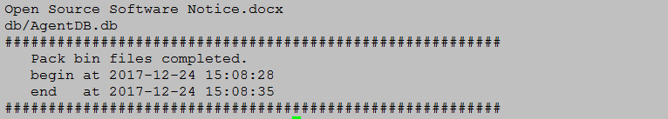

If **Pack bin files completed** is displayed, the packaging succeeds. The generated installation package and source code are archived to directory **${HOME}/AGENT_PACK_TEMP**.

1. Run **cd ${HOME}/AGENT_PACK_TEMP** to go to the generation directory of the installation package.

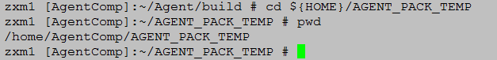

1. Run **ll** to check files under the directory.



**OceanStor BCManager V100R001C00_Agent-SuSE11-x86_64.tar.gz** is the installation package.

**OceanStor BCManager V100R001C00_Agent-SRC-***date***.tar.gz** is the package of the source code.

----End

# FAQ During the Compilation

## Q: If user AgentComp exists when creating the user directory, that is, directory /home/AgentComp exists, what can I do?

A: Specify a directory whose name does not exist under the **/home** user directory, such as **/home/AgentComp1**.

## Q: What can I do if I cannot find directory AGENT_PACK_TEMP after the Agent is packaged?

A: Run **ls –l /home** to view the permission on directory **/home/AgentComp**. If the owner of the directory is user **AgentComp**, the permission is correct. Alternatively, run **su- AgentComp** to view whether **$HOME** is set to **/home/AgentComp** and then run **echo $HOME**.

## Q: What can I do after Make: Must be a separator on rules line *xxx* is displayed when I try to package the software?

A: Check whether the environmental variables of the **GNU Make** have been properly set.

## Q: What can I do after the following information displayed during the yum tool installation?



A: View the configuration file **/etc/yum.repos.d/rhel-source.repo** of the **yum** tool to ensure that the configured **baseurl** is the upper directory of the mounting directory of the image file. Then, run **yum clean all**.

## Q: What can I do after the following message is displayed when I try to package the software?

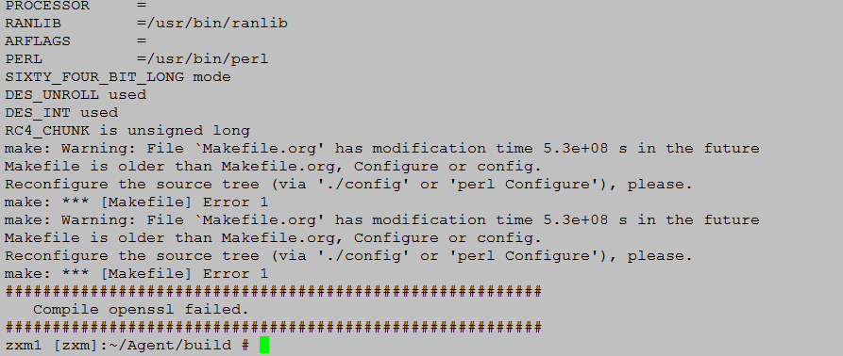

A: Check whether the system time is consistent with the current time.

## Q: What can I do when I cannot find some RPM packages and the following information is displayed after running find ./ "libppl.so7*"?

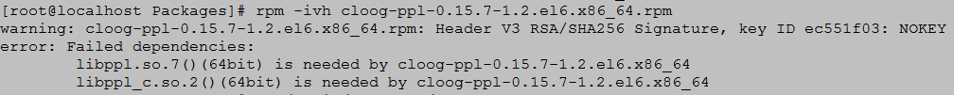

A: If dependency package **lib*.so\*** is displayed, run **find ./ "*ppl*"**.

# Install

## Installing the intelligent-protector on a Linux-based Host

This operation installs the intelligent-protector on a Linux-based host. The intelligent-protector starts automatically after being successfully installed. This section uses a SUSE10-based host as an example. The actual name of the installation package varies with versions.

* + - 1. Prerequisites
* You have compiled the package by referring to the compilation procedure.
  + - 1. Procedure

Check whether the firewall is enabled.

* If no, ensure whether the firewall is required.
* If yes, open the firewall port (port number: 59526) of the server where the Agent is to be installed.

Log in to the host for which you want to perform DR as user **root**.

The intelligent-protector must be installed by user **root**.

Create user **rdadmin**.

note

* When creating the user, you can set the Shell type to **bash**, **ksh**, or **csh**. This section uses **bash** as an example.
* User **rdadmin** has no permission to remotely log in to the host. Therefore, if you want to perform maintenance as user **rdadmin** after the installation, you need to log in to the DR host as user **root** and then run the **su - rdadmin** command to switch to user **rdadmin**.

Run the **echo $SHELL** command to view the default Shell type of user **rdadmin**.

The Shell type can be **bash**, **ksh**, or **csh**.

Run the **useradd** **-m -s /bin/bash** *rdadmin* command to create user **rdadmin**.

note

This section uses **/bin/bash** as the **bash** path. The actual path prevails.

User **rdadmin** already exists if **`rdadmin' already exists.** is displayed.

Run the **passwd rdadmin** command to change the password of user **rdadmin**.

The command output is displayed as follows:

Changing password for rdadmin.   
New Password:

Re-enter the original password of user **rdadmin** and press **Enter**.

The command output is displayed as follows:

Reenter New Password:

Enter the new password again and press **Enter**.

The password is changed successfully if the following command output is displayed:

Password changed.

Run the **passwd -l rdadmin** command to disable this user to remote login.

Run the **su - rdadmin** command to switch to user **rdadmin**.

Run the */home/rdadmin/Agent/bin/***agentcli show** command to check whether the intelligent-protector is installed.

* The intelligent-protector is installed successfully if the following command output is displayed:

Compile at : Wed Jan 27 04:43:58 CST 2016   
Version : V200R001C10   
Build Number: 1.0.4   
SVN : 38594   
rdagent : Running   
nginx : Running   
monitor : Running



* If an earlier version of the intelligent-protector is installed, you need to uninstall it and install the latest version. For details about how to uninstall the intelligent-protector, see Uninstalling the Agent from a Linux-based Host.
* If the latest version of the intelligent-protector is installed, skip the following steps.
* The intelligent-protector is not installed if the following command output is displayed. Then go to [Step 9](#step_05" \o " ).

linux:# /home/rdadmin/Agent/bin/agentcli show   
-bash: /home/rdadmin/Agent/bin/agentcli: No such file or directory

Run the **exit** command to switch to user **root**.

**Optional:** If the **/home/rdadmin/Agent** directory does not exist, create the **Agent** directory under the **/home/rdadmin** directory.

Run the **cd** */home/rdadmin* command to go to the **/home/rdadmin** directory.

Run the **mkdir** *Agent* command to create the **Agent** directory.

Copy installation package **OceanStor BCManager *_Agent-SUSE10-x86_64.tar.gz** of the intelligent-protector to the **/home/rdadmin/Agent** directory on the production application server.

note

The installation path of the intelligent-protector is **/home/rdadmin/Agent**. The path is fixed.

Run the **cd** */home/rdadmin/Agent* command to go to the directory where the intelligent-protector's installation package resides.

Run the **tar -zxvf** *"OceanStor BCManager *_Agent-SUSE10-x86_64.tar.gz"* command to decompress the installation package.

Install the intelligent-protector.

Run the **cd** *bin* command to go to the script save path.

Run the **sh agent_install.sh** command to install the intelligent-protector.

The following command output is displayed:

Please input your name:

Configure the username and press **Enter**.

note

The username consists of 4 to 16 case-sensitive letters, digits, and underscores (_), and must start with a letter. This username is required for adding hosts to eReplication. Keep the username safe.

The following command output is displayed:

Enter new password:

Type the user password and press **Enter**.

note

The password complexity requirements are as follows:

* Contains 8 to 16 characters.
* Must contain at least two of the following types of characters:
* Uppercase letters
* Lowercase letters
* Digits
* Must contain special characters.
* Special characters include `~!@#$%^&*()-_=+\|[{}];:',<.>/?

This password is required for adding hosts to eReplication. Keep the password safe. If you want to change the password after the installation, follow instructions in Changing the Password of the Account Used to Log In To the Agent to change the password.

The following command output is displayed:

Enter the new password again:

Type the user password again and press **Enter**.

The following command output is displayed:

Please choose IP Address binded by nginx, default choice is 0:   
 0 0.0.0.0 any   
 1 10.136.27.243   
 2 192.168.191.25

note

The IP addresses must be the actual in use.

Select listening IP addresses for the **RdNginx** service and press **Enter**. The default value is **0**, indicating that all the IP addresses on the production application server are used for listening.

note

* The value of **IP Address** is the production application server's IP address of the intelligent-protector. The intelligent-protector uses this IP address to listen the connections of the eReplication Server. This IP address is required for adding hosts to eReplication. Keep the IP address safe. If **0** is used, you can use any IP address on the production application server to discover hosts.
* When necessary, you can use the **bin/nginx/conf/nginx.conf** file under the intelligent-protector installation directory to change the IP address of the host where the intelligent-protector resides. The new IP address takes effect after the intelligent-protector is restarted. For details about how to restart the intelligent-protector, see Starting the Agent.

The following command output is displayed:

Please input rdagent listening port number 1024-65535, default port number is 8091:

Type the listening port of the **RdAgent** service and press **Enter**. The default port number is **8091**.

The following command output is displayed:

Please input nginx listening port number 1024-65535, default port number is 59526:

Type the listening port of the **RdNginx** service and press **Enter**. The default port number is **59526**.

note

The value of **Port** is a port that is not used by the intelligent-protector production server. The default port number is **59526**. This port number is required for adding hosts to eReplication. Keep the port number safe.

The intelligent-protector is installed successfully if the following command output is displayed:

OceanStor   
BCManager Agent was installed successfully.

note

By default, the intelligent-protector starts automatically after being installed.

## Installing intelligent-protector on a Windows-based Host

This operation installs the intelligent-protector on a Windows-based host. The intelligent-protector starts automatically after being successfully installed.

* + - 1. Prerequisites
* You have compiled the package by referring to the compilation procedure.
  + - 1. Procedure

Check whether the firewall is enabled.

* If no, ensure whether the firewall is required.
* If yes, open the firewall port (port number: 59526) of the server where the intelligent-protector is to be installed. For details about how to open the firewall port, see Configuring the Firewall.

Copy the intelligent-protector installation package to a specific directory of the production application server.



The name of the directory where the intelligent-protector installation package resides can contain only letters, digits, underscores (_), hyphens (-), periods (.), and one space.

Log in to the production application server as an administrator.

Copy installation package **OceanStor BCManager *_Agent-WIN64.zip** of the intelligent-protector to the application server.

Go to the Windows service management page and check whether there are processes related to the intelligent-protector.

* If the **RdMonitor**, **RdAgent**, and **RdNginx** processes exist, the intelligent-protector has been installed. Then you need to run the **cd** *Agent installation path\bin* command on the CLI to go to the **bin** directory, and run the **agentcli.exe** **show** command to query the version of the intelligent-protector.
* If an earlier version of the intelligent-protector is installed, you need to uninstall it and install the latest version. For details about how to uninstall the intelligent-protector, see Uninstalling the Agent from a Windows-based Host.
* If the latest version of the intelligent-protector is installed, skip the following steps.
* If the **RdMonitor**, **RdAgent**, and **RdNginx** processes do not exist, the intelligent-protector has not been installed. You need to perform [Step 5](#step_04" \o " ).

Install the intelligent-protector.



During the intelligent-protector installation, do not manually close the installation window if no anomalies occur. Otherwise, there will be residual information about the automatically created user **rdadmin** and permission configurations. For details about the troubleshooting case, see What Can I Do If User rdadmin's Information Unable to Be Automatically Deleted When the CLI Window Is Closed Due To Agent Installation Exceptions in Windows.

Decompress **OceanStor BCManager *_Agent-WIN64.zip**.

Under the **bin** directory where **OceanStor BCManager *_Agent-WIN64.zip** is decompressed, right-click the **agent_install.bat** file and choose **Run as administrator** from the shortcut menu that is displayed.

The following command output is displayed:

Please input your name:

note

During the intelligent-protector installation, the system automatically checks whether the **rdadmin** account is created.

* If **intelligent-protector working user rdadmin exist** is displayed, the **rdadmin** account has been created. You need to manually delete the account and its permission configurations before continuing the installation. For details about the troubleshooting case, see What Can I Do If User rdadmin's Information Unable to Be Automatically Deleted When the CLI Window Is Closed Due To Agent Installation Exceptions in Windows.
* If **Please input your name** is displayed, the account has not been created. Then the system automatically creates the **rdadmin** account to run the **RdMonitor** and **RdNginx** services. The automatically created **rdadmin** account cannot be used for remote login.

Type the username and press **Enter**.

note

The username consists of 4 to 16 case-sensitive letters, digits, and underscores (_), and must start with a letter. This username is required for adding hosts to eReplication. Keep the username safe.

The following command output is displayed:

Enter new password:

Type the user password and press **Enter**.

note

The password complexity requirements are as follows:

* Contains 8 to 16 characters.
* Must contain at least two of the following types of characters:
* Uppercase letters
* Lowercase letters
* Digits
* Must contain special characters, including `~!@#$%^ &*()-_=+\|[{}];:'",<.>/?

This password is required for adding hosts to eReplication. Keep the password safe. If you want to change the password after the installation, follow instructions in Changing the Password of the Account Used to Log In To the Agent to change the password.

The following command output is displayed:

Enter the new password again:

Type the user password again and press **Enter**.

The following command output is displayed:

Please choose IP Address binded by nginx, default choice is 0:   
 0 0.0.0.0 any   
 1 10.136.27.243   
 2 192.168.191.25

note

The IP addresses must be the actual in use.

Select listening IP addresses for the **RdNginx** service and press **Enter**. The default value is **0**, indicating that all the IP addresses on the production application server are used for listening.

note

* The value of **IP Address** is the production application server's IP address of the intelligent-protector. The intelligent-protector uses this IP address to listen the connections of the eReplication Server. This IP address is required for adding hosts to eReplication. Keep the IP address safe. If **0** is used, you can use any IP address on the production application server to discover hosts.
* When necessary, you can use the **bin\nginx\conf\nginx.conf** file under the intelligent-protector installation directory to change the IP address of the intelligent-protector production server. The new IP address takes effect after the intelligent-protector service is restarted. For details about how to restart the intelligent-protector, see Starting the Agent.

The following command output is displayed:

Please input rdagent listening port number 1024-65535, default port number is 8091:

Type the listening port of the **RdAgent** service and press **Enter**. The default port number is **8091**.

The following command output is displayed:

Please input nginx listening port number 1024-65535, default port number is 59526:

Type the listening port of the **RdNginx** service and press **Enter**. The default port number is **59526**.

note

The value of **Port** is a port that is not used by the intelligent-protector production server. The default port number is **59526**. This port number is required for adding hosts to eReplication. Keep the port number safe.

The intelligent-protector is installed successfully if the following command output is displayed:

intelligent-protector was installed successfully.

note

By default, the intelligent-protector starts automatically after being installed.