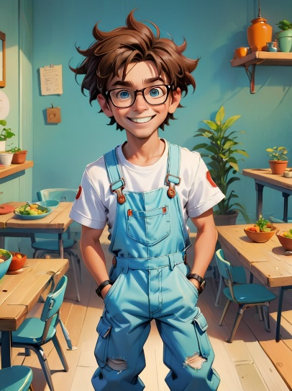Perry jumps out of bed with a big stretch. He yawns, grabs his glasses from the nightstand, brushes his messy hair quickly, and buttons up his bright white T-shirt before putting on his blue overalls.

Perry swings his backpack over his shoulder and walks into class with a bright smile. He waves to his teacher and gives his friend a high five.

Perry carefully carries two bowls to the table, standing on his tiptoes. He places them gently in front of the chairs and says, “All ready, Mom!”

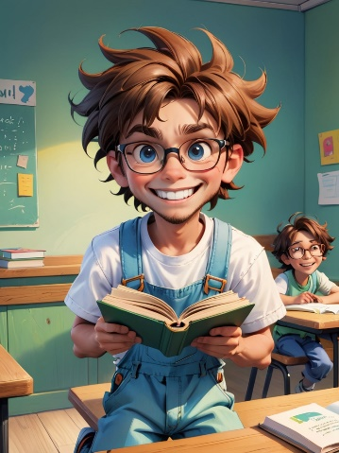Perry kneels down to check under the table, then opens the classroom cabinet. “Found it!” he says, holding the book high in the air with a big grin.

Perry lines up the lunch trays on the table. He picks one up, carefully places it in front of each classmate, and adds a napkin beside it with a smile.

Perry sees his friend sitting alone. He picks up a toy car and walks over. “Wanna play together?” he says, handing the car with both hands.

Perry sees his friend sitting on the floor, crying. He gently kneels down, offers a tissue, and puts a hand on their shoulder. “It’s okay. I’m here,” he whispers.



Perry claps his hands twice and says, “Let’s clean up!” He pushes in the chairs, puts pencils back in the cup, and straightens a stack of books.



Perry stands at the crosswalk holding a younger kid’s hand. He looks left, then right, then left again. “Okay, now we can go,” he says, stepping forward carefully.



At home, Perry cuddles into bed, holding his stuffed bear. He looks up at his mom and says, “I helped a lot today.” She kisses his forehead and turns off the light. “You make the world better, Perry.”

