Angular

Ng-route

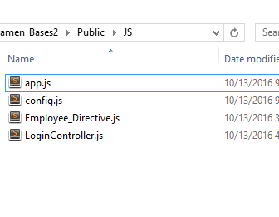

* + Normally saved in a config.js
  + Here we create the myApp module and add the dependencies like ngRoute and others
  + In templateURL we give it the template or the page we want for it to display
  + Main component is the when and the otherwise
  + Load this script <script src="http://cdnjs.cloudflare.com/ajax/libs/angular.js/1.5.8/angular-route.min.js" charset="utf-8"></script>
  + We will have the main view called main page (the structure of the page) and it has

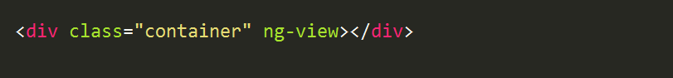

* + Then we will have a menu that will be the index view for the menu with paths

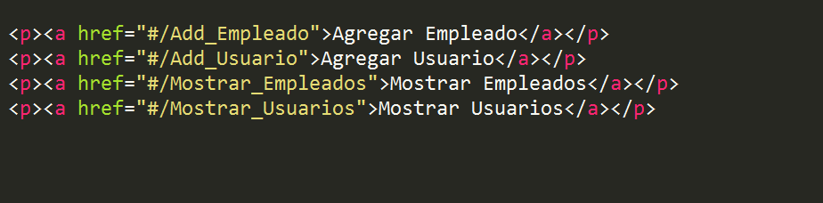

* + We can have our app.js in other file

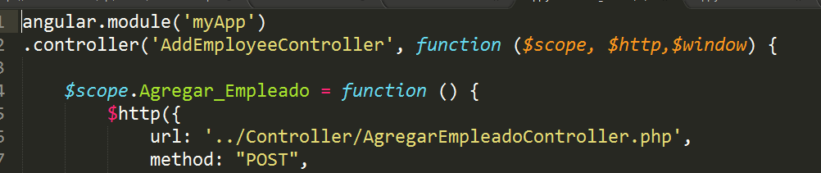

angular.module('myApp', ['ngRoute', 'EmployeeDirective']);

angular.module('myApp')

.config(function ($routeProvider) {

$routeProvider

.when('/', {

controller: "",

templateUrl: "../View/MainMenu.php"

})

.when('/Add_Usuario', {

controller: "AddUserController",

templateUrl: "../View/Add_User.php"

})

.otherwise({

redirectTo: '/'

});

})

Directive

* + - * It can be in a separate file and module and then include it in the main app

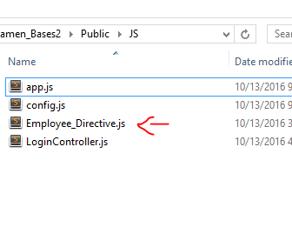

* + - * Camel case in file and with “-” in the view
    - 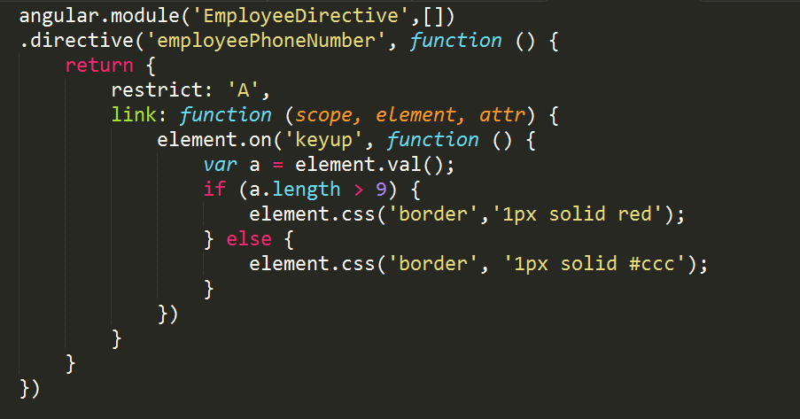

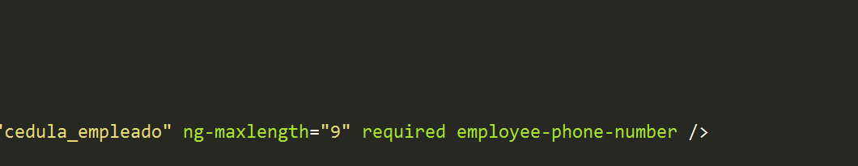

* + - * When it says restrict A it is for attribute and E is for element
        1. A: <div ng-directive></div>
        2. E: < ng-directive></ ng-directive >
      * Link function receives 4 arguments

Factory

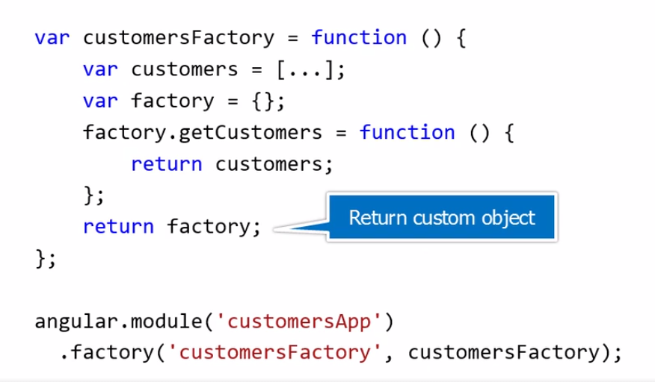

* + Connect with a restful service (this will be in a xxxFactory.js)

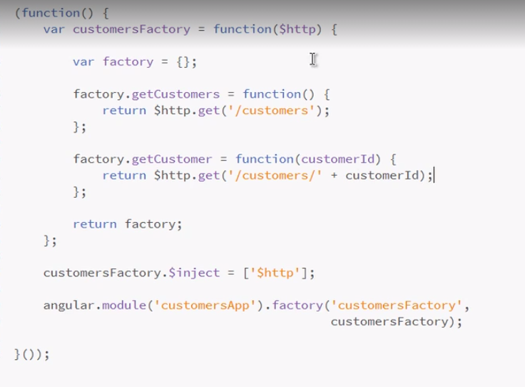

* + Usage in the app (in the controller)

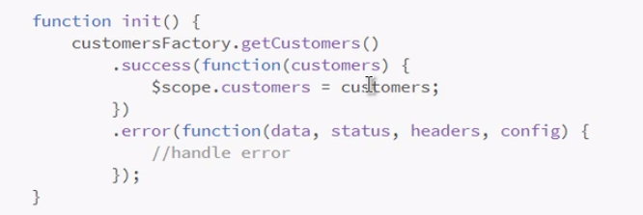

* + We have to add it to the controller



$log

* + Response from server

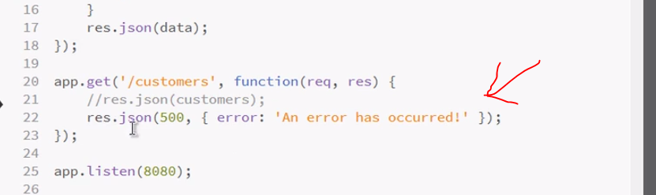

-This is the code of the controller

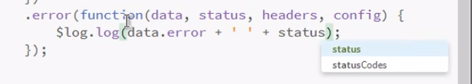

Form

*Form has to have a name in this case it is “myform”*



Make dropdown required



Make button run the function only when form is valid

e.g

in this case the form is called myform

in order to run the function myform would need to be valid using myform.$valid



Dropdown

To retrieve the result it can be either id or label

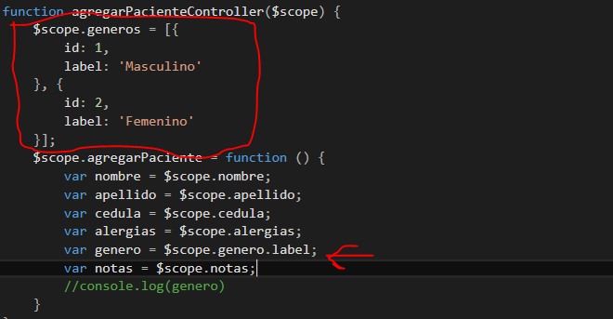

Use the dropdown

<select required ng-options="genero as genero.label for genero **in** generos track by genero.id" ng-model="genero"></select>

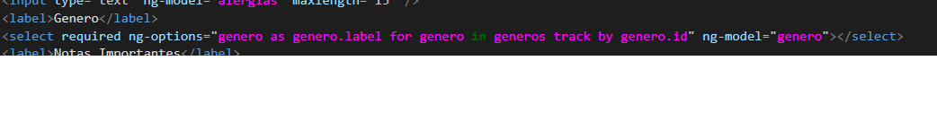

Set Dropdown

Since the dropdowns option have id and label we are getting it from the backend and giving it to the object and then we will pass it to the dropdown with the model named genero

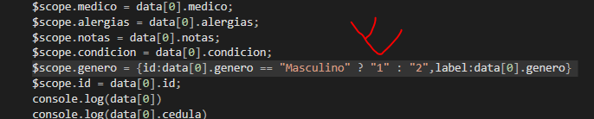

Set date

We have to parse it to a date in order to make it a date



Set time in time input

Time input has ng-model=”hora.value”



Controller

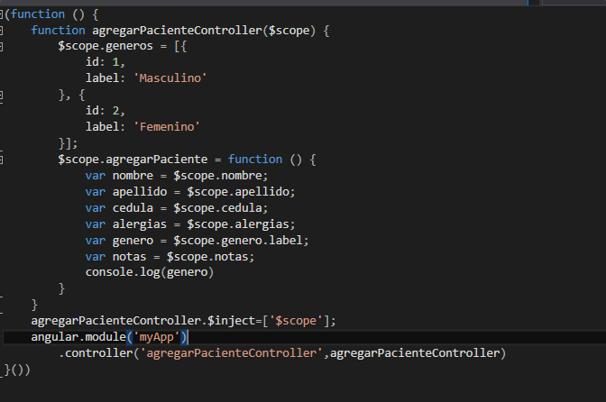

App.js file

