<!DOCTYPE html>

<html>

<head>

<script src="http://ajax.aspnetcdn.com/ajax/jQuery/jquery-1.6.2.min.js"></script>

<title>Page Title</title>

<script>

$(document).ready(function(){

console.log('Hola Mundo');

$('#Movie').bind('keyup click',function(){

var movieName = $('#Movie').val();

console.log(movieName);

if(movieName !=' '){

$.getJSON("https://api.themoviedb.org/3/movie/"+ movieName + "?api_key=2a562783dd6f691cf5e7f97ecc5f9726&callback=?", function(json) {

console.log(json);

$('.title1').html(json.original_title);

$('#Movie').val('');

});

}

else{

$('.title1').html("Invalid");

$('#Movie').val('');

}

});

});

</script>

<style>

</style>

</head>

<body>

<h1>This is a Heading</h1>

<p>This is a paragraph.</p>

<input id='Movie' placeholder='Movie ID'>

<div class='title1'></div>

</body>

</html>

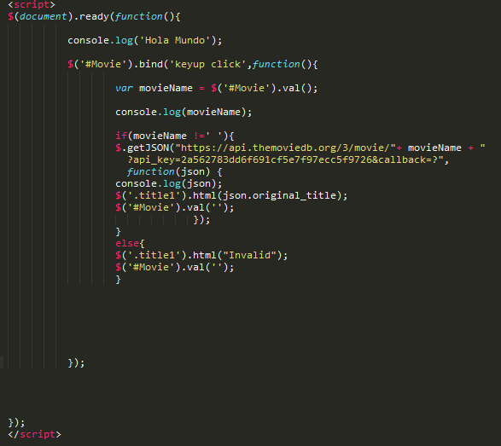

API in web page:

https://api.themoviedb.org/3/movie/135397?api_key=2a562783dd6f691cf5e7f97ecc5f9726&callback=json

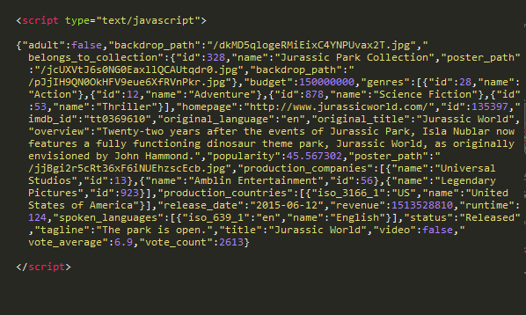

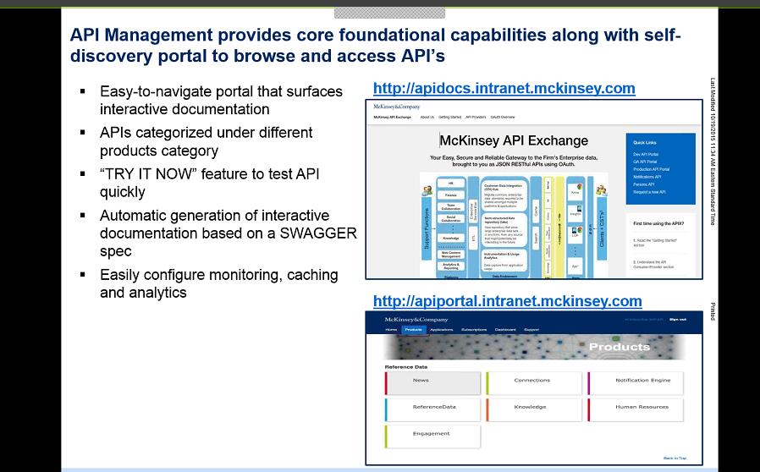

<https://www.youtube.com/watch?v=fEYx8dQr_cQ>

<https://github.com/salmanarshad2000/demos/blob/v1.0.0/jquery-ui-autocomplete/load-data-via-ajax.html>

http://salman-w.blogspot.in/2013/12/jquery-ui-autocomplete-examples.html#example-3