MVC

Create a mvc project

Create a modeL

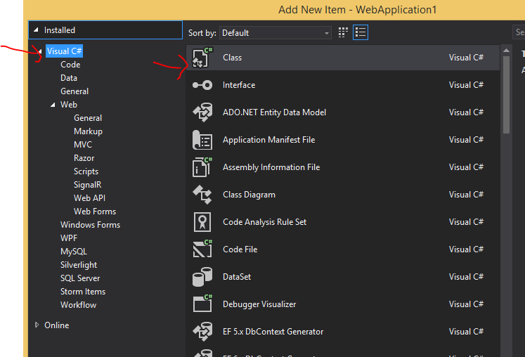

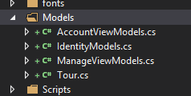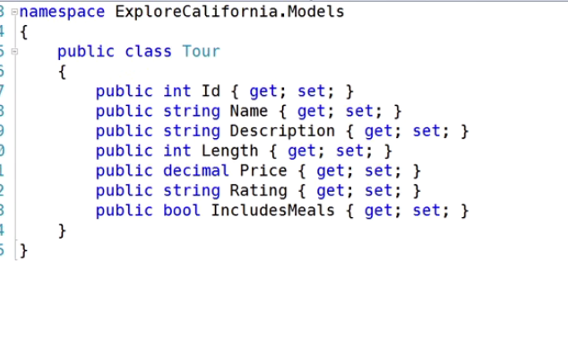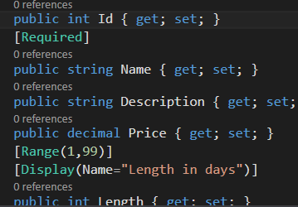

Add validation or change names while displaying



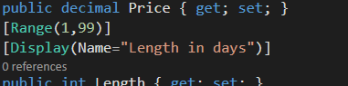

Controller

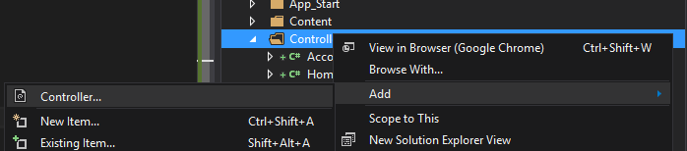

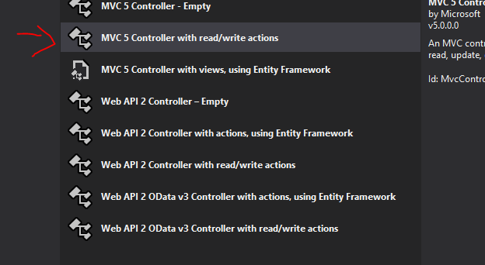

Class that will create the tour in database

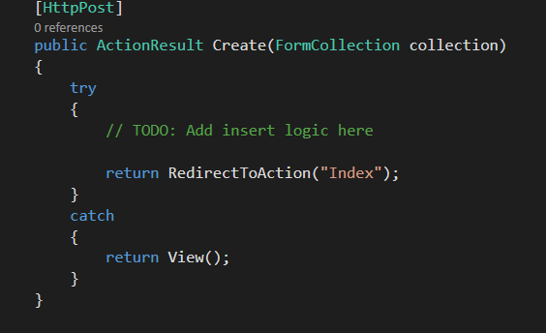

Modify this class to receive a tour object instead of collection

Have to reference the models of the app

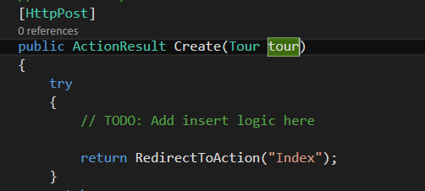

Add view for this and for the index

Index

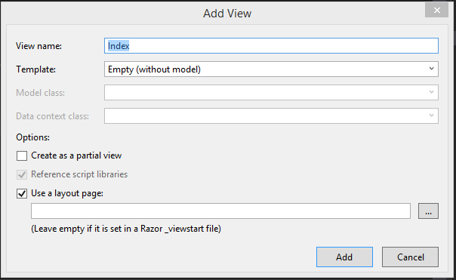

Create view for Form to create tour

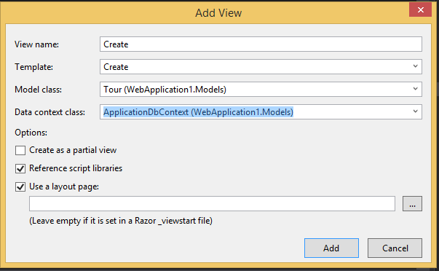

Reference script library is for client side validation

For the logic

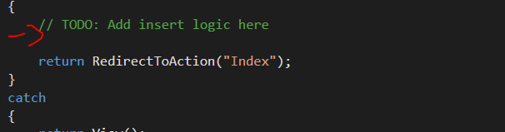

We have to create a instance of ApplicationDbContext which will be the one that add the object into the database

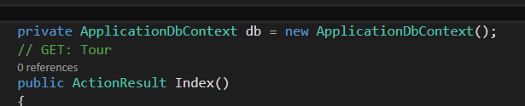

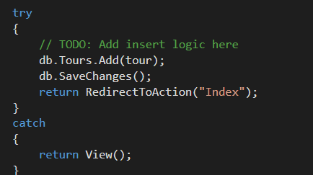

Create Web API

In the solution create an api

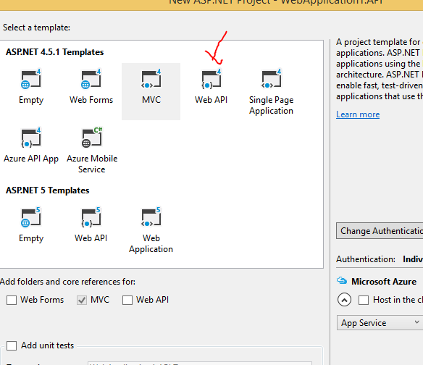

Create a class library to have the dbcontext and model in there so the whole application can reference it including the original app and the web api

Move the tour and dbContext into the dml

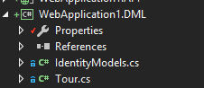

If this has an error

Microsoft.AspNet.Identity;

“Install-Package Microsoft.AspNet.Identity.Core”

Microsoft.AspNet.Identity.EntityFramework

“Install-Package Microsoft.AspNet.Identity.EntityFramework -Version 2.2.1

”

If database already exists change the route in the dbContext

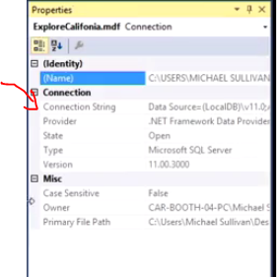

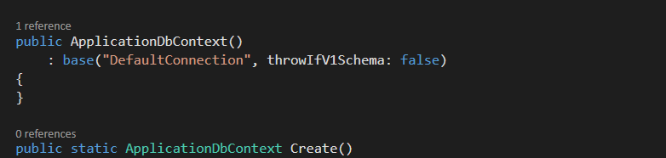

If fails delete the throw…. And remove the white spaces in the path and to escape the \ put @ in front of the path

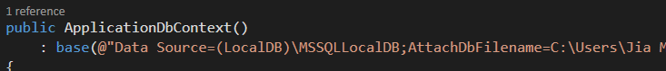

Add reference to this dml to all the rest of the projects

**Create a Tour controller inside the web api**

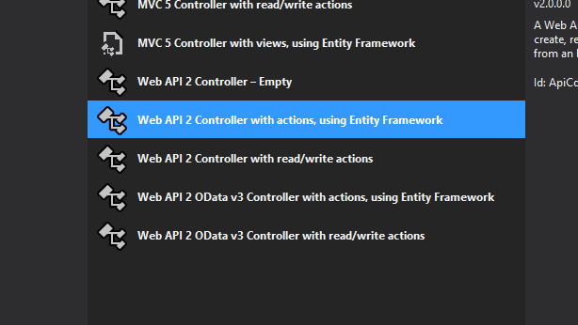

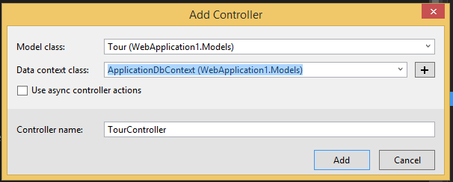

Postman

Create a new entry in the database

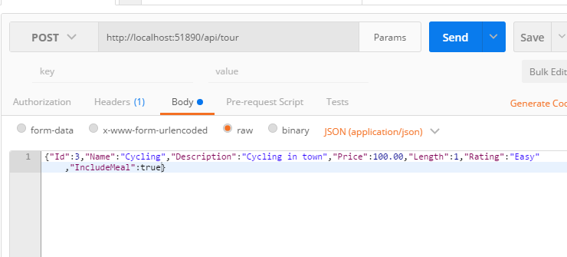

Response

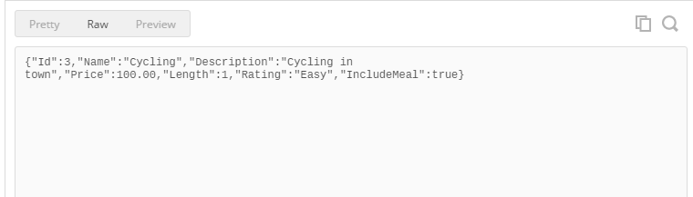

Get all the entries

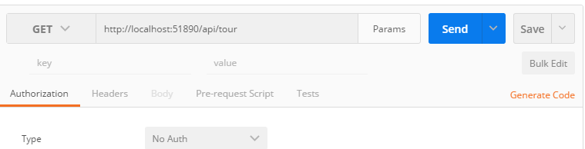

Response

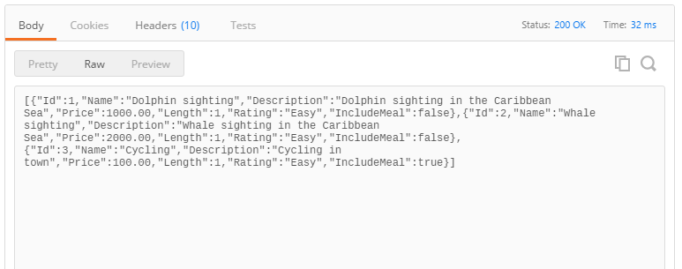

Extra

ActionResult

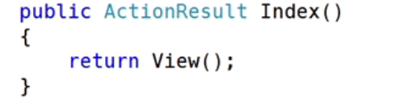

If use of ActionResult it can return anything from a json to a http status code, file, javascript.

DML

Create a DML(data manipulation language) (used for selecting, inserting, deleting and updating data in a database.)

This would be the database

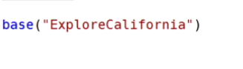

ActionLink

Creates links



DbContext

Create a instace of DbContext

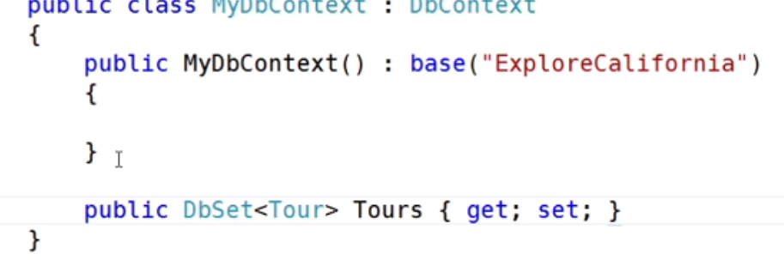

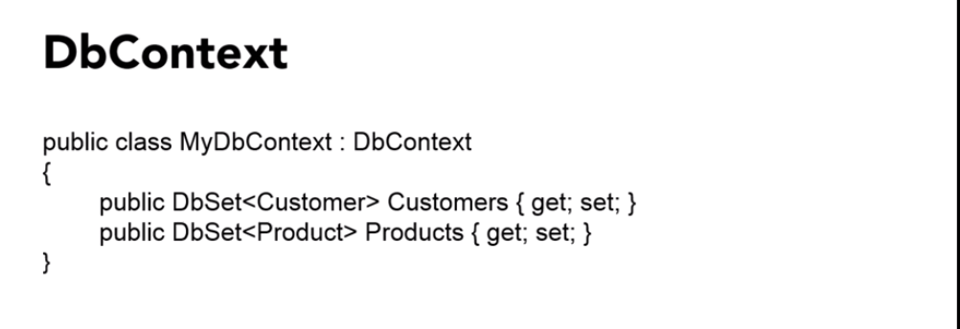

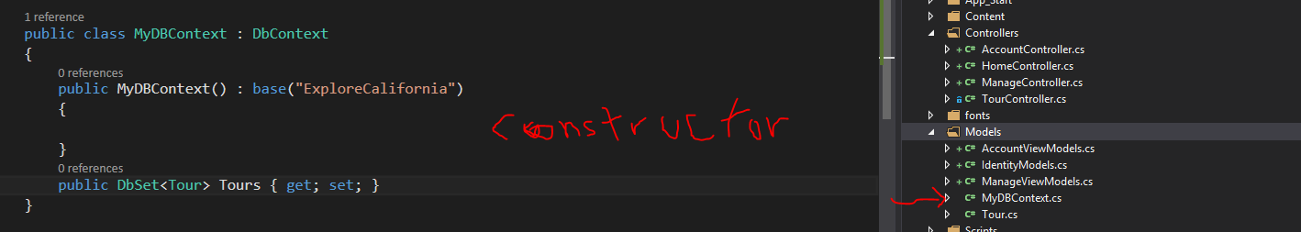

Holds the tours.

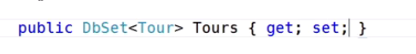

Ado.net





ORM

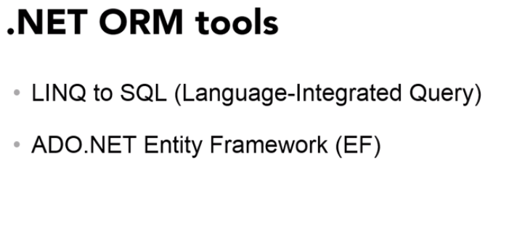

* + 1. Linq

Always with a loop

