Grunt

Install grunt globally

npm install -g grunt-cli

Create Package.json

Go to folder which you want to create it and in cmd do npm init

Install for the application

npm install grunt --save-dev

Create a gruntfile

We will need to create a grunt file in order for grunt to run

Add tasks in grunt

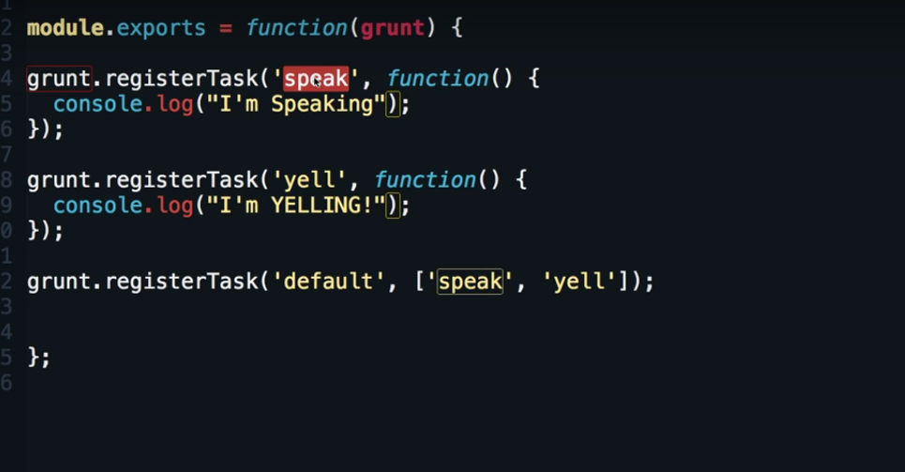

Call grunt directive

Command line write “grunt xxx”

e.g grunt speak

Concat

npm install grunt-contrib-concat --save-dev

in Gruntfile

grunt.loadNpmTasks('grunt-contrib-concat');