Typescript

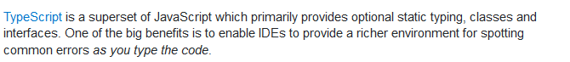

Overload

Have 2 ways of calling a function it can receive a string or a number



Hoisting

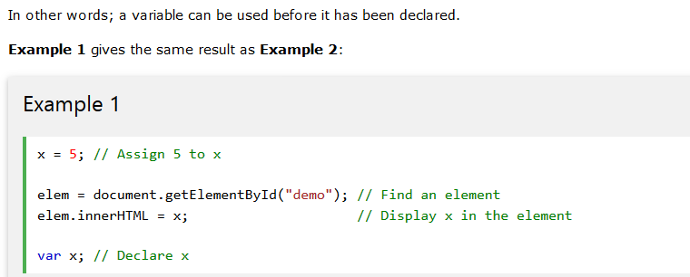

Let

Using let instead of var

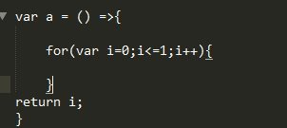

When return i=2

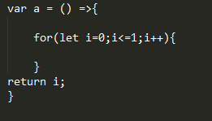

When return i=undefined

Parameter(…a)

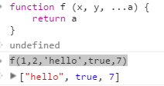

SplIT

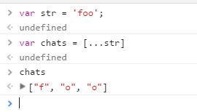

**Add existing variable to the value of another variable**

*Only works when use `` instead of “” or ‘****’***

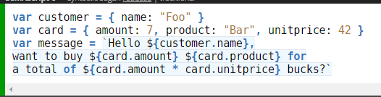

Also we can concat string inside the ${}

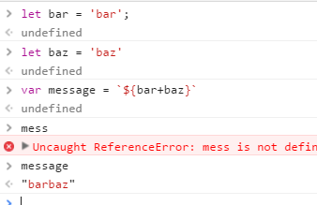

Also it can concat function results

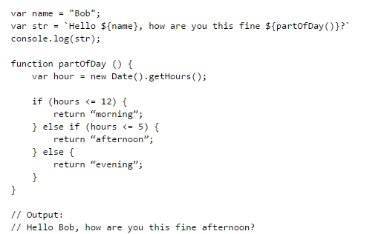

Static class

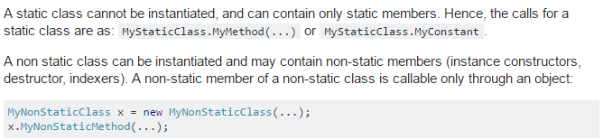

Use static variables when we do not wish to have an object calling it. E.g

*We have class that have a couple of attributes so in this case if an attribute will be shared among the objects it should be static, if the attributes are bound to the object meaning specific to the object it should be non-static*

