Docker

Docker images
sudo docker Images
Create Build
sudo docker build -t <name of image> .
Run Build
sudo docker run -it --rm -p <port>:<port> <name of image>
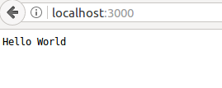

Remove image
sudo docker rmi <Image ID>

