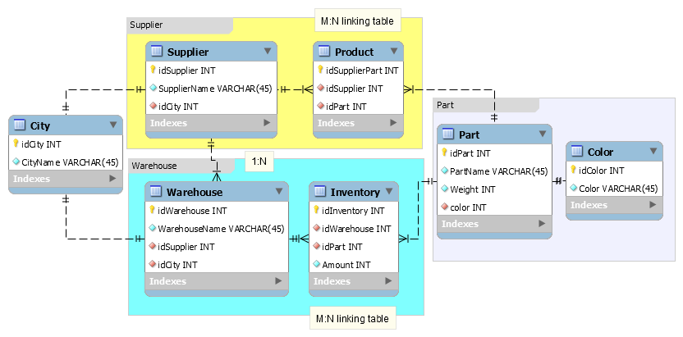

package lab6_db2class;

import java.util.List;

class Color {

public int id;

public int color;

}

class Part {

public int id;

public String partName;

public int weight;

public Color color; // fk

}

class City {

public int id;

public String cityName;

}

class Supplier {

public int id;

public String supplierName;

public City city;

public List<Part> productList; // fk m:n

}

class Warehouse {

public int id;

public String warehouseName;

public City city; // fk

public Supplier supplier; // fk

public List<Inventory> inventoryList; // fk m:n

}

class Inventory {

public int id;

public Part part;

public int amount;

}

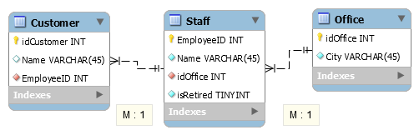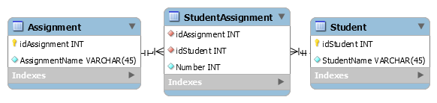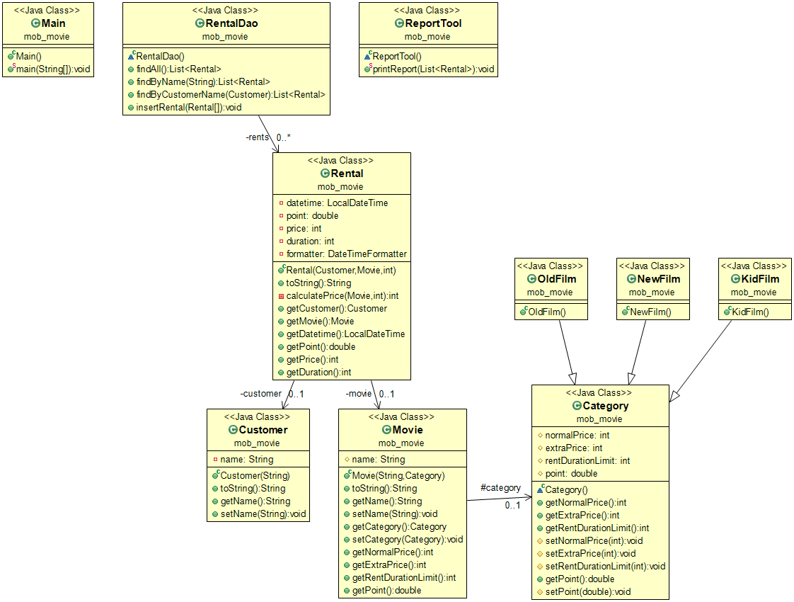

package mob_movie;

import java.time.LocalDateTime;

import java.time.format.DateTimeFormatter;

import java.util.ArrayList;

import java.util.List;

import java.util.stream.Collectors;

/** 電影有分三種類別，有不同的計價、租時: 新片、舊片、兒童片。以strategy pattern表達。 **/

class Category {

protected int normalPrice;

protected int extraPrice;

protected int rentDurationLimit;

protected double point;

// getter

public int getNormalPrice() {

return normalPrice;

}

public int getExtraPrice() {

return extraPrice;

}

public int getRentDurationLimit() {

return rentDurationLimit;

}

protected void setNormalPrice(int normalPrice) {

this.normalPrice = normalPrice;

}

protected void setExtraPrice(int extraPrice) {

this.extraPrice = extraPrice;

}

protected void setRentDurationLimit(int rentDurationLimit) {

this.rentDurationLimit = rentDurationLimit;

}

public double getPoint() {

return point;

}

protected void setPoint(double point) {

this.point = point;

}

}

/* 新片$3 可以租一天，每多一天，一天是$2。新片每租一片，常客基點 2.0 */

class NewFilm extends Category {

public NewFilm() {

setNormalPrice(3);

setExtraPrice(2);

setRentDurationLimit(1);

setPoint(2.0);

}

}

/* 舊片$2 可以租三天，每多一天，一天是$1，常客基點 1.0 */

class OldFilm extends Category {

public OldFilm() {

setNormalPrice(2);

setExtraPrice(1);

setRentDurationLimit(3);

setPoint(1.0);

}

}

/* 兒童片$2 可以租5天，每多一天，一天是$1，常客積點 0.5 */

class KidFilm extends Category {

public KidFilm() {

setNormalPrice(2);

setExtraPrice(1);

setRentDurationLimit(5);

setPoint(0.5);

}

}

/** 電影 **/

class Movie {

protected String name;

protected Category category;

public Movie(String name, Category category) {

this.name = name;

this.category = category;

}

@Override

public String toString() {

return getName();

}

public String getName() {

return name;

}

public void setName(String name) {

this.name = name;

}

public Category getCategory() {

return category;

}

public void setCategory(Category category) {

this.category = category;

}

public int getNormalPrice() {

return category.getNormalPrice();

}

public int getExtraPrice() {

return category.getExtraPrice();

}

public int getRentDurationLimit() {

return category.getRentDurationLimit();

}

public double getPoint() {

return category.getPoint();

}

}

/** 顧客 **/

class Customer {

private String name;

public Customer(String name) {

this.name = name;

}

@Override

public String toString() {

return getName();

}

public String getName() {

return name;

}

public void setName(String name) {

this.name = name;

}

}

/** 一筆租片紀錄 電影:顧客的m:n關聯表 **/

class Rental {

private Customer customer;

private Movie movie;

private LocalDateTime datetime; // 消費時間

private double point; // 單筆累積點數

private int price; // 單筆消費金額

private int duration; // 該片租借幾天

private DateTimeFormatter formatter = DateTimeFormatter.ofPattern("yyyy-MM-dd HH:mm");

public Rental(Customer customer, Movie movie, int duration) {

this.customer = customer;

this.movie = movie;

this.duration = duration;

datetime = LocalDateTime.now(); // 何時租的

point = movie.getPoint(); // 獲得點數

price = calculatePrice(movie, duration); // 租此片花了多少錢

}

@Override

public String toString() {

// String formattedDateTime = duration.format(formatter);

return String.format("Rental: %s rented %s for %s days, in tatal of $%d. Get %.1f points on %s.", customer.getName(),

movie.getName(),

duration,

price,

point,

datetime.format(formatter));

}

// 計算租duration天，該片要多少錢

private int calculatePrice(Movie movie, int duration) {

int basic = 0, extra = 0;

if (duration <= movie.getRentDurationLimit())

basic = movie.getNormalPrice() * duration; // 基本天數的價格

else {

basic = movie.getNormalPrice() * movie.getRentDurationLimit(); // 基本天數的價格

extra = movie.getExtraPrice() * (duration - movie.getRentDurationLimit()); // 額外天數的價格

}

return basic + extra;

}

// getter

public Customer getCustomer() {

return customer;

}

public Movie getMovie() {

return movie;

}

public LocalDateTime getDatetime() {

return datetime;

}

public double getPoint() {

return point;

}

public int getPrice() {

return price;

}

public int getDuration() {

return duration;

}

}

/** Data Access Object Pattern or DAO pattern **/

class RentalDao {

//list is working as a database table

private static List<Rental> rents = new ArrayList<Rental>();

public List<Rental> findAll() {

return rents;

}

public List<Rental> findByName(String name) {

return rents.stream().filter(r -> r.getCustomer().getName() == name).collect(Collectors.toList());

}

public List<Rental> findByCustomer(Customer customer) {

return rents.stream().filter(r -> r.getCustomer().equals(customer)).collect(Collectors.toList());

}

public void insertRental(Rental... rentals) { // zero or more

for(Rental rental : rentals){

rents.add(rental);

}

}

}

/** 列印報表的helper class **/

class ReportTool {

// class method

public static void printReport(List<Rental> rentals) {

int totalPrice = 0;

double totalPoint = 0;

for(Rental rental : rentals){

System.out.println(rental.toString()); // print 單筆rental資料

totalPrice += rental.getPrice();

totalPoint += rental.getPoint();

}

System.out.println("消費總金額是: $"+totalPrice+" 累積點數為: "+totalPoint); // print 總額

}

}

public class Main {

public static void main(String[] args) {

// 有2個客戶 偷懶存在main裡

Customer april = new Customer("April");

Customer joe = new Customer("Joe");

// 有3個電影 偷懶存在main裡

Movie 神力女超人 = new Movie("神力女超人", new OldFilm()); // old

Movie 正義聯盟 = new Movie("正義聯盟", new NewFilm()); // new

Movie 雷神索爾 = new Movie("雷神索爾", new NewFilm()); // new

// List<Rental> rents = new ArrayList<Rental>();

// rents.add(new Rental(april, 神力女超人, 3));

// rents.add(new Rental(joe, 神力女超人, 2));

// rents.add(new Rental(april, 正義聯盟, 5));

// rents.add(new Rental(joe, 雷神索爾, 1));

// for (Rental r: rents) {

// System.out.println(r.toString());

// }

// 消費紀錄存在 RentalDao

RentalDao rentalDao = new RentalDao();

rentalDao.insertRental(new Rental(april, 神力女超人, 3));

rentalDao.insertRental(new Rental(joe, 神力女超人, 2));

rentalDao.insertRental(new Rental(april, 正義聯盟, 5));

rentalDao.insertRental(new Rental(joe, 雷神索爾, 1));

// 印報表

ReportTool.printReport(rentalDao.findByName("April"));

ReportTool.printReport(rentalDao.findByCustomer(joe));

}

}