%% 5.5
a = [-1 2 5 8];
fx = @(x) a(4).*x.^3+a(3).*x.^2+a(2).*x+a(1);
x = linspace(-6,6,100);
%% (1)
y = fx(x);
a_1 = polyfit(x,y,3);
disp(a_1);
%% (2)
y_1 = y + randn(1,100);
a_2 = polyfit(x,y_1,3);
disp(a_2);
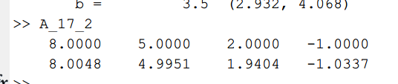
%% lsqcurvefit
g = @(x,x_data) 10*x(1)./(10*x(2)+(x(1)-10*x(2)).*exp(-sin(x_data)));
x_data = 1:20;
y_data = g([1.1 0.01], x_data);
x0 = [0.7 0.07];
x1 = lsqcurvefit(g, x0, x_data, y_data);
disp(x1);
%% fittype
g2 = @(a,b,x) 10*a./(10*b+(a-10*b).*exp(-sin(x)));
f = fittype(g2);
x2 = fit(x_data', y_data', f, 'StartPoint', x0);
disp(x2);
%% 对比
for i = 1:length(x_data)
plot(x_data(i),y_data(i),'o');
hold on;
end
g1 = @(x_data) 10*x1(1)./(10*x1(2)+(x1(1)-10*x1(2)).*exp(-sin(x_data)));
g2 = @(x_data) 10*x2.a./(10*x2.b+(x2.a-10*x2.b).*exp(-sin(x_data)));
fplot(g1);
fplot(g2);
hold off;
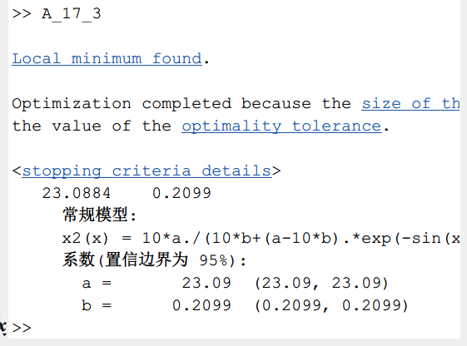
t_data = [0.5 1 2 3 4 5 7 9];
V_data = [6.36 6.48 7.26 8.22 8.66 8.99 9.43 9.63];
plot(t_data,V_data)
V = 10;
x0 = [2,7];

ft = @(a,b,x) V-(V-a).*exp(-x./b);
f = fittype(ft);
x = fit(t_data', V_data', f, 'StartPoint', x0);
disp(x);
