prob = optimproblem('ObjectiveSense','min');

x = optimvar('x',6,'LowerBound',0);

c = [10 5 6 4 8 15];

A = [1 1 1 0 0 0;0 0 0 1 1 1];

Aeq = [1 0 0 1 0 0;0 1 0 0 1 0;0 0 1 0 0 1];

beq = [45;75;40];

b = [60;100];

prob.Objective = c\*x;

prob.Constraints.con1 = A\*x <= b;

prob.Constraints.con2 = Aeq\*x == beq;

[sol,fval,flag,out] = solve(prob);

sol.x

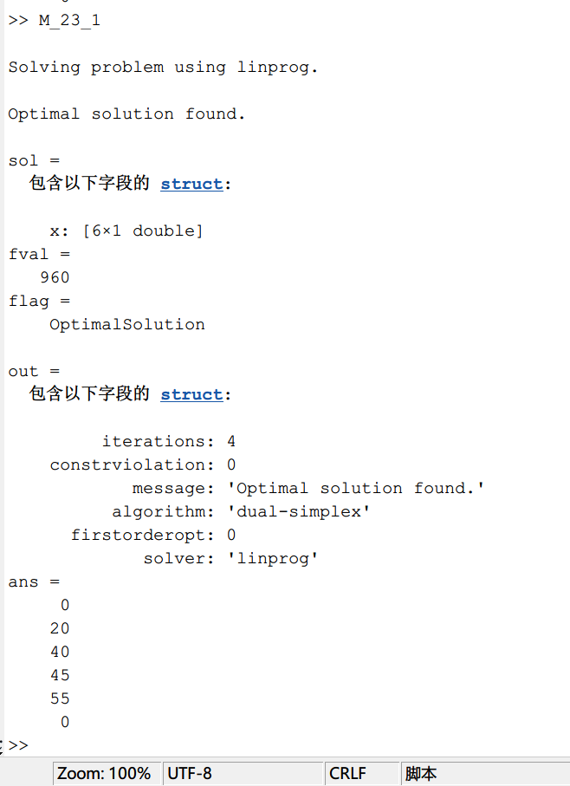

prob = optimproblem('ObjectiveSense','min');

x = optimvar('x',5,'Type','integer','LowerBound',0);

c = [0 0.1 0.2 0.3 0.8];

Aeq = [1 2 0 1 0;0 0 2 2 1;3 1 2 0 3];

beq = [100;100;100];

prob.Objective = c\*x;

prob.Constraints.con = Aeq\*x == beq;

[sol,fval,flag,out] = solve(prob);

sol.x

