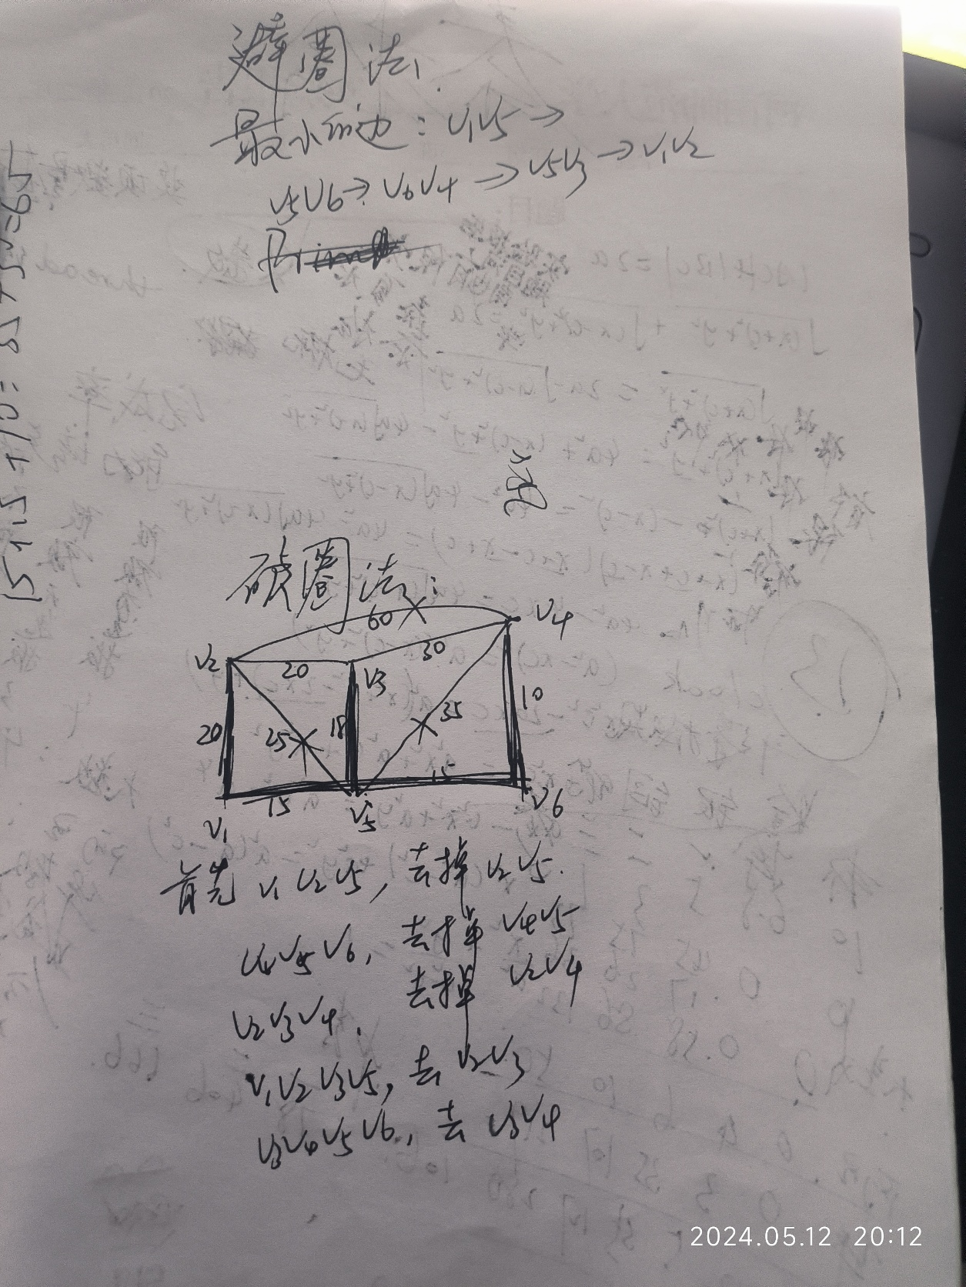

clc;

clear;

close all;

A =[ 0 20 0 0 15 0;

20 0 20 60 25 0;

0 20 0 30 18 0;

0 60 30 0 35 10;

15 25 18 35 0 15;

0 0 0 10 15 0];

s=cellstr(strcat('v',int2str([1:6]')));

G=graph(A,s,'upper');

p=plot(G,'EdgeLabel',G.Edges.Weight);

T=minspantree(G,'Method','dense');

Lmin=sum(T.Edges.Weight);

highlight(p,T)

