subplot(1,2,1);

t = 0:0.01:2\*pi;

a = 1;

x = a.\*(1-cos(t)).\*cos(t);

y = a.\*(1-cos(t)).\*sin(t);

plot(x,y);

title('这是心形线')

grid on;

text(0,1,'心形线');

xlabel('x轴');

ylabel('y轴');

legend('心形线')

axis equal;

axis([-2 2 -2 2]);

gtext('心形线');

subplot(1,2,2);

x = -2:0.01:2;

y = -2:0.01:2;

[X,Y] = meshgrid(x,y);

Z = X.^2 - Y.^2;

mesh(X,Y,Z);

grid on;

title('这是马鞍面')

text(0,1,1,'马鞍面');

xlabel('x轴');

ylabel('y轴');

zlabel('z轴');

legend('马鞍面');

axis equal;

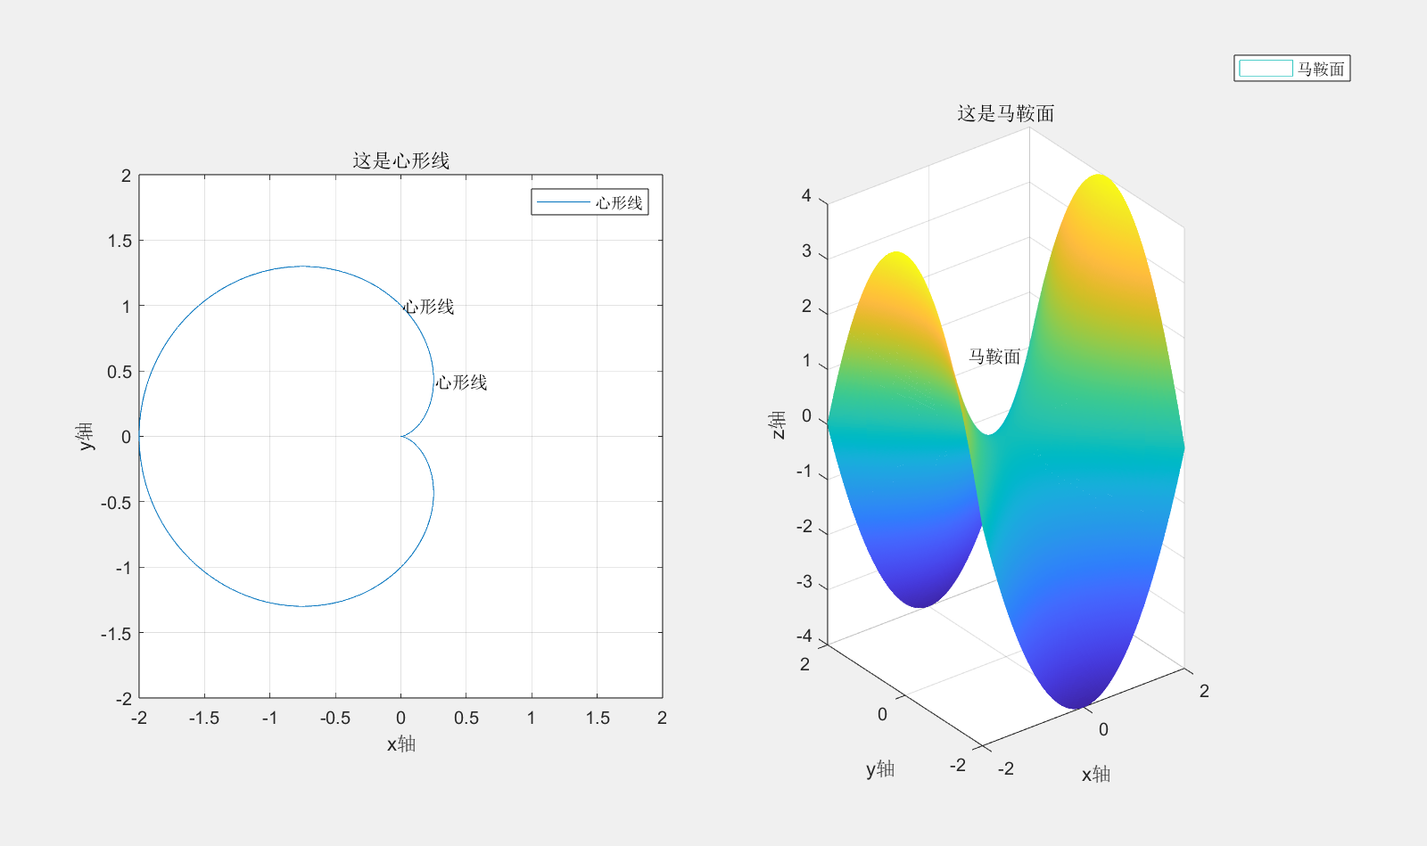

r = 2; % 指定半径

[X,Y,Z] = sphere;

X2 = X \* r;

Y2 = Y \* r;

Z2 = Z \* r;

surf(X2,Y2,Z2)

axis equal

hold on;

f = @(x,y) x.^2+y.^2-r.\*x;

fimplicit3(f,[-2 2 -2 2 -2.5 2.5])

hold off;

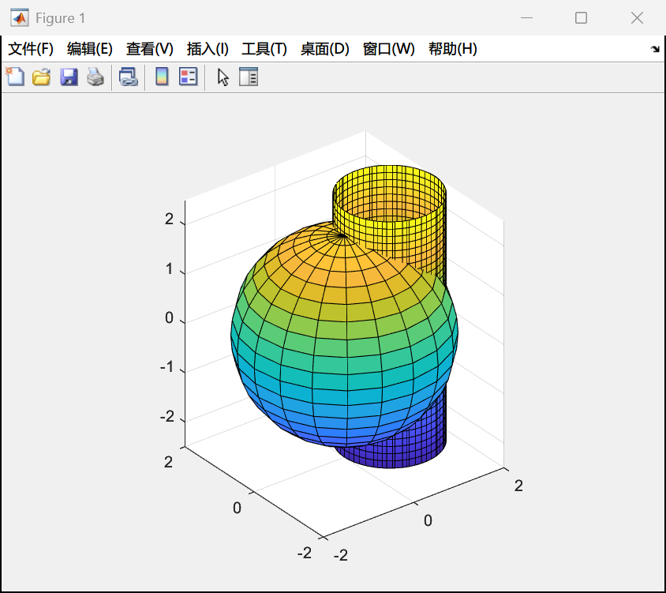

y = @(x) (-x-pi).\*(x<-pi)+sin(x).\*(x>=-pi && x<=pi)+((x-pi)./2).\*(x>pi);

fplot(y,[-6,6]);

