% 方法一

fx = @(x) -(2*x(1)+3*x(1)^2+3*x(2)+x(2)^2+x(3));

A = [-1 -2 0;-1 0 0];

b = [-1;0];

[x,y] = fmincon(fx,rand(3,1),A,b,[],[],[],[],@gx);

function [c,ceq] = gx(x)

c = [x(1)+2*x(1)^2+x(2)+2*x(2)^2+x(3)-10;

x(1)+x(1)^2+x(2)+x(2)^2-x(3)-50;

2*x(1)+x(1)^2+2*x(2)+x(3)-40];

ceq = x(1)^2+x(3)-2;

end

% 方法二

prob = optimproblem('ObjectiveSense','max');

x = optimvar('x',3);

prob.Objective = 2*x(1)+3*x(1)^2+3*x(2)+x(2)^2+x(3);

prob.Constraints.con1 = [x(1)+2*x(1)^2+x(2)+2*x(2)^2+x(3) <= 10

x(1)+x(1)^2+x(2)+x(2)^2-x(3) <= 50

2*x(1)+x(1)^2+2*x(2)+x(3) <= 40

-x(1)-2*x(2) <= -1

-x(1) <= 0];

prob.Constraints.con2 = x(1)^2+x(3)==2;

x0.x = rand(3,1);

[sol,fval,flag,out] = solve(prob,x0);

sol.x

fval

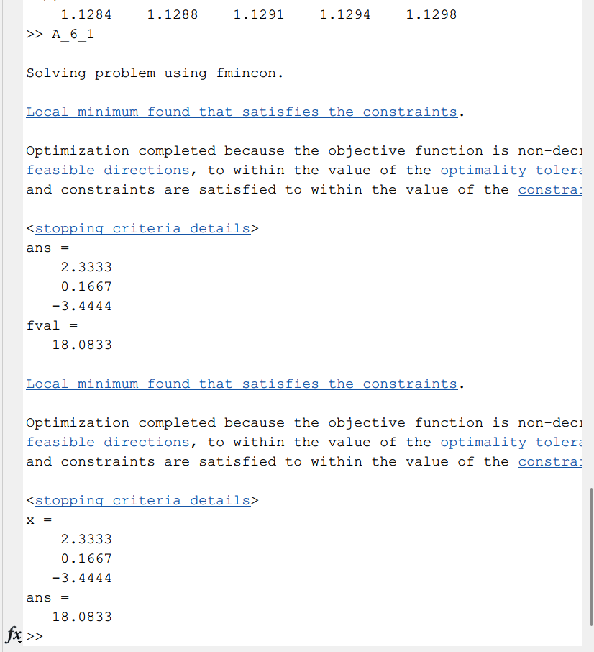

clc;clear;close all;

a = 50;

b = 0.2;

c = 4;

% 原始结果

[x,y] = optim2(a,b,c);

x,y

% [sol,fval,flag,out] = optim(a,b,c);

% sol.x

% fval

Fval_a = [];

Fval_b = [];

Fval_c = [];

% 1. a改变时

count = 1;

for a = 40:2:60

% [sol,fval,flag,out] = optim(a,0.2,4);

[x,fval] = optim2(a,0.2,4);

x

Fval_a(count) = fval

count = count + 1;

end

subplot(1,3,1);

plot(40:2:60,Fval_a)

% 2. b改变时

count = 1;

for b = 0.1:0.02:0.3

% [sol,fval,flag,out] = optim(50,b,4);

[x,fval] = optim2(50,b,4);

Fval_b(count) = fval

count = count + 1;

end

subplot(1,3,2);

plot(0.1:0.02:0.3,Fval_b)

% 3. c改变时

count = 1;

for c = 3:0.2:5

% [sol,fval,flag,out] = optim(50,0.2,c);

[x,fval] = optim2(50,0.2,c);

Fval_c(count) = fval

count = count + 1;

end

subplot(1,3,3);

plot(3:0.2:5,Fval_c)

function [sol,fval,flag,out] = optim(a,b,c)

prob = optimproblem('ObjectiveSense','min');

x = optimvar('x',3,'Type','integer','LowerBound',0,'UpperBound',100);

% 季度 最小 最大 需要 生产 剩余

% 第一季度 40 100 40 x1 x1-40

% 第二季度 0 100 60 x2 x1-40+x2-60

% 第三季度 0 100 80 x3 0

prob.Objective = a*sum(x)+b*sum(x.^2)+(x(1)-40)*c+(x(1)+x(2)-100)*c;

prob.Constraints.con1 = x(1) >= 40;

prob.Constraints.con2 = x(2)+x(1)-40 >= 60;

prob.Constraints.con3 = sum(x) == 180;

[sol,fval,flag,out] = solve(prob);

end

function [x,fval] = optim2(a,b,c)

fun = @(x) a*sum(x)+b*sum(x.^2)+(x(1)-40)*c+(x(1)+x(2)-100)*c;

x0 = rand(3,1);

A = [-1 0 0;-1 -1 0;0 0 0];

B = [-4;-100;0];

Aeq = [1 1 1];

beq = 180;

VLB = [40;0;0];

VUB = [100;100;100];

intcon = [1,2,3];

% [x,fval] = fmincon(fun,x0,A,B,Aeq,beq,VLB,VUB);

[x,fval] = ga(fun,3,A,B,Aeq,beq,VLB,VUB,[],intcon);

end

