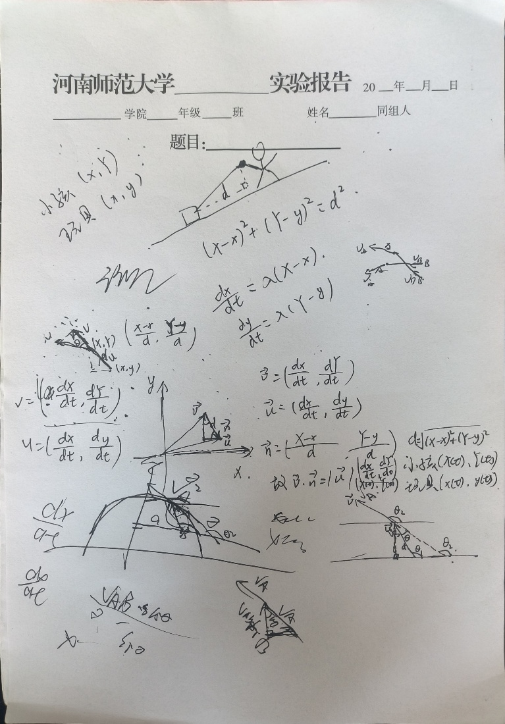

clc;

clear;

close all;

global d;

d = 2; % 定义棍在地面上的投影为1

%% 圆

[t,y]=ode45(@yx,[0,10],[2,0]);

T=0:0.1:10;

X=3\*cos(T);

Y=3\*sin(T);

figure(1);

plot(X,Y,'-')

hold on

plot(y(:,1),y(:,2),'\*')

axis equal

hold off;

legend('小孩','玩具')

%% 直线

[t,y]=ode45(@zx,[0,10],[1,0]);

T=0:0.1:10;

X=T;

Y=T;

figure(2);

plot(X,Y,'-')

hold on

plot(y(:,1),y(:,2),'\*')

axis equal

hold off;

legend('小孩','玩具')

%% 椭圆

[t,y]=ode45(@ty,[0,10],[1,0]);

T=0:0.1:10;

X = 2\*cos(T);

Y = 3\*sin(T);

figure(3);

plot(X,Y,'-')

hold on

plot(y(:,1),y(:,2),'\*')

axis equal

hold off;

legend('小孩','玩具')

%% 函数

function dy = yx(t,y)

global d;

dy = zeros(2,1);

dy(1) = 1/d^2\*((-1)\*sin(t)\*(cos(t)-y(1))+cos(t)\*(sin(t)-y(2)))\*(cos(t)-y(1));

dy(2) = 1/d^2\*((-1)\*sin(t)\*(cos(t)-y(1))+cos(t)\*(sin(t)-y(2)))\*(sin(t)-y(2));

end

function dy = zx(t,y)

global d;

dy = zeros(2,1);

dy(1) = 1/d^2\*((t-y(1))+(t-y(2)))\*(t-y(1));

dy(2) = 1/d^2\*((t-y(1))+(t-y(2)))\*(t-y(2));

end

function dy = ty(t,y)

global d;

dy = zeros(2,1);

dy(1) = 1/d^2\*(2\*(-1)\*sin(t)\*(2\*cos(t)-y(1))+3\*cos(t)\*(3\*sin(t)-y(2)))\*(2\*cos(t)-y(1));

dy(2) = 1/d^2\*(2\*(-1)\*sin(t)\*(2\*cos(t)-y(1))+3\*cos(t)\*(3\*sin(t)-y(2)))\*(3\*sin(t)-y(2));

end

