x = linspace(0,10,1000);

gx = @(x) (3.*x.^2+4.*x+6).*sin(x)./(x.^2+8.*x+6);

y = gx(x);

pp = csape(x,y);

gx_csape = @(x) fnval(pp,x);

disp(gx_csape);

fplot(gx_csape,[0 10]);

gx_inte = integral(gx,0,10);

gx_csape_inte = integral(gx_csape,0,10);

fprintf("g(x)求积分：%f\n", gx_inte);

fprintf("g(x)'求积分：%f\n", gx_csape_inte);

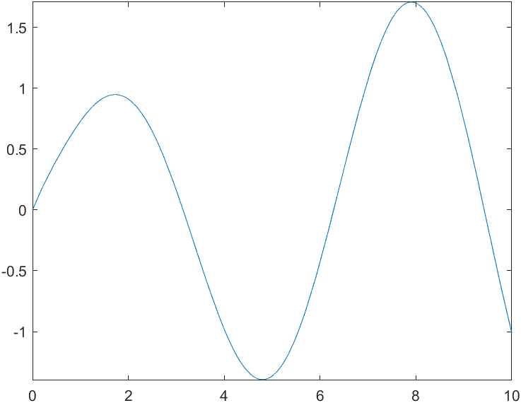

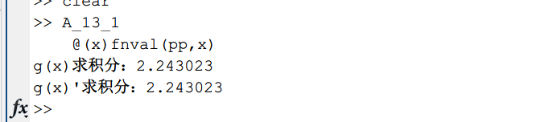

T = 700:20:780;

V = [0.0977 0.1218 0.1406 0.1551 0.1664];

F = griddedInterpolant(T,V,'spline');

pp = csape(T,V);

F_f = @(x) F(x);

pp_f = @(x) fnval(pp,x);

V_750_F = F_f(750);

V_750_pp = pp_f(750);

V_770_F = F_f(770);

V_770_pp = pp_f(770);

fplot(F_f);

hold on;

fplot(pp_f);

hold off;

legend('线性插值函数','三次样条插值函数')

