clc;

clear;

close all;

E = [1,2,2;1,3,4;2,4,3;2,5,3;2,6,1;3,4,2;3,5,3;3,6,1;4,7,1;5,7,3;6,7,4];

nodename = cellstr([' A';'B1';'B2';'C1';'C2';'C3';' D']);

G = digraph(E(:,1),E(:,2),E(:,3),nodename);

p = plot(G,'EdgeLabel',G.Edges.Weight);

[path,d] = shortestpath(G," A"," D","Method",'positive');

highlight(p,path,'EdgeColor','red');

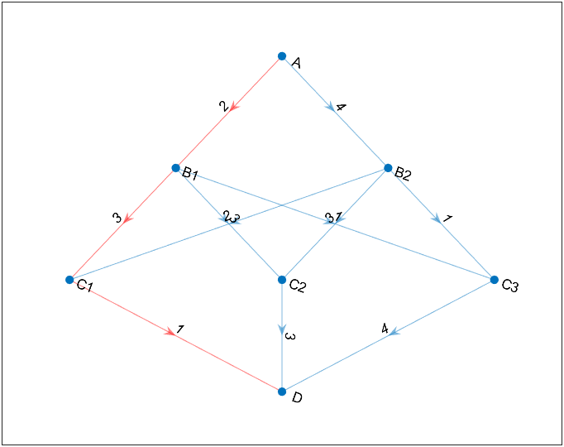

clc;clear;close all;

a = zeros(6);

a(1,2) = 2;a(1,3) = 7;

a(2,3) = 4;a(2,4) = 6;a(2,5) = 8;

a(3,4) = 1;a(3,5) = 3;

a(4,5) = 1;a(4,6) = 6;

a(5,6) = 3;

nodes = 1:6;

s = cellstr(strcat('v',int2str(nodes')));

G = graph(a,s,'upper');

node_min_path = distances(G);

M = max(node_min_path,[],2);

[m,index] = min(M);

fprintf("医院建在v%d,使最远的最短为：%d\n",index,m);

stu_nums = [50 40 60 20 70 90];

M2 = stu_nums*node_min_path;

[m,index] = min(M2);

fprintf("学校建在v%d,使最远的最短为：%d\n",index,m);

