f = @(x) x(1).^2+4.\*x(2).^2+9.\*x(3).^2-2.\*x(1)+18.\*x(2);

[x,fval,exitflag,output] = fminunc(f,[0 0 0])

% [x,fval,exitflag,output] = fminsearch(f,[0 0 0])

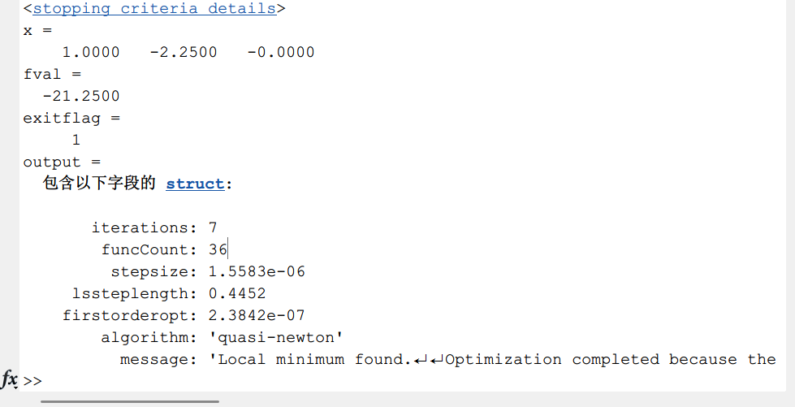

f = @(x) (x(1)-1).^4+2.\*x(2).^2;

[x,fval,exitflag,output] = fminunc(f,[0 1])

% [x,fval,exitflag,output] = fminsearch(f,[0 0 0])

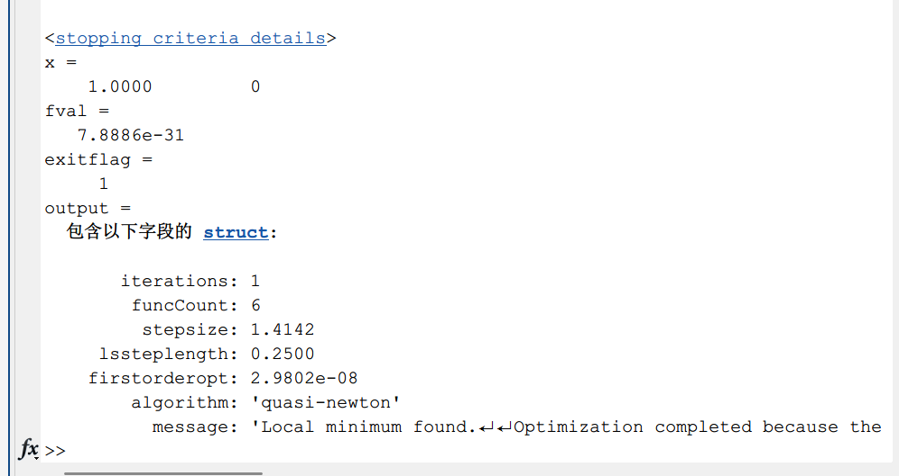

prob = optimproblem('ObjectiveSense','max');

x = optimvar('x',8,'Type','integer','LowerBound',0);

% 产品I A1:x1 A2:x2 B1:x3 B2:x4 B3:x5 x1+x2=x3+x4+x5

% 产品II A1:x6 A2:x7 B1:x6+x7 x6+x7

% 产品III A2:x8 B2:x8 x8

% 利润最大

c = [1.25-0.25 2.00-0.35 2.80-0.50];

prob.Objective = c\*[x(1)+x(2);x(6)+x(7);x(8)];

% 不超过有效台时

A = [5 10 0;7 9 12;6 8 0;4 0 11;7 0 0];

b = [6000;10000;4000;7000;4000];

prob.Constraints.con1 = 5\*x(1)+10\*x(6) <= 6000;

prob.Constraints.con2 = 7\*x(2)+9\*x(7)+12\*x(8) <= 10000;

prob.Constraints.con3 = 6\*x(3)+8\*(x(6)+x(7)) <= 4000;

prob.Constraints.con4 = 4\*x(4)+11\*x(8) <= 7000;

prob.Constraints.con5 = 7\*x(5) <= 4000;

% 产品I

prob.Constraints.con6 = x(1)+x(2)==x(3)+x(4)+x(5);

%

[sol,fval,flag,out] = solve(prob);

res = sol.x

w = fval-(300+321+250+783+200)

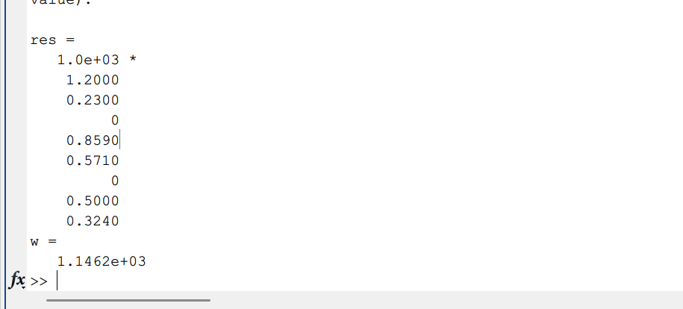

prob = optimproblem('ObjectiveSense','min');

x = optimvar('x',6,'Type','integer','LowerBound',0);

A = [1 1 1 0 0 0;0 1 0 1 0 0;0 0 1 0 1 0;0 0 0 1 0 1;1 1 1 0 0 0;0 0 0 0 1 1;1 0 0 0 0 0;0 1 0 1 0 1];

prob.Objective = sum(x);

prob.Constraints.con = A\*x >= 1;

[sol,fval,flag,out] = solve(prob);

res = sol.x

