**UECM3033 Assignment #1 Report**

* Prepared by: ** Khoo Jia Ming**
* Tutorial Group: T3

_____________________________________________________________________________________

## Task 1 -- setup a github repository

The reports, codes and supporting documents are uploaded to Github at:

<https://github.com/JiaMing1993/UECM3033_assign1>

_____________________________________________________________________________________

## Task 2 -- setup python

## Put here the screen shot of file (python.png)

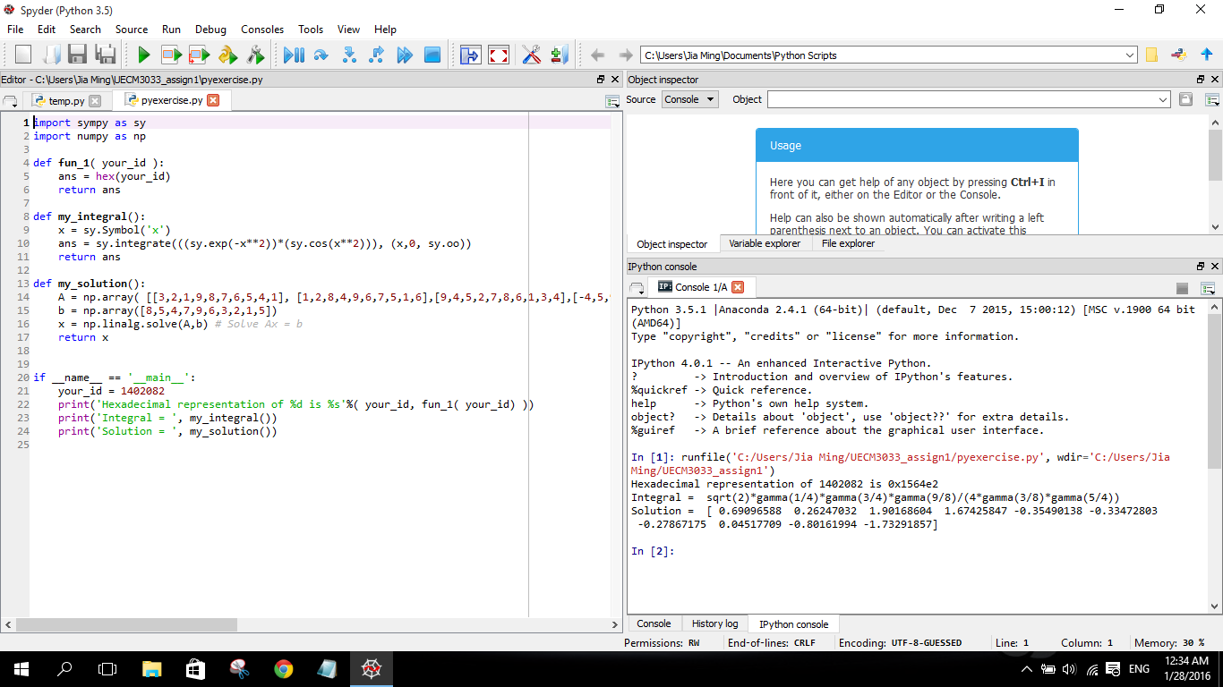

_____________________________________________________________________________________

## Task 3 -- modify and run Python script

The Python script was changed. My student ID was key in to find the hexadecimal representation. The original integral was replaced, and a system of 10 linear equations with unique solution was setup. The report of assignment 1 was written in both markdown file and Microsoft words file. Below are the answer given in console:

1. The hexadecimal value of your student ID.

0x1564e2

1. Write down the definite integrals that you have chosen.
$$\int_{0}^{∞}{\cos\left(x\right)\sin\left(x\right)e^{x}} = \frac{e^{x}\left(\sin\left(2x\right)-2\cos\left(2x\right)\right)}{10}+C$$

2. Write down your system of 10 linear equations.

$${3x}_{0}+{2x}_{1}+x_{2}+ {9x}_{3}+{8x}_{4}+{7x}_{5}+{6x}_{6}+{5x}_{7}+{4x}_{8}+x_{9}=8$$

$$x_{0}+{2x}_{1}+{8x}_{2}+ {4x}_{3}+{9x}_{4}+{6x}_{5}+{7x}_{6}+{5x}_{7}+x_{8}+{6x}_{9}= 5$$

$${9x}_{0}+{4x}_{1}+{5x}_{2}+ 2x_{3}+7x_{4}+8x_{5}+6x_{6}+x_{7}+3x_{8}+{4x}_{9}= 4$$

$${-4x}_{0}+{5x}_{1}+{9x}_{2}+ 3x_{3}+8x_{4}+5x_{5}+6x_{6}+8x_{7}-x_{8}+{5x}_{9}= 7$$

$${9x}_{0}-{5x}_{1}+{3x}_{2}+ 7x_{3}+4x_{4}+8x_{5}+2x_{6}+6x_{7}+9x_{8}+x_{9}= 9$$

$${7x}_{0}+{3x}_{1}+{8x}_{2}+ x_{3}+9x_{4}+{4x}_{5}-{5x}_{6}+{8x}_{7}+{2x}_{8}+{7x}_{9}= 6$$

$${7x}_{0}+{9x}_{1}+{5x}_{2}+ x_{3}+{8x}_{4}+{6x}_{5}+{3x}_{6}+{4x}_{7}+{8x}_{8}+{2x}_{9}= 3$$

$${8x}_{0}+{2x}_{1}+x_{2}+ {4x}_{3}+{7x}_{4}+{6x}_{5}+{9x}_{6}+{2x}_{7}+{5x}_{8}+x_{9}= 2$$

$${4x}_{0}+{8x}_{1}+{3x}_{2}+ 7x_{3}+{2x}_{4}+x_{5}+{9x}_{6}+{3x}_{7}+{5x}_{8}+{8x}_{9}= 1$$

$${6x}_{0}+{4x}_{1}+{8x}_{2}+ 2x_{3}+{5x}_{4}+x_{5}+{9x}_{6}+{3x}_{7}+{7x}_{8}+{5x}_{9}= 5$$

last modified: 29/01/2016