Name: Khoo Jia Ming
ID: 14UEB02082
Course: Financial Mathematics
UECM3033 Assignment 2 Report
Task 1
For LU function, scipy.linalg.lu_factor was used to computed pivoted LU decomposition of a matrix and scipy.linalg.lu_solve was used to solve an equation system, either or or , given the LU factorization of matrix A. For SOR function, lower triangular matrix, upper triangular matrix, diagonal, and omega was defined.
LU method to use. LU factorization was more preferred as it can repeat solve a number of equations. Matrix usually able to be written as a product of lower triangular matrix L, upper triangular matrix U , and also diagonal, D. LU decomposition requires operations. SOR method able to use when the matrix are positive-definite matrix, are able to be cholesky decomposition, and the leading submatrix determinant are larger than 0. In task one, the two matrix given are not positive-definite matrix. Therefore in the task, I am using LU to solve the matrix. By using python to handling the exception, which is ‘try-except’ loops, to be the condition for the program to pick to use LU method or SOR method.
The answer for the two linear system was:
Solve by LU
[1.0, 1.0, 1.0]
and
Solve by LU
[0.99999999999999312, -1.0000000000000049, 3.9999999999999991, -3.500000000000004, 6.9999999999999956, -1.0]
To check the system are running well, I added another positive-definite matrix, if the condition is running, it will use SOR method.
Output for task 1:
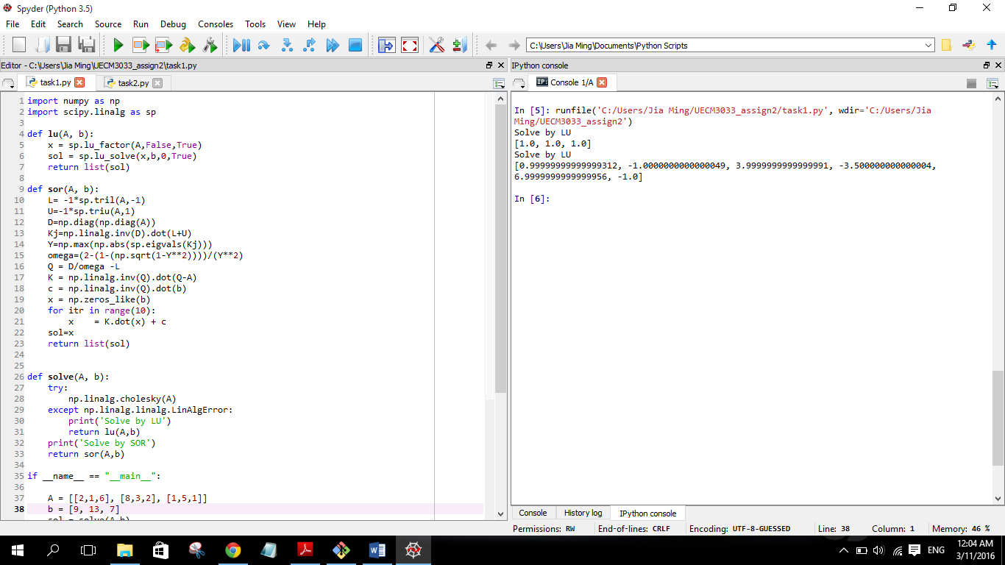
Task 2
800 none zero elements in Σ.
Sparse matrix is a matrix in which most of the elements are zero. By contrast, if most of the elements are nonzero, then the matrix is considered dense. The fraction of non-zero elements over the total number of elements in a matrix is called the sparsity (density). When the sparsity (density) of the element in the matrix are different, the SVD of the element of the matrix are different. Therefore, when the image are shown using the SVD matrix, the image are compressed.
Output for task 2:
