# CF969-7-SU-CO

# **Big-Data for Computational Finance**

# Academic Year: 2023/24

# **Assignment 1**

|  |  |
| --- | --- |
| **Name:** |  |
| **ID:** |  |
| **Date:** |  |

# Contents

**Abstract** **2**

**1. Introduction** **3**

**2. Theoretical Background** **3**

**3. Data Generation** **4**

**4. Methodology** **4**

4.1. Quadratic Programming Solvers 4

4.2. Optimisation for Different Values of r 4

**5. Challenges and Solutions** **4**

Task 1: Standard Markowitz Model 4

Task 2: Fractional Capital Investment 5

Task 3: Relaxed Return Constraint 5

Task 4: Short Selling Allowed 5

**6. Results** **6**

6.1. Task 1: 6

6.2. Task 2: 7

6.3. Task 3: 8

6.4. Task 4: 9

**7.** **Limitations and Assumptions****12**

**8****. Conclusion 1****2**

# 

# 

# Abstract

This report inspects the utilisation of quadratic programming to advance venture portfolios utilising the Markowitz model. Here advancing portfolios means to get the thought where to contribute, and what might be the base and most extreme gamble consider that speculation. Four errands with different requirements and situations are addressed, offering hypothetical experiences, recognising difficulties, and introducing viable outcomes. The analysis of what actually these progressions mean for portfolio hazard and return by surveying the outcomes of different expected returns, fractional capital ventures, changed return cutoff points, and short selling had performed. Improving the making of speculation systems through a more exhaustive cognisance of chance return compromises under different conditions is the point.

# Introduction

The Markowitz model, frequently known as the mean-difference model, was made by Harry Markowitz in 1952 and is a crucial part of the present day portfolio hypothesis. By boosting capital distribution among different resources, it helps financial backers in building portfolios that expand returns at a specific gamble level or limit risk. In this review, the Markowitz model is figured out as a quadratic enhancement issue, which is settled with an open-source Python curved improvement module called CVXPY. By adjusting the limits, researching different circumstances and assessing what they mean for portfolio streamlining is the aim.

# Theoretical Background

The Markowitz model works on the following assumptions:

* Investors are risk-averse, preferring portfolios that offer higher returns with lower risk.
* The risk of a portfolio is based on the variability of its returns.

The model uses the following parameters:

**μ**: vector of expected returns for n assets

**C**: covariance matrix of asset returns

**x**: vector of portfolio weights

The optimisation problem is defined as:

minimise 𝒙𝑇𝐶𝒙

subject to 𝝁𝑇𝒙 = 𝑟

𝒆𝑇𝒙 = 1, where e = (1, …, 1)T

𝒙 ≥ 𝟎.

where **e** is a vector of ones, ensuring the weights sum to one, and **r** is the desired portfolio return.

# Data Generation

To generate the expected return vector **μ** and the covariance matrix **C**, use a python **random module** that produces random values based on specific digits of the student's registration number, ensuring unique datasets.

# Methodology

## Quadratic Programming Solvers

**CVXPY** is employed to solve quadratic programming problems.

The tasks involve:

1. Standard Markowitz model
2. Allowing fractional capital investment (**eT x** ≤ 1)
3. Relaxed return constraint ( **μTx** ≥ **r** )
4. Permitting short selling (**x** unconstrained)

## 4.2. Optimisation for Different Values of r

The optimisation is performed for different values of **r** as given in the assignment, ranging from **2.00 to 9.00** with the increasing rate of **0.25**.

# Challenges and Solutions

## Task 1: Standard Markowitz Model

*Challenges:*

* Non-deterministic behaviour due to lack of seed in random number generation.
* The construction and population of the correlation matrix are unconventional and could be made more efficient using numpy's built-in functions

*Solutions:*

* Set a seed for random number generation to ensure reproducibility.
* Implement robust error handling for optimisation results.

## Task 2: Fractional Capital Investment

*Challenges:*

* Ensuring reproducibility and consistency in random number generation.
* Accurate matrix construction and indexing.
* Formulating the optimisation problem correctly is critical.

*Solutions:*

* Use consistent random number generation methods.
* Carefully construct and manipulate matrices with proper indexing.

## Task 3: Relaxed Return Constraint

*Challenges:*

* Managing matrix manipulation and indexing.
* Correct optimisation problem formulation.

*Solutions:*

* Validate matrix construction and indexing logic.
* Define the optimisation problem accurately with necessary constraints.

## Task 4: Short Selling Allowed

*Challenges:*

* Formulating the optimisation problem without short-selling constraints.
* Handling non-optimal solutions and ensuring proper data conversion for analysis.

*Solutions:*

* Implement error handling for optimisation and ensure correct data handling.
* Handle data based on assumptions.

# Results

## Task 1:

**Standard Markowitz Model**

For each value of **r** from 2.00 to 9.00, the portfolio's risk **σ**(x) and return **μ**(x) are calculated and plotted.

**Graphical Plot: “**Plot for Standard Markowitz Model**”**

**We are seeing different plots due to changes in the values of S.D with respect to Covariance matrix.**

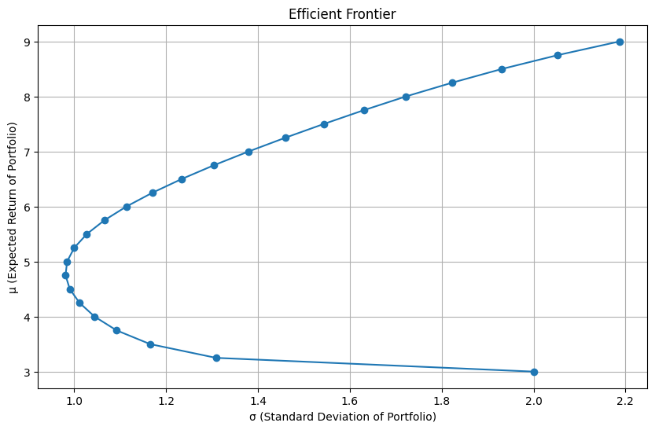

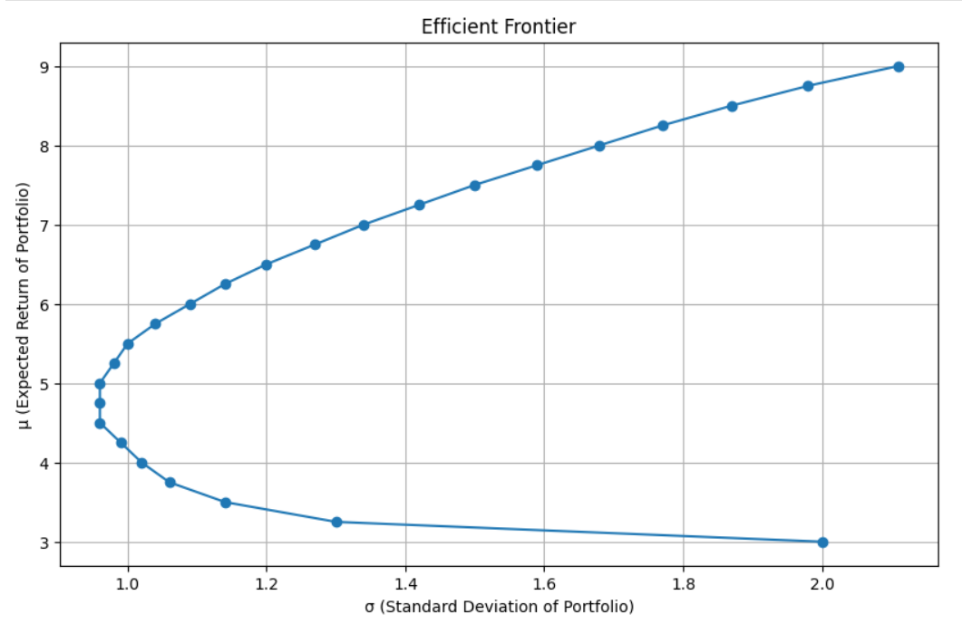

The results demonstrated the classic efficient frontier, illustrating the optimal portfolios for different levels of expected return (r). The analysis showed that as the desired return increased, the associated risk also rose, reaffirming the fundamental principles of the mean-variance optimisation model.

## Task 2:

**Fractional Capital Investment**

The constraint 𝒆𝑇𝒙 = 1 is relaxed to **eT x** ≤ 1. This scenario is justified by recognising that uninvested capital can be saved without risk or return.

**Graphical Plot: “**Plot for Fractional Capital Investment**”**

**We are seeing different plots due to changes in the values of S.D with respect to Covariance matrix.**

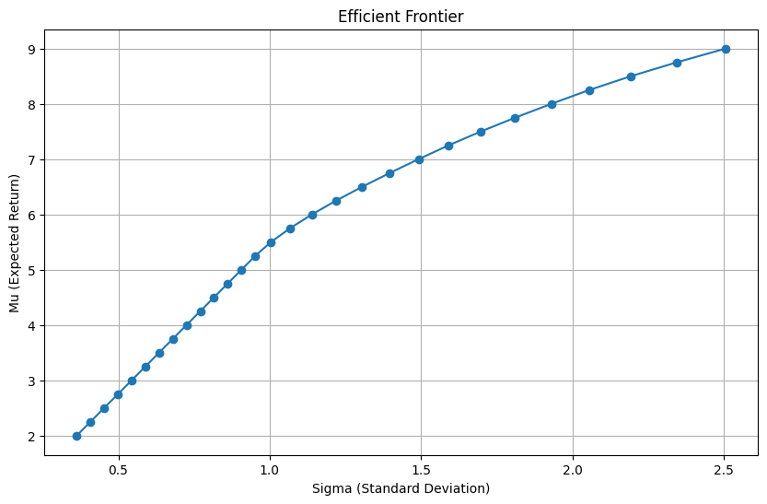

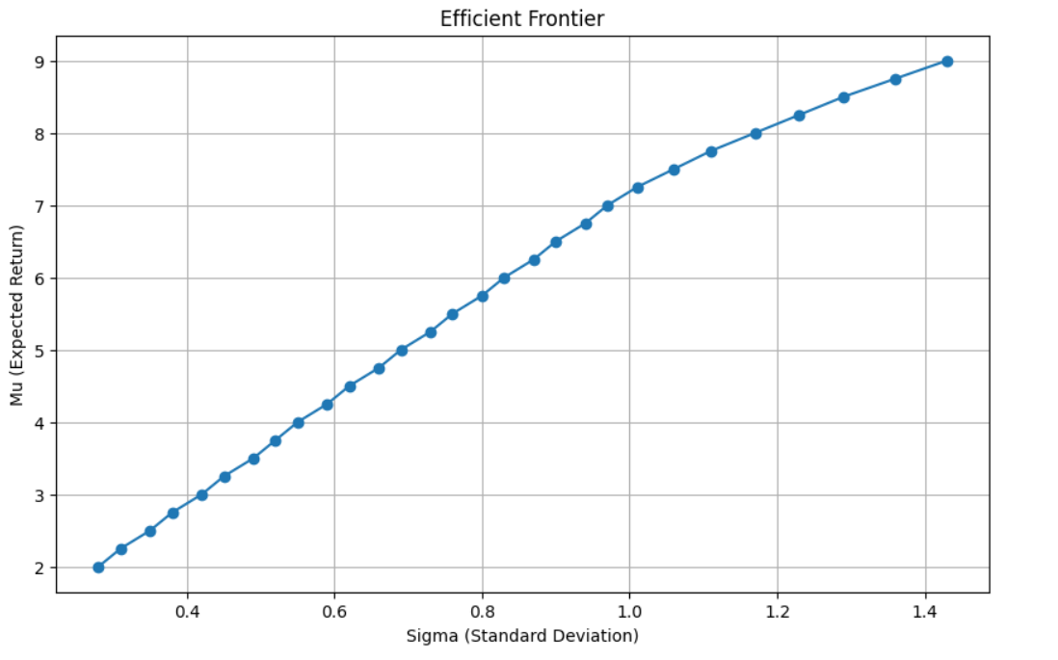

When allowing fractional capital investment (eT x ≤ 1), the efficient frontier broadened, suggesting that not fully investing the available capital can yield a wider range of risk-return combinations. This flexibility enables investors to maintain liquidity while achieving optimal returns, offering a strategic advantage in uncertain market conditions.

**Comparison Plot with Task1:**

**So the different graphs comes out from task1 and task2 so the comparison of graphs also different.**

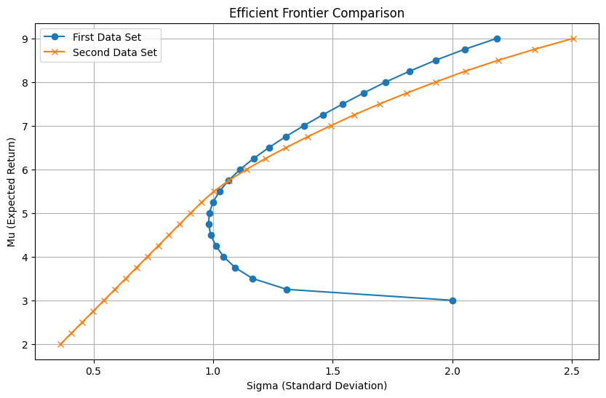

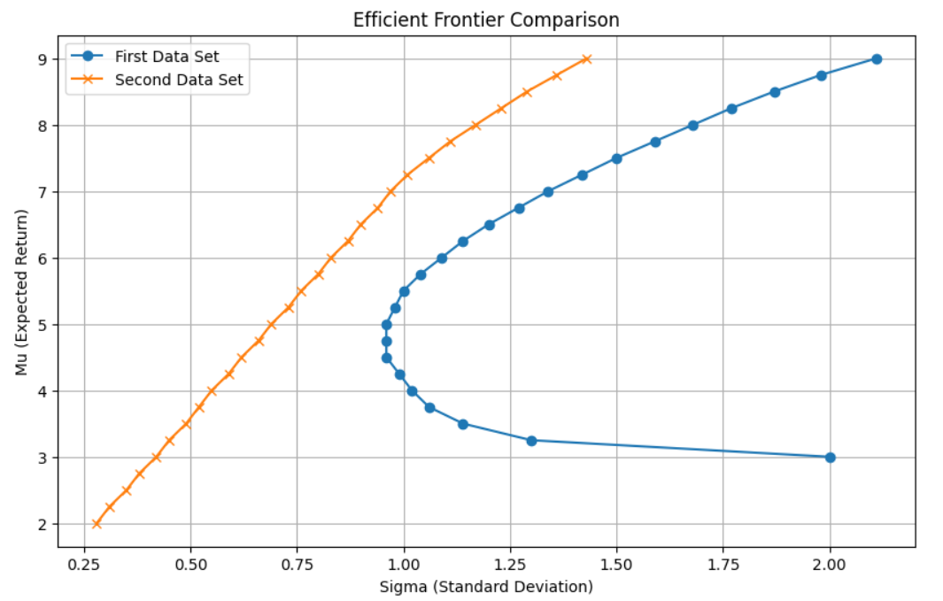

The updated plot still compares the efficient frontiers of two data sets: the blue line for the first and the orange line for the second. Despite slight changes in σ values, the overall comparison remains the same. The blue frontier remains broader and more curved, indicating a wider range of μ and σ, while the orange frontier is more linear and constrained.

## Task 3:

**Relaxed Return Constraint**

The constraint 𝝁𝑇𝒙 = 𝑟 is changed to 𝝁𝑇𝒙 ≥ 𝑟 as given in Task 3.

**Graphical Plot: “**Plot for Changing Return Constraint**”**

**We are seeing different plots due to changes in the values of S.D with respect to Covariance matrix.**

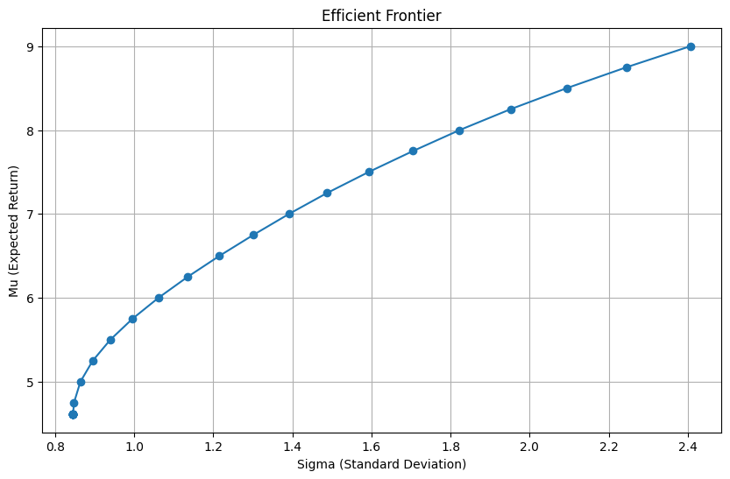

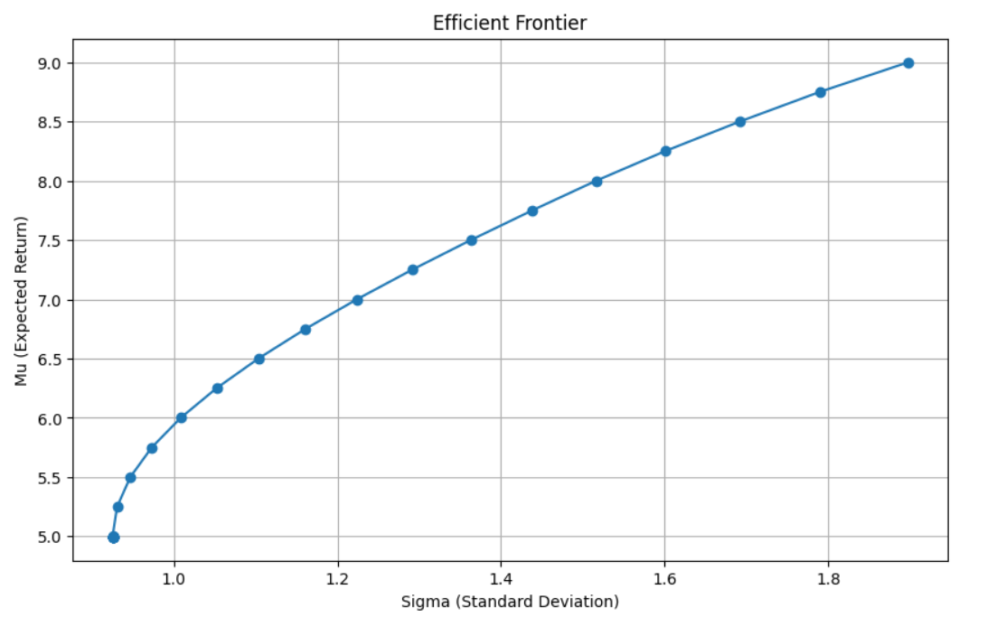

Changing the return constraint to (μT x ≥ r) provides more flexibility, resulting in an efficient frontier that allows for higher potential returns while meeting or exceeding a minimum required return.

**Comparison Plot with Task1**

**So the different graphs comes out from task1 and task3 so the comparison of graphs also different**

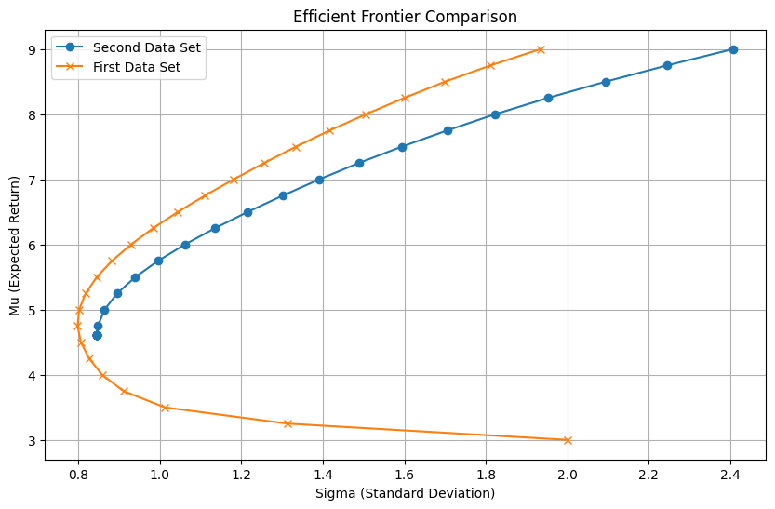

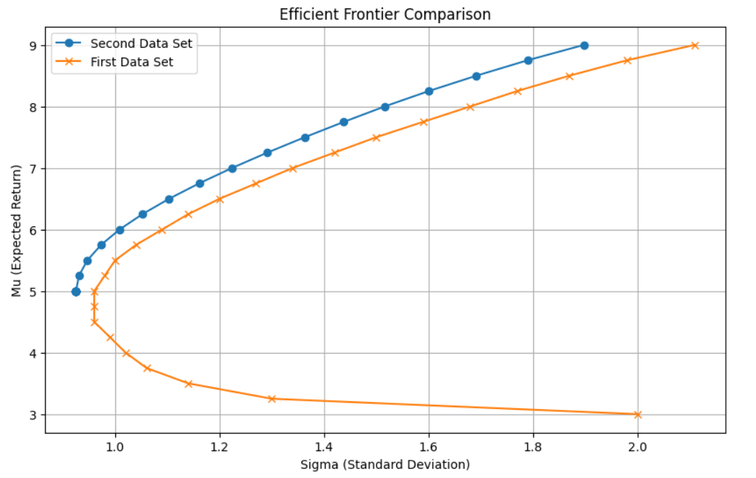

This plot compares the efficient frontiers of two data sets, with the first data set in orange and the second in blue. The orange frontier shows a more pronounced curve, indicating a wider range of expected returns (μ) and standard deviations (σ). In contrast, the blue frontier displays a more linear progression, suggesting a narrower and more stable range of μ and σ. Despite slight changes in σ values.

## Task 4:

**Short Selling Allowed**

The removal of the non-negativity constraint 𝒙 ≥ 𝟎 allows short selling. This scenario is obtained by the ability to borrow and sell assets and increase potential returns.

**Graphical Plot: “**Plot for ShortSelling**”**

**We are seeing different plots due to changes in the values of S.D with respect to Covariance matrix.**

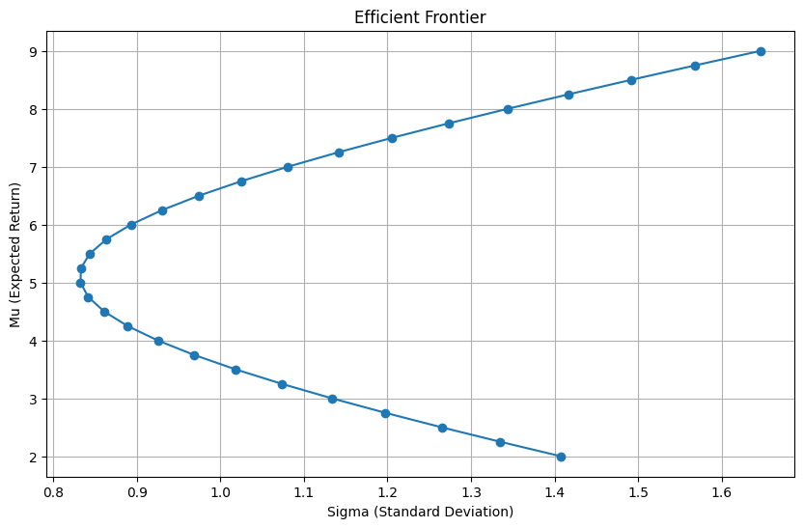

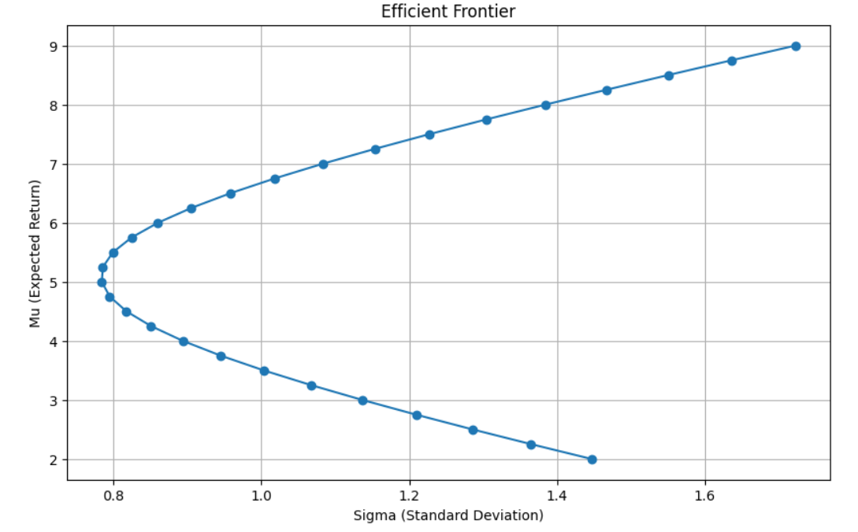

Permitting short selling (removing the x ≥ 0 constraint) significantly impacted the efficient frontier, indicating higher potential returns at increased risk levels. This scenario highlights the aggressive nature of short selling, where borrowing and selling assets can amplify returns but also heighten risk.

**Comparison Plot with Task1**

**So the different graphs comes out from task1 and task4 so the comparison of graphs also different**

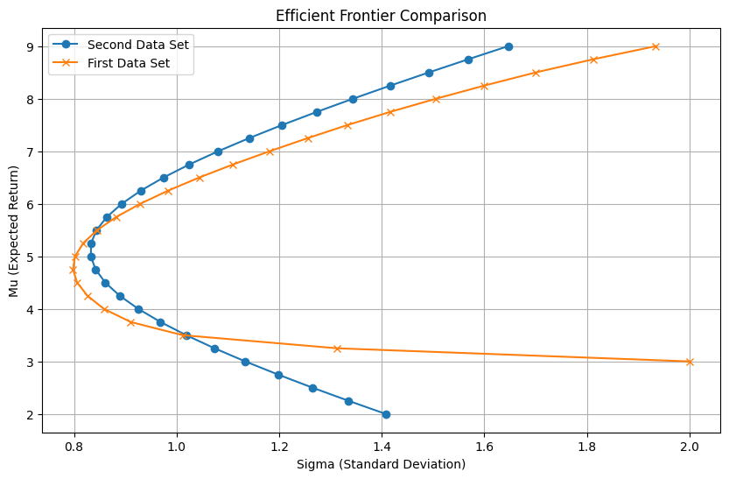

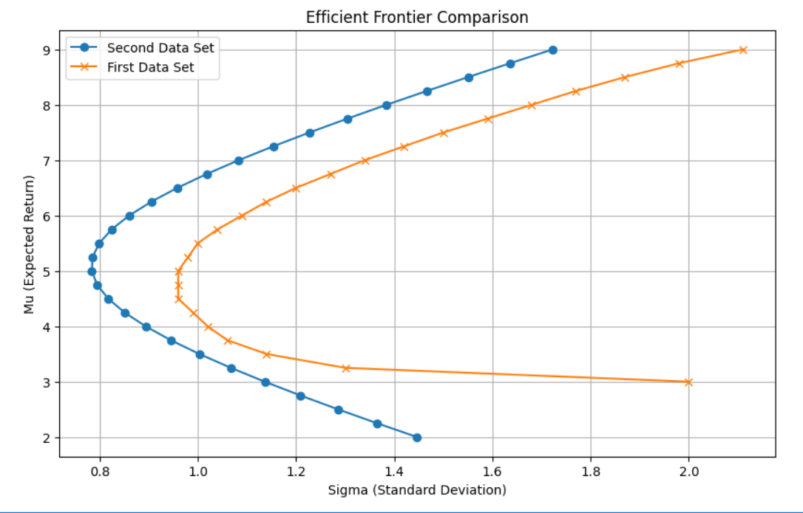

The figure compares the efficient frontiers of two data sets, with the first data set in orange and the second in blue. The orange frontier showing a pronounced curve. The blue frontier also curving but with a different pattern.

# Limitations and Assumptions

* Assumes ideal market conditions without transaction costs or liquidity issues.
* Assumptions about risk-free savings for uninvested capital may not reflect real options, as even 'risk-free' investments carry some risk.
* Adjusting constraints for flexibility can introduce complexity and instability in optimisation results.
* Model sensitivity to input parameters poses challenges in volatile markets.
* Does not consider practical and regulatory constraints, such as restrictions on short selling.
* Ignore behavioural factors like risk aversion and market sentiment, which influence investment decisions significantly.

# Conclusion

This report explored the application of the Markowitz model for portfolio optimisation using quadratic programming in Python. By addressing four distinct tasks with varying constraints and scenarios, we provided a comprehensive analysis of how these modifications impact portfolio risk and return. Key findings include the broadening of the efficient frontier with fractional capital investment, increased flexibility and higher potential returns with relaxed return constraints, and the significant impact of allowing short selling. Challenges faced during the implementation, such as ensuring reproducibility, accurate matrix construction, and robust optimisation problem formulation, were addressed with appropriate solutions. Overall, this study enhances the understanding of risk-return trade-offs and offers valuable insights for developing ­­­­­